ME 421: Final Project
FEA on Bandbeesten Piano
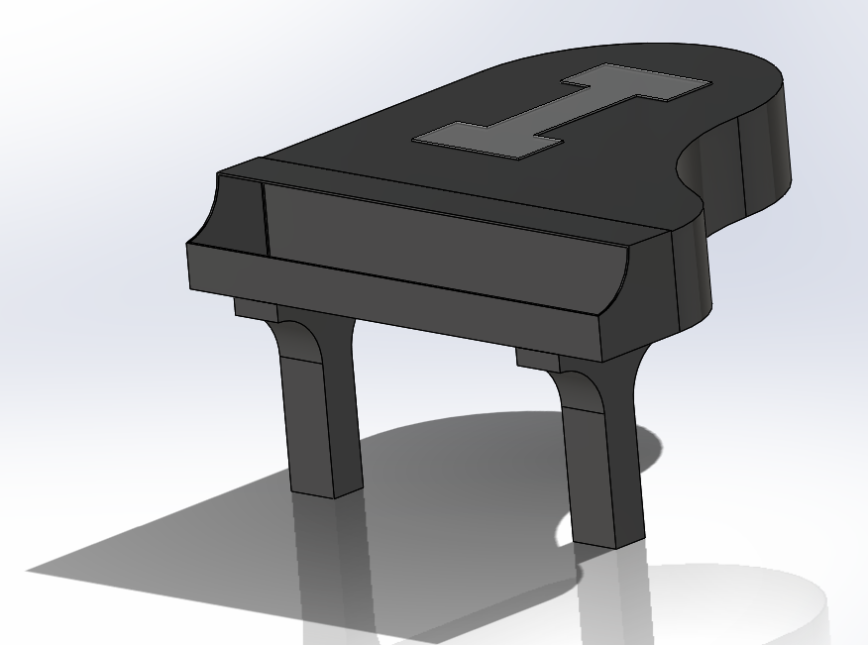

Riley Yager

Overview
The Bandbeesten piano was a part of my senior design project so I wanted to incorporate that somehow into my ME 421 final project. FEA analysis has been done on the piano lid and body itself but the results showed that the piano was really structurally sound in those parts. The one part of the piano that has not had analysis done to it was the legs that support the piano lid and body and connect the entire top of the piano to the frame. The point of this analysis was to see what kind of stresses the legs are seeing while the piano lid is sitting in static conditions. Overall the results that were obtained help me realize that the wooden structure of the piano is really strong and that there shouldn’t be any concern with the piano failing at the legs during static conditions.
I started my analysis using the model that had been created the year before on the piano. One of the problems that I ran into when trying to do the FEA analysis in SolidWorks was the fact that the entire structure was puzzle pieced. This made the analysis a lot more difficult due to the fact that I had to try and create interactions between all the different pieces in the piano assembly. Since the piano was so intricate, it made it nearly impossible to create interactions between all the parts and this leaded to the piano not being able to mesh. Then to try and fix the problem of the piano being an assembly I saved the file as a part instead. SolidWorks then converted all the different pieces into surfaces that didn’t have an assigned thickness. I then tried to create a thickness for each surface but this did not work due to all the complex puzzle pieces in the part.
I then started from scratch and created just the lid and the legs of the piano assembly in order to make the scope of the analysis smaller so that it could be completed. By doing this I had to make a lot of assumptions in the analysis, but the results provide insight on the structure and the stresses that it would see with static conditions applied to it.

Assumptions
One of the assumptions that I had to make when doing the analysis was that the entire piano was made of one solid piece of wood instead of a bunch of puzzle pieced wood glued together. The second assumption that I had to make was the fact that I just fixed the bottom of the legs during the analysis so that stresses would just be seen in the legs. The third assumption that I had to make was that the legs were hollow and did not have any support geometry running through them. The final major assumption that I had to make was the type of wood that the piano was made of. The real piano is made from Birch, however SolidWorks did not have that within its material properties so I had to choose balsa wood instead. These two woods are comparable to each other so the results from the simulation can still be used for the actual piano.

- Piano is made from one solid piece of wood
- Used balsa wood instead of birch wood
- Legs are hollow and have no support structure inside of them
- Static loading with just the weight of the wood hanging being the force applied.
- Changed scope to just the piano lid and the piano legs
- Neglected the weight of the keyboard

Boundary Conditions

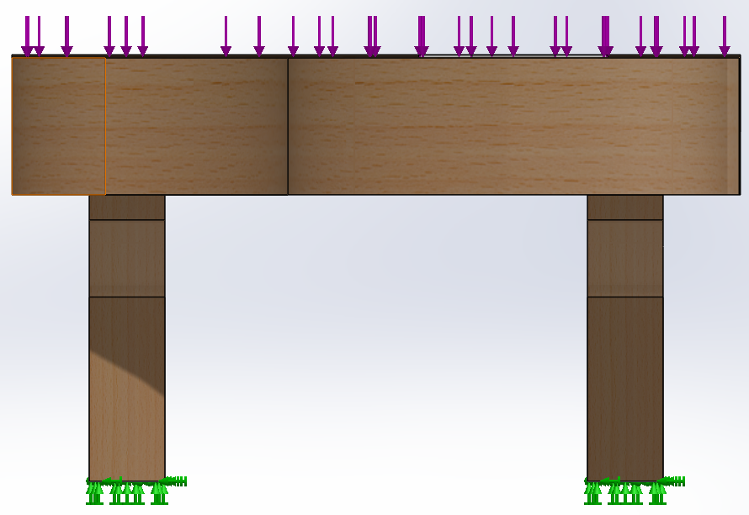
Loading conditions applied to the piano
The picture above shows the boundary conditions that I used for the legs. I fixed the bottom of the legs in all directions so that the piano would not move during loading. This is one of those rough assumptions that I had to make because anytime that I tried to create support material within the legs, the interactions would not work in SolidWorks.
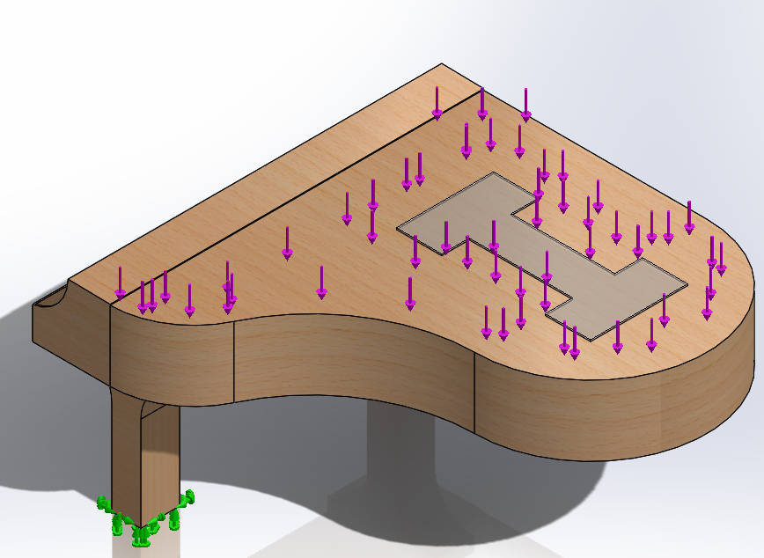
Loading applied to the top of the piano for simulation

Since I was just worried about the static conditions for my analysis, I just took the mass properties of the piano that I created and multiplied that by gravity in order to simulate the force that the piano sees just from its own mass. This made the simulation a lot smoother and allowed me to perform the simulation in a timely manner.

Material Properties
Since the analysis had already been completed on the piano body itself, I made the entire lid and body as a rigid part in SolidWorks so that the results would only be shown in the legs of the piano. I then applied balsa to the legs of the piano to give the material properties of the wood to the legs.
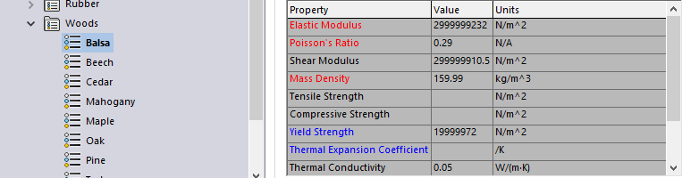

Meshing
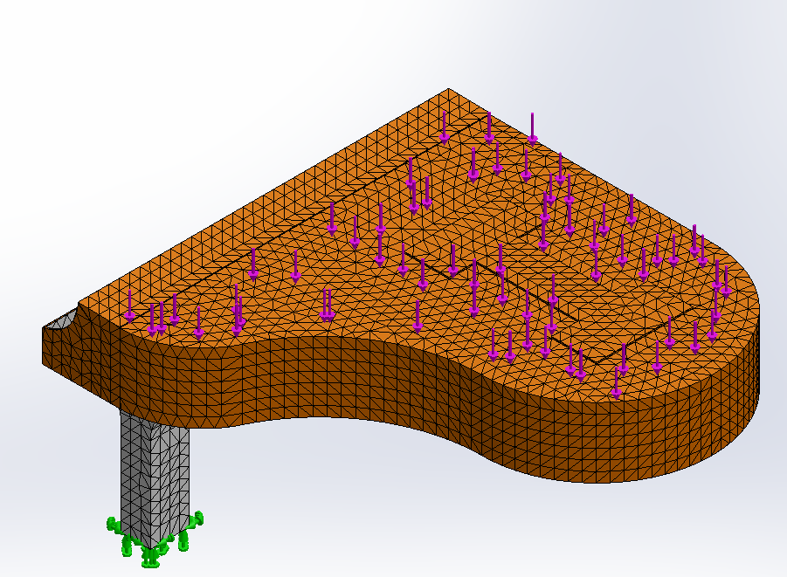
This picture shows the meshing that was applied to the piano and the legs

Meshing in SolidWorks is really simple due to the fact that you just apply the mesh and it meshes the entire part for you. You do not have to create your own meshing you just choose what size of mesh that you want to use and it meshes the part. When you choose a really fine mesh the simulation can take really long to solve, but the results are more accurate. When you have a coarser mesh the simulation runs a lot faster, but the results become less accurate. I tried both ways and created a mesh that was right in the middle when it comes to being too coarse or too fine. It should be noted that the meshing on the piano lid does not really matter due to the fact that I made it a ridged body in the simulation.

Results
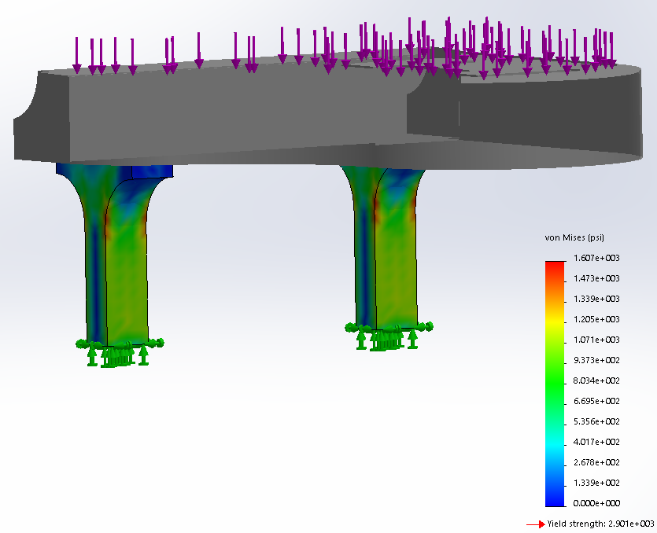
This is the contour plot of the Von Mises stresses in the legs [psi]
The highest stress that the piano legs see is 160 psi and the yield strength of the piano is 290.1 psi so the piano should not break just sitting still. By adding a support to the base of the piano to help hold up the weight of the piano lid would make sure that the piano would no break during things like performances. The results may be a little different than the actual wood that the piano is made of, but the fact that this simulation showed that the wood is not near the yield strength provides insight that the piano should not break due to the fact that the balsa wood is not much harder of a wood then birch. Overall I would say that the results support the notion that the piano is not going to fail from static conditions. The fact that the stress is so far away from the yield strength means that the piano could see a lot higher loading before it would break.

Conclusion
Overall the analysis of the system supported the fact that the piano was built well and should not be worried about breaking during static conditions. This simulation does not take into account the fatigue that the piano takes during each show and practice while the piano is moving so that could be something that is looked into in the future. By adding a support to help reduce the size of the moment arm that the piano lid causes would also reduce the stresses that the legs see as well as extend the life of them. It was interesting trying to re-create the shape of the piano by making it a solid structure because of the fact that the current model that is made in SolidWorks is puzzle pieced together. It would be interesting to also do a test with a puzzle pieced material vs a solid material and see how the stresses varied for the different conditions. This could be performed on a much simpler part so that the interactions would be easy to set and the results could be compared to each other.

