The
INJECTION MOLDING HANDBOOK
For
DESIGN ENGINEERS
And
CATIA USERS

Authors:
Kevin Waring
Garrett C. Hanson
Cody McCallister

From:
University of Idaho
Mechanical Engineering
ME 421

Table of Contents

Table of Contents 1
Basics of Injection Molding 2
Design for Injection Molding 4
Manufacturing an Injection Molded Part 14
Appendix A: Quick Points 17
Appendix B: Considerations for a Future Tutorial 18

Abstract
The following document will provide the basic information required to understand the process of injection molding. This handbook is a stepping-stone for determining if injection molding is the right manufacturing choice for your design. The following sections will address the fundamentals of the molding process, how to optimize your part for molding using CATIA, and the steps taken in getting an injection molded part manufactured.

Basics of Injection Molding

Injection molding is a manufacturing process commonly used to create a large quantity of plastic parts. In its most basic form, the injection molding process requires heated material to be forced into a compressed mold where the material is cooled. The product is then ejected from the mold and the process is repeated. Many things must be considered when choosing to manufacture your part via injection molding. Understanding the process will help clarify if it is the right technique for your product.
An injection molding machine, the simplest device needed to complete an injection mold, consists of two sections: the injection unit and the clamping unit. Both of these components are found in any injection molding device. Each component contains several smaller functions that make the process work.
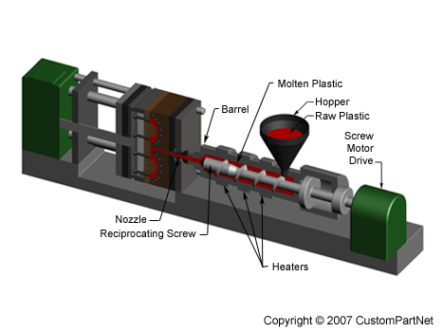
The injection unit is responsible for getting the raw material treated and into the mold. The first component is a material collection container with a hole on the bottom, most commonly called a “Hopper”. The hopper receives the bulk of raw material and feeds it into a tube-like mechanism known as the “Barrel” that heats and transports the material into the mold. This transport is usually done with either a ram injector (hydraulically powered plunger) or a reciprocating screw (the more common approach.) As the material is transported, it is heated by friction, pressure, and heaters surrounding the barrel. The molten material is then pushed through a nozzle at the end of the barrel via pressure and the barrel mechanism. The high pressure forces the molten material into every contour of the mold as the molten plastic is forced though the nozzle into the mold cavity contained in the clamping unit.
Figure 1. Diagram of the injection unit of an injection molding machine.

The clamping unit houses the mold. Molds must sustain tremendous forces and temperatures, so they are made of alloys (usually aluminum or steel.) They are constructed in two halves with a cavity in the middle in the shape of the final part. The front half of the mold, called the mold cavity, is stationary and connected to the nozzle of the barrel. The back half of the mold, called the mold core, is attached to a sliding plate. Before the injection of the molten material, the two halves of the mold must be compressed by forcing the mold core onto the mold cavity. Pins tightened through the mold, or a hydraulically powered press of the mold core against the mold cavity, creates this required compression. This compression force must continue while the molten material is injected through the nozzle and cooled. Due to the high pressures at which the plastic is injected, the mold must be clamped with a force commonly ranging from 10 to 100 tons. After the required cooling time, the two halves of the mold are separated and an ejector pin attached to the mold core pushes the solidified part out of the open cavity.
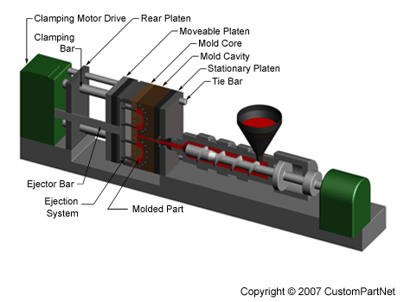
Figure 2. Diagram of the clamping unit of an injection molding machine.

One run through of the injection molding cycle can take from two seconds to two minutes depending on the machine and the part created. The cycle can be described in four stages: clamping, injection, cooling, and ejection. During the clamping phase, the mold core and mold cavity are forced together and remain together until the ejection phase. After the mold is held together, the injection phase begins and raw material placed in the hopper is fed into the barrel and moved into the mold after being heated into a molten state. The molten material is forced into the mold, completely packing the cavity. As soon as the material contacts the mold, the cooling phase begins, where the material solidifies into the shape of the mold. When enough cooling time has passed, the mold cavity and mold core are separated and the part is ejected. This is done via an ejection pin attached to the mold core. This is required because the part shrinks and adheres to the mold. Lastly, some post processing is often required.

Designing for Injection Molding

As design engineers, we are interested in what we can do with injection molding. The options are vast, but you need to understand the limitations of the injection molding process. Once you understand those limitations, you can begin to efficiently design for molding. Luckily for us, CATIA’s Functional Molding Workbench (FMW) is designed to do just that. This workbench feels similar to other CATIA workbenches you are familiar with, but it has some fundamental differences in the design process. CATIAs Getting Started Tutorial on Functional Molding Workbench is an adequate lesson on using the basics of the FMW but fails to portray the value of designing a part in this way. As you can learn in the Overview of the FMW Tutorial, this workbench doesn’t work like other workbenches where you create a part and add or subtract material from it with a rigid history. Instead, you create functional features and volumes that aren’t history based and do not need to be connected to be formed. The FMW also allows for time saving shortcut in a design and gives you the ability to design your part around geometrical requirements in a visual and active manner. The CATIA tutorial fails to tell you why you push the buttons you do, and while the help file is the best way to learn how to use a function, hopefully this lesson explains what makes these functions useful.
Suppose you work for a toy company who makes toy wind-up cars. You have already designed a reliable, cost effective chassis for your wind-up cars, as shown below. Now you need to make the body for the cars in a way that is cheap, fast, and accurate. Having chosen injection molding, you would now open the FMW in CATIA.
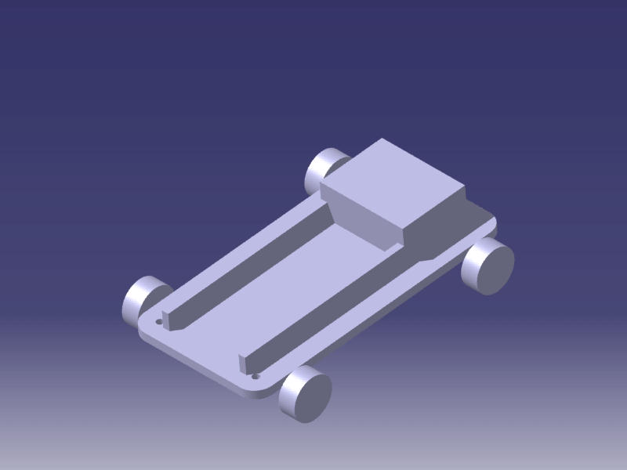
The part we want to make must interact with the chassis, as well as the environment in which it will be used. In this case, the ground must be included for the bottom edge of the car body. To ease the design of the body, start by using a Protected Feature to create the “ground clearance.” This will create a volume in the part that cannot be built in ensure that the toy car will roll on its wheels.
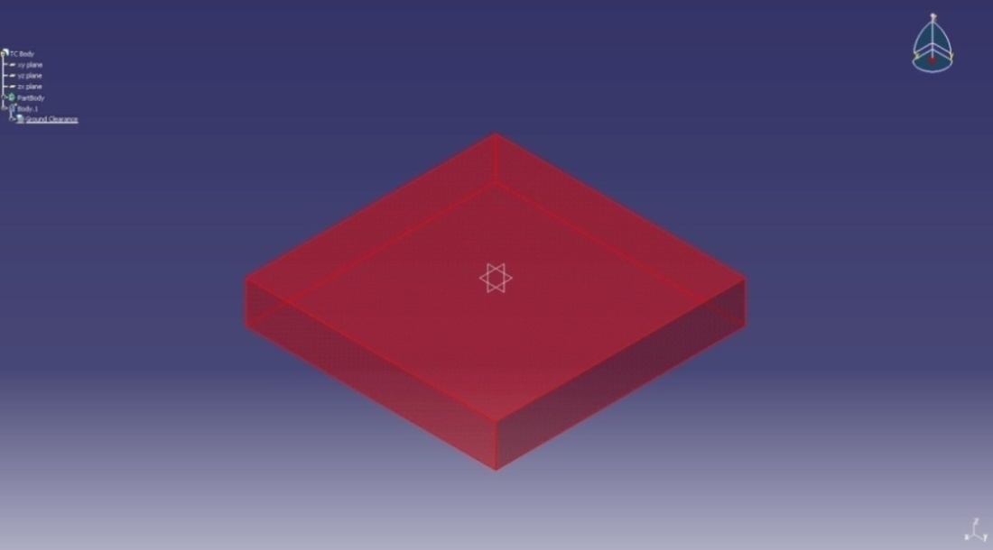
Next, model the chassis using Protected Features. This will serve as a feature to model the toy car body around, as well as aiding in creating the body features. In this example, some of the protected features are larger than their equivalent in the toy car chassis model to create clearance for the body.
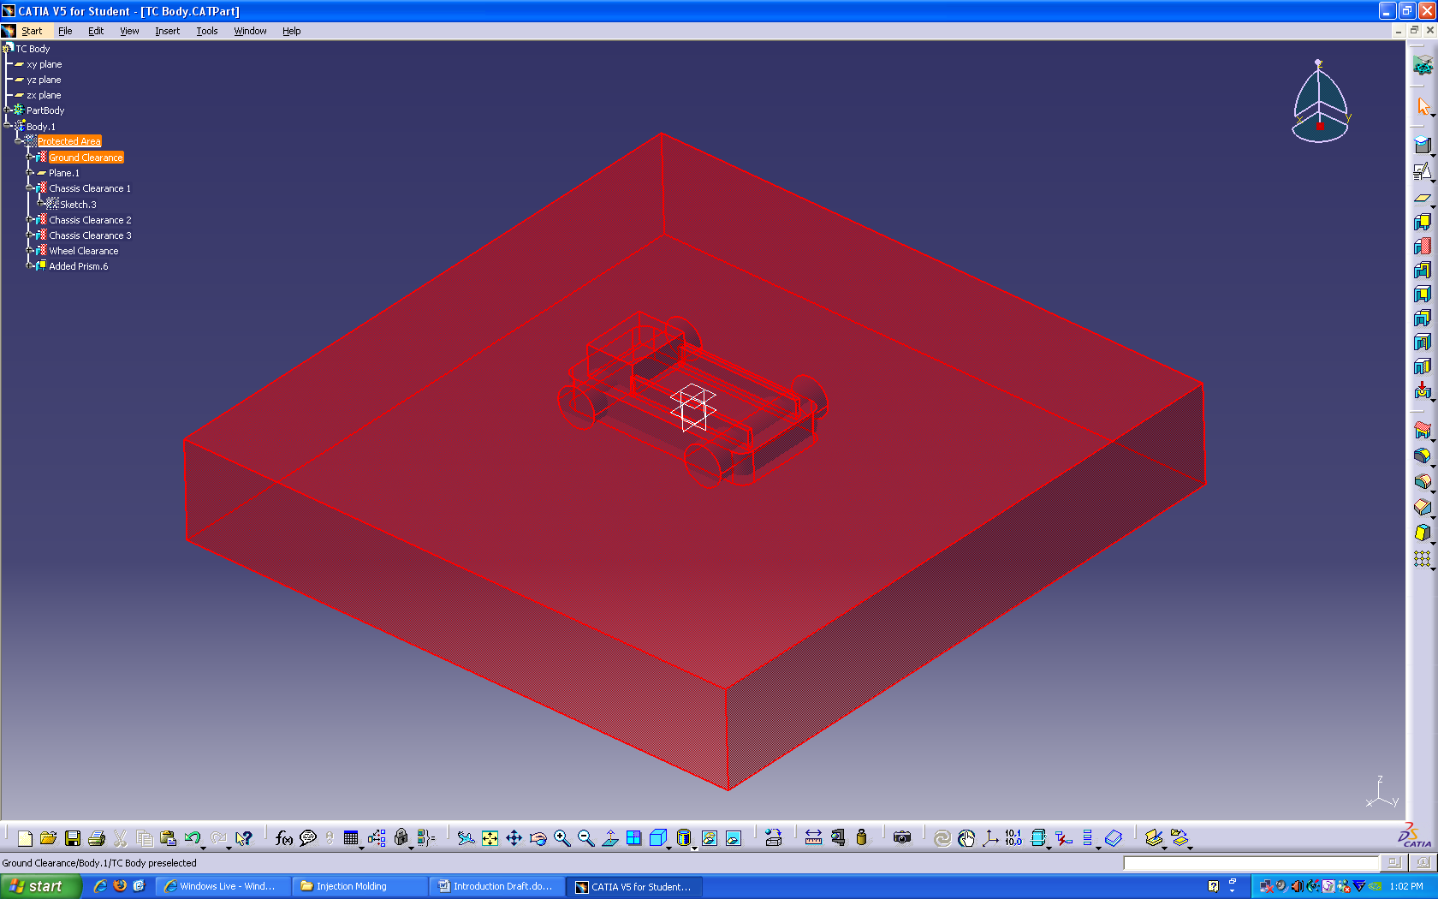
Next, the protected areas were used as a guideline to create the swept surfaces that will later define the top surface of the toy car body. This was done in the Wireframe and Surface Design Workbench.
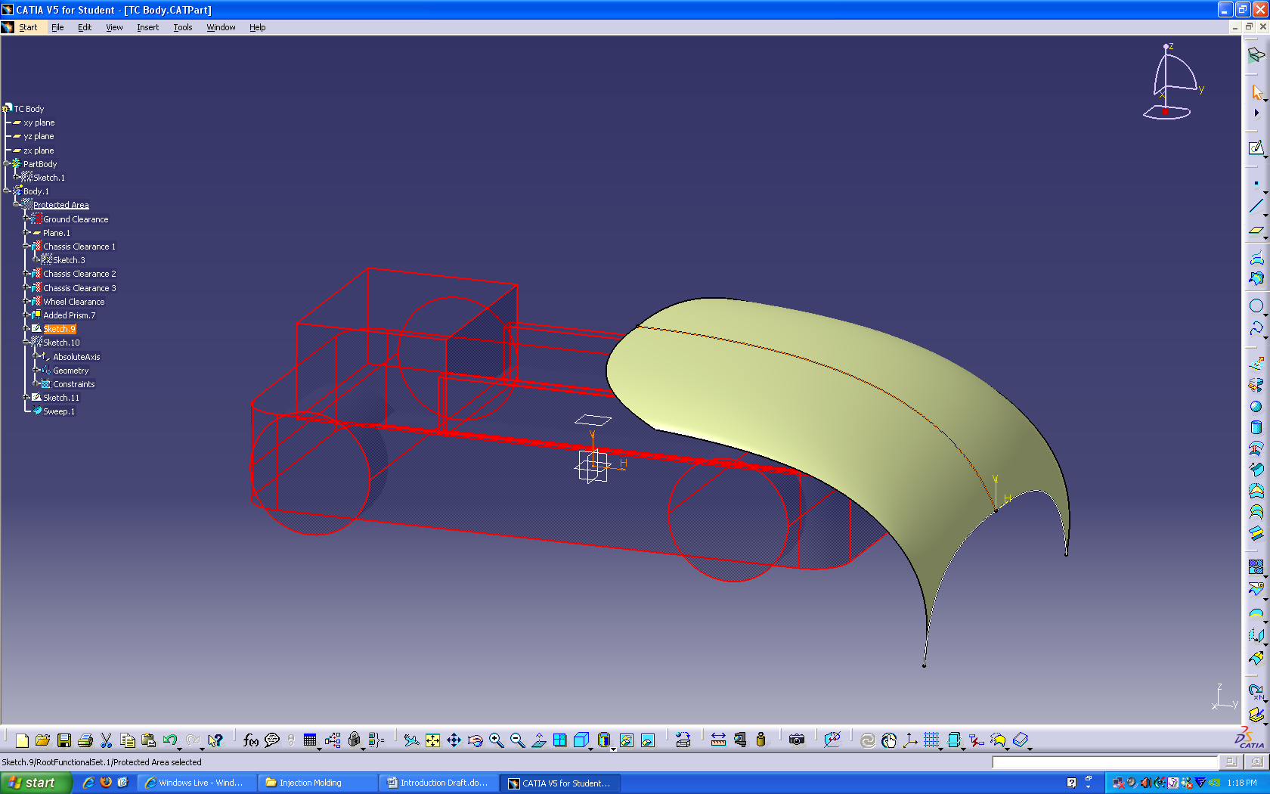
Here is the final surface, which was created by Joining two Sweeps. Notice how the sweeps were extended to make sure the surface would intersect the entire protected feature for the ground.
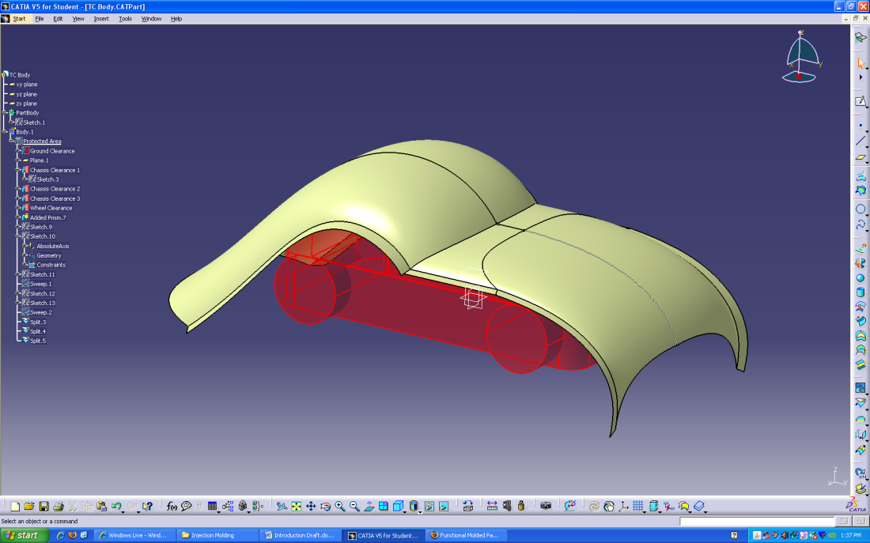
Now, back in the FMW, create a Shellable Feature. This allows the user to create a volume that is already shelled and will keep a uniform wall thickness as the shape is modified. Notice the added draft which will ease the manufacturing process.
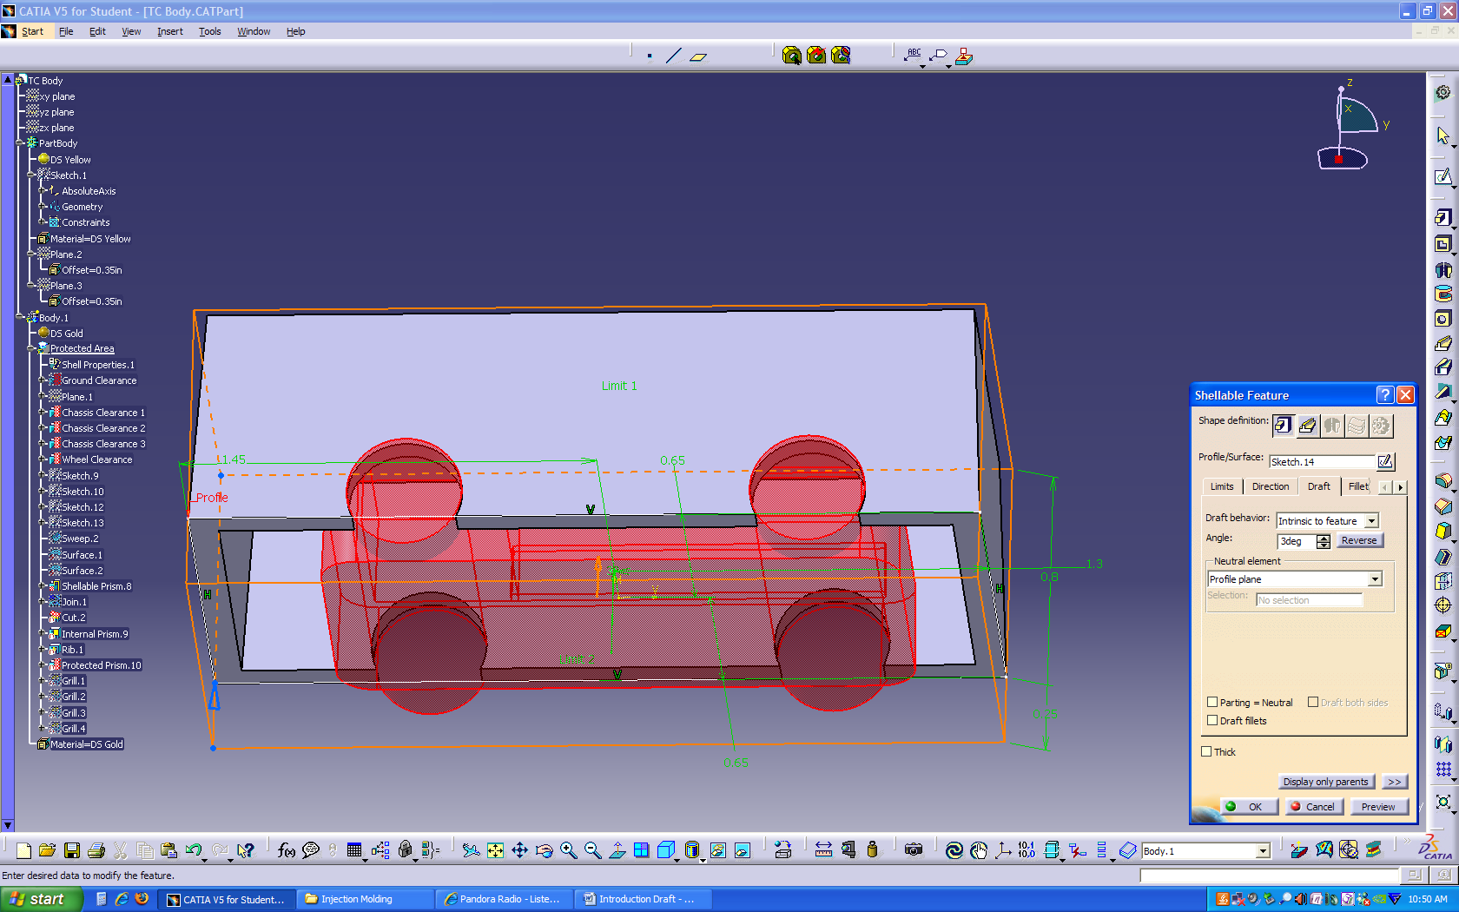
The default shell thickness was too thick, but that parameter can be modified by accessing Shell Properties from the design tree.
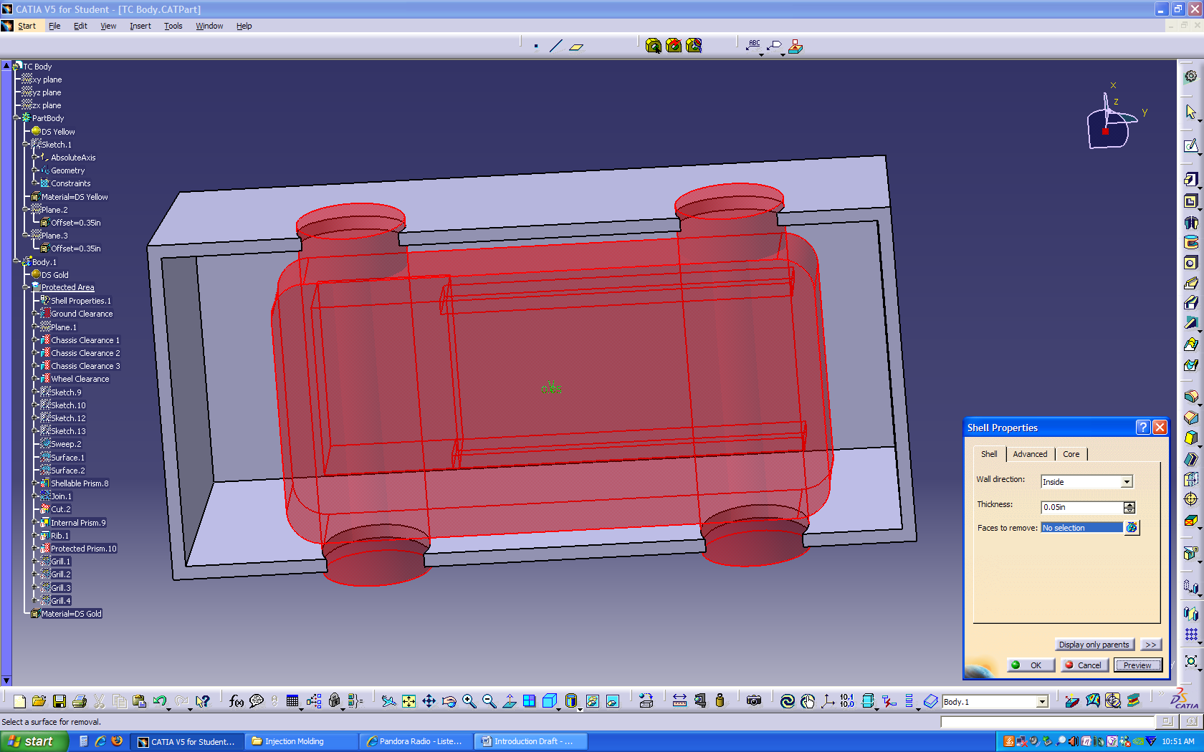
Next, perform a cut to shape the volume.
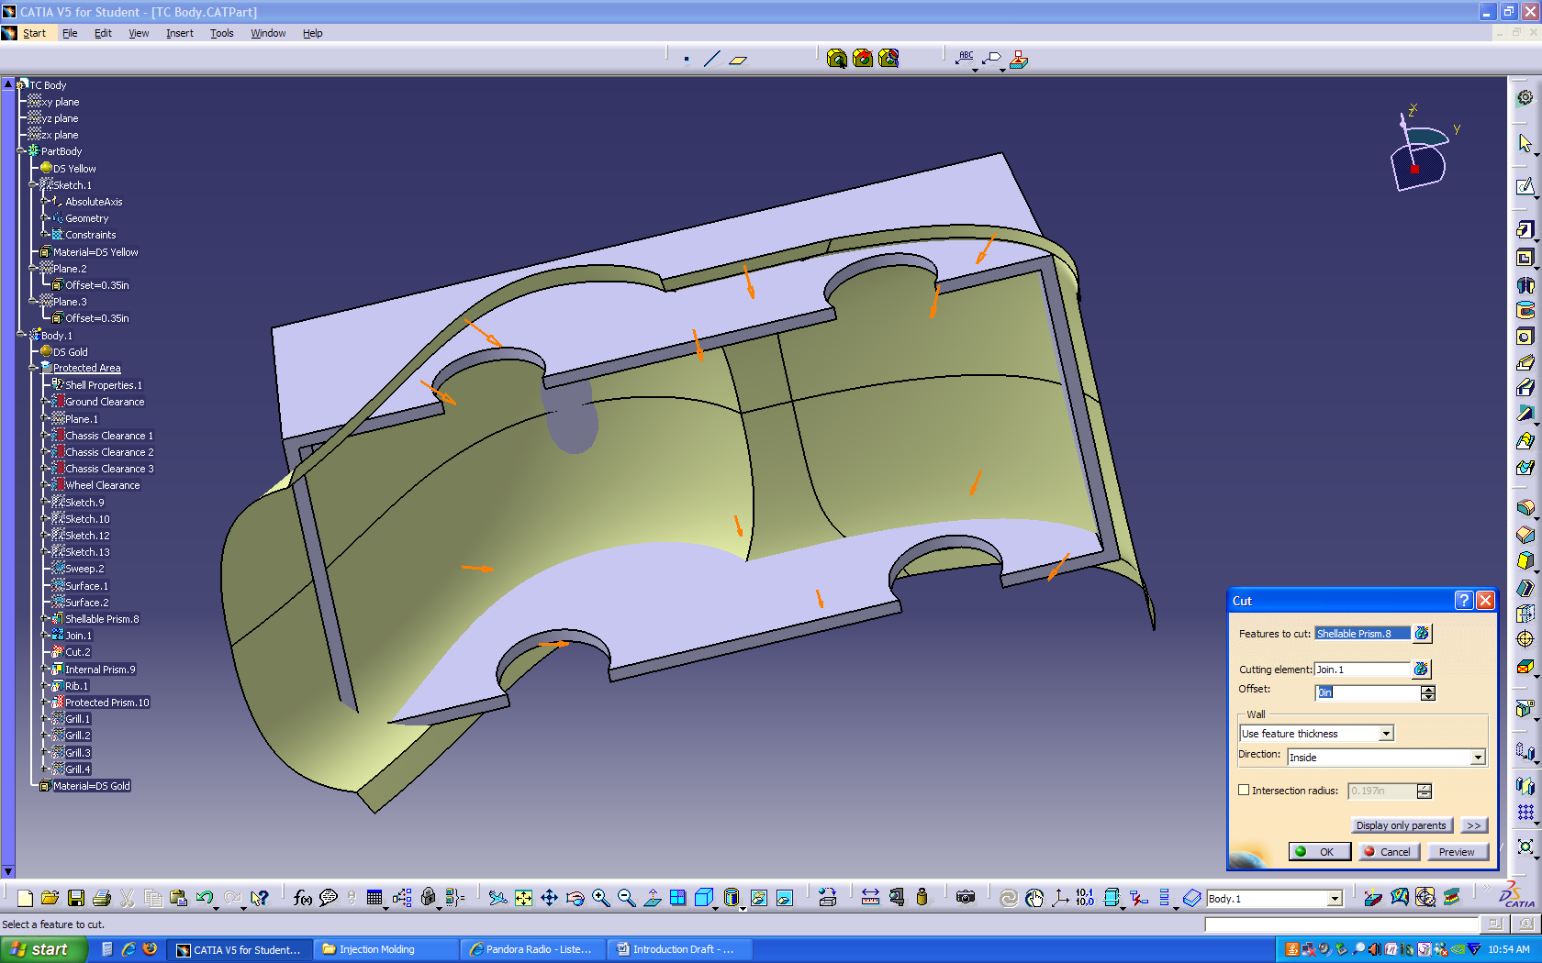
This gives the body the basic needed shape.
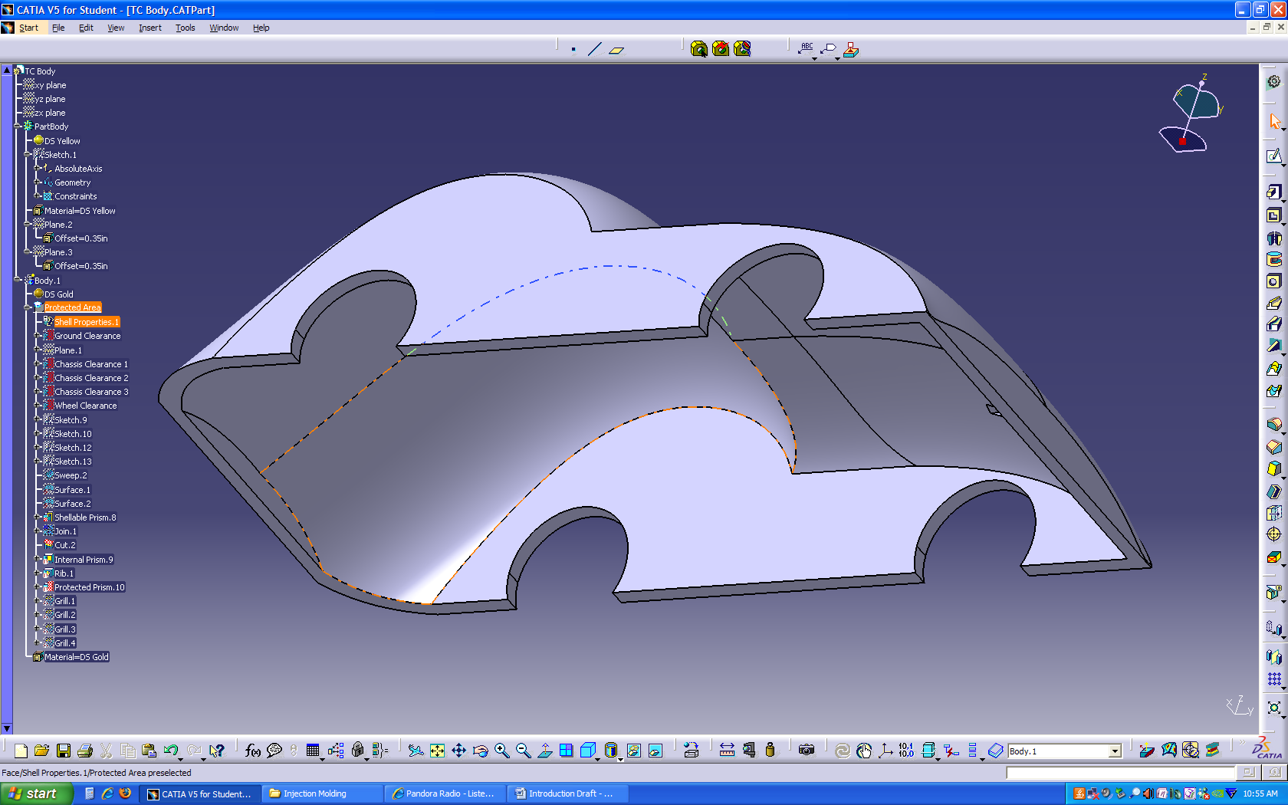
Using the Protected Feature as a template sketch, studs are added as an Internal Feature which will later be used to attach the body to the chassis. Note the draft.
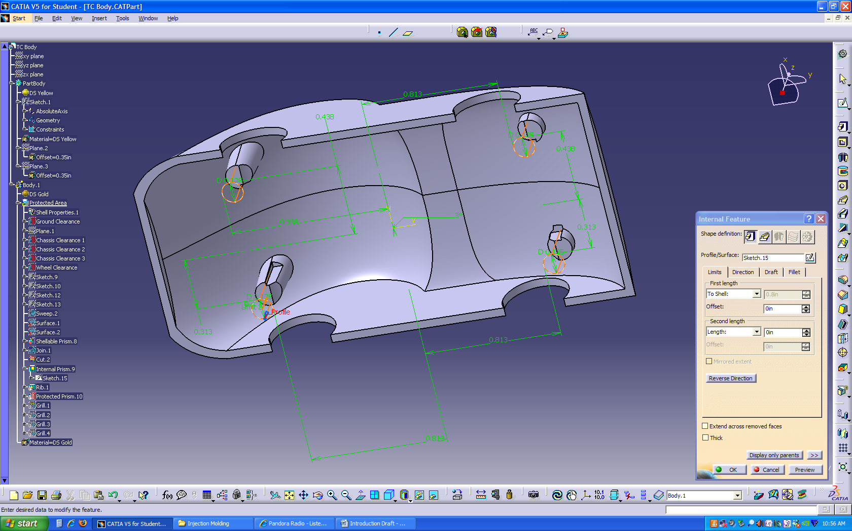
The Rib tool can now be used to add reinforcement, which simply requires a sketch of a pattern of lines. The sketch can exceed the boundary of the volume. This is a lot easier than making a Pad(s) in the Part Design Workbench. Note these too are drafted.
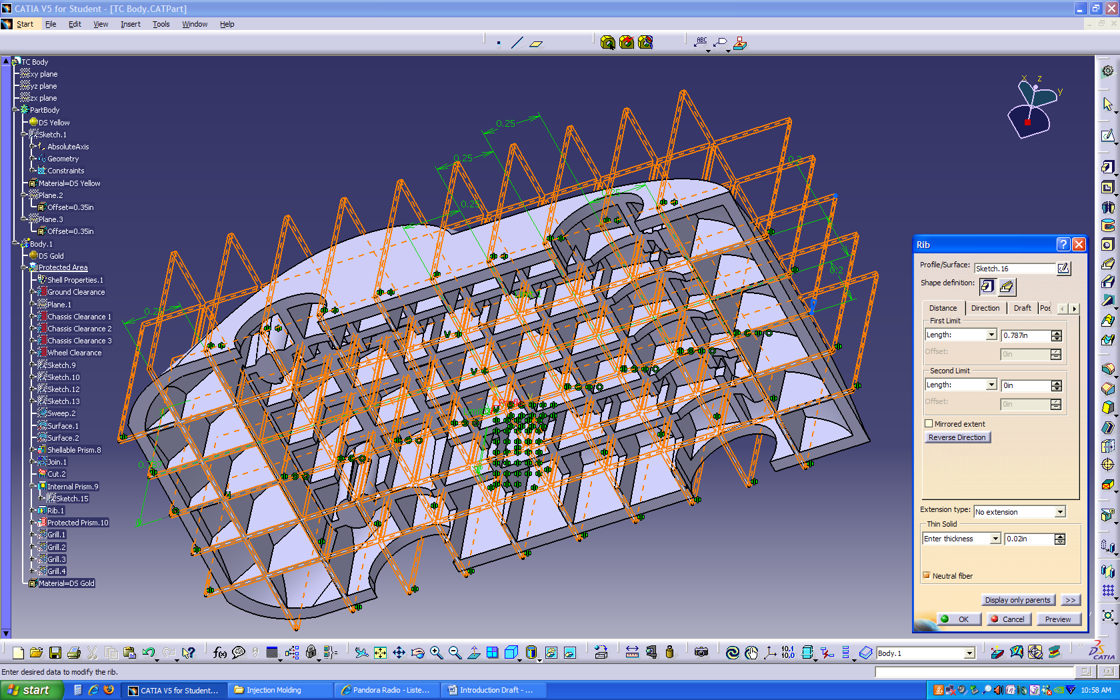
The wheel wells still need a little material removed. Using another Protected Feature, it is easy to modify and draft.
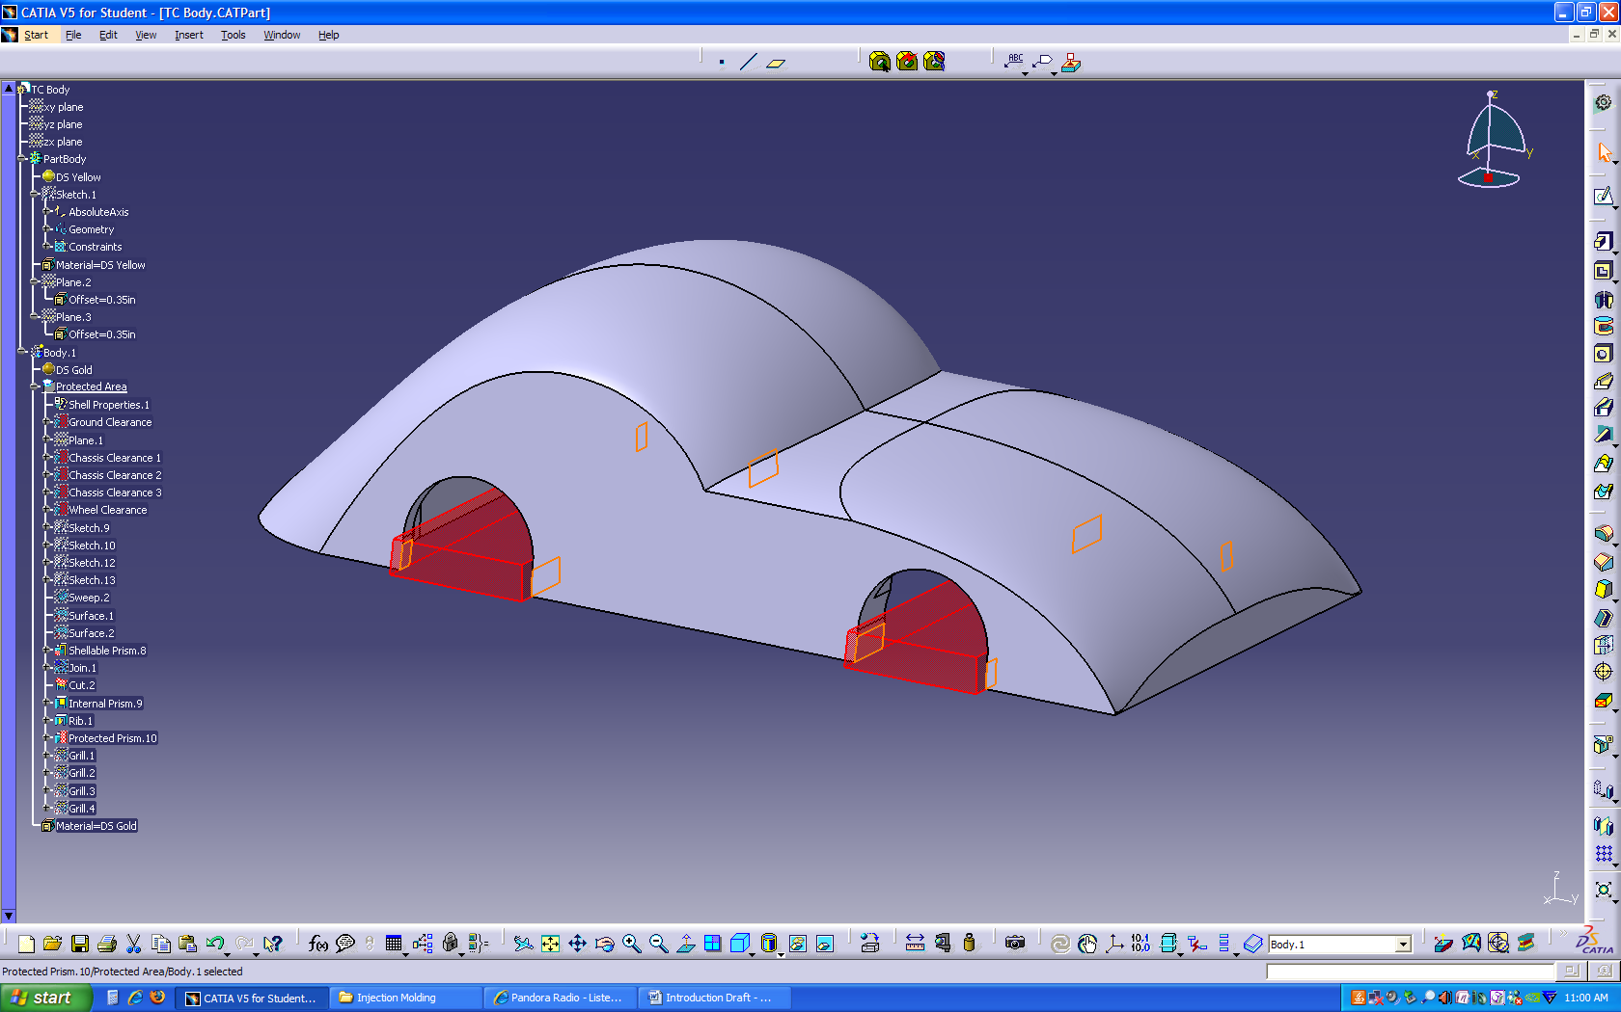
To add some texture to the body, the Grill tool can be used to create a cut of uniform depth on a surface.
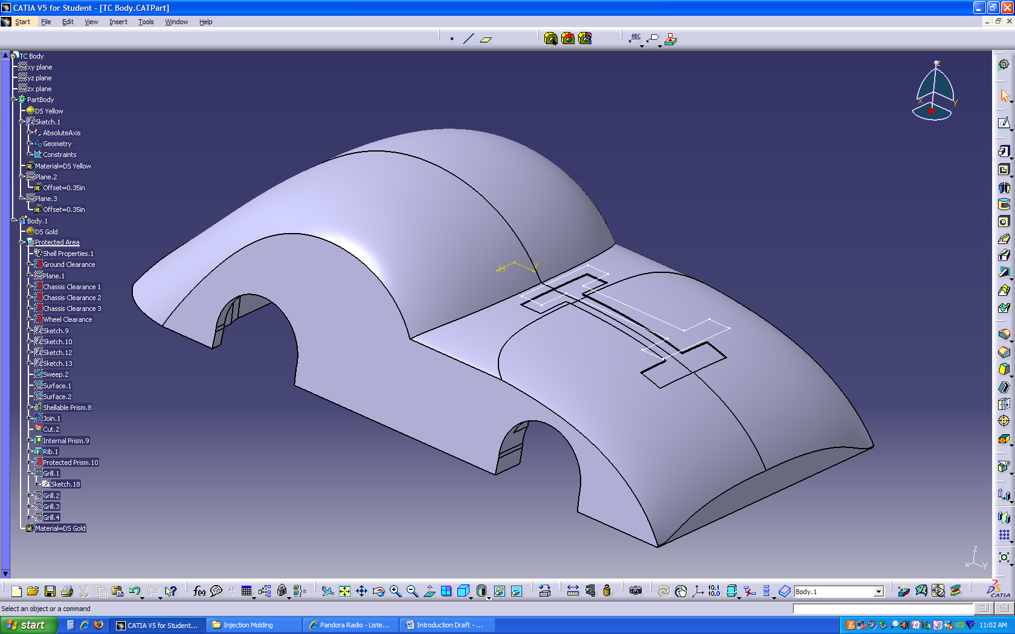

Switching to the Core and Cavity Workbench, you can visually check the design with the Pulling Direction tool. The green surfaces contact the cavity half of the mold, while the red surfaces contact the core half. The blue surfaces contact neither and require your analysis to determine if they can be molded or need to be redesigned. The pink areas are not drafted, which can be problematic for the manufacturing process. The car body must be altered to fix the problem.
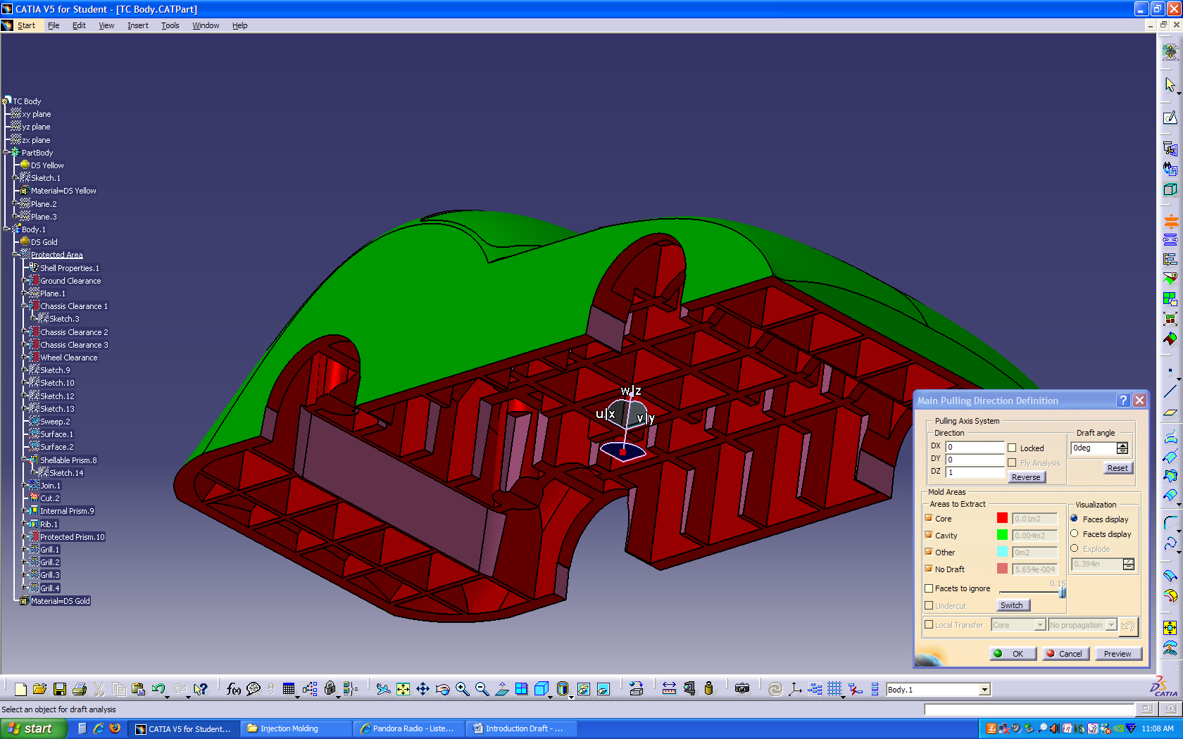
Going back to the Protected Features and adding a draft fixes the problem.
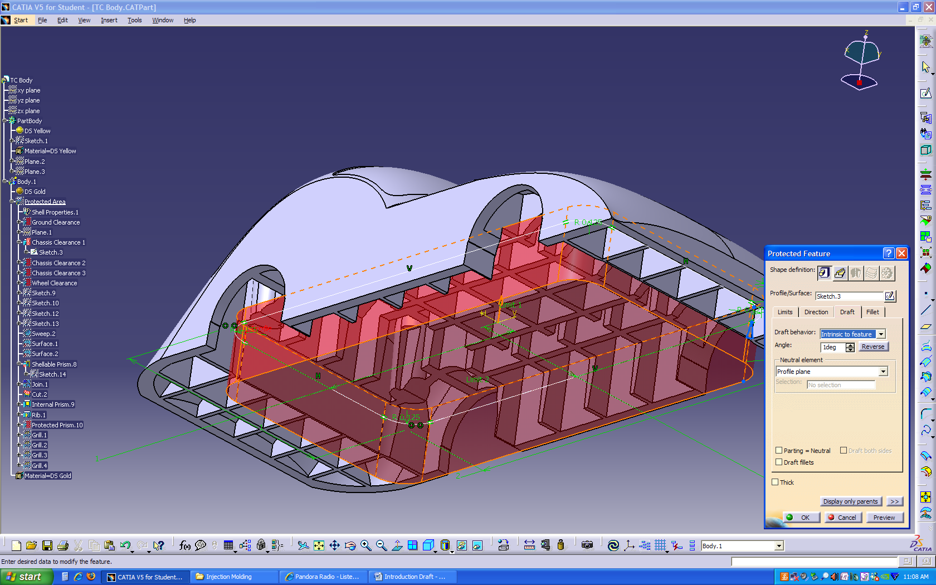
Rechecking the part verifies the correction. Notice the blue areas that are now showing should actually be core features. It is important to recognize that this tool has severe limitations and is not a replacement for manual analysis.
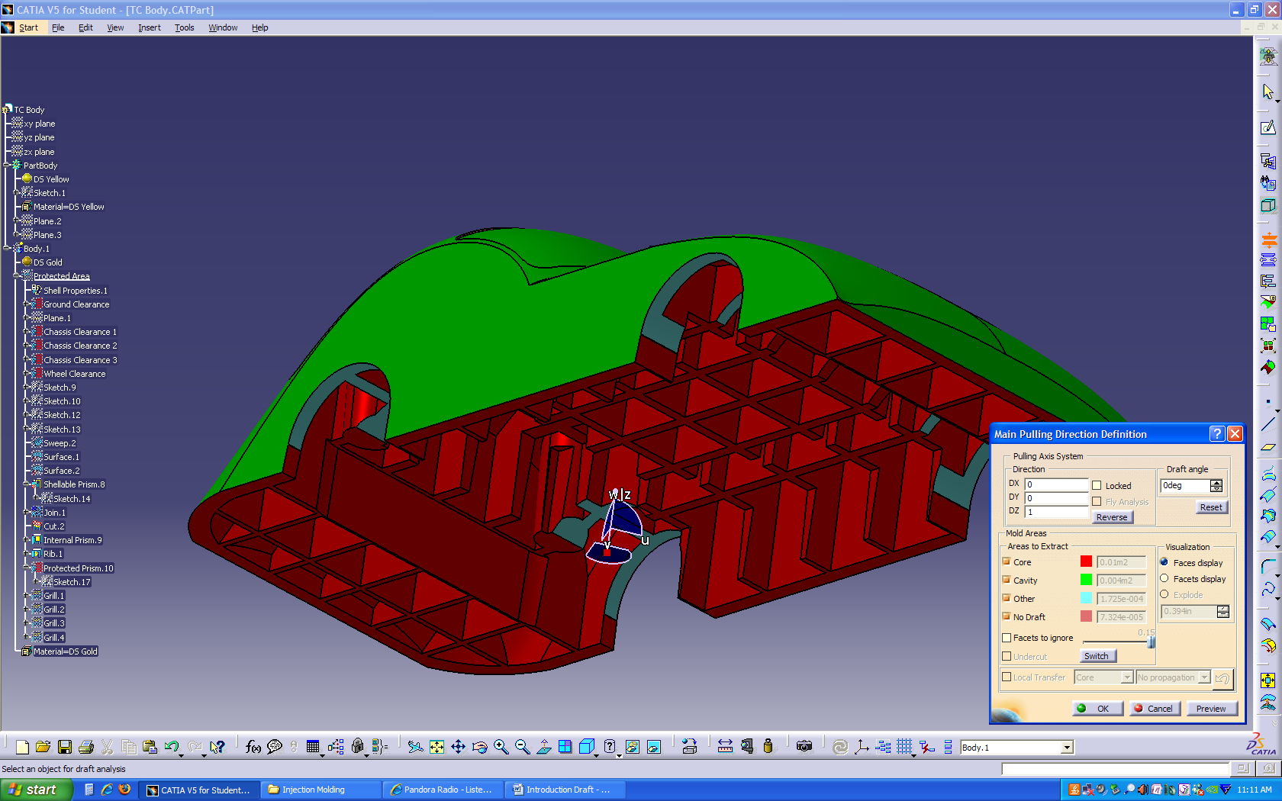
Here’s the completed car with body and chassis together.
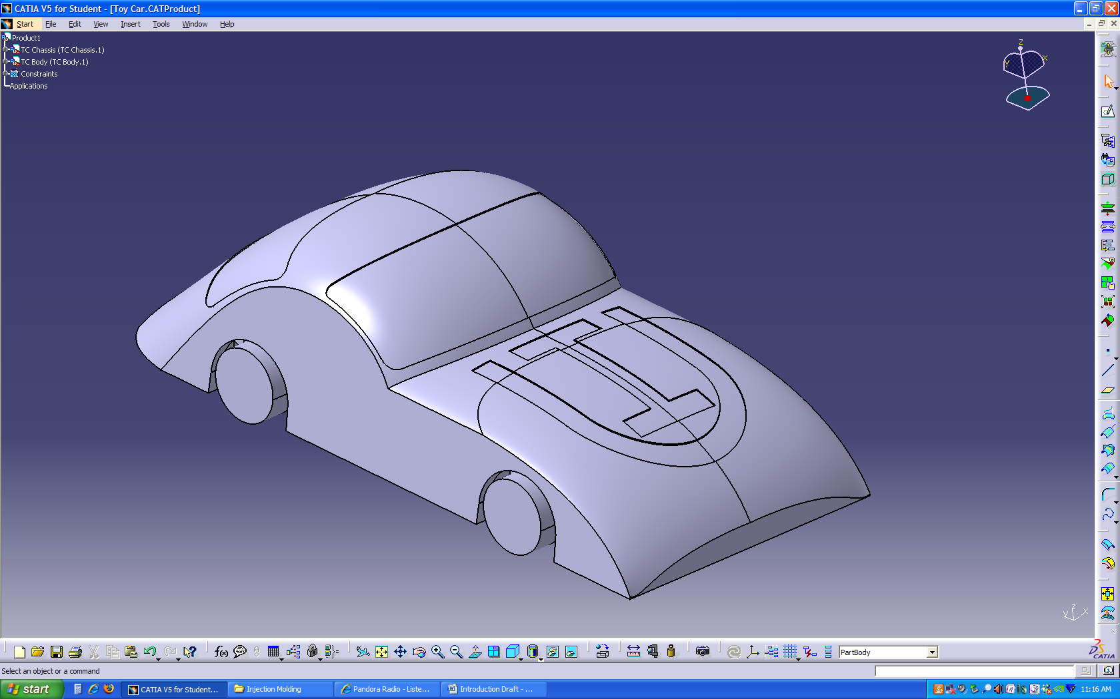

What you should take away from this lesson is that the Functional Molding Workbench is a powerful tool that allows you to design and create parts in a new way. When you are designing a part to be molded, it is important to keep in mind the limitations of the manufacturing process. Using draft angles when injection molding is very important. You must also make sure your part can be molded on a single axis, or it could become very expensive to manufacture. Keep in mind that this lesson has only scratched the surface of the capabilities of the Functional Molding Workbench. There are many more features and tools that can aid you in creating your molded part. For more information on these functions, refer to CATIAs help file. Hopefully, with the insight you’ve gained from this lesson and the rest of this handbook, you are better qualified to design for injection molding.

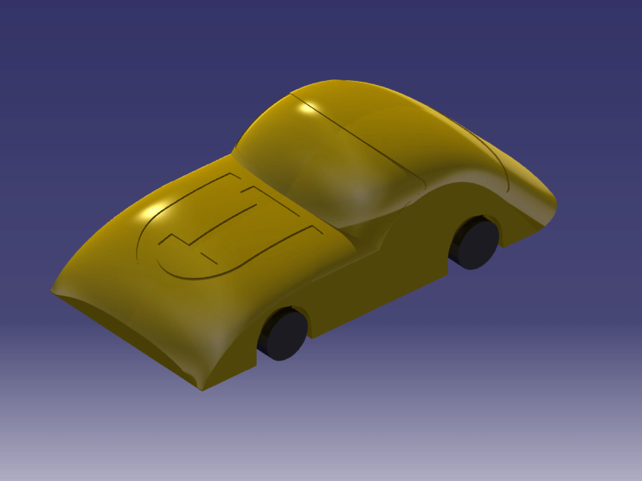

Manufacturing an Injection Molded Part

INTRODUCTION
The materials and processes available for modern day manufacturing are vast. Injection molding is just one of many options, but it has its advantages. Injection molded parts can be produced in large quantities relatively quickly. The shapes can also be quite complex. However, creating an injection molded part is a long, thorough process. The general flow of a project is as follows:
- Initial Design
- Quotes
- Selecting an Injection Molding Company
- Product Consulting
- Prototyping and Testing
- Final Delivery
The entire process can take weeks or months to complete. The decision to use injection molding should be made after thorough consideration. It is most useful for large quantity parts and is restricted to polymers. However, there are several thousand polymers available.
INITIAL DESIGN
The first step in producing an injection molded part is creating a three-dimensional part in a CAD program. The design should be as complete as possible, but the designer should be conscious of the fact that the part could change during testing. The part should be designed in mind for injection molding. For guidelines see the previous section, Designing for Injection Molding.
QUOTES
Once the part is designed, an injection molding company must be contacted for a quote. There are many sites online that can provide quotes, some of them instantly. It is important to decide the final quantity of the part needed. Some companies won’t bid on a project if the production quantity is too low. Each company will then call you to follow up on the price they quoted you and discuss a timetable along with other project needs.
SELECTING AN INJECTION MOLDING COMPANY
When designing a product for consumers, the bottom line is often the dictating factor. The part must be cheap enough to produce that is will return a profit when sold. Therefore, the cheapest quote for the injection molded part will often dictate which company is selected. However, there are other factors to consider.
Wasting time can cost a lot of money, so it is important to produce the part quickly to minimize the time the rest of the project is on hold. The sooner the product can be launched into the market, the sooner a profit can be turned. Some injection molding companies have to outsource the production of the mold itself. They design the mold and then send the work overseas to actually machine it. This can make a project really long if several mold prototypes are needed. It also increases cost due to shipping and paying additional people to make the mold. Communication can also be more difficult from one level of production to another. It pays to keep as many functions under one roof as possible.
Paying more for an experienced injection molding company up front can save a lot of money in the long run. Working with an experienced injection molding staff can eliminate needless mistakes that a less experienced company may make. More established companies will also have more capabilities. They will have seen more projects and know more techniques in creating the final product. The part will most likely be made to a higher quality.
Finally, it is important to work with someone that fits with your engineering team. If talking with an injection molding professional is particularly easy when communicating technical specifications and critical project terms, the process will go much smoother. The injection molding company should be easy to work with.
PRODUCT CONSULTING
When a company is chosen for injection molding your part, they will need more than just the drawing package. The company you contract will need minimum specifications for everything from operating stresses to heating conditions. This includes operational vibrations, local corrosive fluids, and electrical considerations. They need the entire picture in order to confirm that the part you design will work without failure. This step is also important in the process of material selection. The injection molding company will double check your work and ensure that the part solves the proposed problem.
PROTOTYPING AND TESTING
The entire process will take several weeks to complete at best. The company will create prototypes to test the design for strength and manufacturability in the injection molding process. They will also send back prototypes to be tested in the function of the overall product. It should be anticipated that the design will change several times. The part might have an interference in the final assembly, it may be stronger is changed in one small area, or it may be cheaper to produce with a different configuration. Over the entire prototyping and testing period, engineers from both companies will work closely together to refine the final product.
FINAL DELIVERY
Once the design, material, and process are finalized, the part can be produced in large quantities. The greatest cost of the project is now over. The only remaining cost is to produce the parts. Furthermore, the part can be reordered from the company now that the process is defined and the molds have been created.
The molds experience tremendous pressures, so they don’t last forever. Some molds last longer than others depending on the necessary tolerances of the part and the material used for the mold. Larger parts will require greater forces on the molds, so they will likely wear out sooner.
FURTHER CONSIDERATIONS
There are several manufacturing options available, and the best choice for your project might involve more than one. Injection molding is most effective in creating shapes along one axis. Sliders have to be added for more complex shapes and can increase cost dramatically. Some parts cannot be injection molded due to mechanical constraints or economic considerations. Here are some alternatives:
Machining – Polymers can be shaped in lathes or mills to very tight tolerances, but the processes can be long and costly. This process is generally for more specialized parts. For large quantities, it can be feasible to create an automated system that shapes parts in a quick, repeatable process.
Extruding – A polymer can be forced through an opening in order to create a long rod with a uniform cross-sectional shape. This process is most familiar when making pipes and tubes. Solid shapes can also be made. The rod can then be cut into pieces to make blanks for production.
Rotomolding – This involves pouring a precise amount of resin powder into a thin walled mold and rotating the mold in a large oven to melt the resin evenly against the inner surfaces of the mold. This process is used to produce air-filled rubber balls and river kayaks to name a few.
The final solution may be to extrude or injection mold the basic shape of the part and then machine the blank to the final tolerances. The solution will be a mix of function and price. The common constraint is the material. The injection molded parts are produced in a heating process, so they are obviously not functional for heating applications above the temperature with which they were created. For higher heat applications, injection molding may not be a viable option. In this case, a metal or ceramic material might be a better choice. That would change the manufacturing options available. The design engineer should consider every possible option before pursuing a set manufacturing process.

Appendix A: Quick Points

- Manufacturers need the part design, not the mold design.
- The part design needs to include all physical specifications for material and structural verification.
- Injection molding is expensive and should be used for large batches of parts.
- The more sliders there are, the more expensive the part will be. It may be cheaper to use an alternative method, such as one or a combination of the following:
  - Machining
  - Extrusion
  - Rotomolding
- The molds can be cut using either traditional machining tools or EDM.
- The edges should be rounded for easy separation from the mold.
- The lower the tolerances, the cheaper the part.
- The larger the part surface, the more force is needed to keep the mold halves together due to the tremendous pressures used to inject the material.
- Generally, the part is bought from the contracted company, not the mold.
- Heat and service conditions drive the material choice and may drive the design away from injection molding.
- The part design and the injection molding process drive the final shape simultaneously.
- The tooling marks from the process should be made to compliment some feature of the part, or be places where it is the most aesthetically pleasing.

Appendix B: Considerations for a Future Tutorial

- Shape basics
  - Is the design possible to injection mold?
  - Single Axis molding
  - Multi axis molding (Sliders)
- Optimization
  - Material Selection (Part and mold)
  - Fillets, draft angles, and other features
  - Uniform wall thickness
  - Mold Removal
  - Tooling effects on the product
  - Molding advantages (creating features)
  - Tolerances
- Mold Types
  - DME
  - etc.
- Pin Types
  - Guide pins
  - Ejector pins
- Example parts/molds
- Companies

