Green Design Approach

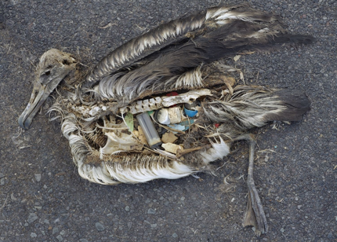

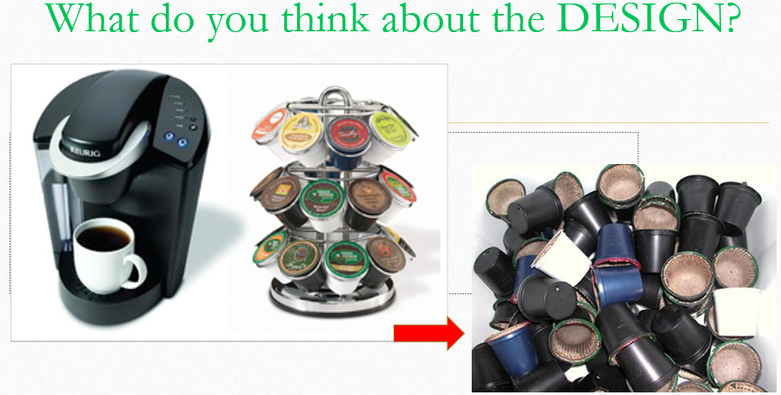

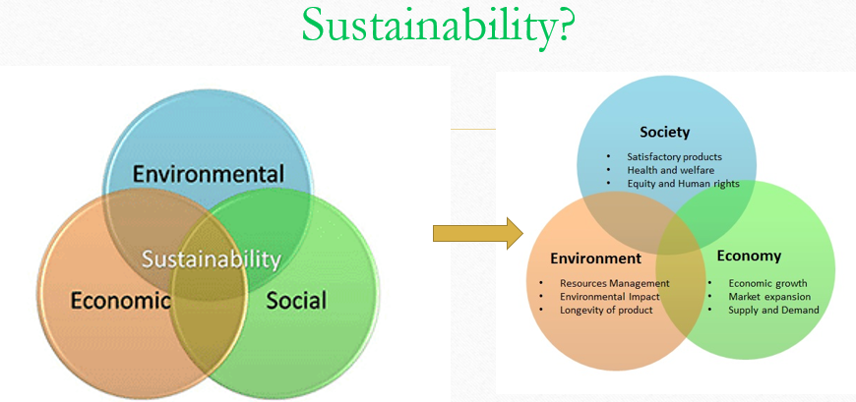

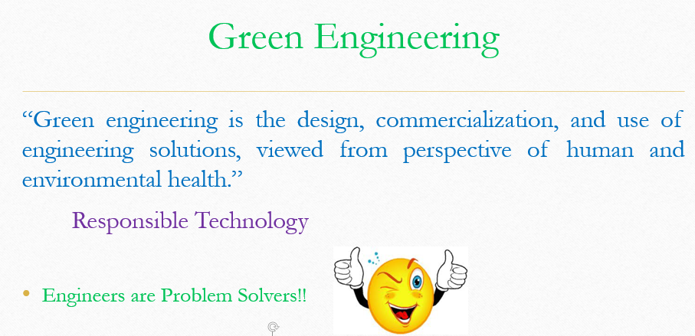

The 12 Principles of Green Engineering
Principle 1: Designers need to strive to ensure that all material and energy inputs and outputs are as inherently nonhazardous as possible.
Principle 2: It is better to prevent waste than to treat or clean up waste after it is formed.
Principle 3: Separation and purification operations should be designed to minimize energy consumption and materials use.
Principle 4: Products, processes, and systems should be designed to maximize mass, energy, space, and time efficiency.
Principle 5: Products, processes, and systems should be "output pulled" rather than "input pushed" through the use of energy and materials.
Principle 6: Embedded entropy and complexity must be viewed as an investment when making design choices on recycle, reuse, or beneficial disposition.
Principle 7: Targeted durability, not immortality, should be a design goal.
Principle 8: Design for unnecessary capacity or capability (e.g., "one size fits all") solutions should be considered a design flaw.
Principle 9: Material diversity in multicomponent products should be minimized to promote disassembly and value retention.
Principle 10: Design of products, processes, and systems must include integration and interconnectivity with available energy and materials flows.
Principle 11: Products, processes, and systems should be designed for performance in a commercial "afterlife".
Principle 12: Material and energy inputs should be renewable rather than depleting.

Green Questionnaire
Resources (Materials, Energy, Water):
- Do you use toxic or hazardous materials in your design?
- How many percentage of your materials are virgin materials?
- How many percentage of your materials are recycled materials?
- How much energy do you need for fabricating your product?
- How much water do you need for fabricating your product?
Waste (Fabrication):
- How much is solid residue for fabrication of your product?
- How much is liquid residue for fabrication of your product?
- How much is gas residue for fabrication of your product?
Waste (Use):
- How much is solid residue of your product during its lifetime?
- How much is liquid residue of your product during its lifetime?
- How much is gas residue of your product during its lifetime?
Waste (End-of-life):
- How much is solid residue of your product after its lifetime?
- How much is liquid residue of your product after its lifetime?
- How much is gas residue of your product after its lifetime?
- What is you plan for recycling or reusing your product after its lifetime?
Final Question:
- Can you change your design to have improve your answers to above questions?

