Anodizing

Why we anodize:
Anodizing is a process that puts vivid colors onto metals. This very thin layer of dye/paint is only about 12 microns deep, so it doesn’t add very much to your tolerances, but it can be scratched off quite easily. Other benefits include stain resistance, corrosion resistance, and of course an ever so slight scratch resistance. As you can see by the pictures, anodizing is mainly for aesthetics and can add a strong finishing touch to any project. There is almost no limitation to size or shape, and the only things to consider outside of costs is small tolerance fitting for such things like small threads and already tight fittings.

Other processes:
There are other forms of anodizing that are not color oriented but chromium oriented for aluminum that leaves a gold or silver finish. By a similar bathing process that makes an aluminum chromate layer instead of a dyed layer. This chromium layer provides a lot better scratch resistance than regular colored anodizing, creates an extremely low friction surface, electrically isolates the metal and still doesn’t affect any thermal properties of the metal either. This may be something to consider as an alternative to heat treating if you are concerned about close tolerances and don’t want to risk deformation or wish to keep curtain properties.
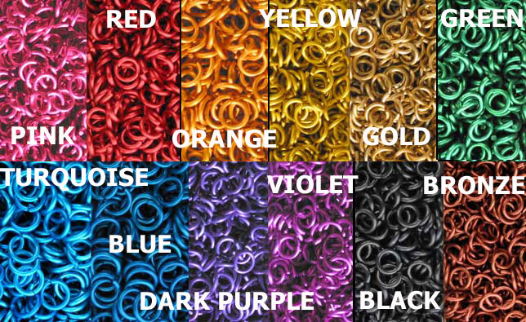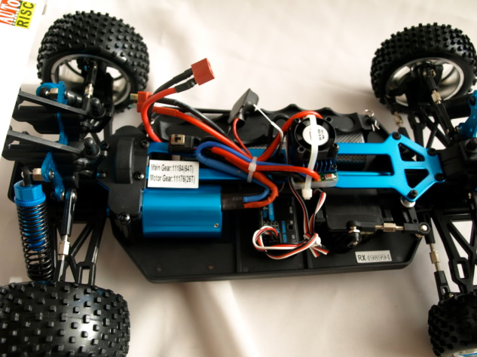
The process:
While there are many varying processes for different types of metals, they are all basically a series of chemical baths that prep the metal’s surface for accepting the dye. A strong acid purposely corrodes the outside layer making it porous, using too strong of an acid or leaving it in for too long can cause scouring and burning. After rinsing the part to be anodized is put into another bath while being electrically charged, the dye is oppositely charged and by attraction the dye is absorbed into said porous layer of the metal. This leaves a very vivid layer of color that dries as smooth as the original metal.
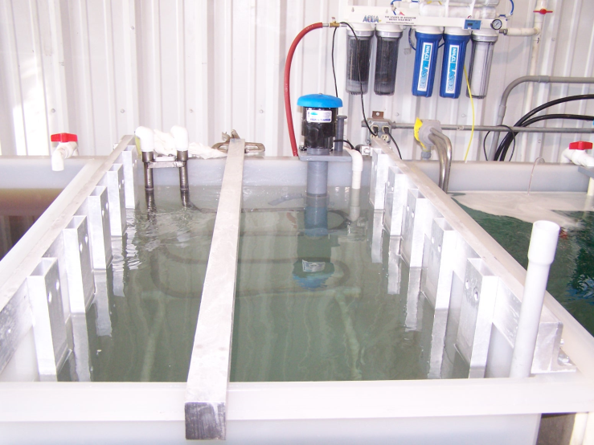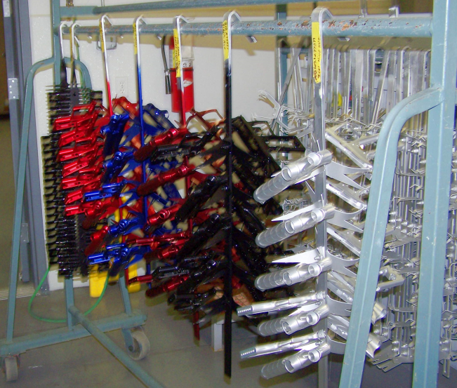

The costs:
While generally inexpensive to do, since anodizing is generally an aesthetic process, it is not normally considered for small projects. If you have a part that is going to be re-used or readily visible, you may want to take it into consideration if your budget allows for it. While the University of Idaho does not have our own anodizing setup; a batch of chemicals with 12 different options for colors can run around $200 and a full turnkey setup can run as little as $5,000. Since there are no local outlets to go by, outsourcing to other cities is required so take into consideration shipping costs when getting price quotes. Since every job is custom, we suggest giving some of the closest outlets a call to see if it is financially feasible to your project.

Sources:
Deming Industries Inc.
2945 North Government Way,
Coer d’ Alene, ID 83815-3744
(208) 664-8121

Novation Racing Inc.
2616 N. Locust Road
Spokane Valley, WA 99206-4371
(509) 922-1912

