Heat Treatment
Why we Heat Treat:
Heat treatments are used to alter the physical properties of materials to behave in a desired manner. Typically these processes are used to increase the tensile/yield strength of a part, or increase the wearability of its surface. These properties can be highly valuable for a part that demands performance under intense conditions. Possible procedures for heat treating include carburizing, nitriding, aluminizing, brazing, and sintering, although other options are available.
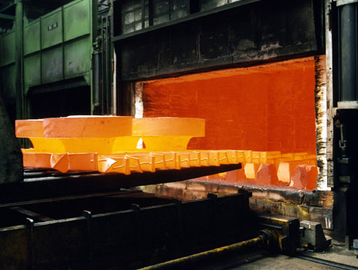
Types of Processes:
There are numerous ways that a given part can be heat treated. Each method may be applied to produce various results depending upon the desired results. A couple common heat treatment processes are:
- Salt Bath Heat Treatment – a part is immersed into molten salt temperatures around 1500°F. Heat transfer occurs to the part through conduction. Convection heat transfer to the part is negated because a solid salt coating forms on the outside of the part due to the large temperature difference between the salt and the part. This salt cocoon protects the part from thermal shock, locks out contaminates like carbon or oxygen, and minimizes scaling and distortion.
  - Effective for heat treating alloy steels (4130, 4340)
  - Protection from decarburization, oxidation cracking, scaling, and distortion
  - Great for carburizing, some brazing, aluminizing, nitriding, and Isothermal Quenching
  - Can be several times faster than radiation or convection heat treatments
  - Great for tempering in sealed environment
- Vacuum Heat Treatment – a vacuum furnace removes the air from an enclosed space, and the part inside the furnace is heated through radiation to temperatures from 2000-2800°F. This can be desirable when contaminates are an issue, considering that carburizing and oxidation are large concerns at these high temperatures.
  - Great for performing brazing and sintering at high temperatures
  - Low contamination from oxygen or carbun due to vacuum seal
  - Quick cooling (quenching) of the part
Possible Risks:
It is important to note that there can be adverse effects when heat treating a part. Special geometries and materials have tendencies to deform at high temperatures, or possible crack, and this can upset tolerances on parts if they are not prepared correctly. Before heat treating a part, it is important to do some research.
- Minimum Distortion – all materials have a minimum distortion that is associated with their chemistry and geometry. These values are available in literature and on the internet, and it is critical to know how much a part might change under heat treatment.
  - Oversizing a part is a countermeasure to possible distortion. If a part has a minimum distortion of 0.005”, then oversizing a part by 0.010” can conserve the geometry of the part. The part is later grinded back down to the desired tolerance and maintain the properties of the heat treatment.
- Cracking – some materials are not suitable for specific types of heat treatment. Low Carbon steels tend to crack and distort easily when heat treated. Research prior to heat treatment is critical to make sure that the materials available will agree with the type of heat treatment desired.
The Costs:
Costs can vary depending upon the procedure, the size of the part, the number of parts, and the deadline for the process. Most orders are specified by the customer, and prices will be determined at the time of order. Small jobs, such as a small steel shaft, can be $50-75 given a couple weeks for the process to be done. Quicker orders can raise the prices to as much as $200-250. A couple tips for heat treatment and reducing prices:
- Research – determine whether heat treatment is necessary early in design process.
- Order Early – putting a quick demand on the procedure will raise prices, and increases the risk of producing a defective part.
- Shop Around – check all local facilities and quote prices for the best option available.

Sources:
Inland Northwest Metallurgical
16203 East Marietta Lane
Spokane Valley, WA 99216-1838
(509) 922-7663

Ace Co Heat Treatment/Metallurgy Division

4419 South Federal Way
Boise, ID 83716-5528
(208) 343-7712

