CHECKSHEET FOR HOLE WIZARD ASSIGNMENT (HW7)
(Submit this sheet as your assignment coverpage)
/10
NAME: _______________________ SECTION #: _____

Hole Wizard Final Products
___Completed question 1(a-d) on the Hole Wizard assignment (2 pts)
___Screenshot of your part file properties summary tab (include author information, the assignment number in the Keywords box, and two notes on lessons learned)
___Screenshot of your part file properties custom tab (include Quantity, PartNo, Material, and Description)
___Isometric view of the completed part and annotated/expanded design tree showing fully-defined sketches (Note: features and sketches created using the Hole Wizard do not need to be renamed)
___Use UI drawing template to create a shop-ready drawing of the part with its file properties (Name, Material, etc.) imported to drawing title block, BOM table, and revision table. (2 pts)
___Correctness of part model, drawing views, dimensions, and hole callouts
Above and Beyond (Exemplary)
___ Exceptional organization and neatness
___ Showcase the interior cross section of all 6 holes using 2 section views
___ Other:___________________________________________________________
Point Deductions
___ No cover page (-1)
___ Not a .doc/.docx (-1)
___ Incorrect filename (-1)

ME301 Hole Wizard Assignment Question 1
Note: The Machine Shop section of the Mindworks website gives information on various tools associated with fasteners and fastener designation
- Using text, internet, and each other, complete the following definitions
- Using your own words and sketches, explain the shape and use of a Socket Head Cap Screw

- Using your own words and sketches, explain the difference between standard ANSI Inch and Metric fastener characteristics

- Using your own words and sketches, explain the shape and use of a Flat Head Machine Screw

- Using your own words and sketches, explain the difference between pipe thread and standard fastener thread designations

- Model the attached block in SolidWorks using the hole wizard feature for all applicable holes. Extrude the sketch to the stock size. Note, the last line in the hole callouts for each of the top three holes is there to help you locate the correct hole wizard options and will not appear in the hole wizard hole callout. Also you’ll have to add the “REAM” text manually.

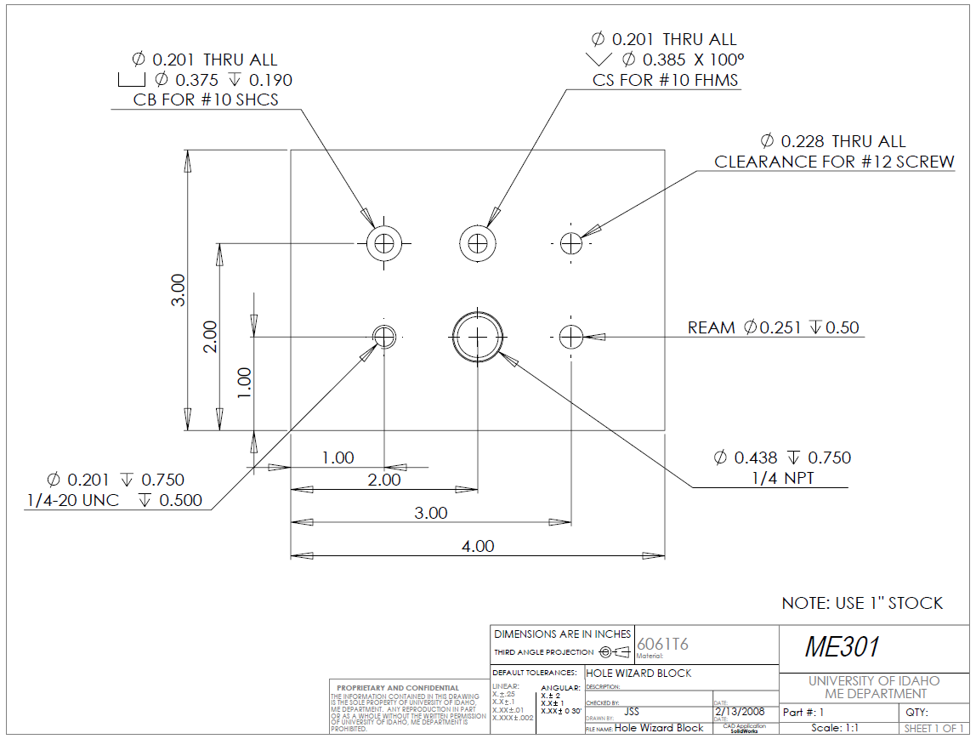

Screenshot of your part file properties summary tab (include author information, the assignment number in the Keywords box, and two notes on lessons learned)

Screenshot of your part file properties custom tab (include Quantity, PartNo, Material, and Description)

Isometric view of the completed part and annotated/expanded design tree showing fully-defined sketches (Note: features and sketches created using the Hole Wizard do not need to be renamed)

Use UI drawing template to create a shop-ready drawing of the part with its file properties (Name, Material, etc.) imported to drawing title block, BOM table, and revision table. (2 pts)

(Above and Beyond) Section views through each hole axis included in shop drawings

