Assembly Drawings: Common Mistakes Addressed

Wrong part number (or none at all) in title block
Make sure your title block has the correct part number for what is on the page!
Main assembly = 00-00 (this page usually has all the subassemblies in exploded view)
Subassembly = 01-00, 02-00, etc. (note that a subassembly always ends in -00)
Part = 01-01, 01-15, 02-12, 14-153, etc.
If you are using a subassembly within a subassembly, your sub-subassembly’s part number must end in -00.
Example: if you have parts 03-02-01, 03-02-02, and 03-02-03, the subassembly they are in is called 03-02-00, NOT 03-02.

Location (order) of drawings
The subassembly pages are like dividers in a binder. The part drawing(s) for a subassembly go with their subassembly page.
Assembly Drawing Package
- 00-00 collapsed view of main assembly
- 00-00 exploded view of main assembly (with sub-assembly-level BOM)
- 01-00 collapsed view of subassembly
- 01-00 exploded view of subassembly (with parts-level BOM)
  - 01-01
  - 01-02
  - 01-03
  - … 01-#
- 02-00
  - 02-01
  - 02-02
  - … 02-#
- 03-00
  - 03-01
  - 03-02
  - … 03-#
And so on.

Labels
Your exploded views should have a bill of materials listing the parts in the picture. Each part has an Item No. Each part should also have a label in the picture, pointing out which part is “item 4”, for instance.

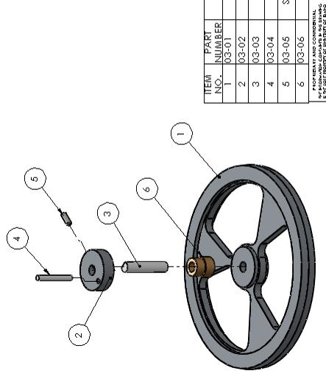

Purchased Parts
If you have purchased parts in a subassembly, do not include a drawing for the part. Instead, use the description field to show where you would buy the part (i.e., include the full part designation from McMaster-Carr). You want someone to be able to find the purchased part and buy one.
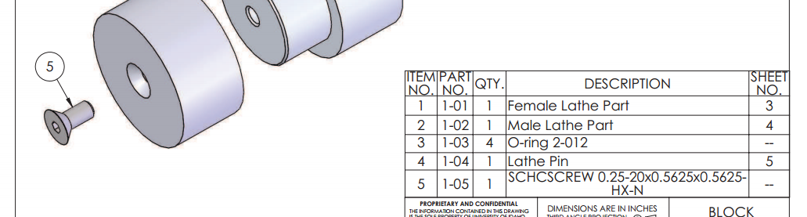

Missing parts
If you restructure your file management and change which subassembly a part belongs to, make sure to update your part numbers. For example if you move part 1-03 to another subassembly:
- 1-00
  - 1-01
  - 1-02
  - 1-04
Should be changed to:
- 1-00
  - 1-01
  - 1-02
  - 1-03
To avoid confusion.

