Practice Problems
A steam power cycle is operating with one open feedwater heater. Steam enters the high pressure turbine at 1600 psia, 1100°F. The steam expands through the high pressure turbine to 100 psia where some of the steam is extracted and diverted to an open feedwater heater. The remaining steam expands through the low pressure turbine to the condenser pressure of 1 psia. Saturated liquid exits the feedwater heater and the condenser. The isentropic efficiency of the both turbines is 85% and the isentropic efficiency of the pumps is 90%. The net power output of the cycle is 220 MW.

- Build a complete property table showing the pressure, temperature, enthalpy, entropy, quality, and mass flow fraction for each state.

- Once the table is complete, determine the following parameters,
- The mass flow rate of the steam in the cycle (lbm/hr)
- The boiler specific heat transfer (Btu/lbm of steam entering the high pressure turbine)
- The thermal efficiency of the cycle
- The heat rate of the cycle
- Compare the values calculated for this regeneration model with those found for the simple Rankine cycle in HW24 and the Reheat cycle in HW25.
- Conduct a parametric study on the open feedwater heater pressure. Explore pressures between 50 psia and 500 psia. Comment on the trends you observe in thermal efficiency, boiler specific heat transfer, and required mass flow rate.

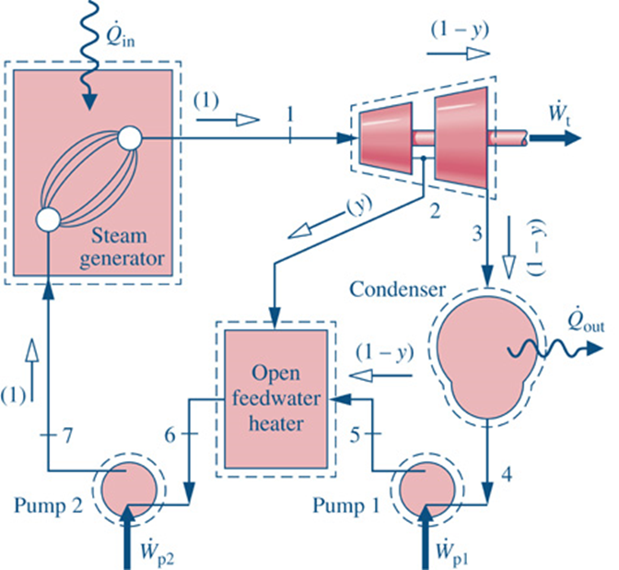

Answers
2a) mass flow ~ 1.5 x 10⁶ lbm/hr
2b) q_in (in the boiler) ~ 1250 Btu/lbm
2c) net thermal efficiency is better than the superheat and reheat versions
2d) Heat Rate ~ 8500 Btu/kW-hr

4) peak efficiency is where p[2] is closer to 50 psia than it is to 500 psia

