Appendix I: Fixed Radius Plot
A fixed radius plot is used to sample trees that are less than the specified breakpoint diameter. These sample trees are determined to be “in” or “out” at ground line. If the measured distance from plot center to the central axis of the tree at ground line is equal to or less than the fixed plot radius the tree is tallied as a sample tree. If this distance is greater than the fixed plot radius, the tree is not tallied.
Figure 1: Trees “in” and “out” of fixed radius plot
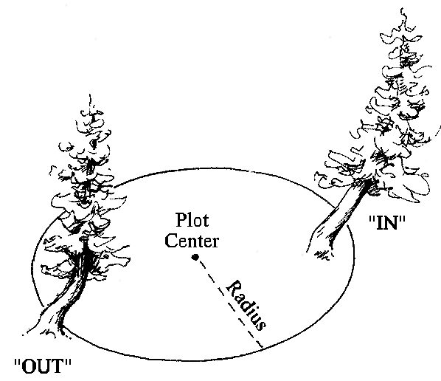
On level ground, the fixed plot radius is determined by holding the measuring tape or pole in a horizontal position from plot center to the central axis of the sample tree. On slopes greater than 9 percent, if a measuring tape or pole cannot be horizontally from plot center to the central axis of the sample tree, the fixed plot radius is corrected for the slope percent by using one of the following methods.

Method 1
Correct the fixed plot radius for slope percent using the “Circular Plot Radii Corrected for Slope” table and then measuring distances parallel to the ground line. This method always results in a circular plot on the slope. Example – 1/300 acre fixed plot on 50 percent slope. Corrected fixed plot radius is 7.2 feet.
Figure 2: Correcting the fixed plot radius for slope percent
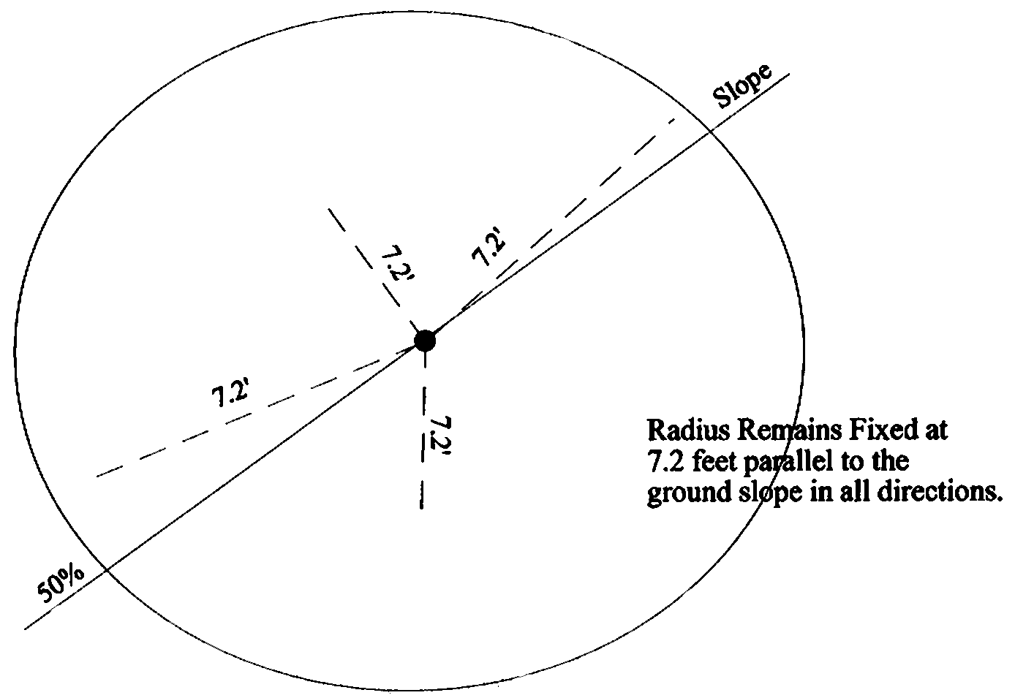
Table 1: Circular Plot Radii Corrected for Slope; plot size in acres
Slope % | 1/300 | 1/100 | 1/50 | 1/20 | 1/10 | 1/5
0-9 | 6.8 | 11.8 | 16.7 | 26.3 | 37.2 | 52.7
10-17 | 6.8 | 11.8 | 16.7 | 26.5 | 37.4 | 52.9
18-22 | 6.9 | 11.9 | 16.8 | 26.6 | 37.6 | 53.2
23-26 | 6.9 | 12.0 | 16.9 | 26.7 | 37.8 | 53.4
27-30 | 6.9 | 12.0 | 17.0 | 26.9 | 38.0 | 53.7
31-33 | 7.0 | 12.1 | 17.1 | 27.0 | 38.2 | 54.0
34-36 | 7.0 | 12.1 | 17.1 | 27.1 | 38.3 | 54.2
37-39 | 7.0 | 12.2 | 17.2 | 27.2 | 38.5 | 54.5
40-42 | 7.1 | 12.2 | 17.3 | 27.4 | 38.7 | 54.7
43-44 | 7.1 | 12.3 | 17.4 | 27.5 | 38.9 | 55.0
45-47 | 7.1 | 12.3 | 17.5 | 27.6 | 39.1 | 55.2
48-49 | 7.2 | 12.4 | 17.5 | 27.7 | 39.2 | 55.5
50-51 | 7.2 | 12.5 | 17.6 | 27.9 | 39.4 | 55.7
52-53 | 7.2 | 12.5 | 17.7 | 28.0 | 39.6 | 56.0
54-55 | 7.3 | 12.6 | 17.8 | 28.1 | 39.8 | 56.2
56-57 | 7.3 | 12.6 | 17.9 | 28.2 | 39.9 | 56.5
58-59 | 7.3 | 12.7 | 17.9 | 28.4 | 40.1 | 56.7
60-61 | 7.4 | 12.7 | 18.0 | 28.5 | 40.3 | 57.0
62-63 | 7.4 | 12.8 | 18.1 | 28.6 | 40.4 | 57.2
64-65 | 7.4 | 12.8 | 18.2 | 28.7 | 40.6 | 57.4
66-67 | 7.4 | 12.9 | 18.2 | 28.8 | 40.8 | 57.7
68-69 | 7.5 | 13.0 | 18.3 | 29.0 | 41.0 | 57.9
70 | 7.5 | 13.0 | 18.4 | 29.1 | 41.1 | 58.2
71-72 | 7.5 | 13.1 | 18.5 | 29.2 | 41.3 | 58.4
73-74 | 7.6 | 13.1 | 18.5 | 29.3 | 41.5 | 58.6
75 | 7.6 | 13.2 | 18.6 | 29.4 | 41.6 | 58.7
76-77 | 7.6 | 13.2 | 18.7 | 29.6 | 41.8 | 59.1
78-79 | 7.7 | 13.3 | 18.8 | 29.7 | 42.0 | 59.3
80 | 7.7 | 13.3 | 18.8 | 29.8 | 42.1 | 59.6
81-82 | 7.7 | 13.4 | 18.9 | 29.9 | 42.3 | 59.8
83 | 7.8 | 13.4 | 19.0 | 30.0 | 42.5 | 60.0
84-85 | 7.8 | 13.5 | 19.1 | 30.1 | 42.6 | 60.3
86 | 7.8 | 13.5 | 19.1 | 30.3 | 42.8 | 60.5
87-88 | 7.8 | 13.6 | 19.2 | 30.4 | 42.9 | 60.7
89 | 7.9 | 13.6 | 19.3 | 30.5 | 43.1 | 61.0
90-91 | 7.9 | 13.7 | 19.3 | 30.6 | 43.3 | 61.2
92 | 7.9 | 13.7 | 19.4 | 30.7 | 43.4 | 61.4
93-94 | 8.0 | 13.8 | 19.5 | 30.8 | 43.6 | 61.6
95 | 8.0 | 13.8 | 19.6 | 30.9 | 43.7 | 61.9
96-97 | 8.0 | 13.9 | 19.6 | 31.0 | 43.9 | 62.1
98 | 8.0 | 13.9 | 19.7 | 31.2 | 44.1 | 62.3
99-100 | 8.1 | 14.0 | 19.8 | 31.3 | 44.2 | 62.5
101 | 8.1 | 14.0 | 19.8 | 31.4 | 44.4 | 62.8
102 | 8.1 | 14.1 | 19.9 | 31.5 | 44.5 | 63.0
103-104 | 8.2 | 14.1 | 20.0 | 31.6 | 44.7 | 63.2
105 | 8.2 | 14.2 | 20.1 | 31.7 | 44.8 | 63.4
106-107 | 8.2 | 14.2 | 20.1 | 31.8 | 45.0 | 63.6
108 | 8.2 | 14.3 | 20.2 | 31.9 | 45.1 | 63.8
109 | 8.3 | 14.3 | 20.3 | 32.0 | 45.3 | 64.1
110-111 | 8.3 | 14.4 | 20.3 | 32.1 | 45.5 | 64.3
112 | 8.3 | 14.4 | 20.4 | 32.2 | 45.6 | 64.5
113 | 8.4 | 14.5 | 20.5 | 32.4 | 45.8 | 64.7
114-115 | 8.4 | 14.5 | 20.5 | 32.5 | 45.9 | 64.9
116 | 8.4 | 14.6 | 20.6 | 32.6 | 46.1 | 65.1
117 | 8.4 | 14.6 | 20.7 | 32.7 | 46.2 | 65.3
118-119 | 8.5 | 14.7 | 20.7 | 32.8 | 46.4 | 65.6
120 | 8.5 | 14.7 | 20.8 | 32.9 | 46.5 | 65.8
121 | 8.5 | 14.8 | 20.9 | 33.0 | 46.7 | 66.0
122 | 8.5 | 14.8 | 20.9 | 33.1 | 46.8 | 66.2
123-124 | 8.6 | 14.8 | 21.0 | 33.2 | 47.0 | 66.4
125 | 8.6 | 14.9 | 21.1 | 33.3 | 47.1 | 66.6
130 | 8.7 | 15.1 | 21.3 | 33.7 | 47.7 | 67.4
135 | 8.8 | 15.3 | 21.6 | 34.1 | 48.3 | 68.3
140 | 8.9 | 15.4 | 21.8 | 34.5 | 48.8 | 69.1
145 | 9.0 | 15.6 | 22.1 | 34.9 | 49.4 | 69.9
150 | 9.1 | 15.8 | 22.3 | 35.3 | 50.0 | 70.0

Method 2
The slope limiting distance to borderline trees by using the “Slope Correction Table” (the slope being corrected is the slope from plot center to the tree, not the overall plot slope). Measure the distance parallel to the ground line to the borderline tree. This method always results in an oval on the slope. Following is a list of fixed plot sizes and the specific radius for each.
Table 2: Method 2 plot size/radius slope
Plot Size | Plot Radius
1/1000 | 3.7 feet
1/500 | 5.3 feet
1/400 | 5.9 feet
1/300 | 6.8 feet
1/250 | 7.4 feet
1/200 | 8.3 feet
1/150 | 9.6 feet
1/100 | 11.8 feet
1/50 | 16.7 feet
1/20 | 26.3 feet
1/10 | 37.2 feet
1/5 | 52.7 feet
1/4 | 58.9 feet
1/3 | 68.0 feet
1/2 | 83.3 feet
1 | 117.8 feet
To determine the slope limiting distance, multiply the plot radius for the appropriate plot size by the appropriate slope correction factor.

Example 1
1/300 acre fixed plot with a borderline tree on a 45 percent slope. A 1/300-acre plot equals a 6.8-foot radius and the slope correction factor for a 45 percent slope is 1.10. 6.8 x 1.10 = 7.48; thus, a tree on a 1/300 acre fixed plot at a 45 percent slope can be 7.5 feet from plot center.

Example 2
The same plot has another borderline tree on a 25 percent slope. The slope correction factor for a 25 percent slope is 1.03. 6.8 x 1.03 = 7.0; thus, a tree on a 1/300 acre fixed plot at a 25 percent slope can be 7.0 feet from plot center.
Figure 3: Plot size radius slope
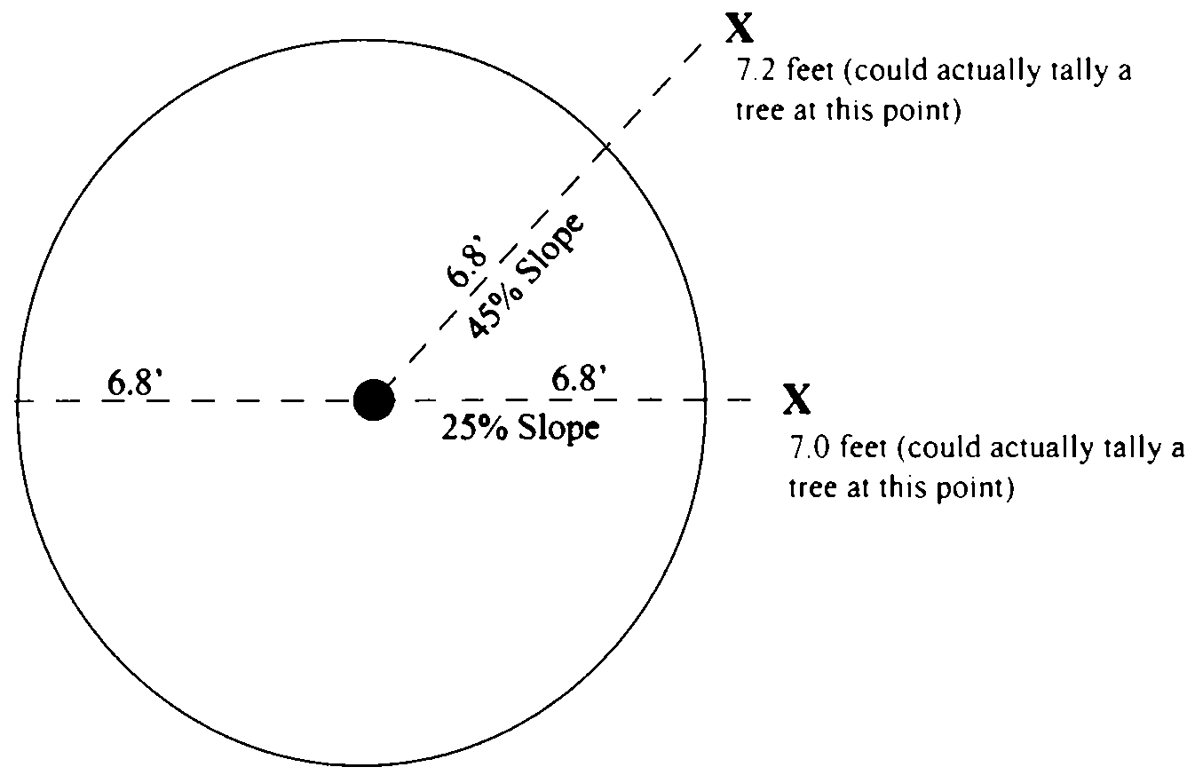
Table 3: Slope Correction Table
Percent of Slope | Degree of Slope | Correction Factor
0 to 9 | 0-6 | 1.00
10 to 17 | 7-10 | 1.01
18 to 22 | 11-12 | 1.02
23 to 26 | 13-14 | 1.03
27 to 30 | 15-17 | 1.04
31 to 33 | 18 | 1.05
34 to 36 | 19-20 | 1.06
37 to 39 | 21 | 1.07
40 to 42 | 22 | 1.08
43 to 44 | 23 | 1.09
45 to 47 | 24 | 1.10
48 to 49 | 25-26 | 1.11
50 to 51 | 27 | 1.12
52 to 53 | 28 | 1.13
54 to 55 | 29 | 1.14
56 to 57 | 29 | 1.15
58 to 59 | 30 | 1.16
60 to 61 | 31 | 1.17
62 to 63 | 32 | 1.18
64 to 65 | 33 | 1.19
66 to 67 | 34 | 1.20
68 to 69 | 34 | 1.21
70 | 35 | 1.22
71 to 72 | 36 | 1.23
73 to 74 | 37 | 1.24
75 | 37 | 1.25
76 to 77 | 38 | 1.26
78 to 79 | 38 | 1.27
80 | 39 | 1.28
81 to 82 | 39 | 1.29
83 | 40 | 1.30
84 to 85 | 40 | 1.31
86 | 41 | 1.32
87 to 88 | 41 | 1.33
89 | 42 | 1.34
90 to 91 | 42 | 1.35
92 | 43 | 1.36
93 to 94 | 43 | 1.37
95 | 44 | 1.38
96 to 97 | 44 | 1.39
98 | 44 | 1.40
99 to 100 | 45 | 1.41
101 | 45 | 1.42
102 | 46 | 1.43
103 to 104 | 46 | 1.44
105 | 46 | 1.45
106 to 107 | 47 | 1.46
108 | 47 | 1.47
109 | 47 | 1.48
110 to 111 | 48 | 1.49
112 | 48 | 1.50
113 | 48 | 1.51
114 to 115 | 49 | 1.52
116 | 49 | 1.53
117 | 49 | 1.54
118 to 119 | 50 | 1.55
120 | 50 | 1.56
121 | 50 | 1.57
122 | 51 | 1.58
123 to 124 | 51 | 1.59
125 | 51 | 1.60
126 | 52 | 1.61
127 to 128 | 52 | 1.62
129 | 52 | 1.63
130 | 52 | 1.64
131 | 53 | 1.65
132 to 133 | 53 | 1.66
134 | 53 | 1.67
135 | 53 | 1.68
136 | 54 | 1.69
137 to 138 | 54 | 1.70
139 | 54 | 1.71
140 | 54 | 1.72
141 | 55 | 1.73
142 to 143 | 55 | 1.74
144 | 55 | 1.75
145 | 55 | 1.76
146 | 56 | 1.77
147 | 56 | 1.78
148 to 149 | 56 | 1.79
150 | 56 | 1.80

