University of Idaho

College of Education

University Annual Assessment Cycle

Prepared by
College of Education
Office of Assessment and Accreditation
208-885-5014

Purpose:
The purpose of this document is to assist faculty and programs with the development, refinement, and uploading of data relating to the University of Idaho Annual Assessment System. This guide is not designed to supersede any University policy, and is a supplement only to the information provided by Institutional Research.
What is Assessment?
Loosely defined for Higher Education, assessment is a process of collecting data to inform programs about progress towards goals and objectives, in the context of learning objectives (Banta, 2002). For the purposes of the University of Idaho Annual Assessment Cycle, assessment is the process of:
- Identifying Program Learning Objectives (Column 1)
- Selecting program specific tools and procedures (Column 2)
- Setting benchmarks (Column 3)
- Collecting data and analyzing results (Column 4)
- Making curricular and Co-curricular changes in response to those results, as well as refining benchmarks, assessment procedures, and potentially Program Learning Outcomes. (Column 5)

Why Do We Do This?
Assessment is an integral component of education and the process known as “closing the loop” (Astin, 1991; Maxim, 2004; Middaugh, 2009; Wright, 2008). Assessment as a practice can also provide programs with useful data upon which program changes can be made, new requests for resources can be based, and which gives all involved faculty an ownership in the academic community of which we are a part.
As part of the University of Idaho, all programs and certificates (and by extension, degrees, departments, and colleges) are subject to review and accreditation by various accrediting bodies. The Northwest Commission on the Accreditation of Colleges and Universities (NWCCU) is the University level accreditor that reviews university programs for continued operations and provides regional accreditation to the University of Idaho, thus making the University eligible for student financial aid, government grants, and ultimately, recognition as an accredited institution of higher education. Without NWCCU accreditation, the University would not be able to receive any federal funds, and the potential exists that our ability to issue degrees would be revoked by the Idaho State Board of Education.
NWCCU accreditation is separate from specialized program accreditations (such as NCATE, COPART, ABA etc.), and in support of our ongoing NWCCU activities, the Provost and Board of Regents have mandated that all programs participate in the Annual Assessment Cycle.

What is the Annual Assessment Cycle?
The Annual Assessment Cycle is an online system, managed by the University of Idaho Office of Institutional Research and Assessment. This system is organized by degree, and provides a framework to upload information relating to program assessment.

How to Post Your Assessment Plan on the Web
Assessment plans and analyses, summarized in the format provided in the assessment template, are posted on the University of Idaho website and can be accessed via VandalWeb.
(http://www.webs.uidaho.edu/ira/assess/assessment_plans.htm)
You will need your VandalWeb login to post your assessment information.
1. | Click here to access the site. You will need your VandalWeb login to post your assessment information. The address is https://vandalweb.uidaho.edu/PROD/twbkwbis.P_WWWLogin?ret_code=M
2. | Select College of Education and click the link beneath it entitled Assessment.
3. | Select your Program and hit SUBMIT
4. | Note the five columns of the Assessment Plan:  1) Learning Outcomes  2) Assessment Tools and Procedures  3) Benchmarks  4) Results  5) Curricular and Co-curricular Changes to be Made
 | Each column has an "Edit" link. Hit EDIT to enter, remove or change information within each column. Enter the text as you want it to appear (you can copy/paste from a Word document or other e-format); use bullet points, paragraphing, and other formatting features as appropriate. To line up the columns you must enter a dividing line between paragraphs by typing <hr>.
 | NOTE: you must hit SUBMIT to save your work. This includes any changes/additions you might make to previously submitted text.

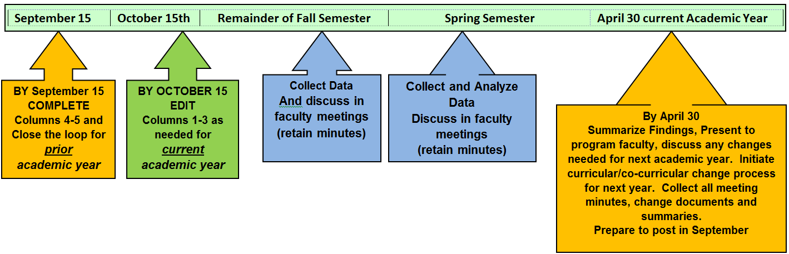

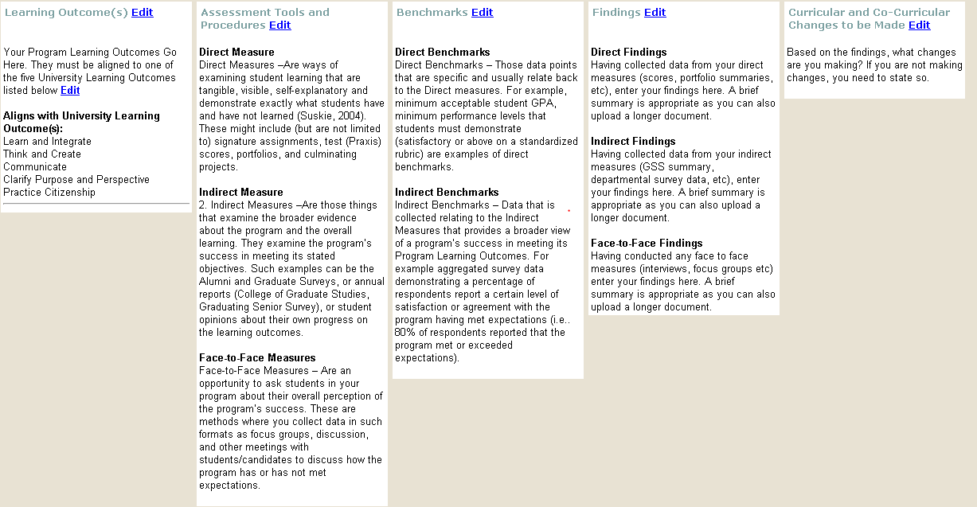
Quick Reference Guide
Column 2
Minimum 1-2 Measures per outcome
Column 1
Recommend 3-5 Outcomes (Rows)
Column 5
Summary of changes resulting from findings, (if no changes, then state so)
Column 4
Summary findings of data.
Column 3
Data collected from your measures

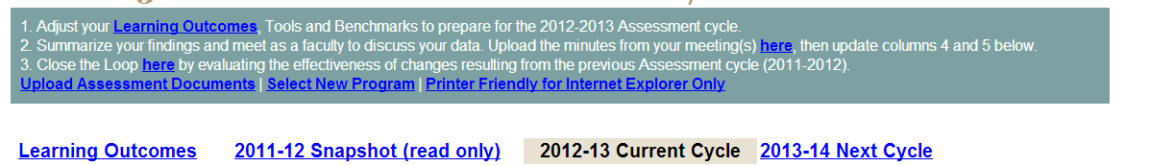
AT THE TOP OF YOUR SECREEN…
REMEMBER TO
[] Upload Findings (Summary/Meeting Minutes)
[] CLOSE THE LOOP
[] Upload any supporting documentation

About Each of the Columns
Column 1 - Learning Outcomes:
The University of Idaho has five key learning outcomes. They are;
Learn and integrate | Through independent learning and collaborative study, attain, use, and develop knowledge in the arts, humanities, sciences, and social sciences, with disciplinary specialization and the ability to integrate information across disciplines.
Think and create | Use multiple thinking strategies to examine real-world issues, explore creative avenues of expression, solve problems, and make consequential decisions.
Communicate | Acquire, articulate, create and convey intended meaning using verbal and non-verbal methods of communication that demonstrate respect and understanding in a complex society.
Clarify purpose and perspective | Explore one’s life purpose and meaning through transformational experiences that foster an understanding of self, relationships, and diverse global perspectives.
Practice citizenship | Apply principles of ethical leadership, collaborative engagement, socially responsible behavior, respect for diversity in an interdependent world, and a service-oriented commitment to advance and sustain local and global communities.
- Review outcomes and alignment from previous years
- Identify new/existing program outcome(s) and determine what
University Learning outcomes your program outcomes align to.
- Input any changes into Column 1 (for every row)
- Ensure that your program outcomes are accurately reflected in the online system
To Do
Column 2 – Assessment Tools and Procedures:
This next column is about what tools (methods) you will utilize to measure your benchmarks. These tools are practices that your program will do annually (at a minimum) to collect assessment related data. This column is broken into three types:
- Direct Measures –Are ways of examining student learning that are tangible, visible, self-explanatory and demonstrate exactly what students have and have not learned (Suskie, 2004). These might include (but are not limited to) signature assignments, test (Praxis) scores, portfolios, and culminating projects.
- Indirect Measures –Are those things that examine the broader evidence about the program and the overall learning. They examine the program’s success in meeting its stated objectives. Such examples can be the Alumni and Graduate Surveys, or annual reports (College of Graduate Studies, Graduating Senior Survey), or student opinions about their own progress on the learning outcomes.
- Face-to-Face Measures – Are an opportunity to ask students in your program about their overall perception of the program’s success. These are methods where you collect data in such formats as focus groups, discussion, and other meetings with students/candidates to discuss how the program has or has not met expectations.
- Ensure that each outcomes has at least ONE measure (or more depending on the outcome to be measured)
- Review measures from previous years, make any changes as necessary (make sure to capture any changes and why)
- Determine who and how those measures will be collected on a consistent basis
- Collect the data!
- Input any changes to the relevant DIRECT, INDIRECT and or FACE-to-FACE Measures for each of your program outcomes into COLUMN 2

To Do
Column 3 – Benchmarks:
Your benchmarks are the targets that you set in your program that you have identified as “Measures of Success”. These benchmarks should be those things that collectively demonstrate that your program is meeting (or moving towards) your overall program learning objectives. This column is also broken into two sections:
- Direct Benchmarks – Those data points that are specific and usually relate back to the Direct measures. For example, minimum acceptable student GPA, minimum performance levels that students must demonstrate (satisfactory or above on a standardized rubric) are examples of direct benchmarks.

- Indirect Benchmarks – Data that is collected relating to the Indirect Measures that provides a broader view of a program’s success in meeting its Program Learning Outcomes. For example aggregated survey data demonstrating a percentage of respondents report a certain level of satisfaction or agreement with the program having met expectations (i.e.. 80% of respondents reported that the program met or exceeded expectations).

As with any process of this type, your Program Learning Outcomes will guide your benchmarks, and your benchmarks will influence the tools and procedures you use to collect data.
- Review your benchmarks from the previous year.
  - Do they continue to make sense?
  - Are they still relevant?
  - Do you still have at least one benchmark for each learning outcome?
- Input any changes to your benchmarks in the online system into COLUMN 3
- Collect the data!

To Do
Column 4 – Findings:
This column is where you will report your findings for your Direct, Indirect, and Face-to-Face measures.
*** You will also need to upload copies of your findings each year***
To Do
- After you collect the data…
- Summarize the findings for each (as outlined in your Column 2)
  - Direct
  - Indirect
  - Face-to-Face findings
- Meet as a faculty (program or department) to discuss the findings and any changes you need to make to your program based on those findings
- Input the summary of the findings into COLUMN 4
- Upload any copies of your findings (survey results, focus group summaries, test score summaries) and minutes of the discussions
Column 5 –Curricular and Co-Curricular changes to be made:
This is where, based on your findings, your program will meet to discuss any changes that need to be made, based on the data. These changes can be as broad or as narrow as the data and your faculty feel is appropriate and warranted.

***You will need to upload copies of the program meeting minutes where you discussed the data and the changes***
- Using your findings, determine if any program changes (curricular, requirements, structure, organizational, other) are necessary
- Input those changes into COLUMN 5
- Take Copies of the Agenda and Minutes for every meeting where you discuss findings/changes and upload them to the online system (the green box at the top of the screen)

To Do

Remember, in each cycle (annually) there are four easy steps!

- By September 15th - Complete your analysis of findings for the PREVIOUS ACADEMIC YEAR.
  - Upload your findings (Column 4)
  - Report any Curricular/Co-Curricular changes you will/have made to improve the program for THIS ACADEMIC YEAR (Column 5)
  - Close the Loop by discussing the impact of changes already made (Green box at the top)
- By October 15th - Adjust your Learning Outcomes, Tools and Benchmarks for the CURRENT ACADEMIC YEAR

- Throughout the academic year use your Direct, Indirect, and Face-to-Face measures to collect your evidence. Discuss this with your program faculty.

- By April 15th – Summarize your findings to date, begin discussion about needed program changes. Collect this in meeting minutes and prepare to upload next September!

If you have any questions, please contact
Daniel Campbell
College of Education
Office of Assessment and Accreditation
208-885-5014
dcampbell@uidaho.edu

