Modeling a Cessna Aircraft
Josh Frei
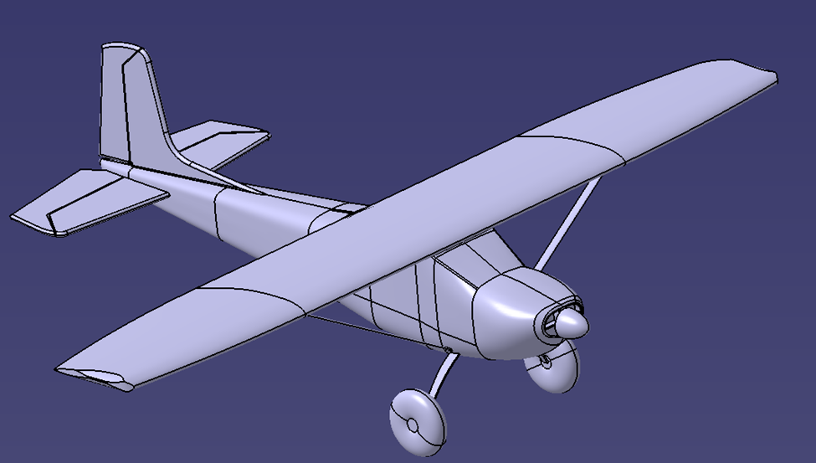
ME421 CATIA Fall 2018
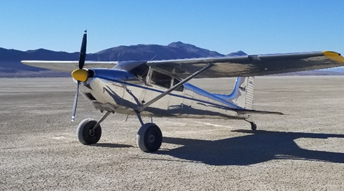

CATIA Final Project
Modeling a Cessna Aircraft

Before starting this project the intention was to use surface modeling and generative shape design to create the 3D model of a 1954 Cessna 180. After making the first few sketches I realized it would be easier to just use the part design workbench instead of surface modeling so I didn’t have to go through the extra step of filling the space after making it a surface design. This meant most of this model was done using the multi-section solid tool (loft). Other features that didn’t need complex shapes were done using the simple pad tool and filleting the edges as they would be on a real airplane.

Sketch Tracer
To start the model, a sketch of the fuselage was created. This was done using the sketch tracer tool and a picture of the airplane to trace. A combination of lines and splines were used to make the profile. Using the “Create an Immersive Sketch” tool, you can select an image to display on a plane to sketch from. It then asks you to crop the photo to the spot you need. The trace picture is shown in the photos below.
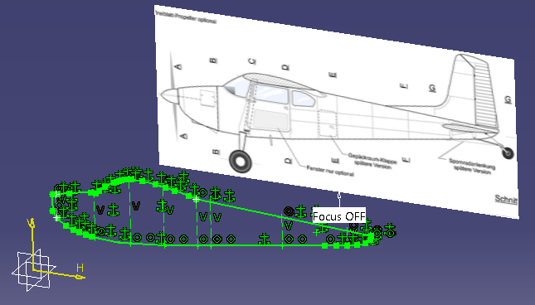
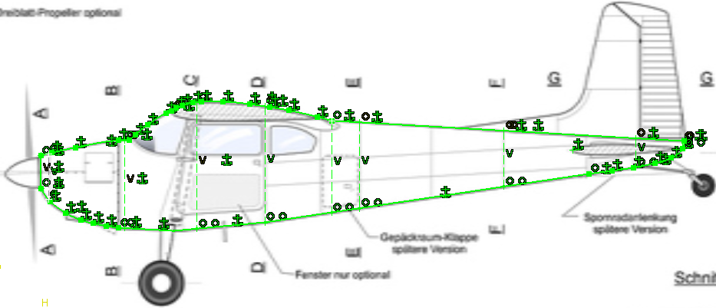

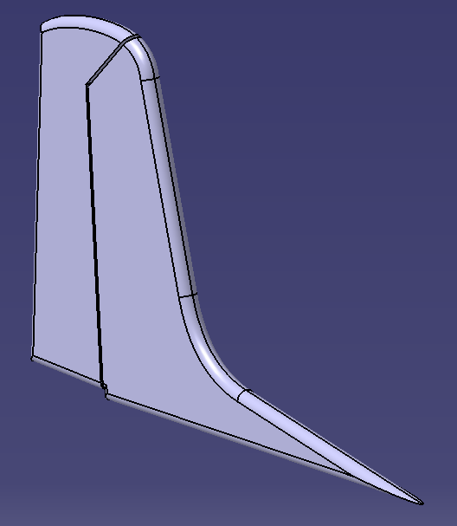
To get comfortable with the sketch tracer tool, the next thing made was a sketch and pad the vertical tail. After padding, the fillet tool was used to give it a smooth shape. The horizontal tail was done later using the same process.

Creating the Fuselage
The Fuselage was built using the multi-section solid tool. To do this sketches of the fuselage cross-sections were drawn and sketches were made so the lofts would follow the fuselage profile. To ensure proper lofting, closing points were replaced as needed so the profile followed the correct path.
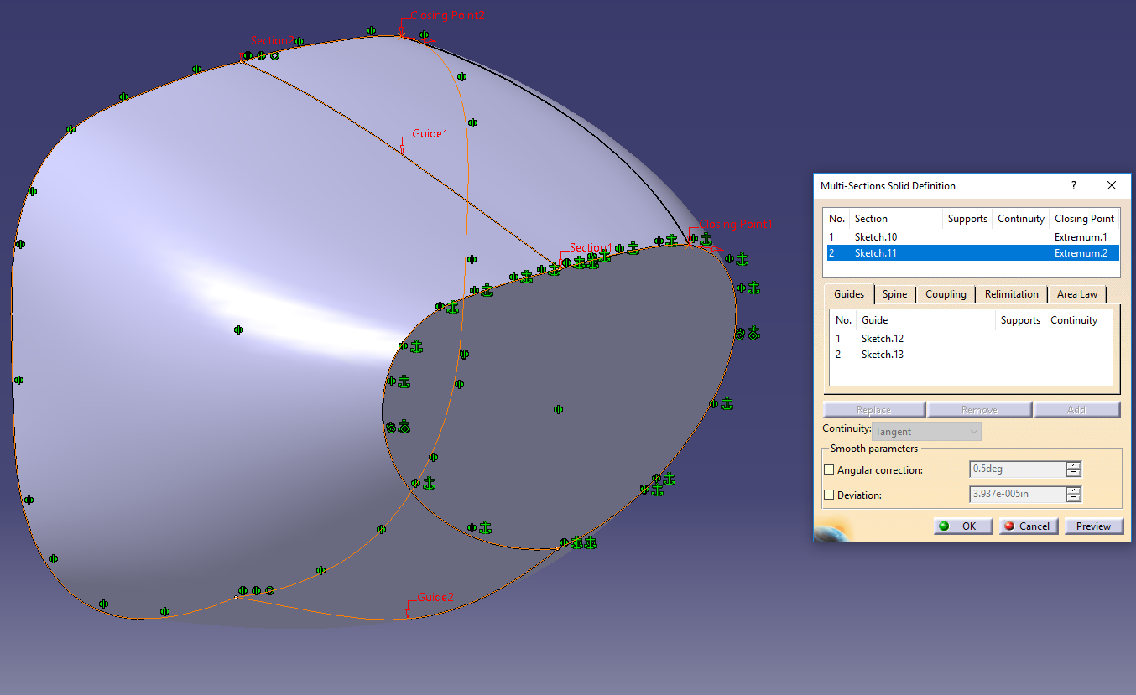

Another thing that it is important to remember is that even though the sketch of the entire fuselage was there, and it intersected the cross section sketches of the fuselage, you cannot use the fuselage profile as a guide. Guides have to be separate sketches. This discovery made the fuselage a very long process. To make the separate guide sketches, the original fuselage profile was traced.
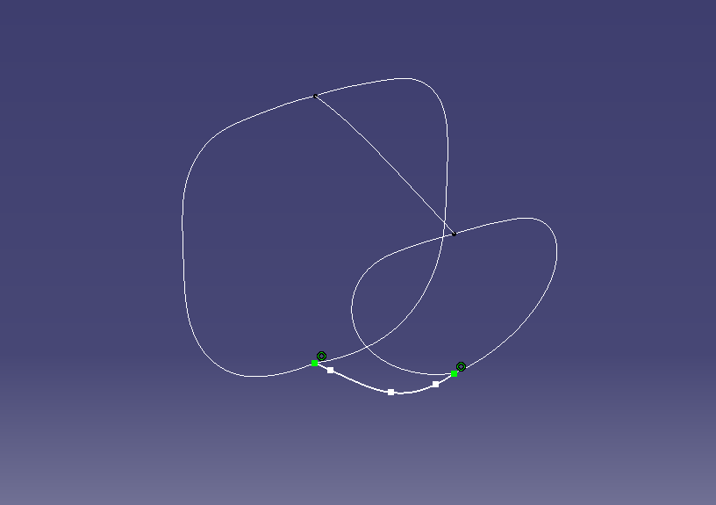

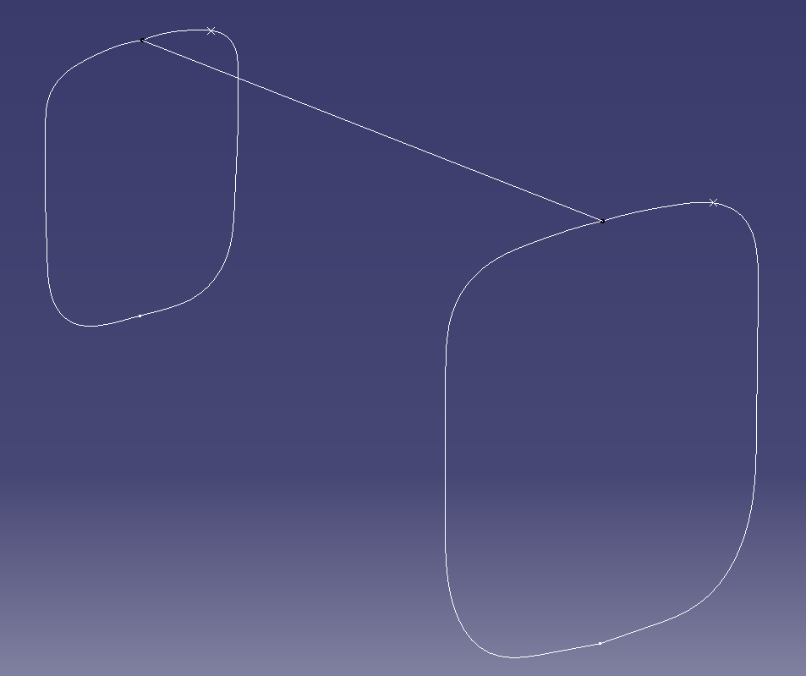
Since the cross section of the fuselage are not the same as it goes down the airframe, the cross section sketches had to be made separately and could not be projected and scaled from another sketch. More sketches of the cross sections and guides are shown below. Some lofts needed two guide curves while others needed one.
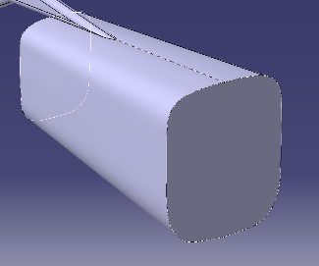

Some of the more complex shapes didn’t loft quite as easy as the others. The closing points had to be just in the right spots and only trial and error solved that. Another problem was that on some of the lofts, it needed the “ratio” option checked in the “coupling” tab of the multi-sections solid definition properties tab. This is accomplished by simply selecting the coupling tab and switching the drop down selection to ratio.
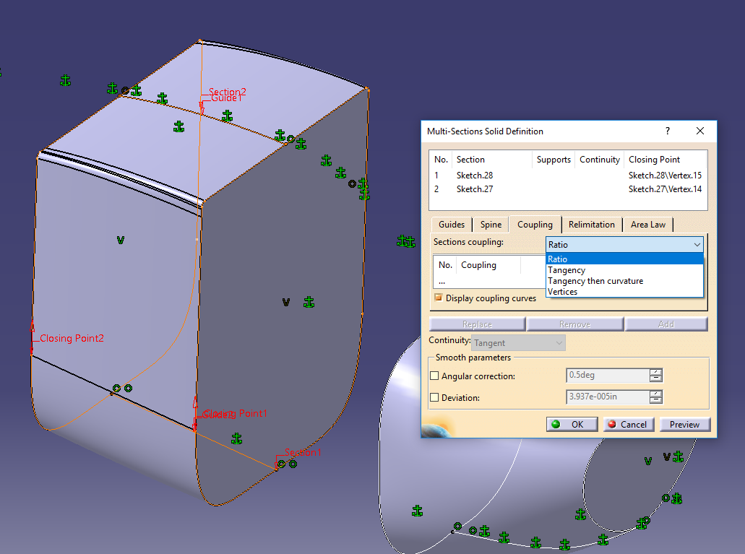

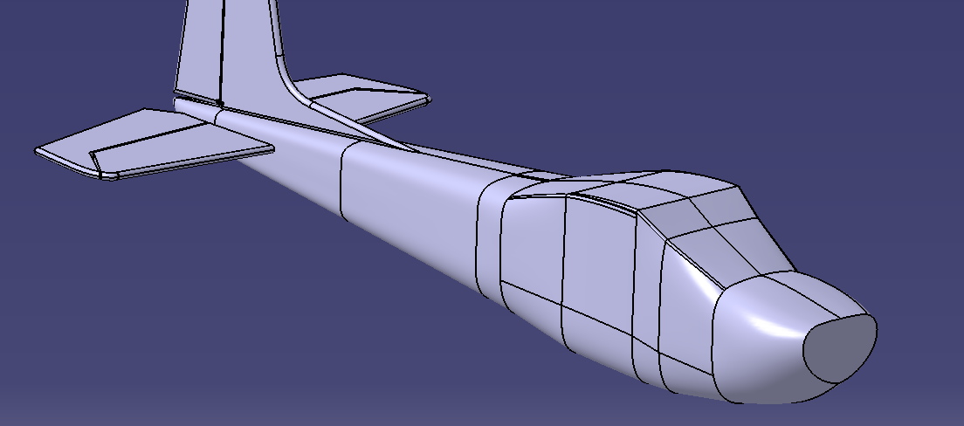
The fuselage was finished by continuing the same steps listed above.

Creating the Wings
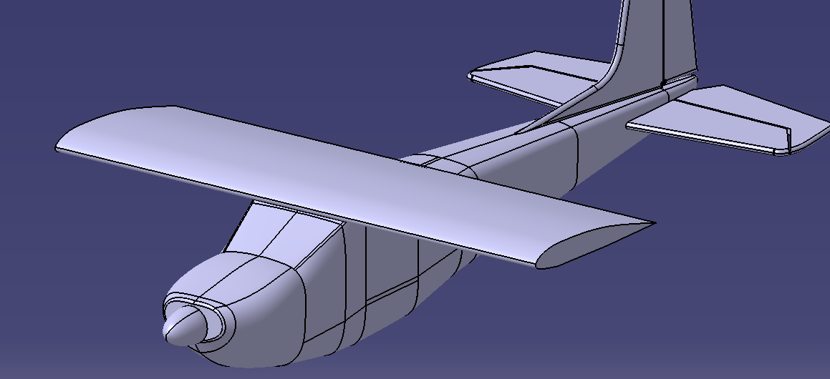
Due to the design of the wings, a simple pad of the airfoil shape was made outward from the fuselage. This was done by tracing the sketch of the original side view.

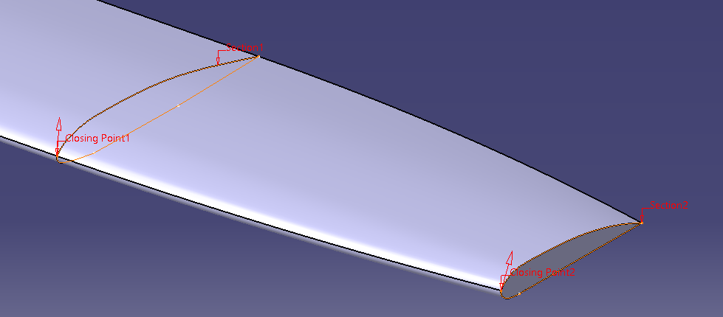
Next a loft was needed to do the next part of the wing. A simple sketch on a plane outward of the fuselage and the outline of the existing part of the wing were all that were needed.

Creating the wings proved to be a fairly simple task that didn’t take much time.

Other Features
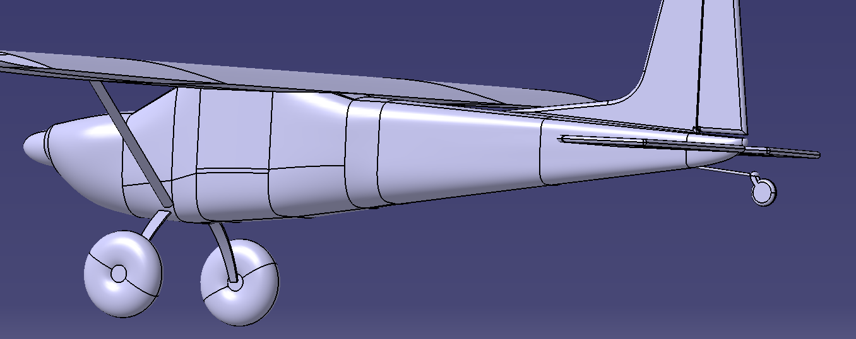
After the main parts of the airframe were finished, a nose cone, landing gear, engine intakes, and wing struts, were added. These were all done using simple CATIA features like pads, shafts, pockets, and ribs.

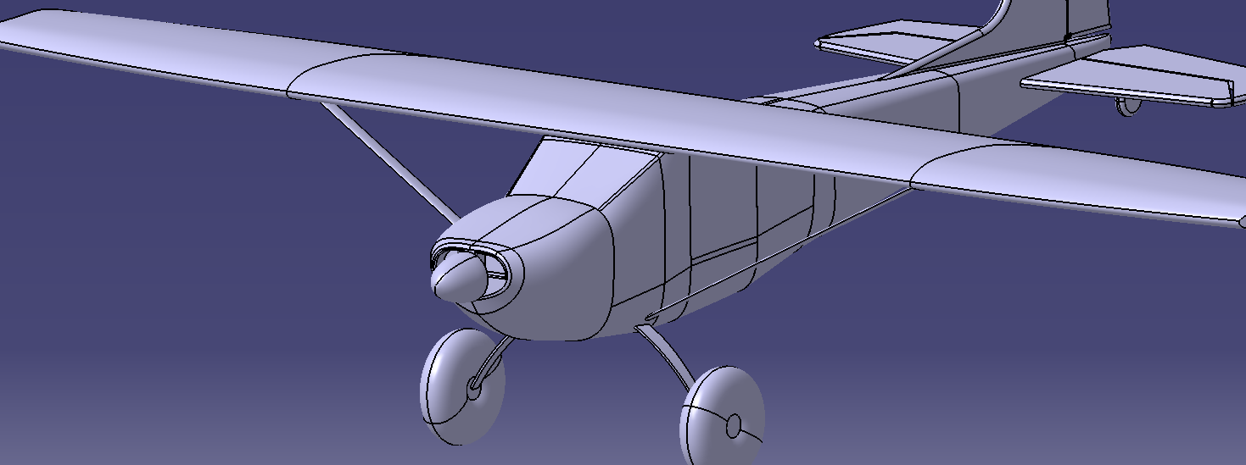

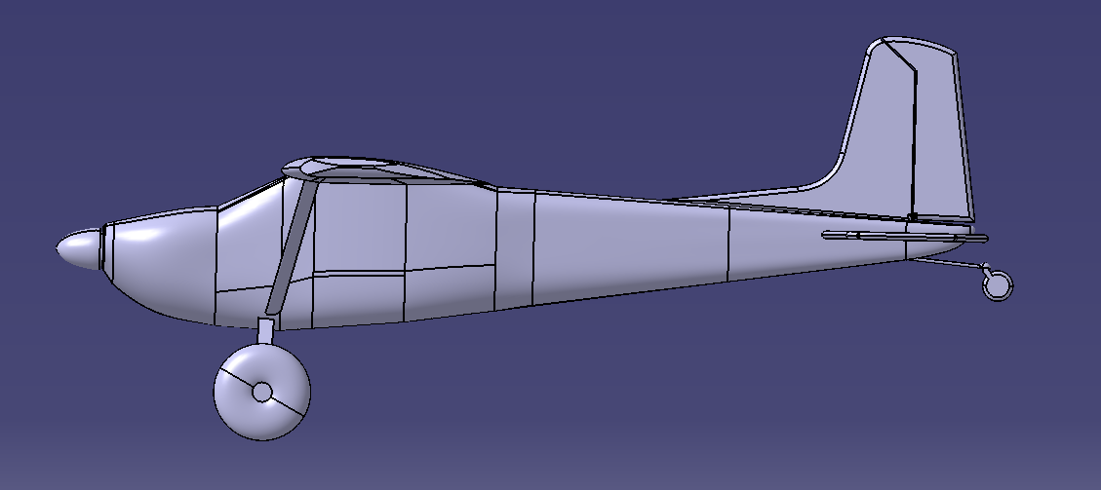
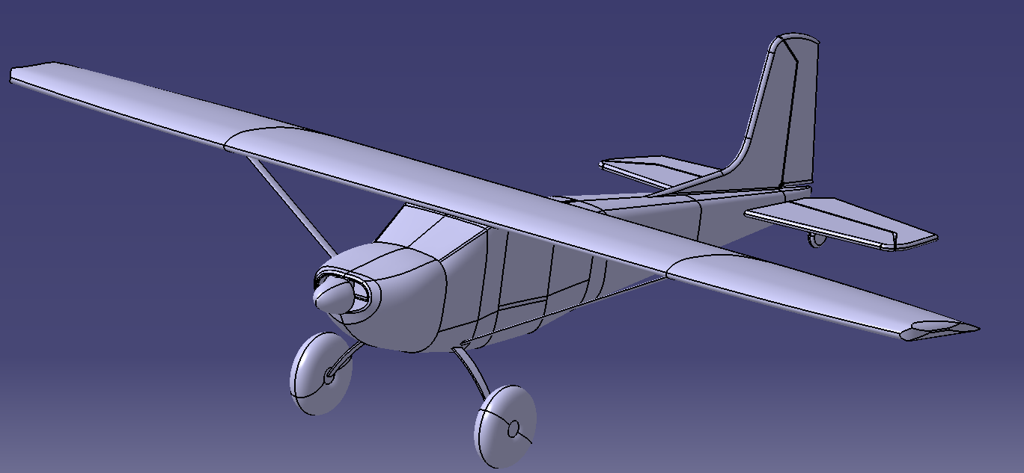
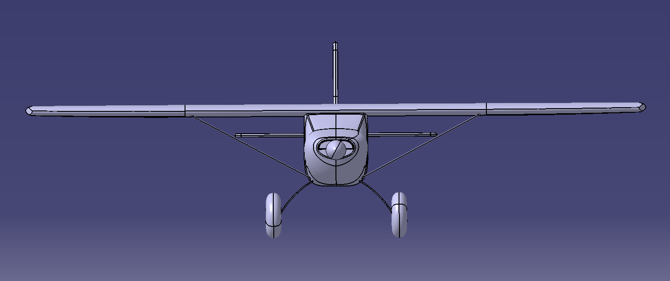
Final Product
Lessons Learned
This project was very beneficial in refining my CATIA skills. The biggest thing I learned was how to properly use the multi-sections solid feature. Many things have to be set right in order for the loft to work properly. First thing I learned is that even though the closing points may line up, sometimes I had to move both of them to a new spot in order for it to close properly. Next thing I learned was that the guide curves have to be on complete separate sketches. At first I wanted to use the original fuselage curve that I traced as a universal guide for all the lofts that I would be doing. I quickly learned that this was not possible in CATIA. This meant this project was going to take a lot longer to finish. The last big thing that I learned was that sometimes it doesn’t like the loft and you have to set the coupling to ratio as shown in the documentation above. All these lessons gave me a lot of knowledge on performing a multi-section solid properly. Overall this project was very beneficial for gaining knowledge of CATIA. It did take more time to do than was originally planned. Because of this, I did not have time to sketch the windshield and windows on like I wanted to. I also wanted to overlay a blue strip on the side to make the renderings look better. As of right now, I just have the material set to aluminum to simulate a small ornament or decoration a person may put on display. In the future I would like to finish it off with all the different colors and small details.

