Utilizing Generative Shape Design in Custom Shoe Modeling
Hunter Kanniainen
ME 421 – Fall 2018

Background
Having a passion for sneaker collecting, the concept of shoe design has always interested me. While applying generative shape design tools within ME 421 assignments, I started to see how valuable these tools could be in shoe design applications. Once accepted as my final project, I set my sights on what pair of shoes to model. My final choice was to model a pair of Pharrell x Adidas PW Hu Holi NMD’s. I chose these shoes for a multitude of reasons: an interesting, sculpted sole, one piece upper for complex surface modelling, and excitement as I had just purchased these shoes. Here are the shoes I used as reference:
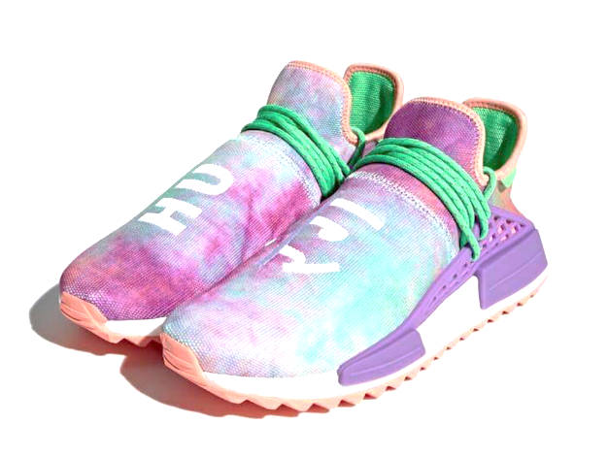

Sole and Sketch Tracer
Creating the sole was the first task, as it required several complex geometries that could later be used to define the shoe’s upper. To obtain a proper scale for the shoe, dimensions for my own pair of shoes were obtained with a tape measure, and applied to the images used in the sketch tracer. Several profiles were obtained from the images, and generative shape design tools allowed these profiles to be combined into curved sketches.
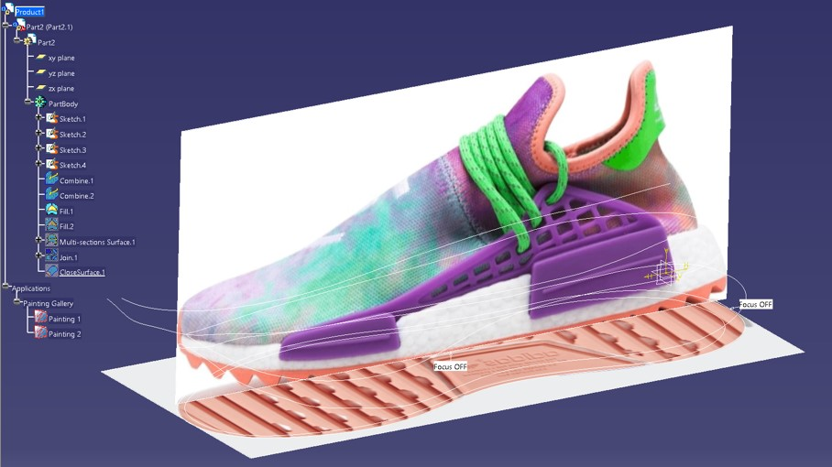
Once these sketches were combined, a top profile and bottom profile were obtained. Generative shape design allowed me to create a multi-sectioned surface that essentially lofted these profiles together. The top and bottom profiles were closed thereafter. Once the surfaces were created, a solid fill feature converted the sole into a solid part.
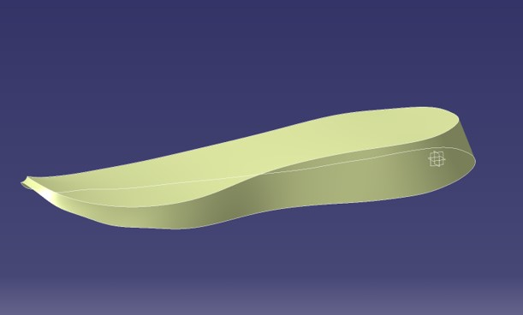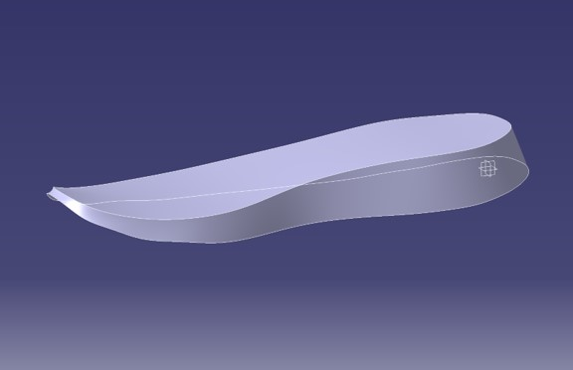

Shoe Upper
The shoes upper started by creating a bottom sketch to project onto the top of the sole. This was essentially the same sketch as the top of the sole, but slightly scaled down as the shoe’s sole slightly protrudes from the upper in all directions. A top profile was also made, this modelling the collar of the shoe. Guide curves were then created to allow for a multi-sectioned surface to loft across. Creating this loft turned out to be much more difficult than anticipated. Some primary issues with the loft feature included:
- Disconnect between guides and profiles – When attaching a guide curve to the top or bottom profile, the coincident mate was automatically created between the endpoint of the guide curve and the plane on which the profile lied. This meant the curve was not necessarily intersecting the profile, causing feature failure.
  - Fix: Adding points from the generative shape design toolbar coincident to profiles being lofted.
- Twisting geometry – Once the guide curves were indeed connected, the loft would generate but would twist in unpredictable ways. Even selecting new closing points failed to straighten the feature.
  - Fix: Creating the shoe upper in multiple sections.
Sketches now had to be split into two portions, one for each side of the upper, but the solution looked promising.
- Warped geometry – Once new sketches were applied to create the left side of the shoe upper and then the right, the loft feature was no longer useful. Filling the surface was the new plan, and a surface did indeed generate. The issue, however, is that the surface failed to look as planned and was created with massive concave/convex portions resembling a mountain range.
  - Fix: Further separation into fourths.
Alas, the surfaces would generate. Now all that was left was to thicken the surfaces.
- Unworkable geometry – When trying to thicken the surfaces, CATIA reported that the geometry could not be defined as a 2D element, so it could not generate the extrude.
  - Fix: Change the order of surfaces being thickened.
Images of the final surfaces in quarter sections can be found below.

Single quarter of surfaced upper:
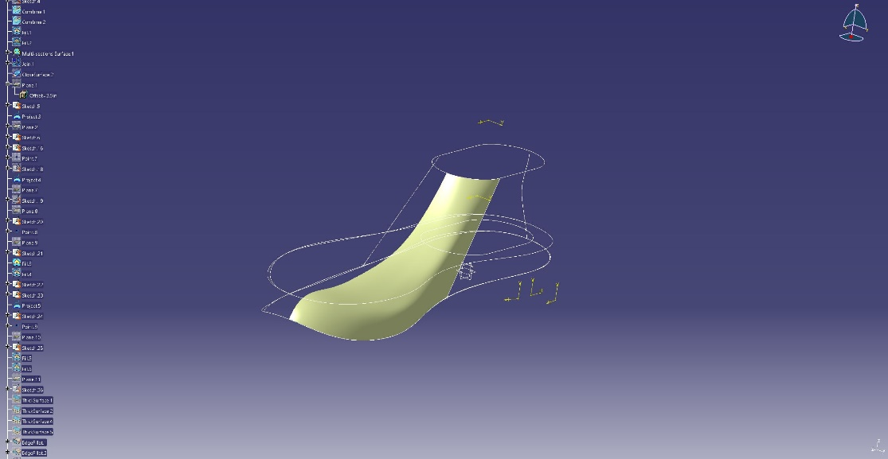
Front and back quarters of surfaced upper:
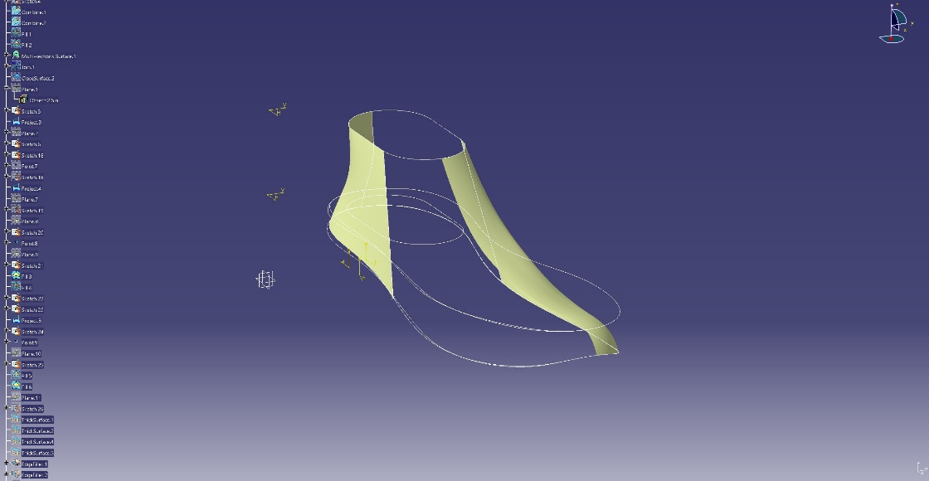
Fully surfaced shoe upper:
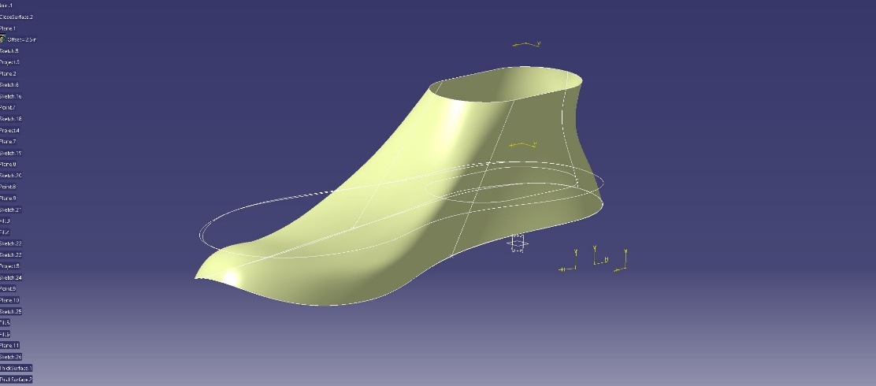

Thickened surface with colors applied to solid faces:
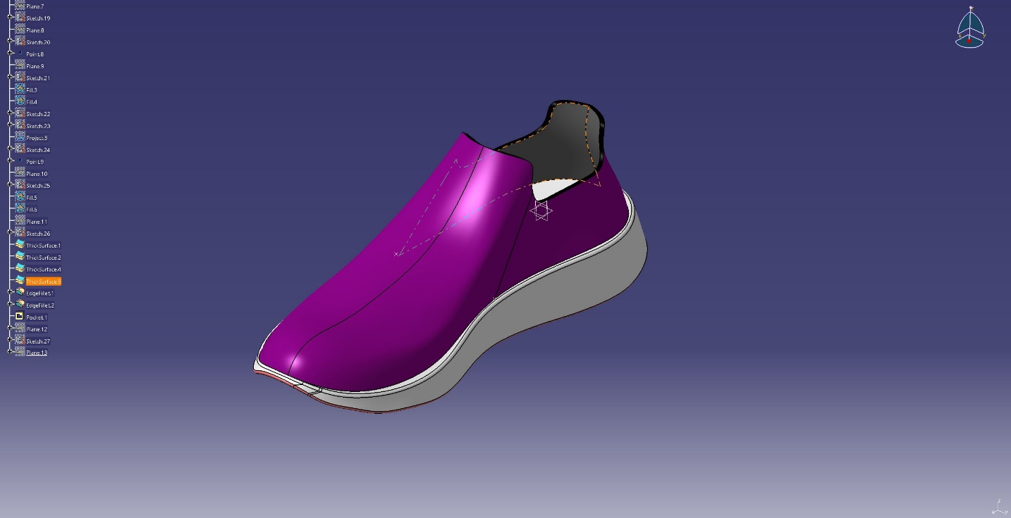
The multi-section surfaces in the sole created odd curvature lines that acted as small cusps. These did not affect the overall shape of the shoe, however, so changing the view method corrected this. An image of the shoes with the updated view method follows below.
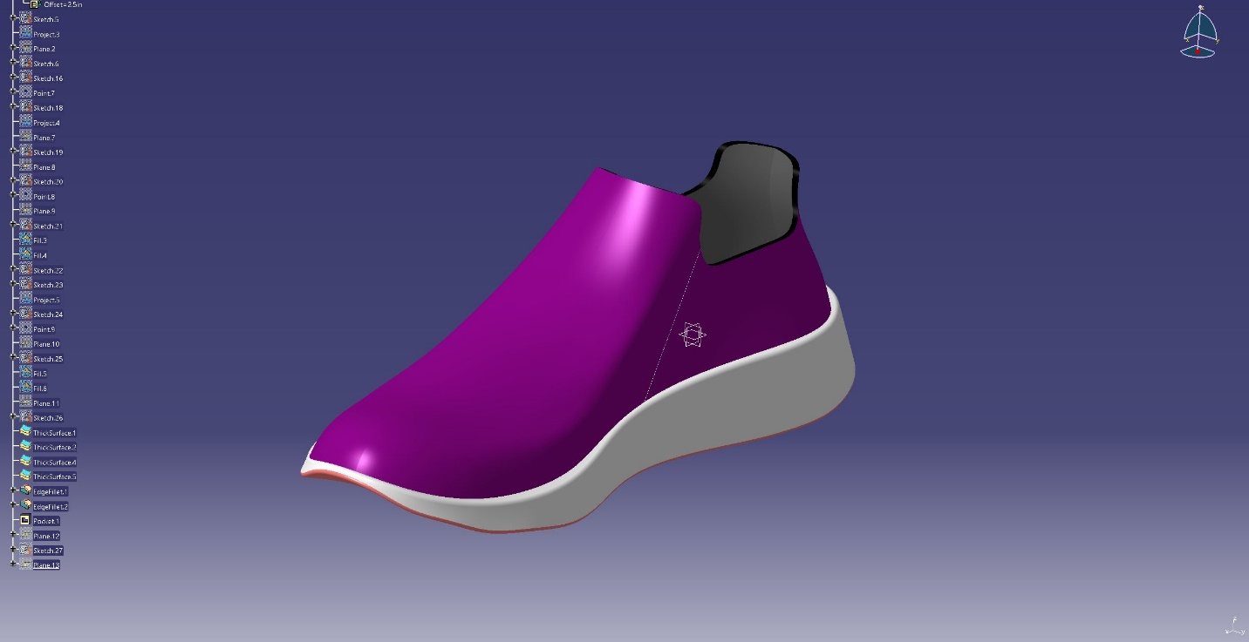

Some more images of the shoe at varying angles:
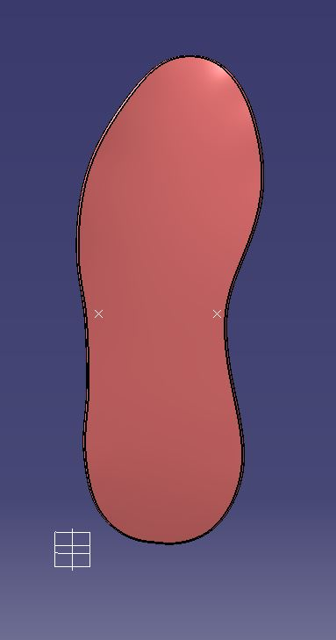

Shoe Rendering Setup
The final step in this project was rendering the shoes in an environment. Sneaker culture is very intertwined with streetwear fashion, so an empty white-aesthetic warehouse acted as the background. Tile floor appearance was applied to the floor imported into the product’s environment. Finally, a reference plane was created for the shoe once it was inserted into the product and a mirror copy of the shoe was created by CATIA’s “Insert → Symmetry” function.
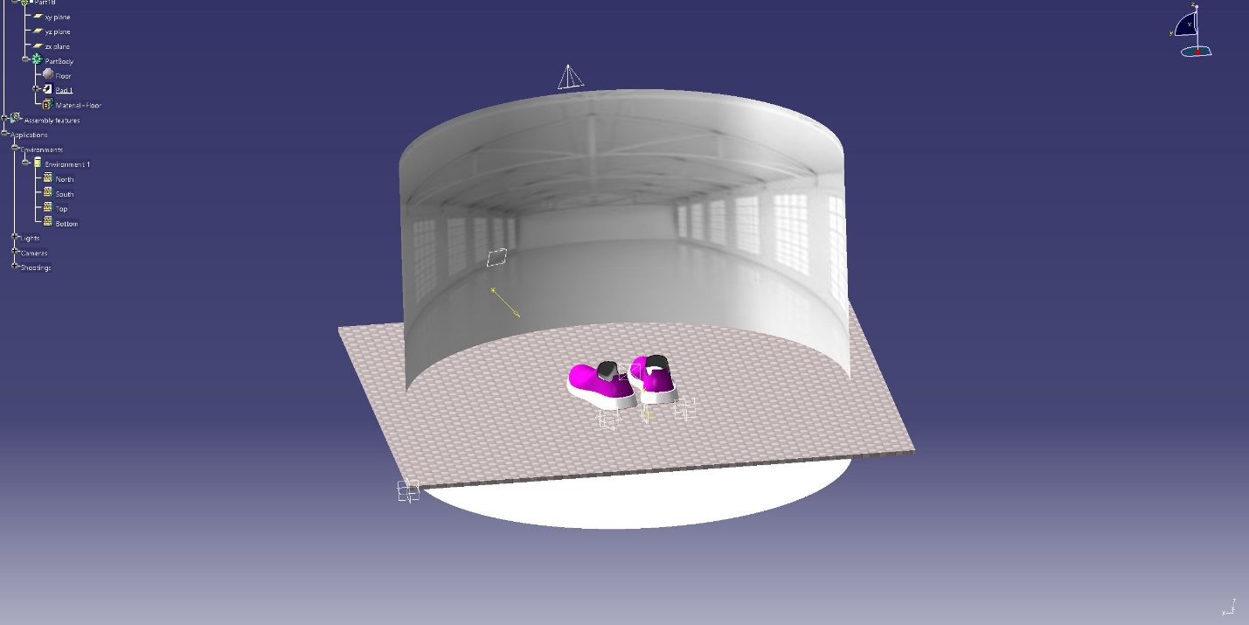
Final Shoe Renders

Lessons Learned & Future Recommendations
For students hoping to pursue projects utilizing generative shape design in the future, here are a couple of lessons that I learned that they may find useful:
- Sketch Tracer – The sketch tracer is a powerful tool in shape design as it allows you to model several contours to obtain difficult profiles.
- Coincidence Issues – Be prepared to drag points around randomly that are not functioning properly. They may just be coincident to the wrong entity.
- Complex Surfaces – If modelling complex surfaces fails, try separating it into several smaller portions. CATIA can handle these sections in a more manageable manner.
- Do Not Panic – Surfaces will fail. You will panic. Do not panic.

