Aspin Rotary Valve Engine
Ryan Bowen, Mike Brewster & Matt Sjoren

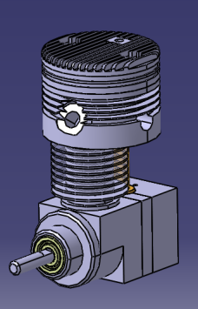
The rotary valve engine was a lot of fun to model up. It was interesting to see how the engineering and technology involved with the rotary valve helps the efficiency of the engine. There was some research involved with modeling the roller and bushing bearings. Fortunately the bearings required were a common size and easy to find.
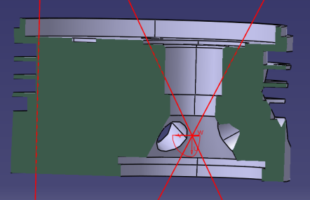
One of the most difficult parts to model was the cylinder head. Within the cylinder head, is the intake and exhaust ports, and the opening for the spark plug to get the correct angle and position of all three ports. It is important that all three are correctly placed because of the way the rotary valve works. If the ports are incorrectly modeled the timing of the rotary valve would be off and this would cause the engine not to run. Another challenging job was starting the assembly process. It was unclear where some of the bearings were placed along the crankshaft. It took some time but by process of elimination we were able to figure out where the bearing needed to be.
Some of the assumptions were made for this project. The plans called for Meehanite grey iron for the piston and not knowing the exact material properties we assumed just standard cast iron properties from CATIA. Another assumption made was to consider where the cam part needed to go in the assembly. After talking to Dr. Odom the decision was made to not implement it into the assembly, however that part was modeled. There was also a bearing in the bill of materials provided with the original plans that be determine where in needed to go. Even though the bearing has been modeled it was never incorporated into the assembly. When compiling the drawing package the assumption was made to reorder the part numbers within the drawing package for the sake of simplicity and to put them in a logical order if there was anyone wanting to machine the engine.

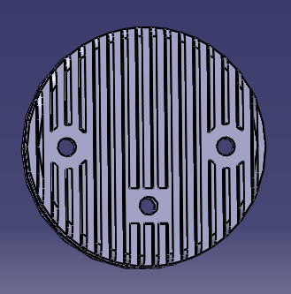
There was a very interesting question involving a screw hole when modeling the cover for the cylinder head. The center hole at first appeared not to have any purpose at all, however, after reading the assembly directions we noticed a small comment on how there is a set screw that is positioned above the 20 tooth timing gear. The instructions say to initially have the set screw touching the gear and then back it off a couple thousandths of an inch. The set screw is to keep the gear shaft and bevel gear on the other end meshed with the bevel gear on the crankshaft.
To determine the timing of the engine the piston was positioned at top dead center and the rotary valve positioned over the opening for the sparkplug. To make sure that the rotary valve was then advanced to the exhaust port, special attention was given to see where the piston was located and to see if the stroke of the piston was going upwards. The same attention was given with the valve at the intake port as well.
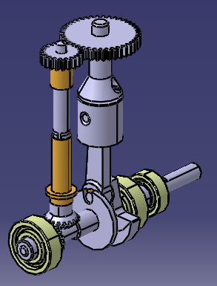
Overall, the modeling of the rotary valve engine was a lot of fun and a lot was learned on how the operation of the engine worked. It would be exciting to be able to machine the engine and determine the amount of power it created with the displacement of the engine. In the literature portion of the construction plans this engine was modeled after a World War II German torpedo. The original engine was able to produce 275 horsepower and could reach maximum speed from a cold start within two seconds. It would be interesting to see how the modeled version would compare to the original engine.

