Mig Welding Training Checklist
Safety
- Apparel – all skin should be covered by non-synthetic fabric – polyester and the like will melt to your skin. Skin shown will get sunburned from electric arc flash.
- Leather gloves should be worn to protect hands – do not handle hot metal with gloves – use pliers instead
- Helmet- Mig welding needs at least a shade 10 lens welding helmet. Tig welding can be done with a shade 9 lens. (Higher is darker)
- Welding exhaust fan should be on at all times.
- Don’t weld galvanized metal, or any metal with a plating (chrome, galvanized, cad-plated, etc.) These can release poisonous gases – especially galvanized. If you need to weld these, grind off surface anywhere near the weld.
- Don’t weld anything that has been in contact with flammable liquids (IE don’t weld gas tanks or oil pans)
Setup
- Plug in machine
- Turn on CO2 tank – shielding gas keeps oxygen from reaching molten steel. If this happens, you will get a porous brittle weld
- Connect ground cable to table, or to piece being welded
- Set internal settings for material to be welded- follow poster in welding area.
- Trim wire to 1 cm length – use wire cutters; no arcing off the wire onto the table.
- Pull cover off tip, and check gas holes, contacts, etc.
- Surface prep: Grinders and wire brushes can be used to clean the surface to be welded. This ensures a strong, good looking weld.
- Turn on machine – ready to weld
Clean-up
- Turn off machine
- Turn off CO2 tank
- Clean stinger tip of metal splatter
- Coil stinger and ground cable
- Clean up area of splatter and wire pieces
- Put away helmets, lens up to prevent scratching
- Turn off exhaust fans

Welding technique
- Angle of welder: welder should be as close to perpendicular to the surface, and angled 20-30 degrees in the direction of travel as shown below.

- Push vs. Pull welding: this has to do with welder travel direction. Push is stronger, with more penetration; good for thick metals. Pull is a weaker weld, with less penetration; good for thin metals to prevent burning through.

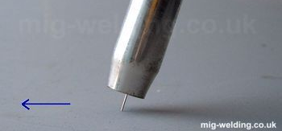
Push welding
Pull welding

- Stitch welding: Technique used to create strong welds with less distortion than a full length weld. Welder is placed in position, trigger pulled, and welder is moved in a back and forth motion for approximately an inch; an inch is skipped then the process repeats.

- Full length weld: Highest strength weld, but most heat distortion and residual stresses. Welder is placed in position, trigger pulled, and moved in either a crescent moon path, or back and forth as above.

- Speed: Demonstrate results of too fast, and too slow welding.
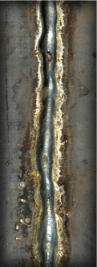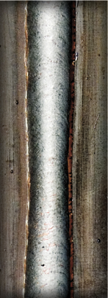
Too Slow
Too Fast

