Manufacturing Date:
5/20/10
Manufacturing Plan for Manual Machining
Material:
Aluminum
Quantity:
1

Part Number:
2-02
Operation # | Machine Description | Operation Description | Tool Type | Estimated Time
1 | Manual Mill | Face all sides to square | Facing End Mill | 30
2 | Manual Mill | Mill L-shape | Rough End Mill | 30
3 | Manual Mill | Step drill .505" hole | 1/4" drill bit | 10
4 | Manual Mill | Step drill .505" hole | ½" drill bit | 5
5 | Manual Mill | Ream .505" hole | .505 Reamer | 5
6 | Manual Mill | Drill 2 thru all holes on top | .266 drill bit | 10
7 | Manual Mill | Countersink 1 hole on top | Ø.52x82° bit | 5
8 | Manual Mill | Counterbore 1 hole on top | Ø.44 depth .25 | 5
9 | Manual Mill | Center/dowel pin drill | Ø.124 depth .3 | 5
10 | Manual Mill | Center/dowel pin ream | Ø.126 depth .3 | 5
Notes/drawings/setup sketch
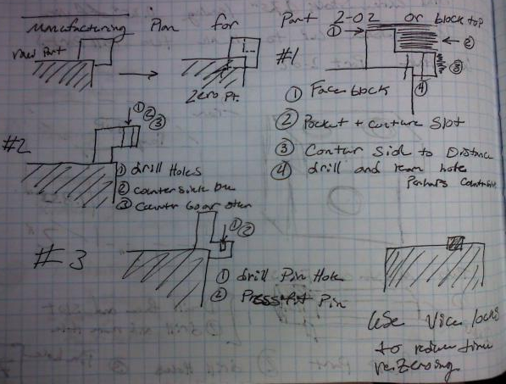
Tips:
- Always adjust speed while machine is running
- Ream at half speed
- Edge finder is used at 1000 rpm
- Facing tool needs to be angled slightly
Part Description:
L-shape Block that fits into U-shaped block
Stock:
2x2x2 block

Part Name:
Top Block Part

