Direct Data Transfer from MasterCAM X2 to HAAS CNC Mill
(Using the RS232 serial cable)

PART ONE: Set the Haas Mill to Receive Data
- Press “LIST PROG”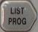. Scroll down and highlight “ALL” on the screen using the arrow buttons.
- Press “RECV RS232”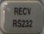.

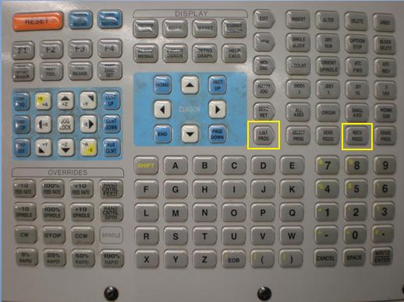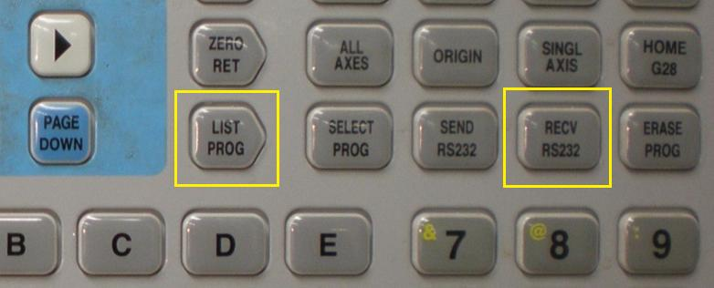
2
1
2
1

PART TWO: Send MasterCAM Data From Computer to Mill
- Make sure MasterCAM is talking to the correct CNC machine. If you see “Generic Mill” next to “Properties” then you are NOT connected to the correct machine.
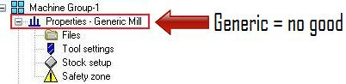

- To assign a specific machine to MasterCAM (for post-processing purposes) expand “Properties” under “Machine Group” and double click “Files”.

- To choose a specific CNC machine, click the “Replace” icon in the “Machine Group Properties” window. After you select “Replace” a new window appears titled “Open Machine Definition File”. Select the Haas Mill file and then click “Open”.
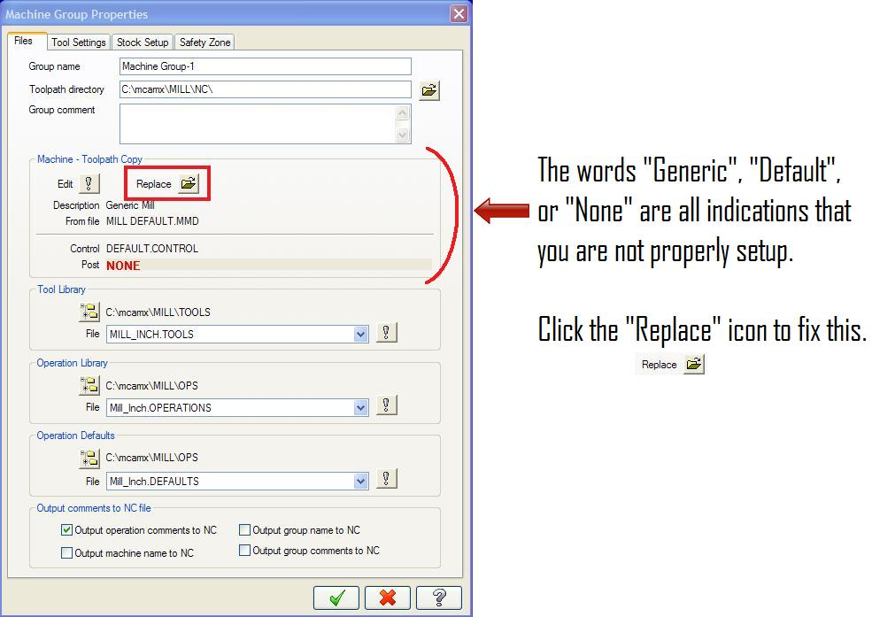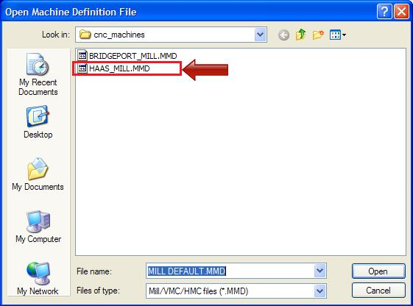
Select the “OK” button from the “Machine Group Properties” window to complete the machine assignment.
- In the “Toolpaths” window press the “Select All Operations” button. Then select the “Regenerate All Selected Operations” button.

- Select the “Post Selected Operations” button. This will bring up the “Post Processing” window shown below. Check the “Send to Machine” check box and then select the “Communications” button.
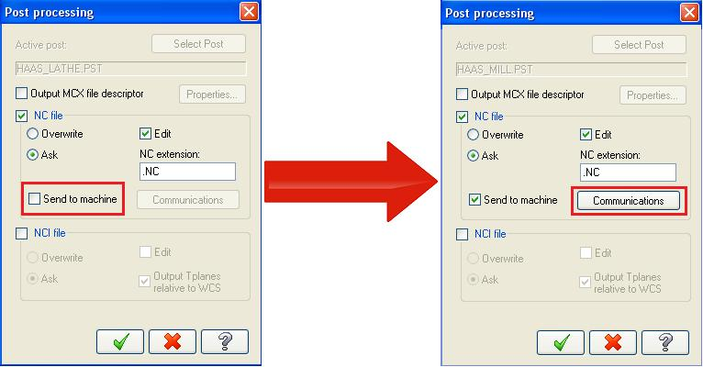

- Ensure the Communications window resembles the example window shown below, where the Baud Rate is set to 9600 and Stop Bits is set to 2. Click okay button in the “Communications” window if everything looks good.
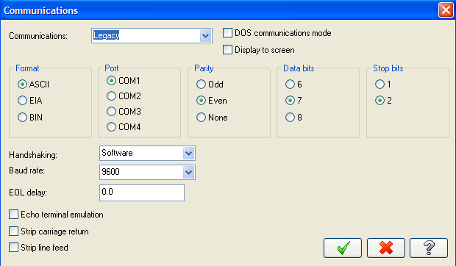

- Click the okay button in the “Post Processing” window. A new window will appear titled “Save As”. Enter a file name that you will remember. Do not change the destination folder, leave it as “nc”, click the save button when finished.
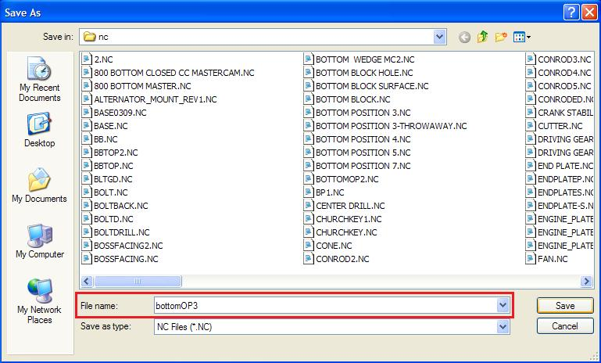
- After you save your NC file a new window will appear showing all of the G-code for the data you are transferring. When you close this window the data will be sent to the mill automatically.

