Electric discharge machining (EDM)
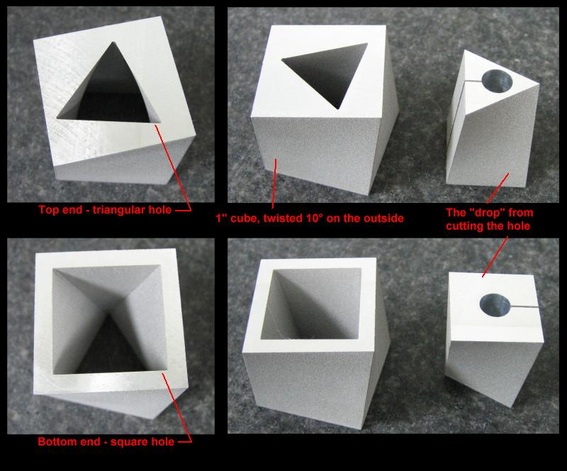
Electric discharge machining is a process where a desired shape or feature is cut out using electrical discharges. It is often used to make intricate shapes, or cut materials, which would be difficult to do using traditional machining methods (turning, milling, drilling, grinding).

Some examples of what can be achieved would be a round hole on one side of the material opening up to a square hole on the other side (achieved using wire EDM), or intricate angles. Using ram EDM a desired shape (design) may be pushed into the material to create a desired feature that does not go all the way through the material. Another option is small hole drilling of holes 0.004” to 0.256” at depths of up to 300 times the diameter width.

Advantages:
- Complex shapes that would be difficult to produce with conventional cutting tools
- Extremely hard material to very close tolerances
- Very small work pieces where conventional cutting tools may damage the part from excess cutting tool pressure.
- There is no direct contact between tool and work piece. Therefore delicate sections and weak materials can be machined without any distortion.
- A good surface finish can be obtained.
- Very fine holes can be easily drilled.

Common Capabilities:
- Tolerances +/- .0002”
- Wire diameters from .002” to .012”
- Tapers of up to 30 degrees

Disadvantages:
- The slow rate of material removal.
- The additional time and cost used for creating electrodes for ram/sinker EDM.
- Reproducing sharp corners on the work piece is difficult due to electrode wear.
- Specific power consumption is very high.
- Power consumption is high.
- "Overcut" is formed.
- Excessive tool wear occurs during machining.

Cost:
Determined by part dimensions, features, and tolerances.

Local options:

Northwest Wire EDM
http://www.northwestwireedm.com/

1620 N. Mamer Road
Building C, Suite 300
Spokane, WA 99216

PH: 509.893.0885
FX: 509.893.0696
Email: info@northwestwireedm.com

EDM Capabilities:
- Wire EDM
- Small Hole EDM
Additional capabilities:
- WaterJet

AMI Machining, Inc
http://www.wireedm.com

11784 North Tracey Road
Hayden, ID 83835-9865

PH: 208. 772.3996
Email: Jgrimm@wireedm.com

EDM Capabilities:
- Wire EDM
- Small Hole EDM

Additional resources:
- http://en.wikipedia.org/wiki/Electrical_discharge_machining
- http://www.youtube.com/ReliableEDM
- http://www.reliableedm.com/
- http://www.reliableedm.com/Complete-EDM-Handbook.html
  - This is a handbook which contains over 200 pages specifically dealing with EDM.
