Tutorial and Guidelines
On
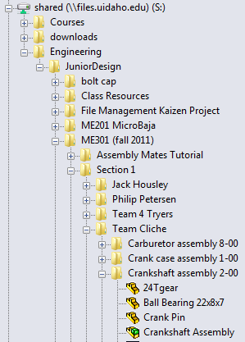
Solidworks File Management
Understanding how SolidWorks locates the files you have saved is very important. Starting from the farthest line on the left in the photo above, SolidWorks works its way to the right when it comes to locating parts. A good way to think of it is SolidWorks will search the folder you opened an assembly from for all of the parts needed to load that assembly. If the part is not within that folder then you will be asked to locate it manually. This is explained in the external references section. An example would be trying to load the crankshaft assembly seen above, but the 24 tooth gear part file was not in that folder then it would ask you to locate it.

Proper File/Folder Naming
Due to the large amount of parts in final projects, naming files and folders appropriately is advised. Many of the parts on legacy drawings are not given a specific name. The same part may be referred to differently by different members. By properly naming files and folders, you can avoid confusion. You will know exactly what part you are talking about and keep your project files organized. Communicating any changes to your team is a key part in preventing problems.

The “File Management Kaizen Project” folder is equivalent to a personal or team folder. In that folder you should have projects. In the project folder you should have an “Assemblies” folder where the importance of naming files correctly is important.

Subassemblies should be labeled like the ones shown above. They should include the name or description along with the subassembly number each is associated with in the drawing package. The default settings sort the subassemblies by alphabetizing their names. It is up to personal preference whether to place the assembly number before or after the name. Whatever method it is you choose however, keep in mind it must be consistent throughout the project.

Once you go into your subassembly folders, they should look similar to the ones above. One has the part numbers before the name, while the other has the opposite. Once again the order does not matter as long as it is kept consistent throughout the project. Naming these files will make referencing parts from drawing packages much easier since all parts in a subassembly should be in that subassembly’s folder.
Key Points
- Label subassemblies folders/files with a name and associated assembly number.
- Label parts with name and associated part number.
- As a team, communicate any changes to file names (might have to manually find part with altered name to get assemblies to load).
- Subassembly drawing packages will include all parts in their respective subassembly folders.
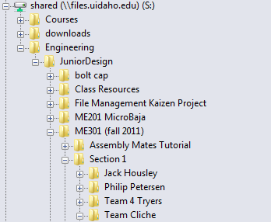
Once your team has formed, create a team folder. This is where all of the parts of the project should be kept up to date.
Start by working underneath one common drive that each team member has access to. The shared drive on campus is usually the best option; however the same folder model can be made on dropbox.com.

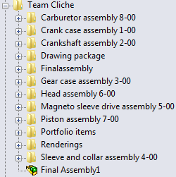
The final assembly itself should be seen on the same folder level as the sub-assemblies that make it up as seen on the left.
Once you are provided with your project, it is important to develop a useful CAD plan that labels each sub assembly. Notice how each sub assembly has its own folder labeled with name and number.
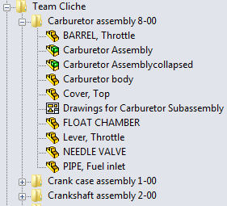
Inside of the sub-assembly folders should be each part that makes up that assembly and the assembly itself.

The drawing sheets for that assembly are also seen at this level.

External File References
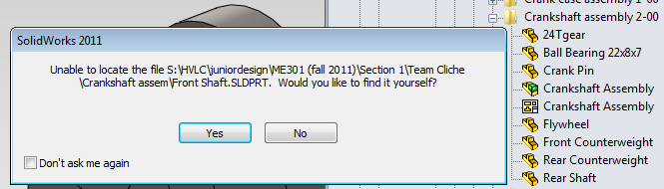
Note: The easiest way to avoid confusion is to keep one updated team folder (as shown in common practice) that contains the most recent version of every part.

Seen above is a screen that should be taken seriously. In the above example the crankshaft assembly file was trying to be opened. While it was loading, the dialog box shown above appeared. This is because the front shaft part file was not inside of the crankshaft assembly folder where SolidWorks would try to locate it by default.
If you say yes to the above menu you will open the file explorer on the computer and will be able to try and locate the part yourself.
If you choose to locate the file yourself you will create an external reference and change the default file search location for that specific part. This creates the most confusion if external references are made to removable thumb drives because without the thumb drive you do not have the ability to open the subassembly.
Doing this is not always a bad thing; however if you are unable to locate the part on the computer you are working on, it is better to close the assembly you tried to open and move the missing file into the subassembly folder so it can be located by default upon reopening.
If each team member has their own assigned subassembly then they hold the responsibility of keeping track of their own external references.
When it comes to final assembly avoid using external references. When the team is ready for final assembly, make sure to have your files organized as shown in the common practice section.
Key Points
- The common practice section shows the easiest way to avoid having external reference confusion.
- If you create external references, know where they are.
- Equal division of subassembly work will allow each person to keep track of their own file locations.
- Not having external file references for final assembly is the best plan of attack.
- File management is a team effort and can be monitored using good communication practice.

Using Smart Fasteners/Toolbox
When working on a subassembly that includes tapped holes, “Smart Fasteners” can populate the holes with screws. At times you might have to make a few modifications. People have used this feature in the past and found some issues. Sometimes opening assemblies on different computers changes the fasteners because they are being referenced off the toolbox and not a part file. Another issue to take into account is that if your copy of SolidWorks does not have a license for “Toobox”, your assembly will be missing these parts.
- Right click on fastener. Then go to “open part” in order to open it as a part.

2. Once you are in the part’s workspace, click on “File”. Then click on “Save As”.
3. SolidWorks will give you a prompt telling you that if you “save as”, references will be replaced by the new name and location. If you select “save as copy”, then references for the parts will remain the same. You want to “save as” so it can be referenced from a folder instead of “Toolbox”

4. The last step is to properly name and “save as” in the subassembly folder where it belongs.

