Practice Problems
A steam power cycle that incorporates one reheat leg is shown in the sketch. Steam from the boiler enters the high pressure turbine at 1600 psia, 1100°F. The steam leaves the high pressure turbine at 400 psia and then enters the reheat section of the boiler where it is reheated back to 900°F (assume no pressure drop). The steam then enters the low pressure turbine where it expands to 1 psia. Enough heat is exchanged in the condenser such that the water leaving the condenser is saturated liquid at 1 psia. Both stages of the turbine have isentropic efficiencies of 85% and the pump has an isentropic efficiency of 90%. The net power output of the cycle is 220 MW.

- Develop an array table of properties for the six state points shown in the cycle. For each state point, list the pressure, temperature, enthalpy, entropy, and quality.

- Once the property table is built, determine the following parameters for this cycle,
  - The mass flow rate of the steam in the cycle (lbm/hr)
  - The power output (MW) of each turbine (high pressure and low pressure)
  - The power required by the pump (MW)
  - The heat transfer rate at the condenser (Btu/hr)
  - The heat transfer rate at the boiler (Btu/hr)
  - The thermal efficiency of the cycle
  - The heat rate of the cycle

- Conduct a parametric study to investigate how the reheat pressure (P[2]) effects the thermal efficiency of the cycle. Plot thermal efficiency vs. P[2] for 50 psia < P[2] < 600 psia. In the REFLECTION for this problem discuss the mechanical engineering implication(s) of the parametric study.

- Compare your results for the reheat cycle with the standard cycle from HW24.
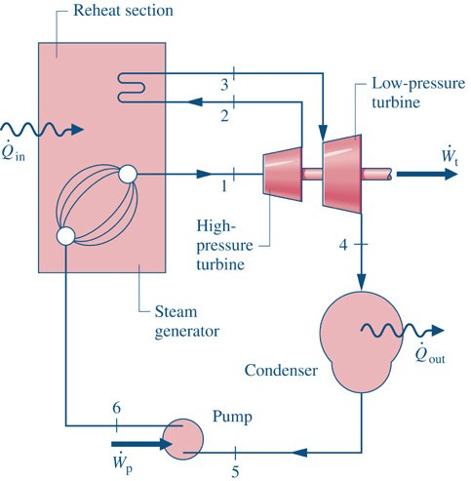

Answers
2a) mass flow is ~ 1.3 x 10⁶ lbm/hr
2f) net thermal efficiency is ~ 38% (slightly higher than the same cycle from HW24 without reheat)
3) the best choice of p[2] for peak efficiency is going to be closer to 50 psia than it is to 600 psia
4) for commenting about the difference the cycles you can embed this as comments in your code.

