**ME 322 – Mechanical Engineering Thermodynamics**

**Exam 2**

Spring 2012

DO NOT TURN THIS COVER PAGE OR LOOK THROUGH THE EXAM QUESTIONS UNTIL YOU ARE INSTRUCTED TO DO SO.

Please read the following statement:

Article II, Section 1 of the University of Idaho Student Code of Conduct states,

*Cheating on classroom or outside assignments, examinations, or tests is a violation of this code. Plagiarism, falsification of academic records, and the acquisition or use of test materials without faculty authorization are considered forms of academic dishonesty and, as such, are violations of this code. Because academic honesty and integrity are core values at a university, the faculty finds that even one incident of academic dishonesty seriously and critically endangers the essential operation of the university and may merit expulsion.*

Passing on exam information to someone who has not taken the exam constitutes cheating on an examination. Such action is a violation of the University of Idaho Student Code of Conduct.

I have read and understand the above statement.

___________________________________________________ October 19, 2012

Signature Date

___________________________________________________

Printed Name

**EXAM INSTRUCTIONS – PLEASE READ THIS CAREFULLY**

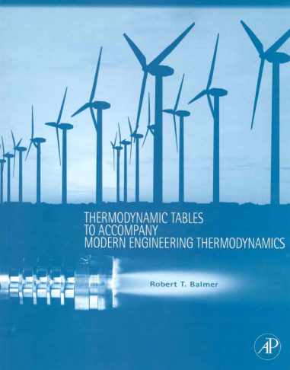**You will have 50 minutes to complete this exam. This time limit will be strictly enforced. This is a CLOSED TEXTBOOK exam. The only resources allowed are a hand-held calculator and the course textbook supplement cited below,**

**Balmer, R.T., “Thermodynamic Tables to Accompany Modern Engineering Thermodynamics, Elsevier Inc., Burlington, MA, 2011.**

**You may use the blank pages in the booklet to write anything you desire IN YOUR OWN HANDWRITING. Absolutely no cutting and pasting in the book is allowed.**

**No computers, cell phones, iPhones, iPods, iPads, music players, or any other electronic equipment may be used during the exam with the exception of a hand-held calculator.**

**Show all of your work in the space provided on the exam. Partial credit cannot be awarded if the work is not shown. Each problem on the exam is worth 5 points. There are a total of 40 points on this exam.**

1. Two lbm of saturated liquid water at 18 psia are trapped inside of a piston cylinder assembly. The water is then heated until it becomes a saturated vapor. The piston moves without friction inside of the cylinder. Determine the heat transferred (Btu) during this process. Is this heat transferred to the water or from the water?
2. Specific entropy values of a pure substance in three different phases are shown in the table below. The values were determined at the same pressure, but different temperatures. Identify which entropy value is associated with the proper phase; solid, liquid, or vapor.

|  |  |
| --- | --- |
| **Specific Entropy** | **Phase** |
| *s* = 2.5646 kJ/kg-K |  |
| *s* = 0.1297 kJ/kg-K |  |
| *s* = 1.8431 kJ/kg-K |  |

1. An insulated, rigid tank is being filled with R-134a from a pipe as shown. The tank is initially evacuated. The R-134a is flowing in the pipe at 200 psia, 200°F. The valve between the tank and the pipe is now opened and the R-134a flows into the tank until the pressure reaches 140 psia. At that point, the valve is shut off. What is the temperature in the tank at the end of this filling process?



1. Ocean Thermal Energy Conversion (OTEC) is a technology that uses the warm surface waters and cold deep waters of the ocean as thermal energy reservoirs to drive a heat engine. Consider an OTEC application where the surface water is 80°F and at a depth of several miles, cold water exists at 45°F. Determine the maximum thermal efficiency of the heat engine that utilizes these reservoirs.
2. In class we discussed how the *h-s* (Mollier Diagram) helps us understand the operating characteristics of an adiabatic turbine. Consider an adiabatic steam turbine operating with the conditions shown in the *h-s* diagram shown below. Determine:
   1. The specific work delivered by the turbine (Btu/lbm)
   2. The isentropic efficiency of the turbine
   3. The specific entropy production of the turbine (Btu/lbm-R)



1. Sulfur dioxide gas undergoes a reversible and adiabatic process from 400 psia, 500 R to a temperature of 600 R. The sulfur dioxide can be modeled as an ideal gas with constant heat capacities (Table C.13a). Determine the pressure (psia) of the sulfur dioxide at the end of this process.
2. In an industrial process, two chemicals are mixed together in a rigid reactor vessel as shown in the sketch below. The chemicals react and produce a single product. Known flow rates and properties are given on the sketch. The flows are steady. The kinetic and potential effects can be neglected. The property values are referenced to the same datum state for all three fluids. Determine the heat transfer rate (Btu/hr) required for this process.
3. Compressed air has many uses in industry. Consider a situation where compressed air is supplied to a paint-spraying process by a steady-flow air compressor.
   1. Identify at least three different things that cause entropy production within compressor.

1.________________________________________________________________________

2.________________________________________________________________________

3.________________________________________________________________________

* 1. One of the goals of ME 322 is to analyze systems and consider how entropy production might be minimized. Explain how minimization of entropy production in the air compressor is related to environmental impact.
  2. We can *never* have an air compressor that operates with zero entropy production in the real-world because of irreversibilites. If this is true, why do we even bother analyzing air compressors with zero entropy production?

