Using Vectors & Torque to Understand Muscles as Movers

Name

For each of the muscles indicated on the following pages, complete the following:

- Identify the muscle indicated on the diagram.
- Identify the plane of view on the diagram.
- Determine the linear and/or angular motions associated with the muscle in that plane by completing the following steps:
  - Draw a vector that represents the direction of pull for the muscle in the plane depicted, placing the point of attachment on the bone that reflects the typical movement associated with that muscle.
  - Resolv the muscle force vector into its parallel and perpendicular components (for shoulder joint muscles) or horizontal and vertical components (for shoulder girdle muscles).
  - Draw a moment arm for the muscle in the plane depicted.
  - Draw a curved arrow to indicate the direction of rotation created by the muscle.
- Visualize the muscle from the other 2 planes not depicted for the muscle, and attemp to “see” the resolution and the moment arm for each plane. You may want to attempt to draw a diagram for each plane.
- Identify the linear and angular motions in the other 2 planes

Answer the questions at the end of the lab.

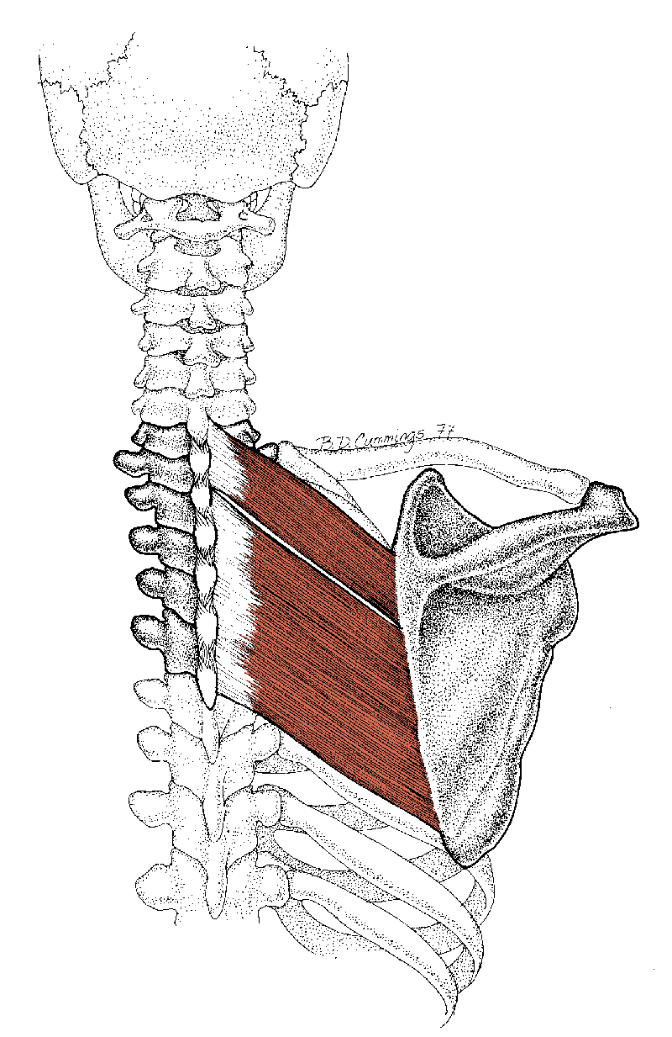
An example has been done for you below.
Downward rotation
retraction
elevation
Moment arm

The answers are found on the following pages. Remember, it is difficult for me to draw perfectly right angles using the drawing tool in Word, but the drawings are close approximations. The “movements in the other planes” are guesses based on the direction of the muscle’s pull. However, not all the joint actions I’ve identified will actually be listed for a muscle in your muscle cards. The moment arm in that plane may not be sufficiently large enough to create enough torque for the muscle to be a considered a prime mover. This lab is simply designed to help you identify the potential that a muscle has for creating linear and angular movements of bones, based on the direction of its pull and the presence of a moment arm.

The color code for the drawings is as follows:

Vector representing muscle’s resultant line of pull

Component vectors

Axis of rotation

Mechanical axis of bone (shoulder muscles only)

Moment arm

Torque produced by muscle or
No Torque in Frontal Plane

Muscle insertion angle

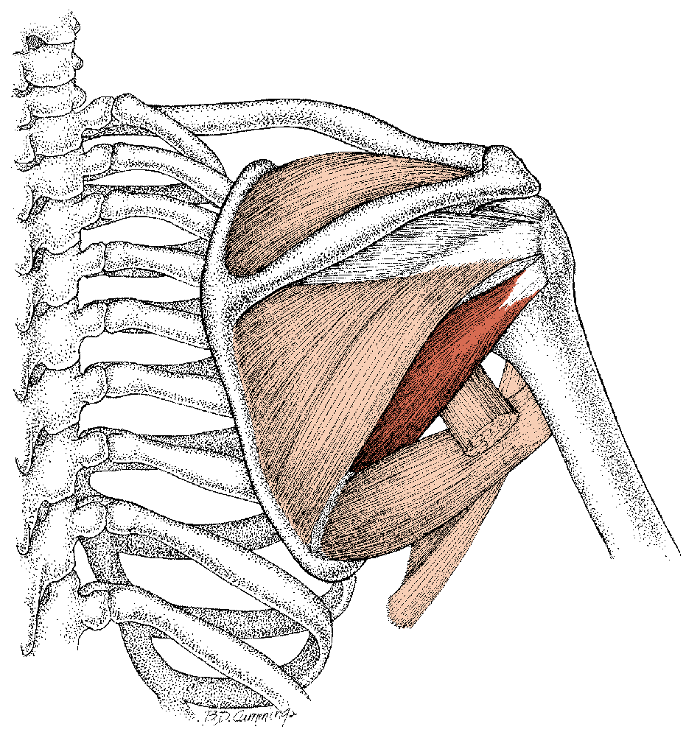
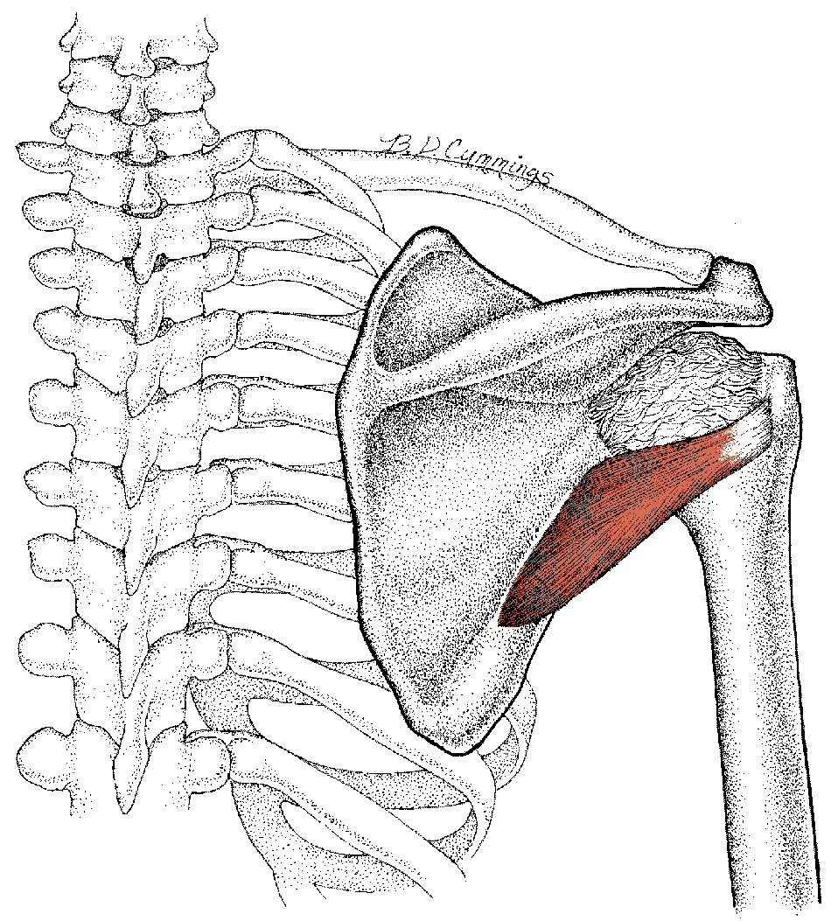
No Torque in Frontal Plane

#1
Muscle: teres minor
Plane: frontal
Linear movements: pulls humerus
inferiorly and medially
Angular movement: adduction of humerus

Muscle insertion angle: 120°
Movements in other planes: lateral rotation
of humerus; extension of humerus
#2
Muscle: infraspinatus (I changed the muscle from the one originally indicated on your lab)
Plane: frontal
Linear movements: pulls humerus
superiorly & medially (this one is difficult – it really depends on the direction of muscle pull that you draw – if your pull is more downward,then the parallel component would have an inferior pull – that would be OK on this one if you drew it that way)
Angular movement: no torque produced in frontal plane because muscle pull goes through axis – therefore, no moment arm – again, if you drew your muscle line of pull more downward, you might actually have a small moment arm for an adductor torque
Muscle insertion angle: 75°
Movements in other planes: lateral rotation
of humerus; extension of humerus
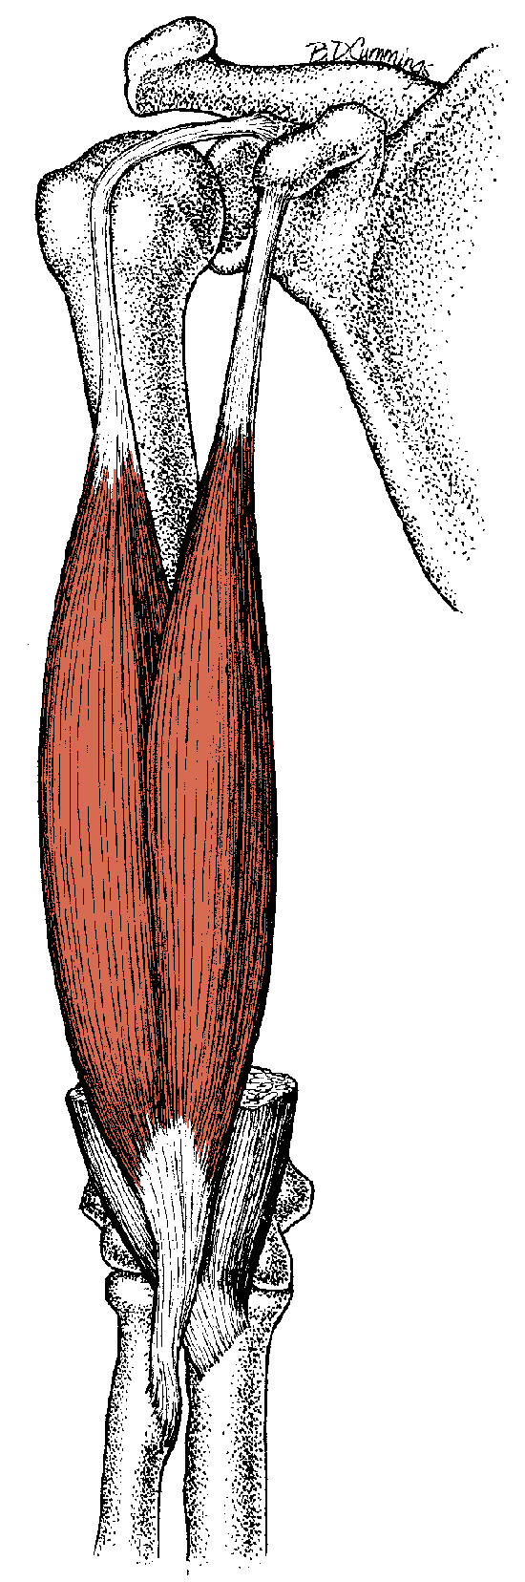
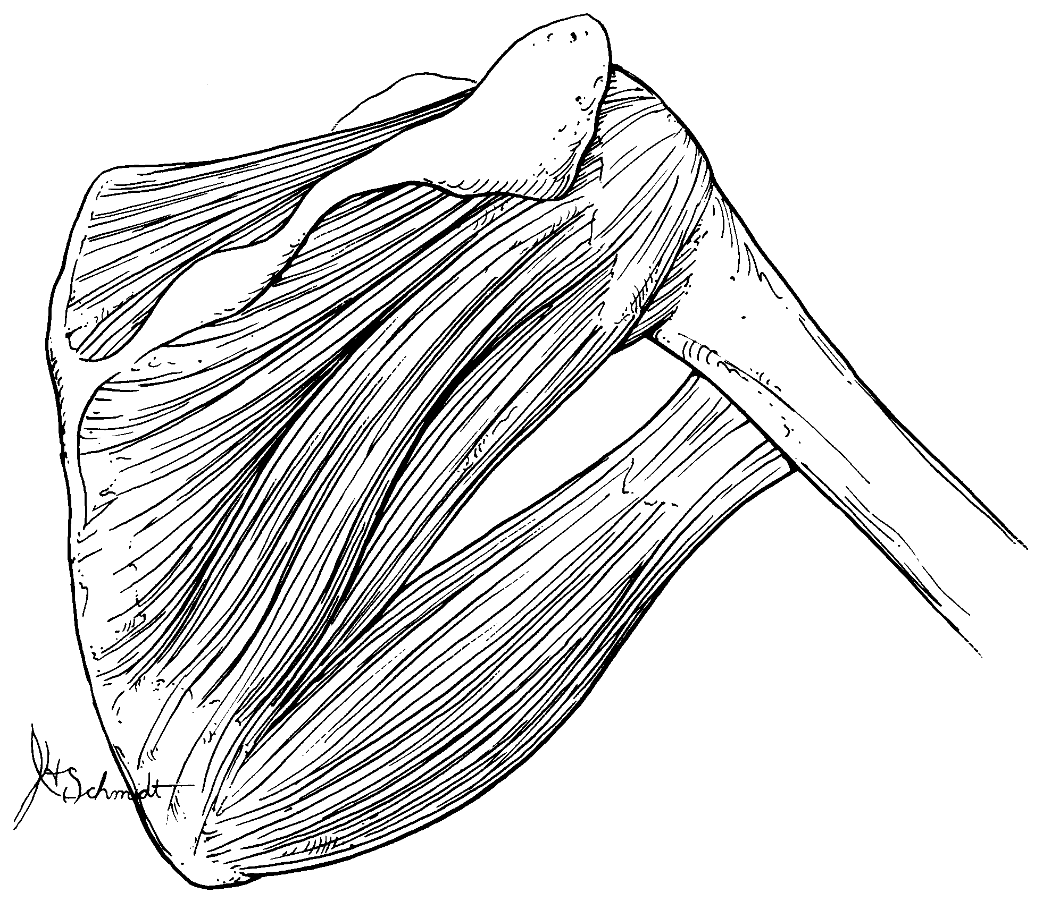
#3 – About the Elbow
Muscle: biceps brachii
Plane: frontal
Linear movements: pulls radius superiorly – again, this is a tough one – if your line of pull is slightly lateral, then there would be a slight lateral pull as well (I cannot produce subtle changes in direction with the drawing tool in MS Word)
Angular movement: abduction – this represents muscle potential, not what joint action actually occurs at the joint – bony & ligamentous structure opposes abduction
Muscle insertion angle: 20°
Movements in other planes: flexion of radius (if you put rotation in transverse plane that is fine, though understand that rotation occurs at radioulnar joint, not elbow joint )
#4
Muscle: teres major
Plane: frontal
Linear movements: pulls humers up and in

Angular movement: adduction of humerus

Muscle insertion angle: 85°
Movements in other planes: extension & medial rotation of humerus

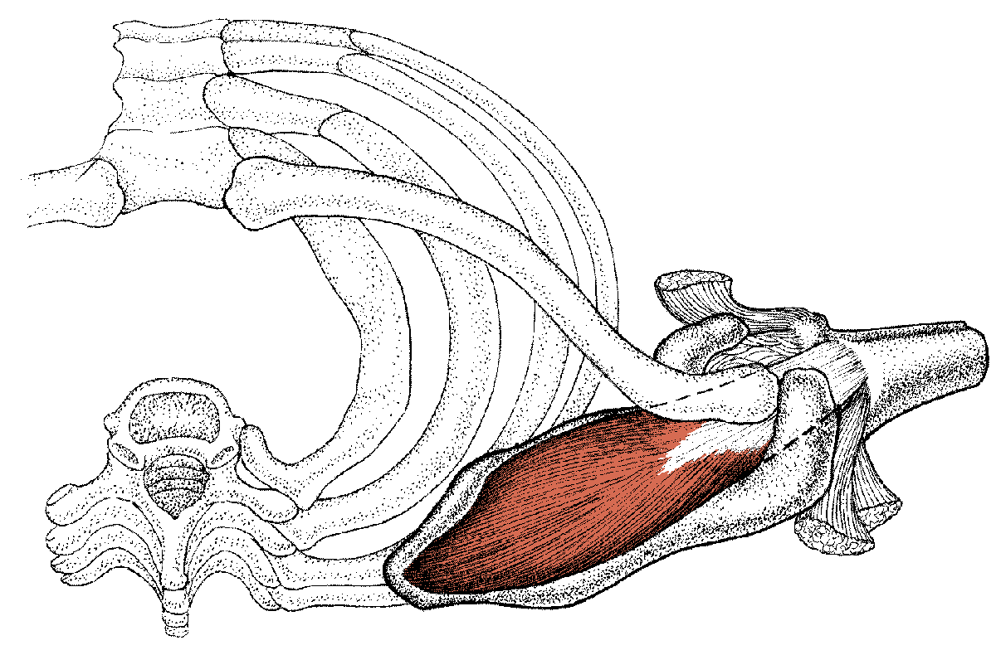
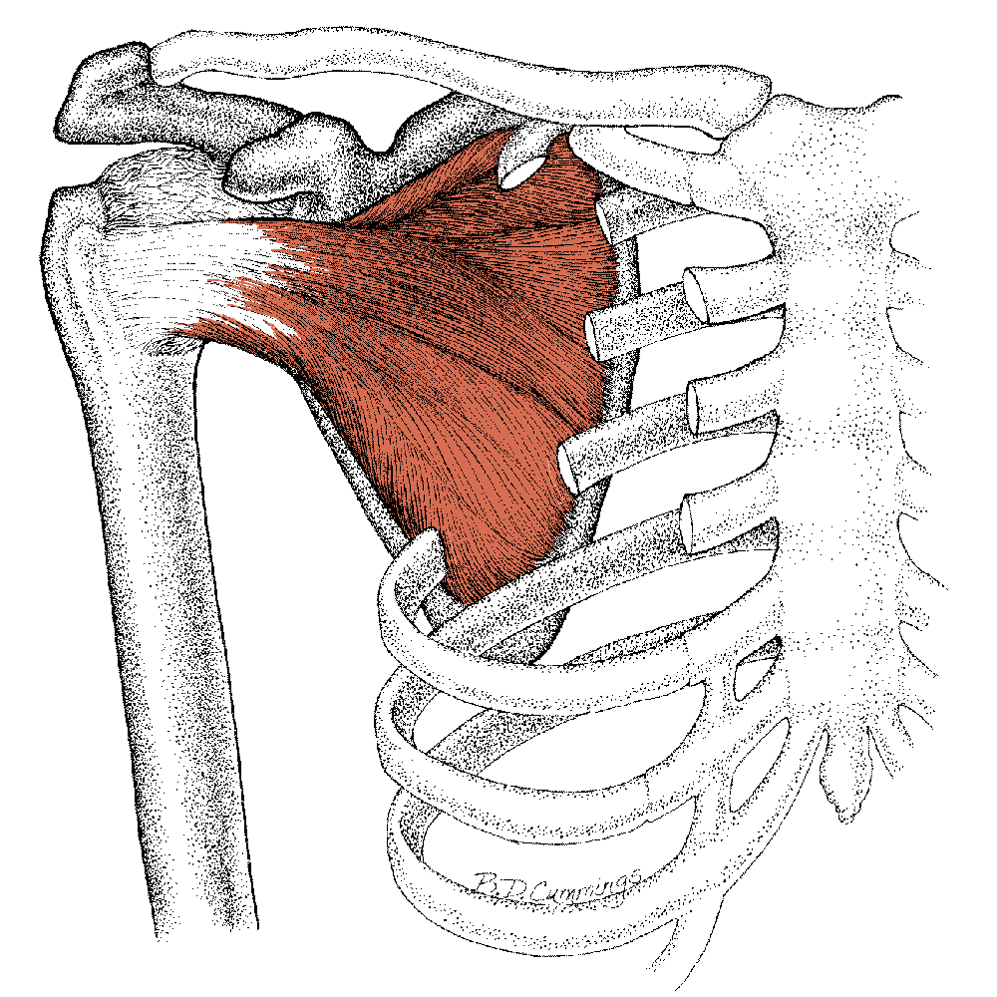

#5
Muscle: supraspinatus
Plane: transverse
Linear movements: pulls humerus
posteriorly and medially
Angular movement: None – no moment arm
Muscle instertion angle: 25°________________
Movements in other planes: abduction of humerus; none in sagittal plane, no moment arm
#6
Muscle: subscapularis
Plane: frontal
Linear movements: pulls humerus medially and slightly inferiorly
Angular movement: adduction of humerus
Muscle insertion angle: 95°
Movements in other planes: medial rotation
of humerus; no real forward or backward pull
for sagittal plane motion

No Torque in Transverse Plane

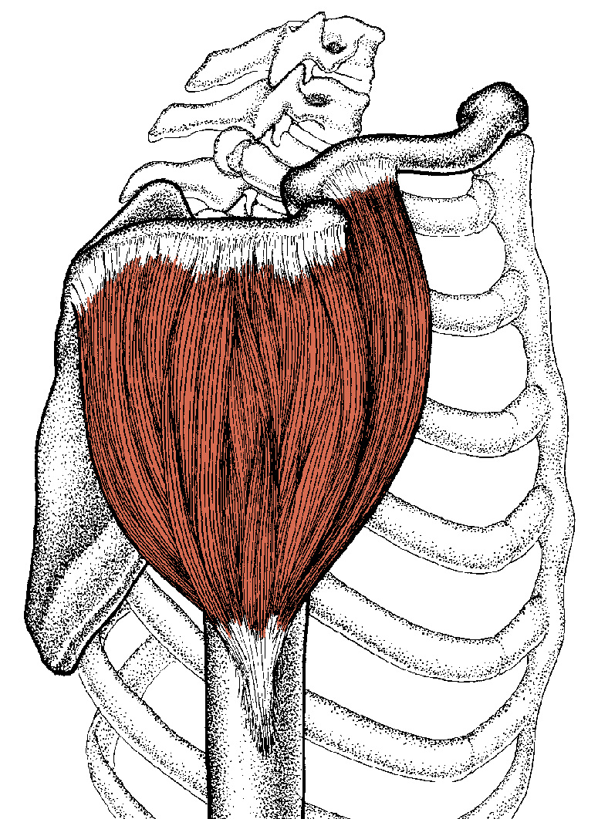
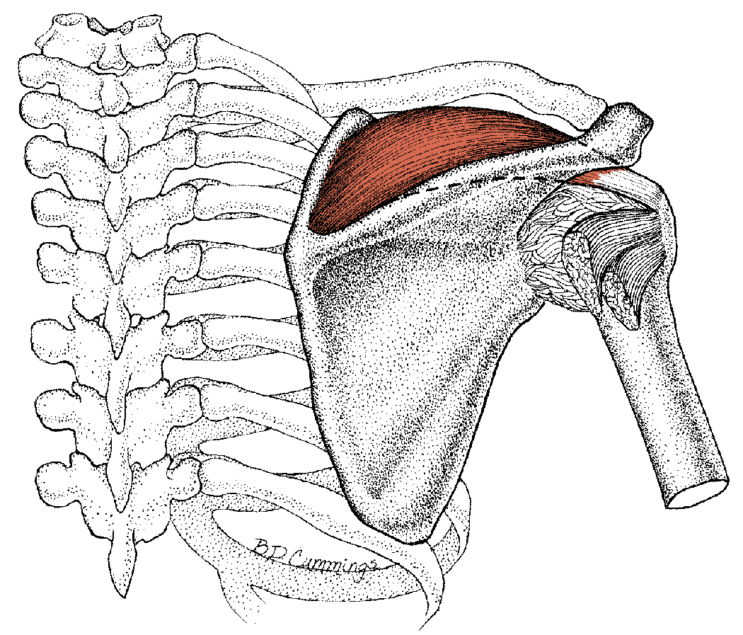

No Torque in Sagittal Plane

#7
Muscle: deltoid
Plane: sagittal
Linear movements: pulls humerus superiorly and slightly posteriorly (depends on how you drew your line of pull – the posterior pull is very small, if at all)
Muscle insertion angle: 5°__________________
Angular movement: none – no moment arm – of course, if you treat the muscle as 3 separate parts, then the anterior & posterior deltoids would have moment arms for flexion & extension, respectively
Movements in other planes: abduction of humerus – again, as a whole, the muscle would not create transverse plane rotation, but if you treat it as three separate parts, then the anterior &
posterior deltoids would have moment arms for medial & lateral rotation, respectively

#8
Muscle: supraspinatus
Plane: frontal
Linear movements: pulls humerus up and in
Muscle insertion angle: 50°________________
Angular movement: abduction of humerus
Movements in other planes: see #5

Work on only the upper portion of this muscle.
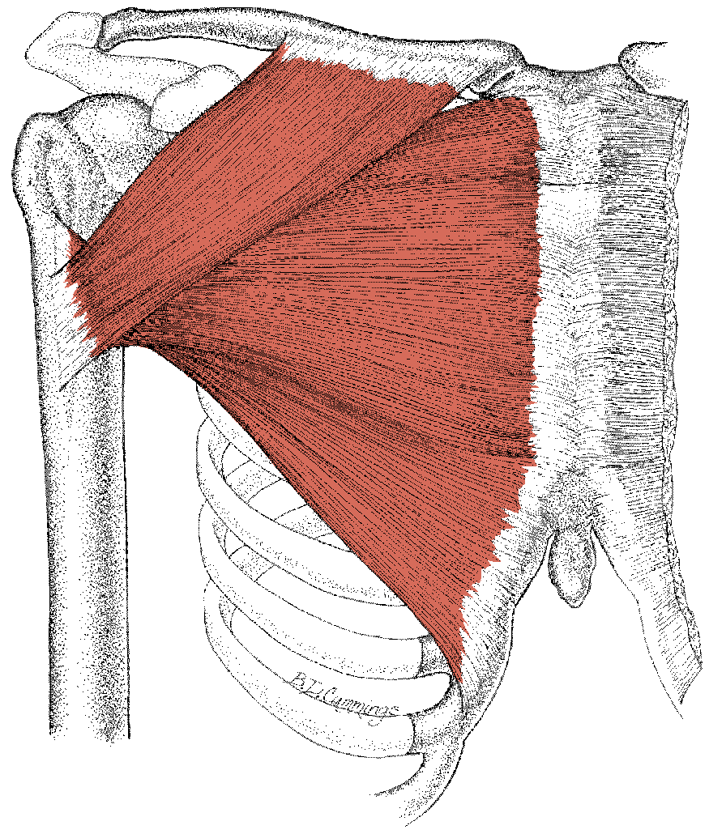
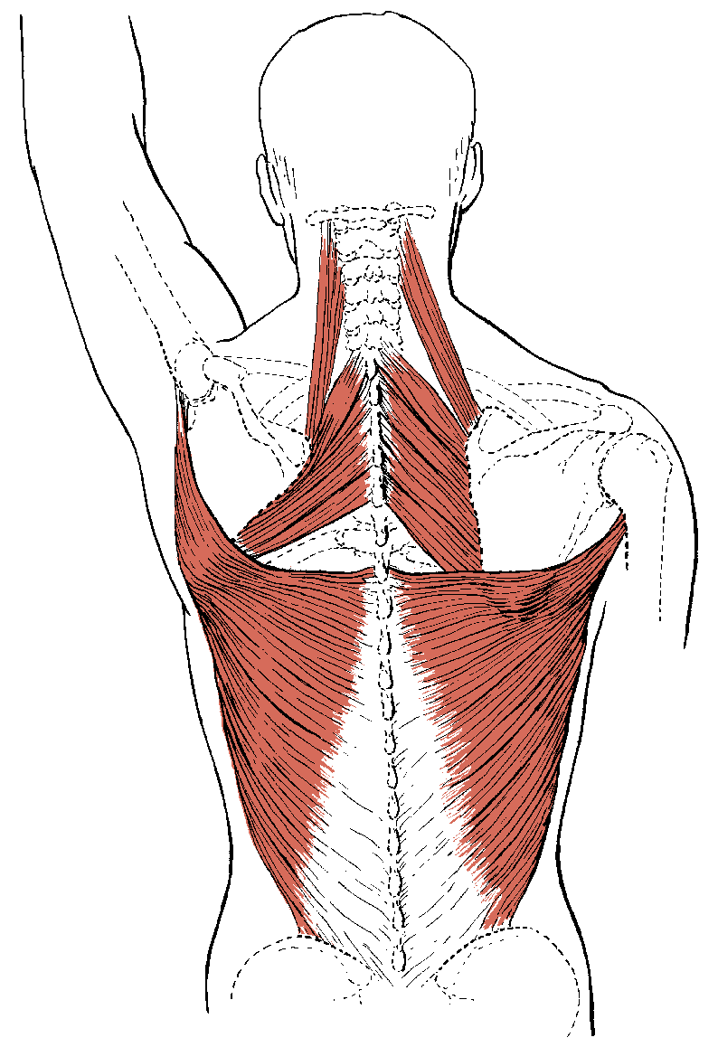

#9
Muscle: pectoralis major - clavicular
Plane: frontal
Linear movements: pulls humerus up and in
Angular movement: adduction of humerus
Muscle insertion angle: 60°
Movements in other planes: flexion, medial rotation, horizontal adduction
#10
Muscle: levator scapula
Plane: frontal
Linear movements: retraction & elevation
Angular movement: downward rotation
Movements in other planes: none

Note: the components in this example were determined using the vertical and horizontal reference system rather than normal and tangential components we have been using in class. For this reason, do not worry about MIA. The same is true for examples #12 and #13.
Work on only the middle portion of this muscle.

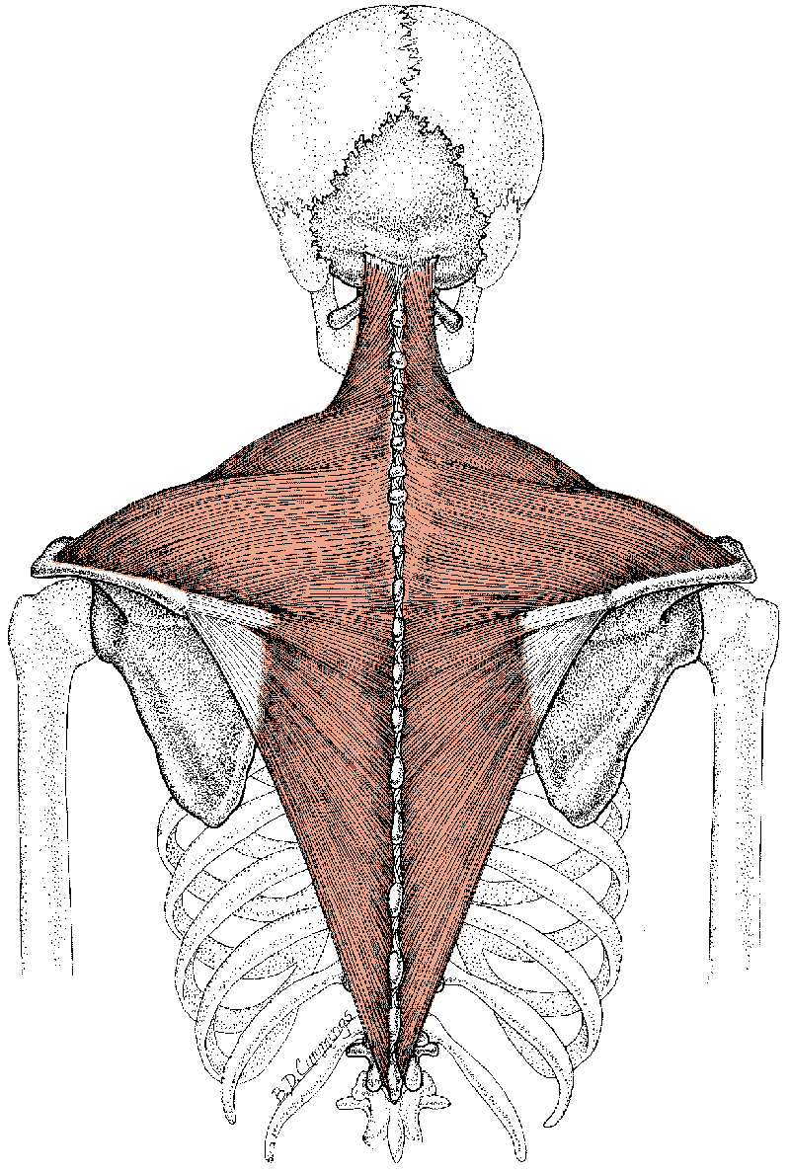

#11
Muscle: latissimus dorsi
Plane: frontal
Linear movements: mostly down – the medial and lateral pulls cancel each other out for the most part
Muscle insertion angle: 150°_______________
Angular movement: adduction
Movements in other planes: extension, medial rotation
#12
Muscle: middle trapezius
Plane: frontal
Linear movements: retraction & elevation (though elevation is not usually listed as a normal movement caused by this muscle – the upward pull is very small, and depends on what direction you draw your resultant muscle vector
Angular movement: downward rotation (as I’ve drawn it – although this movement is not listed as a normal movement for the trapezius – the moment arm is very small and very dependent on where you place the muscle force vector)
Movements in other planes: none
See example #10.
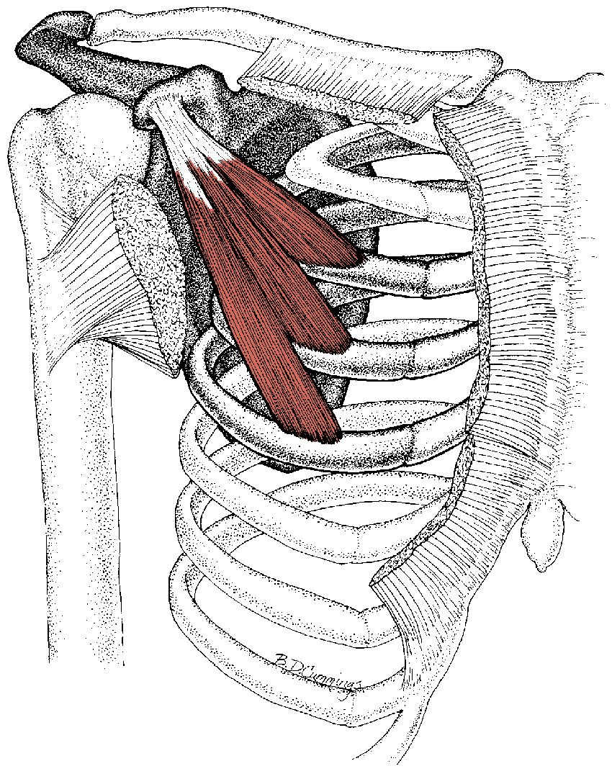
#13
Muscle: pectoralis minor
Plane: frontal
Linear movements: depression & retraction, given the rules we have been using to this point
Angular movement: upward rotation (blue circular arrow) – see comments below
Movements in other planes: This muscle is a difficult one to appreciate from a two-
dimensional drawing. Although our drawing would indicate retraction and upward rotation, in fact, this muscle causes protraction (green circular arrow) and downward rotation. This is because of the anterior pull of the muscle which forces it lateral around the rib cage, and because of the motion available at the sternoclavicular joint (see green axis and orange moment arm) as well as the acromioclavicular joint.
See example #10.
Questions:

- What was the joint action that you determined for the biceps brachii in the plane depicted in the diagram? Is it normal for the biceps brachii to cause this joint action? Why or why not?

See comments under biceps brachii drawing.

- Did any of the answers that you determined for a given muscle conflict with the actions that are stated for that muscle in your textbook? Why do you think this might have occurred?

Conflicts have been commented on for the appropriate muscles. See comments under each muscle.

