Merge, Coordinate, & Simplify: Productivity Tricks for Outlook 2010.

Contents
Setup 2
Mail merge 3
Make a meeting 10
Searching 15
Rules 20
Permissions 27

Setup
All the instructions listed in this document are based on the following assumptions:
Office Professional 2010 is installed.
Outlook 2010 is configured to connect to an Exchange server.
The instructions below are simple examples of ways to use Outlook to increase productivity. If you have any questions on these examples feel free to email me at darrenk@uidaho.edu. Thank you and I hope this information is helpful.

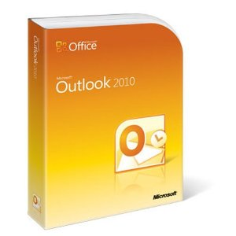

Mail merge
How to create a mail merge using Outlook 2010 in conjunction with Word 2010 and Excel 2010.
First create an Excel spreadsheet that contains the following headers on row 1; First Name, Last Name, Email Address, Street, City, State, and Zipcode. Fill in the information for your practice mail merge but use your own email address for all the rows. Save the excel sheet and name it Address. Once it is filled out and saved go ahead and close it.
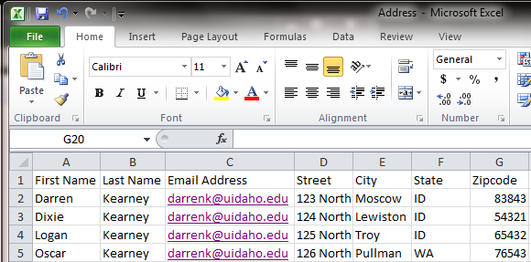

Next create a simple letter in Word and save it as Simple Letter (or any other name).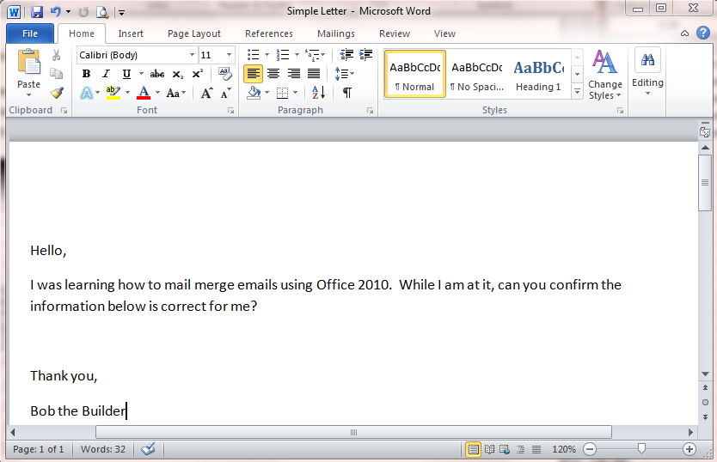

Select the ‘Mailings’ tab in Word then click on the ‘Start Mail Merge’ button. A drop down menu will appear, select ‘E-mail Messages’.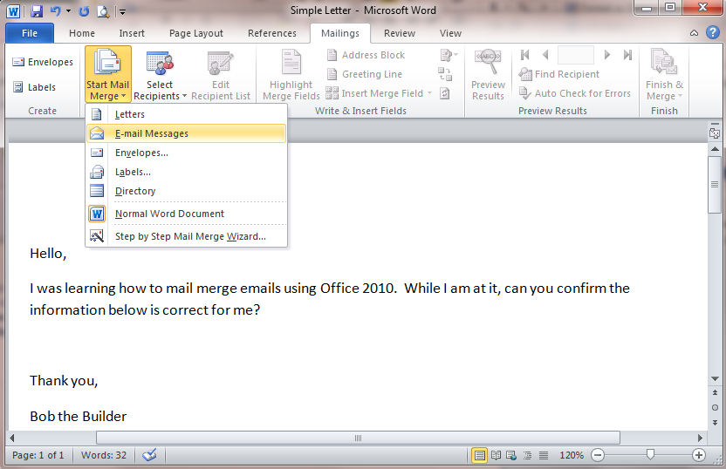

Under ‘Select Recipients’ click on the ‘Use Existing List’ menu item. This is the first step to join the Excel document to the mail merge.
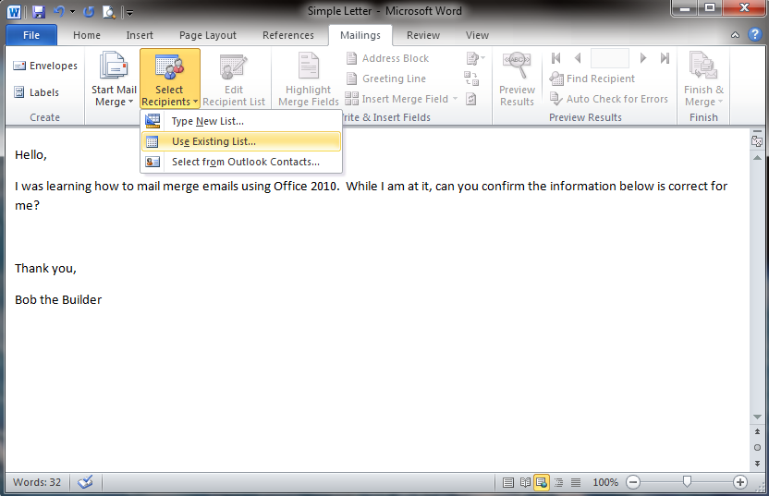

In the ‘Select Data Source’ window, browse to where you saved the ‘Address’ Excel file, select it then click on the ‘Open’ button.
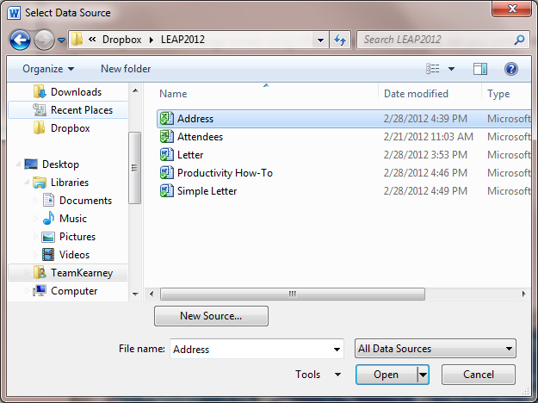

All the available sheets in the Excel file are listed with their default names. Notice that the ‘First row of data contains column headers’ is checked by default. Make sure ‘Sheet1$’ is selected then click on ‘OK’.
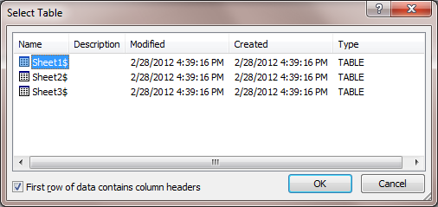

You have the option of just selecting a few records from you list by click on the ‘Edit Recipient List’ button.
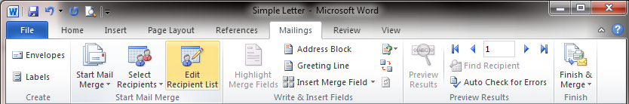
Here you can see how the data is laid out in the Excel file and uncheck records you do not want sent. Click on ‘OK’ when you are ready to return to your document.
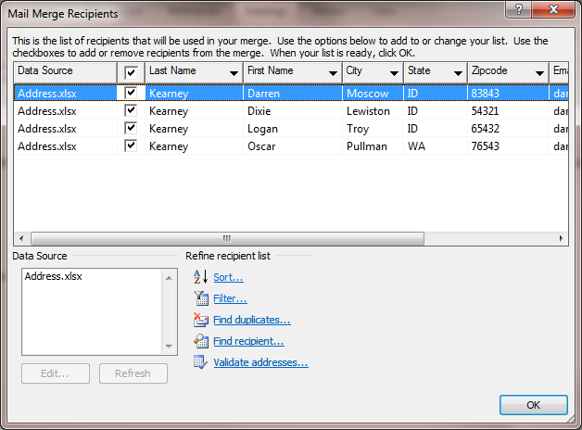

Now we will start adding content from the excel file by using the ‘Insert Merge Field’ menu item. You can use the drop down or open the window. Here we are using the drop down.
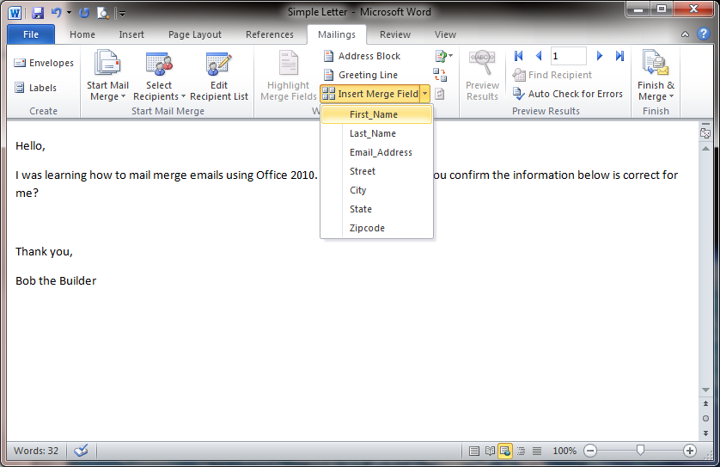
All fields are added by moving the curser to the location you want fields to be placed and then adding them. Go ahead and add all the fields where you feel they should go.
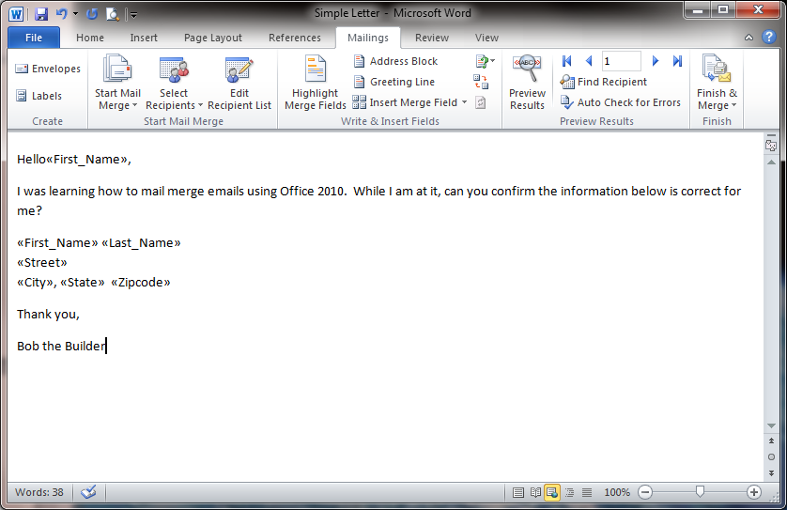

After you have added all the fields it is a good idea to review the mail merge by clicking on the ‘Preview Results’ button. This will display the first row of data from the Excel data and allow you to go through all the rows if you like. Once your done previewing the merge unclick the ‘Preview Results’ button.
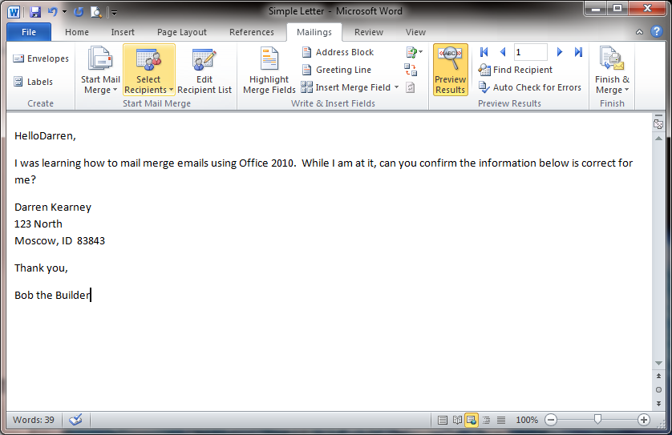

The final step in the merge is to select ‘Send E-mail Messages’ under the ‘Finish & Merge’ button to bring up the ‘Merge to E-mail’ window.
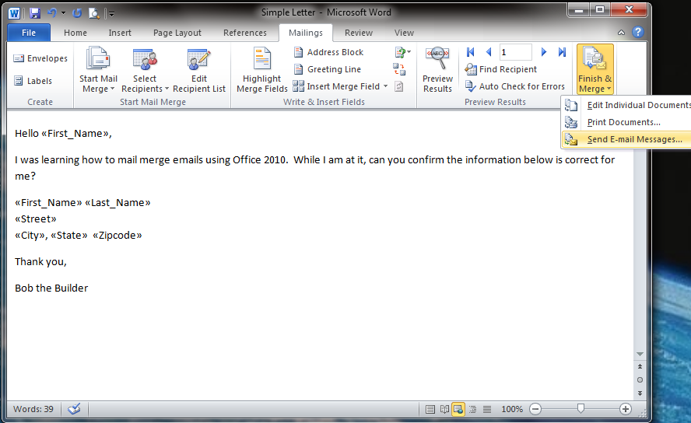
Make sure that the ‘Email_Address’ field is selected for the ‘To’ option and fill in the subject line of your emails (I added ‘Please review your address’). Finally you can complete the merge by clicking on the ‘OK’ button. This will send all the emails using Outlook.
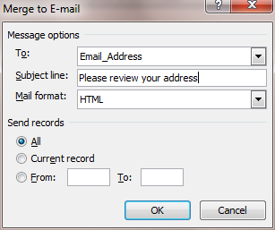

In our example you should have added your own email address to the email fields so all of the emails will show up in your inbox as well as your sent mail.
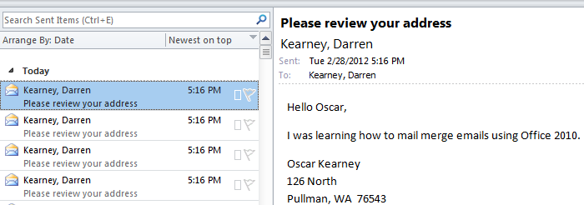

Make a meeting
Having to setup a meeting in Outlook is a snap (especially if everyone’s calendar is up to date). Even if only a few members of the meeting use calendaring it is a great way to make it easy for them to add it to their calendar.
Start by opening your calendar and finding the date you want to create the meeting on.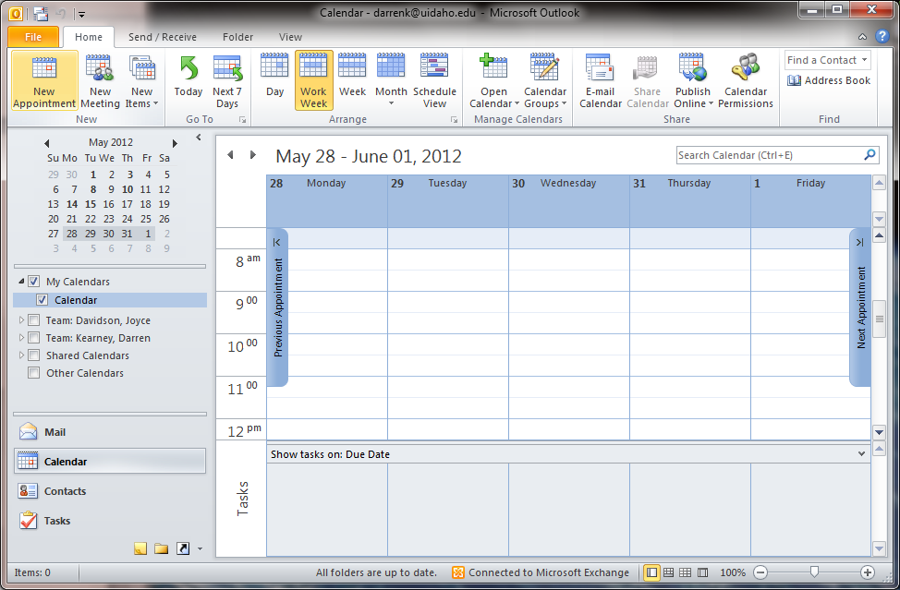

Click on the open date and an ‘Appointment’ window will open.
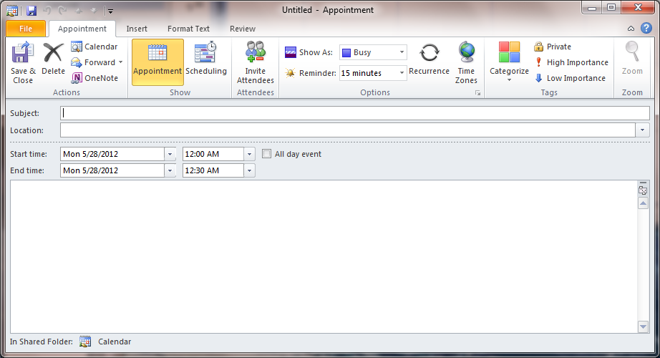

Fill out the ‘Subject’ line and set the correct time and date if they are not correct.
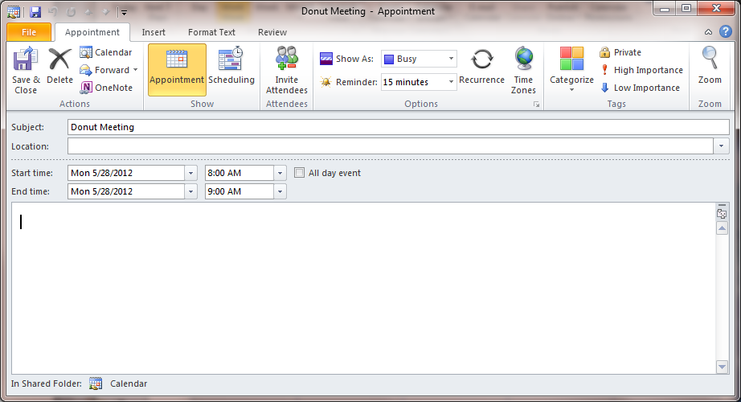

Click on the ‘Scheduling’ button on the Ribbon bar then click on the ‘Add Others’ drop down menu and select ‘Add from Address Book’.
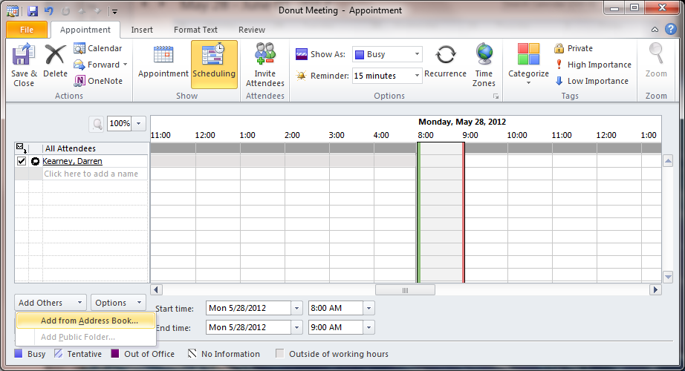

Make sure the ‘Global Address List’ is selected under ‘Address Book’, then start searching for all the meeting attendees. Make sure to add them to the ‘Required’ text block.
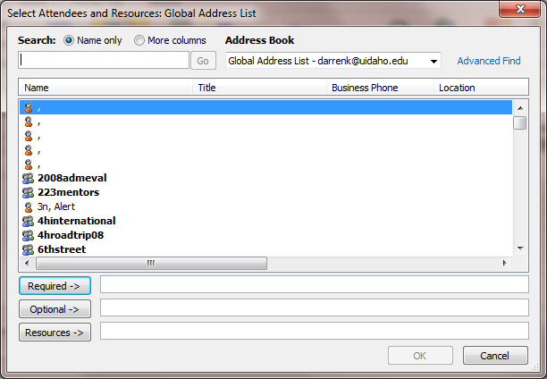

Resource calendars for particular rooms can also be added by finding them and clicking on the ‘Resources’ button. Once you have all the attendees and resources click on ‘OK’.
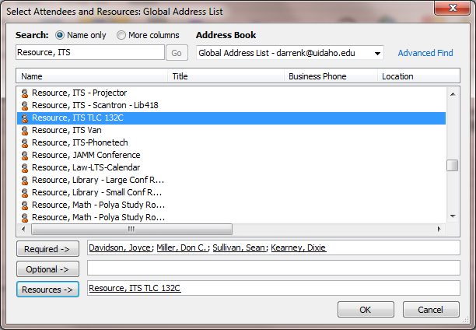
Now you will see the status of each person’s calendars and if they have events listed. Calendars that have hash marks through them are not sharing their free/busy information. Since by default free/busy information only goes out 2 months we will change the date of the meeting in our example.
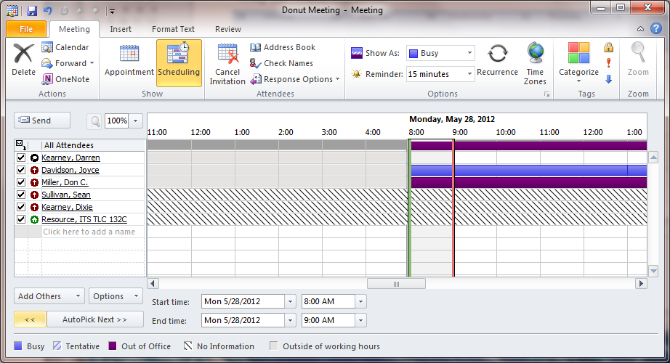
Here you see all the free/busy information even if you don’t have any other rights on the calendars. In this case multiple people are busy during the selected time.
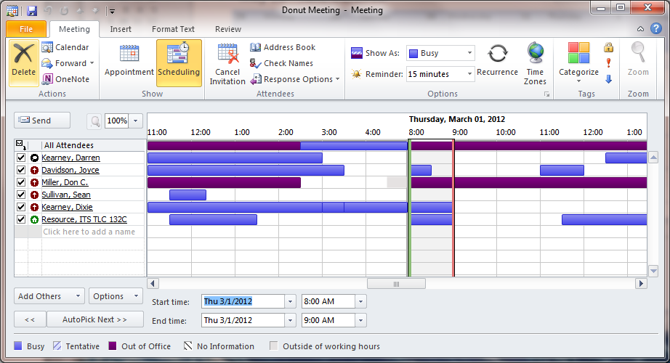

To find a time when everyone is free and that meets the meeting length, click on ‘AutoPick Next>>’ and the calendar will move the date and time automatically.
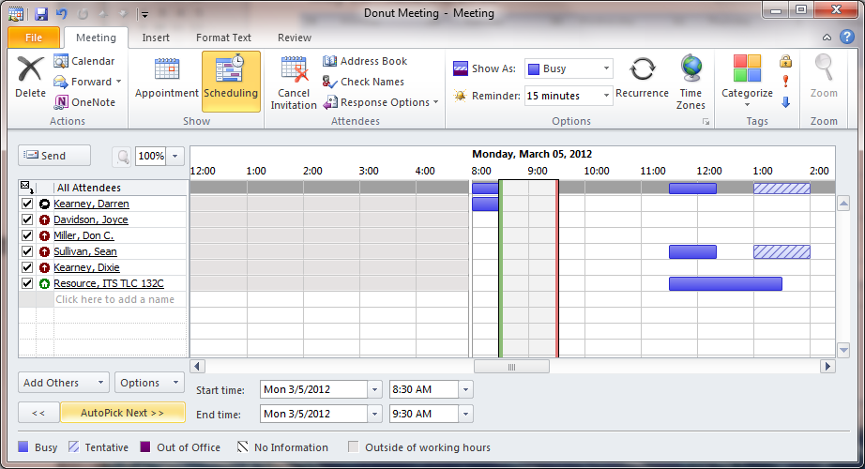
From here you can select ‘Appointment’ and can fill in the message before sending the request.
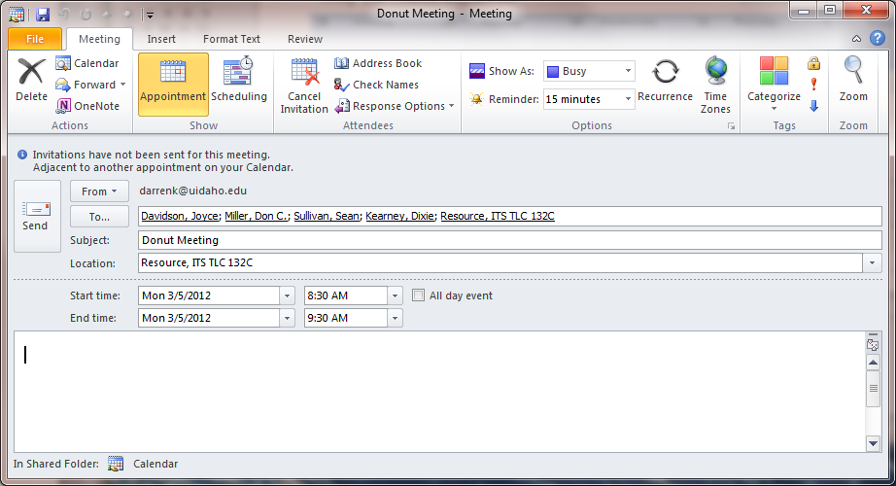

Searching
One of the best kept secrets in Outlook is the ability to setup Search Folders. These saved searches are available on every machine you setup Outlook on and make it quick and painless to find emails regardless of the folders they are stored in. They also make it easy to remove large emails from your account freeing up your quota.

The default search folders are found within the Mail view by scrolling down.
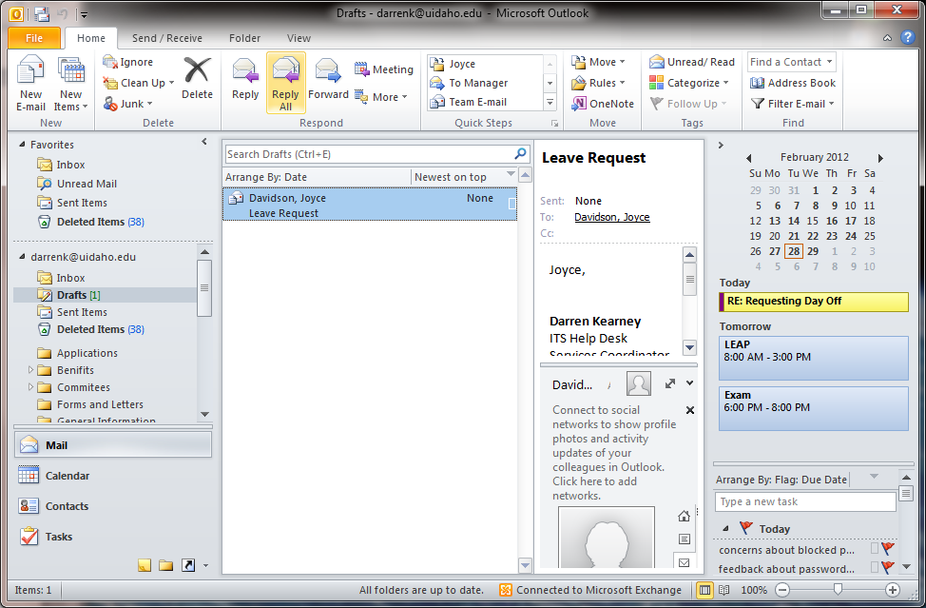

To create a new Search Folder click on the folder tab then select ‘New Search Folder’.
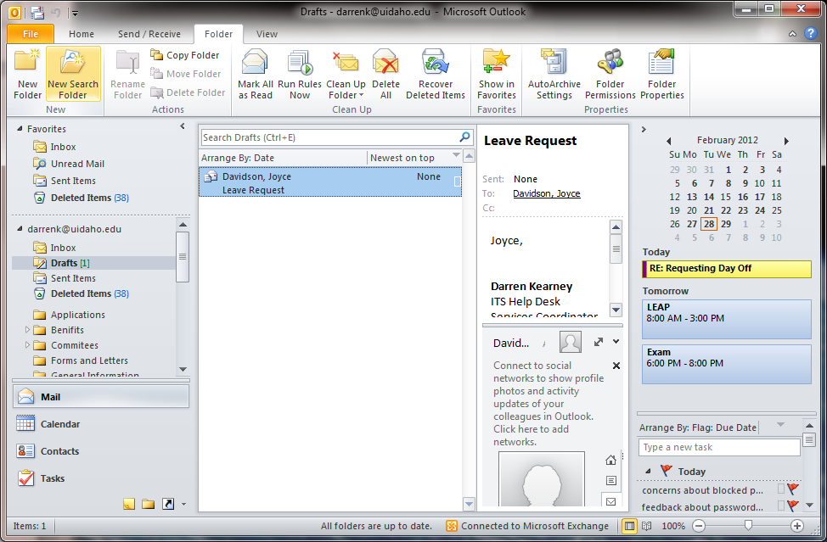

The ‘New Search Folder’ window provides a list of common search types to select from and allows you to select the account it will run the search on if you have more than one account listed.
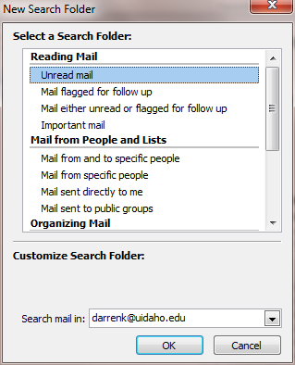
In our example we are selecting ‘Mail with specific words’ then clicking on ‘Choose’.
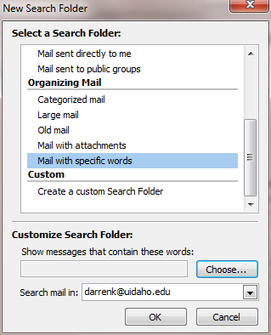

In the ‘Specify words or phrases to search for in the subject or body:’ text field add the word or phrase you want to search for then click on ‘Add’.
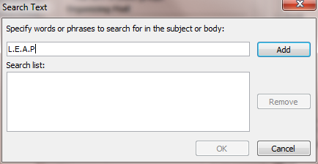

You can add multiple search words to narrow your search. Once you are done click on ‘OK’.
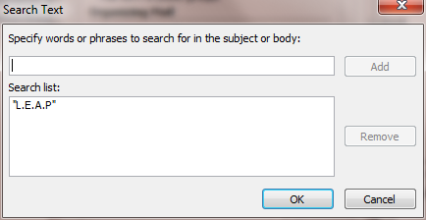

Once you’re back to the ‘New Search Folder’ window, just click on ‘OK’.
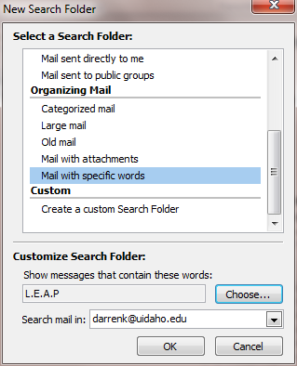

Depending on how many emails you have it can take a bit of time to finish the search so be patient.
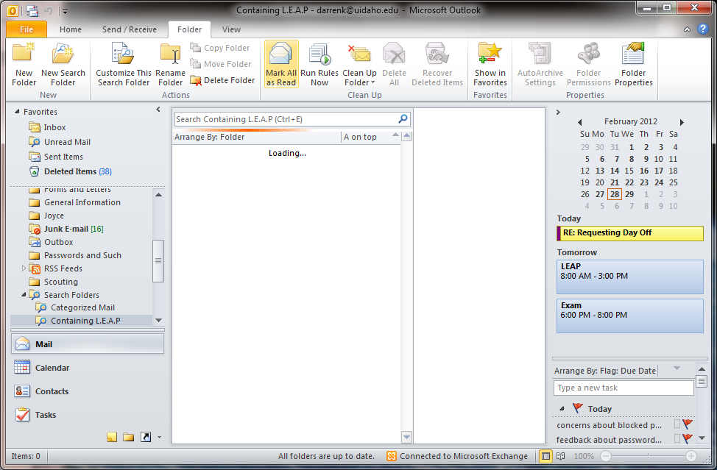

Here you see the folder has been added under ‘Search Folders’ and it is listing all emails that meet the criteria regardless of what folder they are stored in.
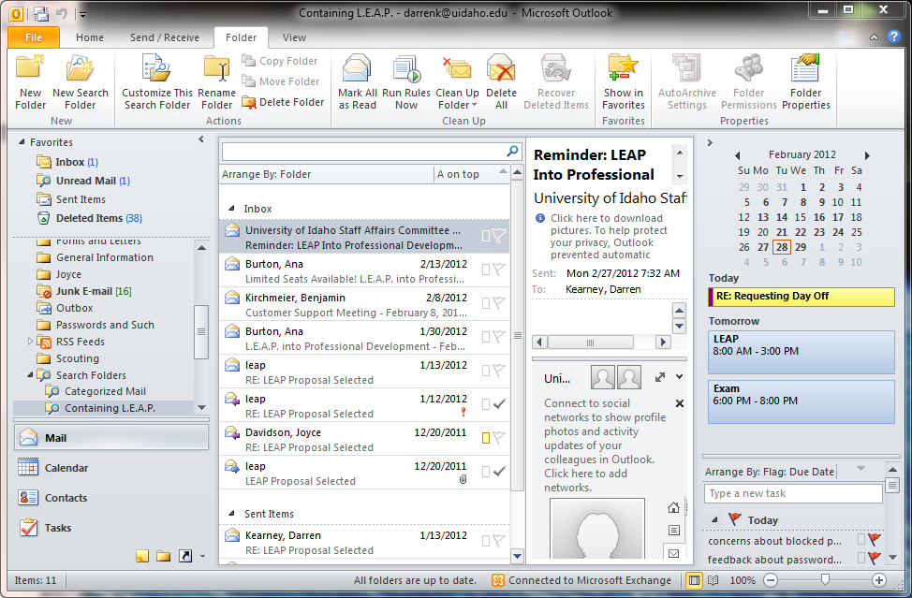

Rules
Rules are actions taken based on the criteria you have set.
Start by selecting the ‘Rules’ drop down then clicking on ‘Manage Rules & Alerts’.
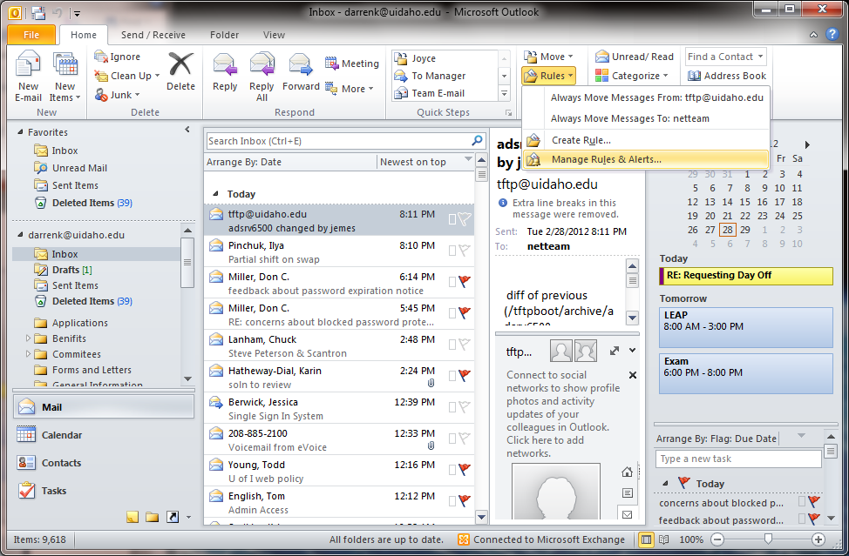
The ‘Rules and Alerts’ window allows you to see all the rules and alerts set on your account. Other information provided is which ones are ‘client-only’ versus the ones that are account.
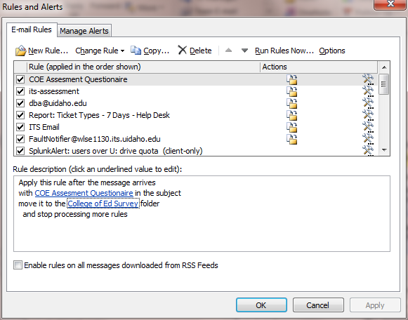

Review any rules you have and remove any marked ‘Error’. Once you’re ready click on ‘New Rule’.
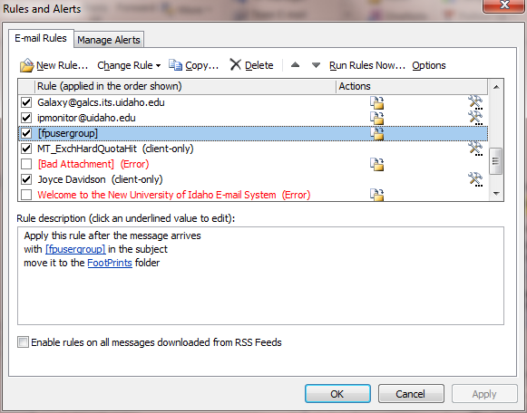

In the ‘Rules Wizard’ window you will see the standard rules templates.
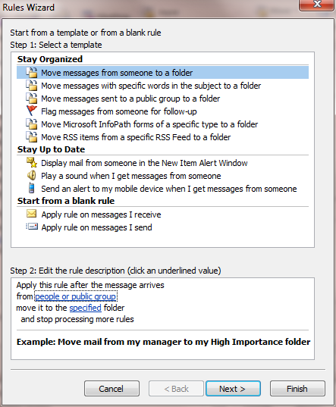

For this example we will select ‘Apply rule on messages I receive’ then click next.
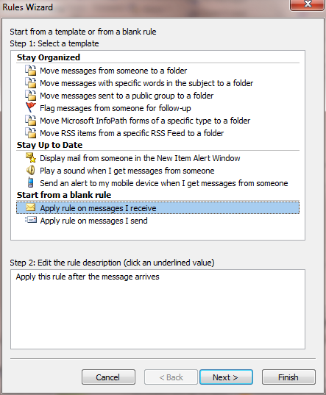
Select the ‘from people or public group’ option. You will see that the ‘Step 2:’ box starts to populate with the required information based on your selections. Click on the ‘people or public group’ link.
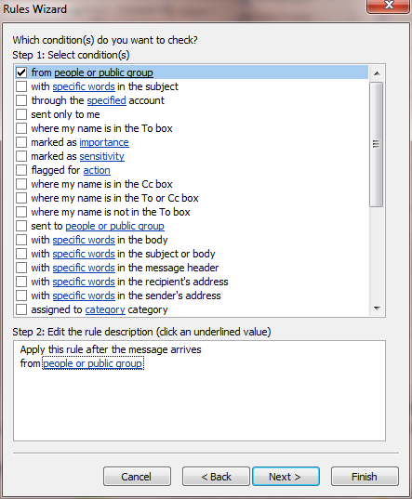
A ‘Rule Address’ window will open up and allow you to select one or more objects from the list. Make sure they are added to the ‘From’ field then click on ‘OK’.
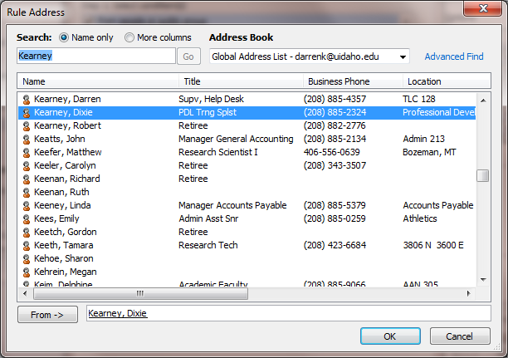

Notice the name of your selection has been added. Click on ‘Next’.
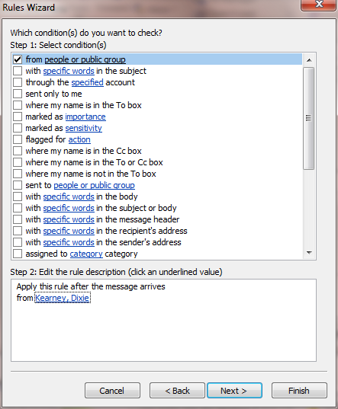

Now we select an action from the list. Here we will assign to a category. Once you have selected the action click on the link at the bottom.
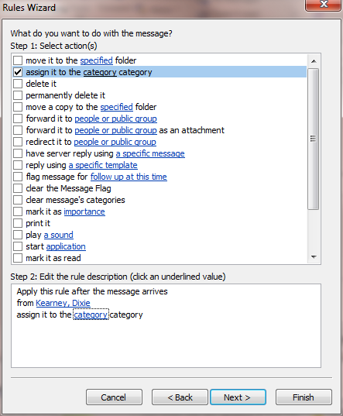

Select the category you wish to use then click on ‘OK’.
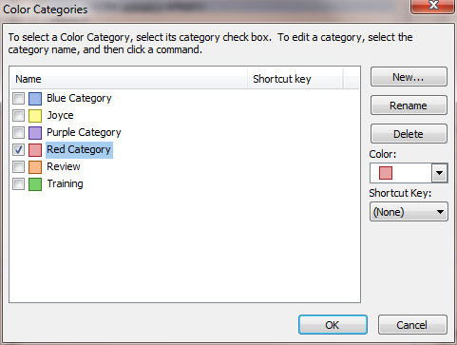

Once the category is updated click on ‘Next’.
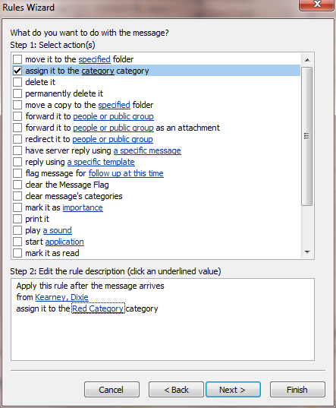

You can add expectations to your new rule here but for this example just click on ‘Next’.
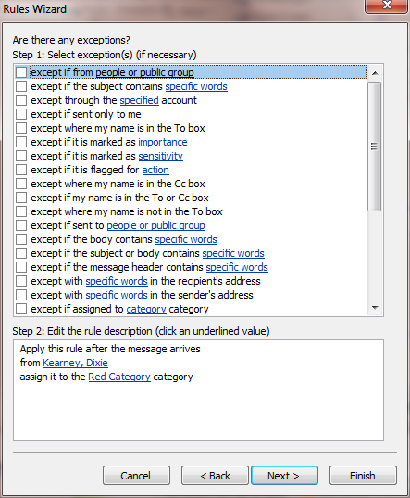

Finally name the rule and decide if you want it to run on emails already in your inbox. Click on ‘Finish’ to end.
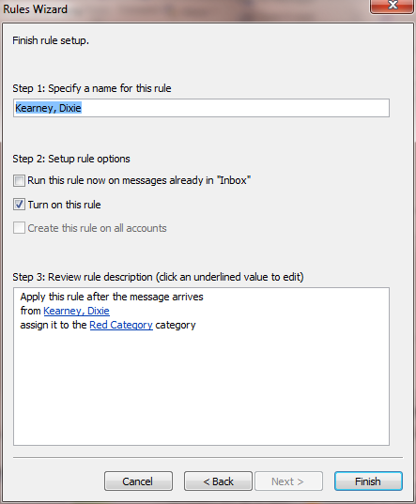

Permissions
Many people share their calendar but did you know you can share almost every item in your Exchange account? One of the other common things to share is your inbox. If you need someone to look after your inbox when you’re out of the office, setting permissions allows you to control access and functionality.

In our example we will be giving permissions to our Inbox. You can quickly access the permissions settings by right clicking on the folder. Remember you can always remove the permissions the same way.
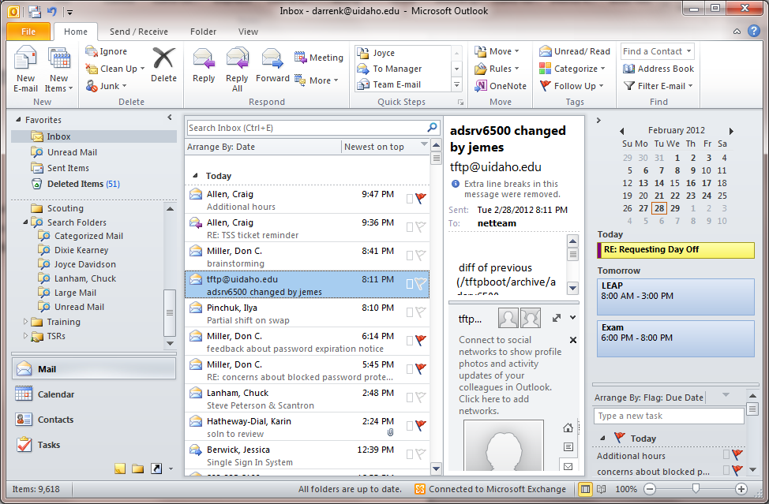

Another way of accessing permissions is to click on the ‘Folder’ tab then click on ‘Folder Permissions’.
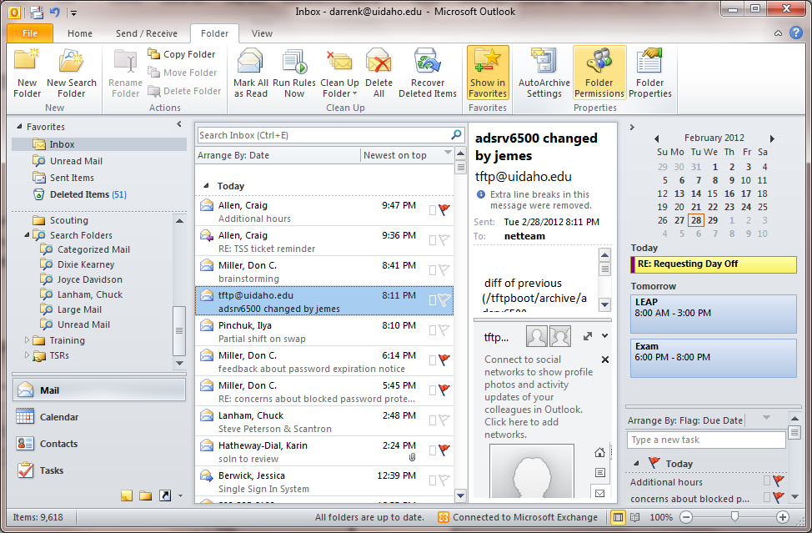
Here is the ‘Inbox Properties’ window showing the ‘Permissions’ tab. To give permissions start by clicking on the ‘Add’ button.
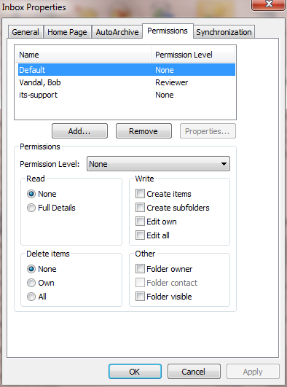

Search for the person or group you want to grant permissions to then add them to the ‘Add’ text field. Click on ‘OK’ when your done.
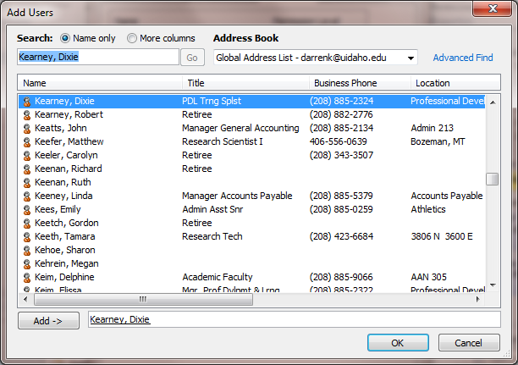

Once someone is added they are granted no permissions by default. You can set the permissions manually or use the drop down to select one of the permission templetes.
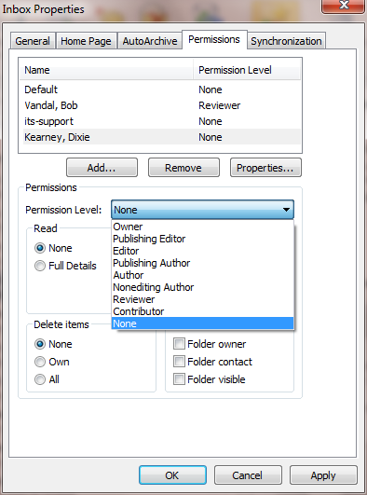

Here I have set ‘Reviewer’ permissions. This is commonly referred to as read-only. The person added will only be able to see the contents of the folder and read them but cannot delete or edit anything.
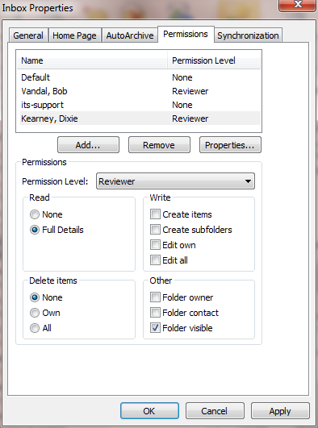

Editor rights are commonly referred to as full-access rights. Users with Editor rights can delete, add, and read everything in the folder. Finally click ‘Apply’ to set the rights you have chosen.
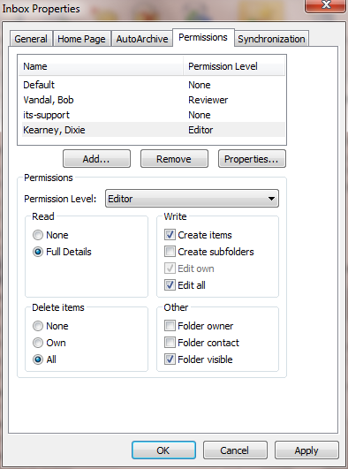

Once the rights are set it is easy for the person to open your inbox. Start by clicking on the ‘File’ tab.
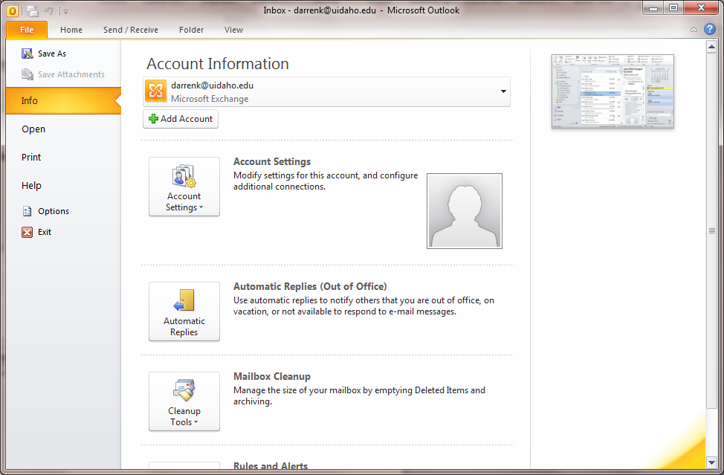

Select the ‘Open’ menu item and click on ‘Other User’s Folder’.
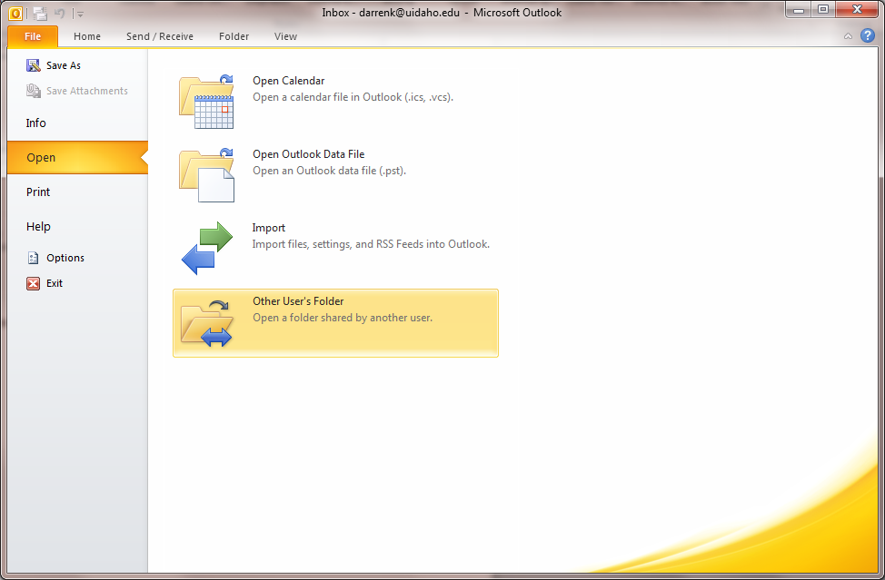

In the ‘Open Other User’s Folder’ window, make sure the ‘Inbox’ is selected then click on the ‘Name’ button.

Select the account you have been granted rights for then click on ‘OK’.
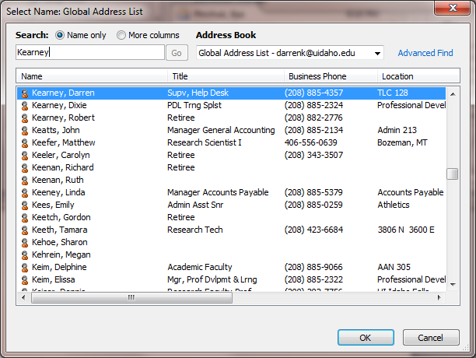

Finally, click on the ‘OK’ button to open the folder.
