Vegetation Measurement & Assessment (REM 357 & REM 410)
~~Measuring Biomass ~~

•• Read the on-line material and the required readings for this module. Conduct the requested analysis listed on the next page.

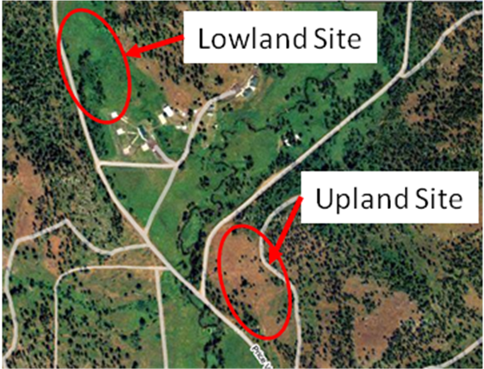
In the fall of 2008, I conducted a biomass comparison of two mountain meadow sites near McCall, Idaho near the Price Valley US Forest Service Guard Station (N 45°01’05.8” W 116°26’02.7”). One site was an “Upland Site” on a west-facing hillside the other site was a “Lowland Site” in the floodplain. Check out these sites in Google Maps. (Click on Satellite or Terrain in Google Maps to explore the site further).

Price Valley Uplands Site is a native prairie dominated by Idaho Fescue, Bluebunch Wheatgrass and native forbs.
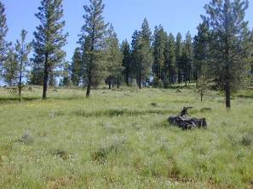 | 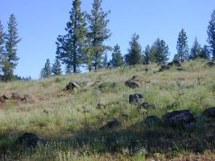

Price Valley Lowland Site is a riparian meadow dominated by native plants including sedges, perennial grasses, and forbs.
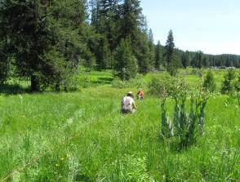 | 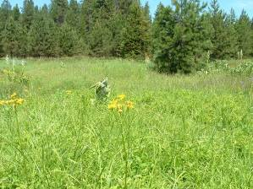
Vegetation Measurement & Assessment (REM 357 & REM 410)
~~Measuring Biomass ~~

Data Summary Assignment #7 (60 points total): Name:________________
Due by Midnight on Tuesday, October 30th through Blackboard (https://bblearn.uidaho.edu/)

- Examine the excel spreadsheet that includes 68 circular plots that were clipped on each site (upland and lowland). Information about plot frame size, conversions, and dry matter are included in this data file: Assign_7_Biomass_Data.xls.

- Calculate the average pounds per acre of dry matter of herbaceous biomass on these two sites based on the data in the spreadsheet (Note: calculate biomass for each site separately). Include in your answer some measure of variance (such as standard deviation or standard error).

- Calculate how many acres on each site would be needed to provide forage for an herbivore of your choice for a month (Note: again complete two separate calculations – one for the uplands and one for the lowlands). To accomplish this you will need to:
  - Select an herbivore that might use the grasses and forbs on the study sites. Select a deer, big-horn sheep, moose, elk, rabbit, domestic sheep, domestic cow, horse or mule.
  - Search books or the internet to determine the average weight of an individual animal.
  - Determine if the animal is a ruminant (e.g., cow, sheep, moose, or deer), hind-gut digestor (e.g., horse, mule, or rabbit).
  - How much animals eat depends on their digestive system:
- Ruminants will eat about 2.5% of their body weight in dry matter of forage each day.
- Hind-gut fermentors will eat about 3.0% of their body weight in dry matter of forage each day.
  - Determine how much forage the animal will eat in a month.
  - Then, calculate how many acres would be needed to provide this amount of forage on the lowland site and how much would be required on the upland site.

IMPORTANT NOTE: Keep in mind that the total amount of herbaceous biomass cannot be removed from the site because it would leave the site susceptible to erosion and could lead to land degradation. In this case, assume that you could only use 45% of the total herbaceous dry matter available.

ANOTHER NOTE: You can assume that everything that was clipped is potential forage for animals. In other word, we did not include wood or inedible plants in clipping of biomass.

- Write a 1 to 2-page report that describes and compares the mean forage production on the two sites. Which site is most productive? How much difference is there between the sites?
Also, describe the forage supply created for the animal you chose above. Include your calculations at the end of your report or in an attached spreadsheet.

