Homework 3
Climate Change Ecology, Spring 2015
Due Friday, March 13, 2015

Your name: ___________________________________________________

Please answer the following questions in a different font (like this) to help me find your answers. Turn in a print out of your homework before class. You may work in a group, but your answers and your words must be your own.

I. Phenology

1. Why are phenological studies some of the best for establishing the impacts of climate change on biology? (3 points)

2. What are the most important messages of Table 4.1? (3 points)

3. Growing degree days.

A. Use the “moscow_tmin_tmax_2012.csv” file emailed to you. This CSV file gives the date, maximum temperature, and minimum temperature for the Moscow weather station in 2012.

a. Write the equation for growing degree days using a formula with variables; define each variable and note its units. (3 points)

b. Calculate the growing degree day (GDD) amount above a baseline of 10ºC for each day. First compute the average daily temperature, and use this in your GDD calculation. Then use the IF formula that looks something like this (read syntax/help on IF): “=IF(D2 > 10,D2-10,0)”. What is the minimum of the daily GDD? Maximum? (3 points)

c. Calculate the cumulative growing degree days (since January 1) for each day in the entire time series. Use a formula that sums the current daily GDD and previous day’s accumulated GDD (except for the first cell). When should you expect lilacs to bloom (which bloom after 100 GDD)? (3 points)

d. Assume a climate change scenario of 2ºC in 2100 (applied evenly throughout the year) and redo your calculations. When will lilacs bloom then? What is the time difference? (3 points)

e. Include a screenshot of the first few lines of your Excel file that illustrate all the calculations above. (3 points)

B. How is this year’s phenology different than average? Using “moscow_daily_climate_data_2015.csv” and “moscow_daily_mean_tmax_tmin_1971_2000.csv” emailed to you, compute the GDD for a baseline of 40 deg F (note units change).

f. What are the GDD values for February 19 in 2015 and for the 1971-2000 average? (3 points)

g. For the 1971-2000 average year, when does GDD equal or exceed the value for February 19, 2015? (3 points)

h. Include a screenshot of the first few lines of your Excel file that illustrate all the calculations above. (3 points)

4. There are three reasons why climate change may lead to phenological timing mismatches of species and resources and/or between species. For each (below), describe a documented case. (9 points)

a. different T sensitivity among species

b. different cues for phenology at one location

c. cues from other regions

II. Ecosystems and habitats

5. What is the difference between “ecosystem structure” and “ecosystem function” (define each)? Describe one published example of how climate change is affecting each. (6 points)

6. Explain what the below figure says about climate change and treeline shifts. (5 points)

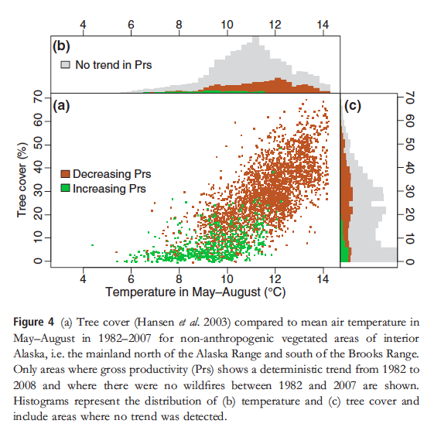

III. Public acceptance of climate change

7. The impacts of climate change on plants, animals, and ecosystems is an excellent means for getting people connected to this issue. What is an example of a local impact that may resonate with people in the following locations? Describe the situation and how it is affected by climate. (10 points)

a. Northern Idaho

b. Southern California

c. Florida

d. Alaska

e. New York City

