Six-bar Tensegrity Kinematic Model

CATIA Final Project Fall 2010

George Korbel

Overview of a six bar tensegrity structure
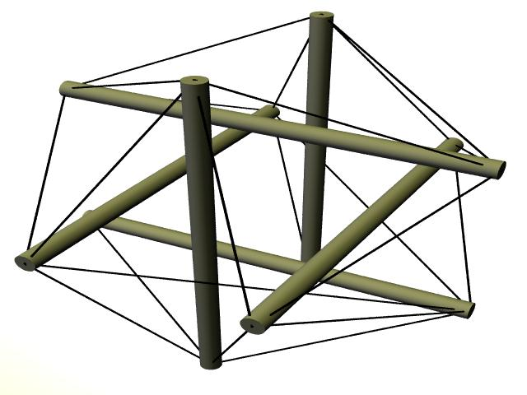
Tensegrity defines a class of structures where all members are strictly in either tension or compression. A six bar tensegrity has six compression members with tension members connecting them. The word tensegrity is the combination of the words tension and integrity and these are the main principles in this type of structure. Pictured below is an example of a six-bar tensegrity structure.

Notice that the image above has tendons (tension members) connecting the bars (compression members). If we compare this image to the one on the cover page of this report we see that the tendons are missing and instead there are two transparant triangular plates connecting the bars together. CATIA does not have the ability to kinematically model flexible members. Because of this the tendons had to be replaced with other constraints in order for the model to be solvable. This will be discussed in more detail in the DMU Assembly section later in this report.
Project Description
The main objective of this project was to construct a kinematic model of a six-bar tensegrity structure in CATIA. The idea came from a 2010-2011 senior design project doing a feasability study on a modular six-bar tensegrity robotic arm. The senior design team has been tasked with designing and building this six-bar tensegrity by NASA. The advantage of tensegrity structures over traditional robotic arms is that tensegrity structures take much less material to build but can still accomplish the same strength. The purpose of this kinematic model is to provide a motion study and an aestetically pleasing animation to the senior design team. The motion study could be used to determine the angles which will cause interference between the components of the stucture. The animation has already been used in the senior design teams first semester client design review. It has and will in the future be used as a tool to visually demonstrate the objectives of the project.
Part Modeling
The Solidworks parts modeled by the senior design team were used as templates for the CATIA kinematic model. Some of the parts used in the kinematic model were saved as .step files in Solidworks and then converted to CATIA part files (specifically the skateboard bearings), but most were created in CATIA using the Mechanical Design—Part Design Workbench with the Solidworks files as references. These parts are outlined below.

Main parts
Baseplate—There are two of these in the six-bar configuration. The holes for the pivots and servos were hidden for the final animation. The holes for the servos will be used in the future for a complete assembly animation for the tensegrity senior design team.

Pivot/bearing Sub-Assembly (exploded view)—There are a total of six of these assemblies in the six-bar configuration. (Part1 is actually called a “pivot bushing”)

12 inch bar—There are six of these in the six-bar configuration.

Rod/Pivot connection—There are six of these in the six-bar configuration
Rod and rod pivot connection pivot about here
Rod is fixed here

Parts used for constrainment purposes
Ball joint inserts—There are six of these in the six-bar configuration. The ball inserts were used to create a ball joint between the end of each rod and their respective center plate.

Center Plates—There are two of these in the six-bar configuration. Each center plate constrains the ends of three rods using ball joint constraints between the ball joint inserts and three spherical holes cut out of the three corners of the part.

DMU Assembly
After the parts were modeled they were assembled in the Digital Mock Up (DMU) Kinematics workbench. The first iteration was not the six-bar configuration but a more simple three-bar tensegrity structure shown below. By starting with the simpler three-bar it was easy to learn how to set up and control the model which helped with six-bar model greatly. Both the three and six-bar assemblies were constrained using a few basic joints. The most used joint was a revolute joint. Revolute joints constrain the axis of two cylindrical features together and constrain a plane on each feature to the desired offset. The other joints used were cylidrical (constrains two cylidrical features axis together), rigid (forces two parts to move as if they were connected or fixed together), spherical (creates the ball joint at the center plate ball joint insert connection, and a few planar joints to add in some parts for asthetics (baseplate with out holes and center plates without middle).

Once the three-bar model was constructed and simulated the six-bar was completed with ease since almost all of the joints were exactly the same. The only new constraints were the ones that fixed the two center plates position. Once creating the first iteration of the six-bar configuration it was realized that the center plate needed to be redesigned in order for the model to look and simulate properly. The final six-bar assembly is pictured below.

As you can see in the three and six-bar assemblies there are no tendons (tension members). As stated in the Overview of Tensegrity section of this document CATIA does not have any apparent way to create members that would simulate a tendon routed through and across different parts then roll up on a spool like a real tensegrity robot requires. The same motion can be obtained by fixing the rods similar to above using the center plates then changing the lengths of the rods. However, this project was created to help the senior design team in their project and the decision was already made to change the lengths of the tendons and not the rods.
The center plates do cause interference when the mechanism is simulated but since we know that they will not actually exist in the real model we can ignore that interference. A large part of the center of the center plates is cut out to minimize the interference in order to cause the least amount of confusion. These plates are left in simply for the purpose of helping those not familiar with the six bar tensegrity structure determine exactly how the model is connected.

The following three images are all of the joints created in order to define the model. Each joint has two or three constraints contained within it.

DMU Kinematics Simulation
After creating all of the kinematic joints and constraints the model had the same number of degrees of freedom as its “bar number” (three-bar has three DOF and six bar has six DOF). There are many ways that these could be resolved but the decision was made to give one degree of freedom to each pivot. After some experimentation it was determined that changing the angle of rotation about the z-axis gave a much smoother movment (with the z-axis pointing straight up through each pivot). This is mainly because the diameter of the pivot is fairly large. Once this was determined a control was created for each pivot by changing the joint to “angle driven.” Finally, the safe operating angles were determined experimentally (by adjusting each control until there was a conflict) and the angle limits were input into the model. Now the model could be simulated. Although the angle limits for the six-bar (shown on next page) seem arbitrary there was a great deal of time put into finding the points of solid member interference and finding the limits of the CATIA kinematics model.

Images below were taken while simulating both the three and six-bar models at various angles. A closer look at the top window in each of the four images below will reveal that the angle slider controls change as the model moves. A video animation was also created for the six-bar configuration.

Rendering and animation in Infrastructure-Photo Studio workbench
Below is a screen capture of the set up for rendering still shots and video animations. The rendering applications created are one light positioned to cause the structure to throw an interesting shadow, one camera positioned to catch the motion of the simulation during animation and to catch a good view of the shadow cast by the light. Also included in the rendering was a custom floor (shown below as a wood pattern—final render done with a pine grain pattern).
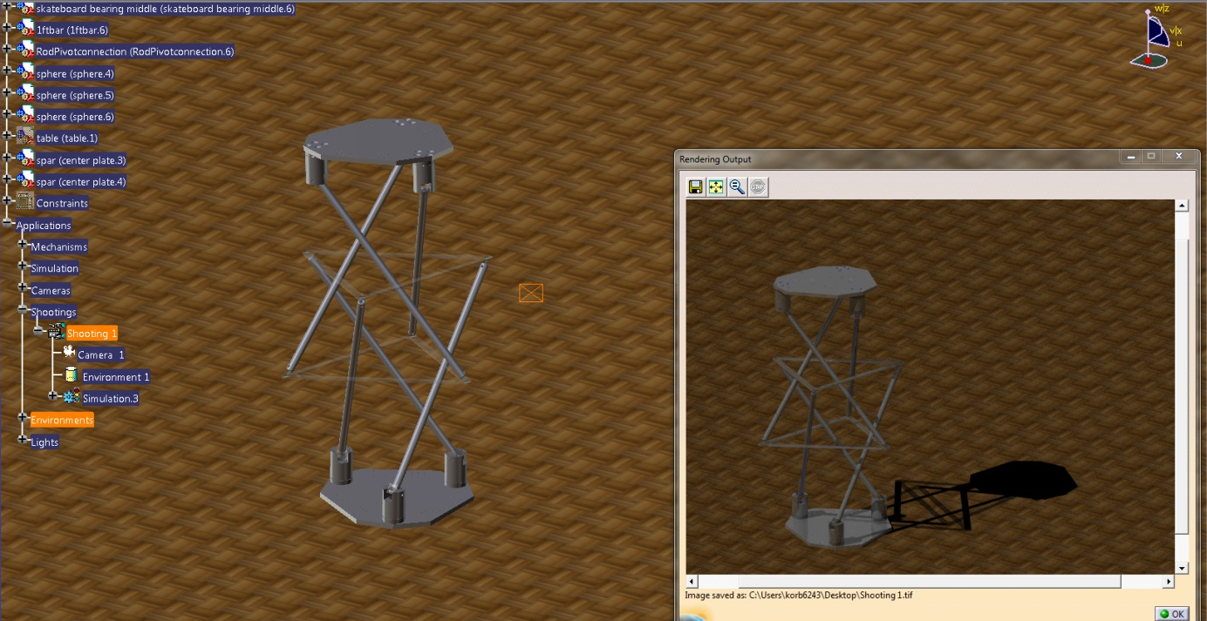

The final image is a capture of the final settings for the animation. At one point the duration was set to 60 seconds with a frame rate of 40 frames per second. After watching the first few frames it was determined that at these settings the animation would take around two hours. It was decided that this was beyond what was needed for this project and the time was reduced to 45 seconds and the frame rate was reduced to 30 frames per second. This took about an hour to simulate.

Lessons learned
This project was not only a tool to help the senior design team but has also been a test of the CATIA DMU kinematics workbench. It showed that there limits to the degrees of freedom that CATIA can handle. At six degrees of freedom the model had difficulty simulating. There were many times when the kinematic model would freeze in position until the model was re-simulated. There were also times while simulating the three-bar model where CATIA would become unresponsive and would have to be closed and restarted. Most likely the limits of the kinematic workbench are not far from what was done in this project.

Problems encountered
The most important problem in this project was that CATIA does not have a way to simulate a routed tendon. The main idea behind this project was to simulate exactly what the senior design project would be doing. Without being able to model and simulate the tendons there was no way to do this. Instead the model was simulated using the center plates to add constraints. Even though this solved the model the animation produced is not accurate enough to be used for a motion study for the senior design team. Any data taken from this model using CATIA’s kinematic sensor would be useless to them. The only other problem was the limits of CATIA’s kinematic workbench as outlined in the Lessons Learned section.

Conclusion
The kinematic model and animation produced will be helpful to the tensegrity senior design team and help determine the limits of the CATIA DMU Kinematics workbench. Although the outcome of this project does not accurately model the motion of a real six-bar tensegrity structure under robotic control it can still be deemed a success.

Future work
The model created will continue to be used to create animations for the senior design team during next semester. The next step in this process is to add all of the components that will be on the senior design team’s real model and simulate as well as render high quality images for them. A complete model will be created with all parts that were left out because of the limitations of CATIA. These include the AX-12 servo motors that will control the motion of the model, all electrical wires that will be used in the actual design, and all fasteners that will be used in the actual design.

