B-2 Bomber Final Project
Richard Baughman
Me421

Goal
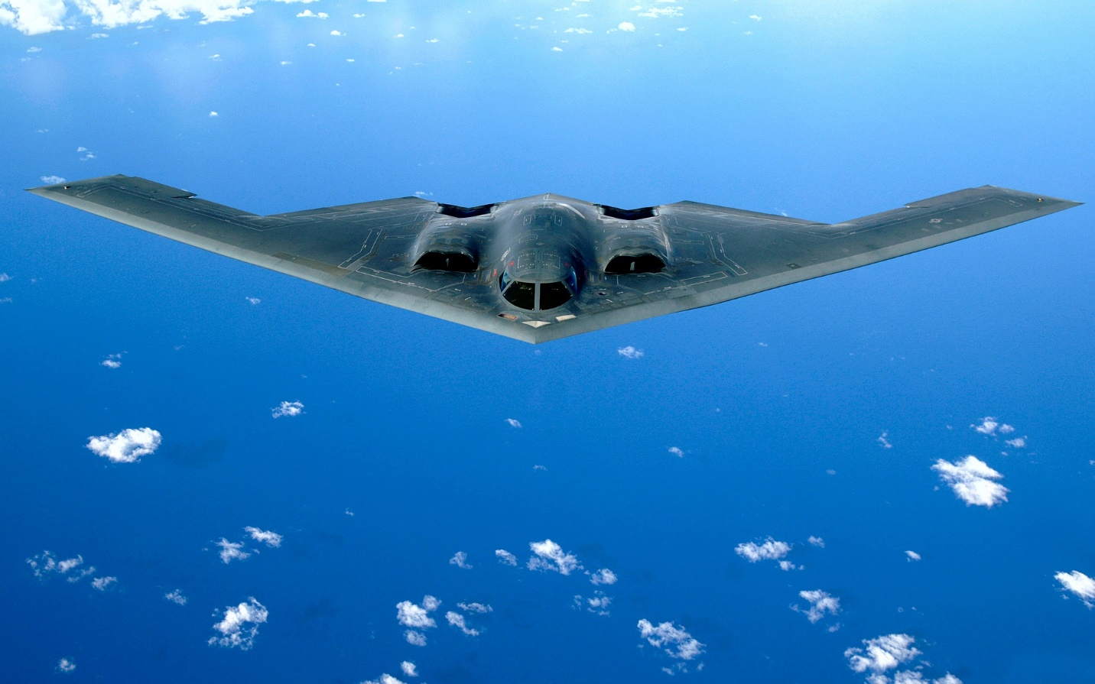
- using surface modeling create the surface of this B-2 Bomber

Documentation
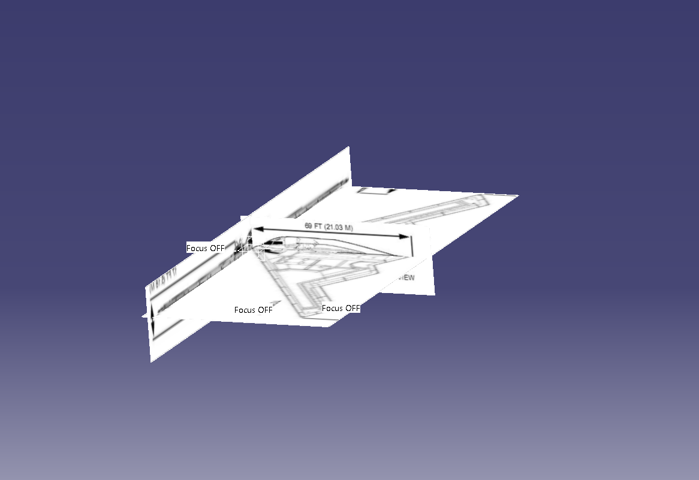
- Step 1 was to use sketch tracer to get the general shape of the bomber. The trickier part of this was to get the correct dimensions on each picture so the lineup correctly.
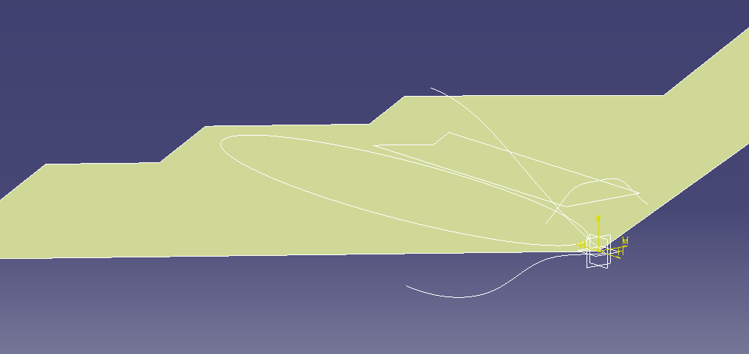
- Using the sketches made profiles of the top side and front views to be used in shaping later
- After profiles were drawn I hid the pictures so they were not in the way
- With the top profile I then used the fill tool to make my first starting point

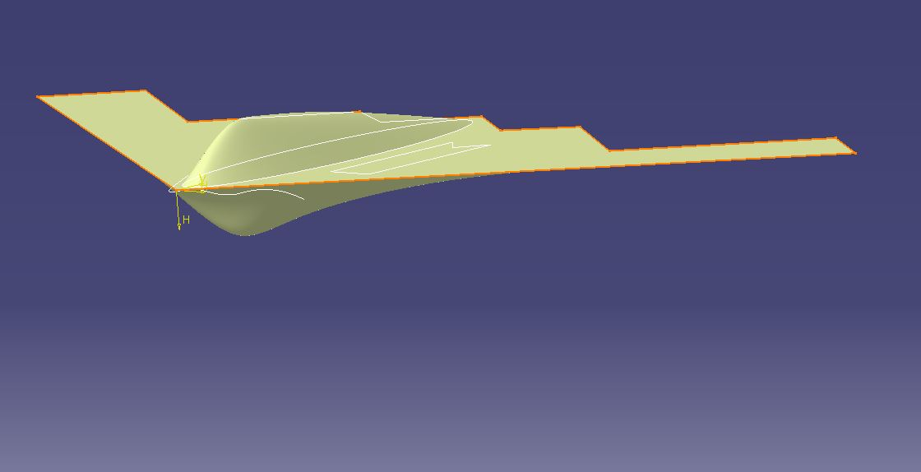
- I started on the bottom plane and used the bump tool to add the curvature to the bottom.(had to made bump larger to get all of the bottom surface to correct shape
- Then using the profile of the cabin I used the bump tool again to the correct size and shape.(using the bump tool I used the point curve for all of my bumps)
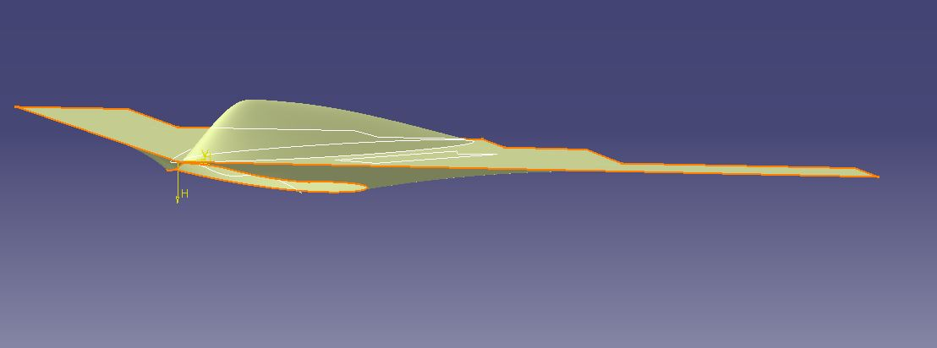
- To correct the shape of the bottom I extruded my side profile and used the split tool to remove excessive surface.
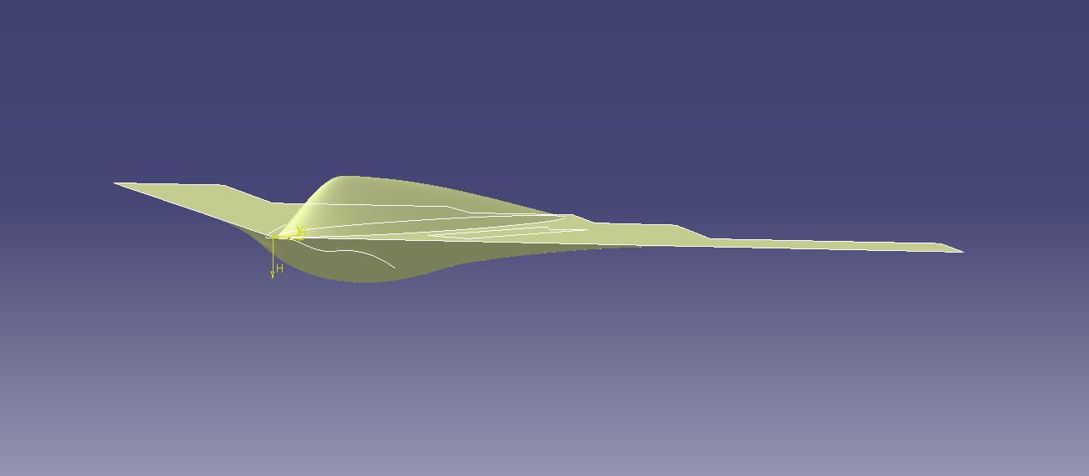
- Then using the fill tool filled the surface giving me the correct side profile.

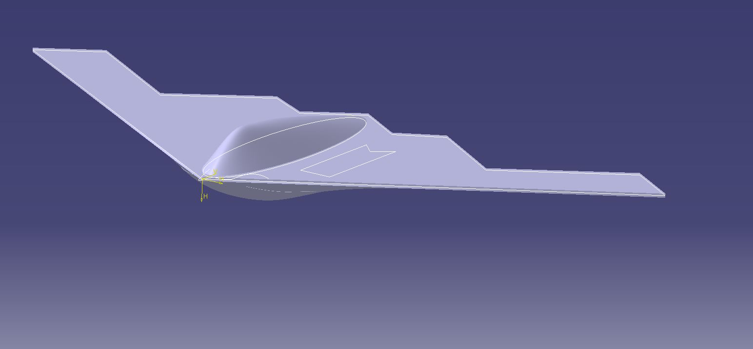
- After both surfaces were created I moved to the part bench and added thinness (This was the hardest part while the bump tool is useful when you bump out one spot to causes another part of the surface to dip down. This creates two surfaces intersecting which will cause an error when you try and add thickness).

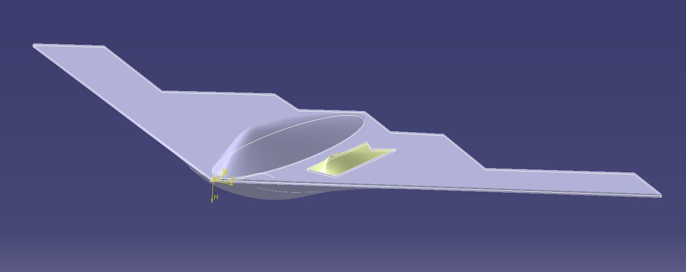
- Next is the exhaust ports on either side of the cabin. Started by projecting my initial outline to the top of my surface.
- Then using the fill tool on the sketch and them finally bumping it to match my profile.

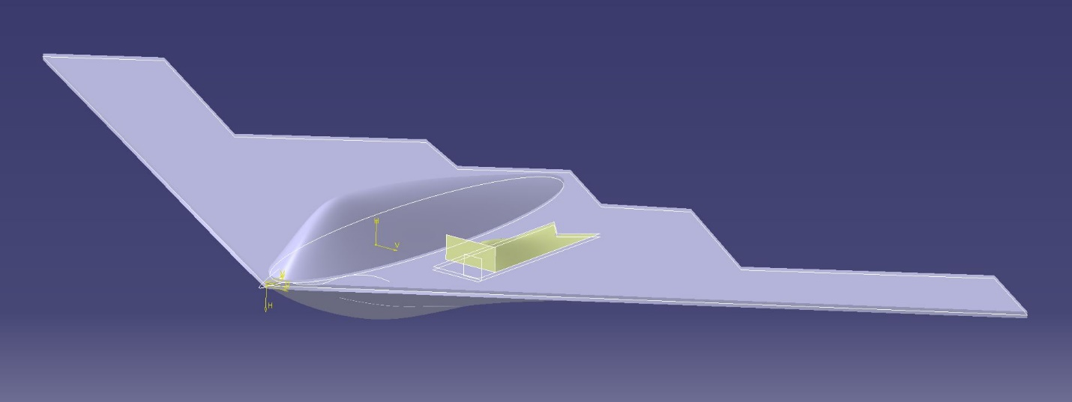
- Then adding the final detail to the ports using the my profiles made a new plane where the port is open,
- Then creating a rectangle and filling it before splitting it to remove unwanted surface

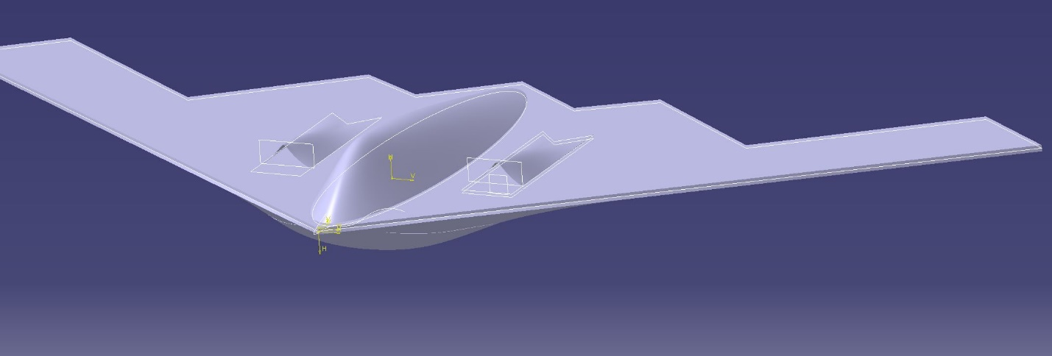
- Then using the symmetry tool moved the same surface to the other side and added thickness to both of them

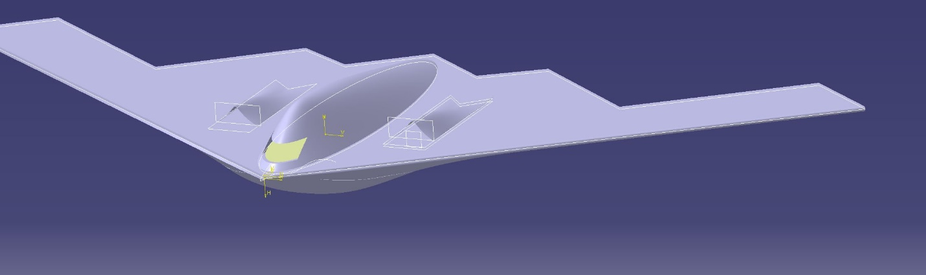
- Adding windshield on the front plane made a rectangle (I forgot to draw this profile show I had to go back to the initials pictures to sketch it. This is why I did not delete them).

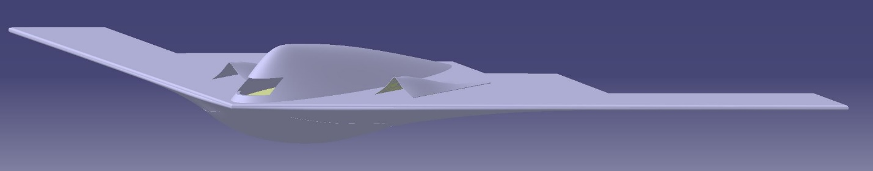
- The final step to the surfacing is to filet the edges to get that smooth shape
- When doing the fillets you have to change the fillet form tangent to minimal so the corners will meet.
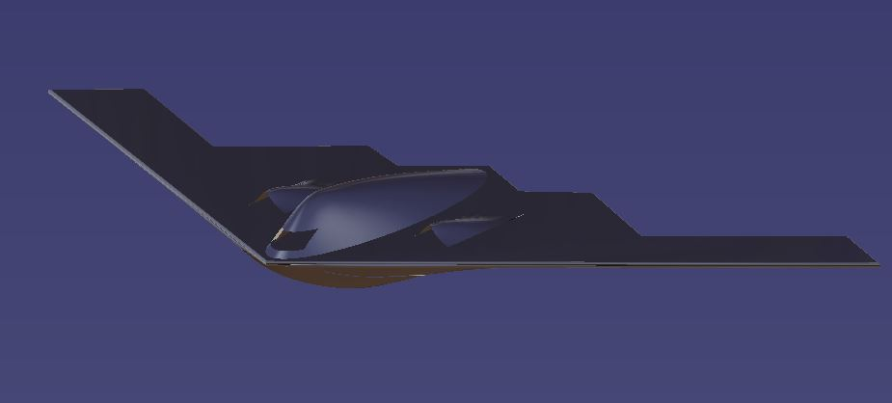
- Added the material to the plane to fully complete it.

Final
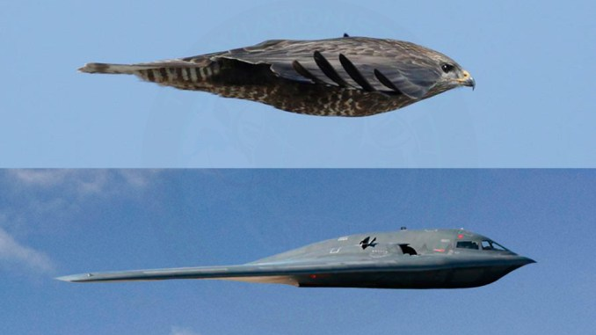
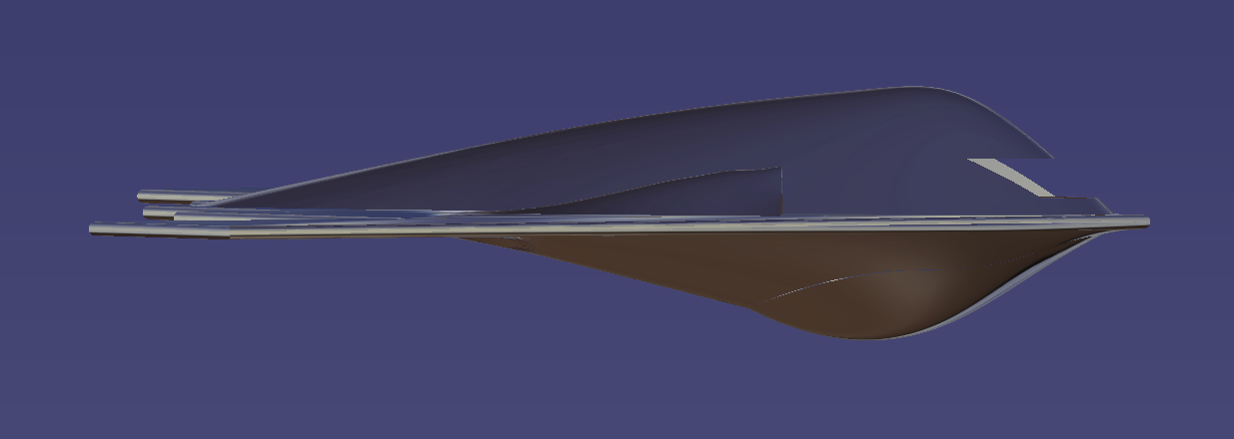
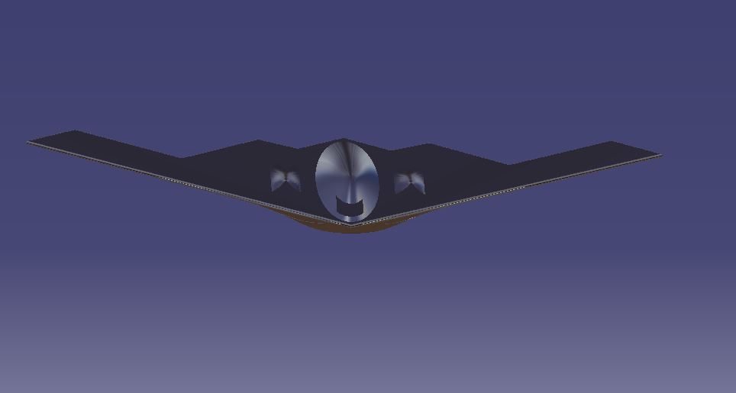
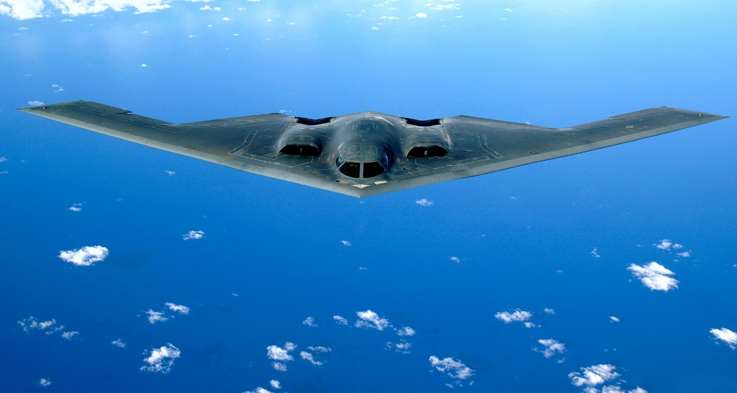
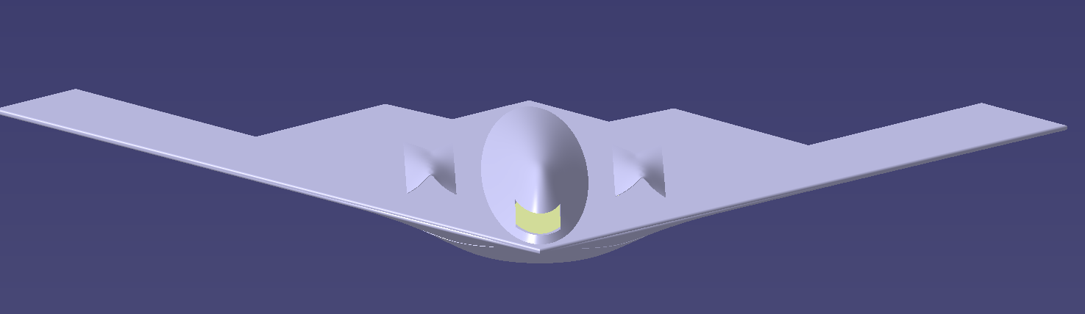

Key tools
- Bump tool
  - Used to make the majority of the shape
- Fill tool
  - Used to create surface
- Split
  - Helped to get the shapes just right
- Sketch tracer
  - Needed to get the profile of the plane
- Filet edge
  - Used to create final details
- Thick surface
  - Needed to make surface 3D

Biggest challenges
- The best advice I can give to a surface models if you are creating a 3d model stay organized. I had to start over because I had too many surfaces and it created many problems.
- The next was making sure your surfaces to not intersect the best case scenario is to make them connect at one point so you can join the pieces and use the close surface tool instead of the add thickness tool.

Lessons learned
- Staying organized is the biggest thing learned paying attention to your design tree and making sure you know everything in there. If you see something weird it is probably going to come back to haunt you if you do not fix it then.
- Take the most time creating you profiles they are the key elements to your project coming out correctly
- Don’t get hung up on one tactic on how to do something. If a method is not working take a step back and try a different way. My first method fell apart and I got nowhere switching my view made a big difference and made me move forward.
- Taking notes also helped me a lot keeping track of everything on screen is difficult having a hard copy to refer to helped me quite a bit.

