Exporting SolidWorks and CATIA files to IQ station
CATIA
- Open your part in Catia
- Go to Tools > Options. Select ‘General’ then ‘Compatibility’, and then scroll to the ‘STEP’ tab. Under export, change the ‘Application Protocol (AP)’ to ‘214 iso’. Click OK.
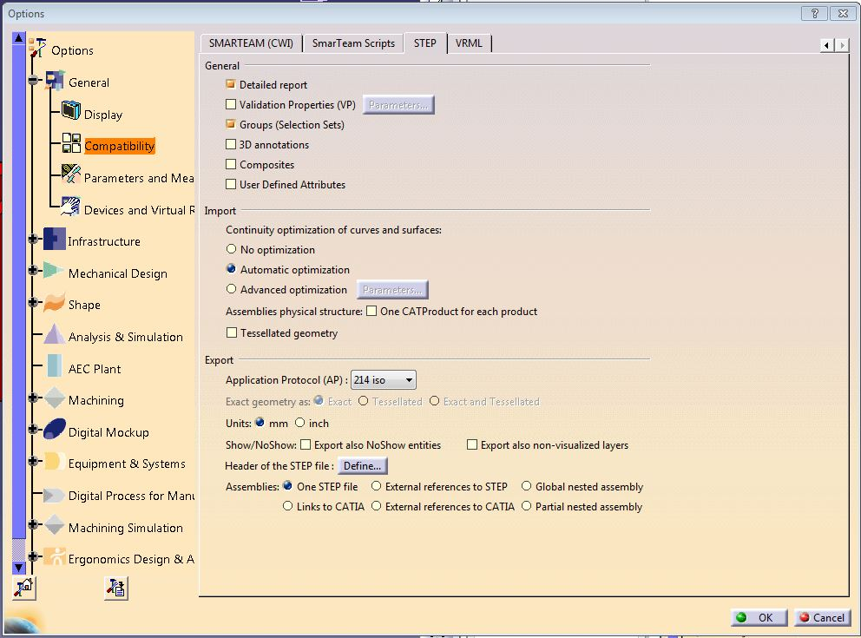

SolidWorks and CATIA
- Save part as a step file. Check the ‘Save as new document’ box, and save as a ‘stp’ file to a flash drive or a shared network location.
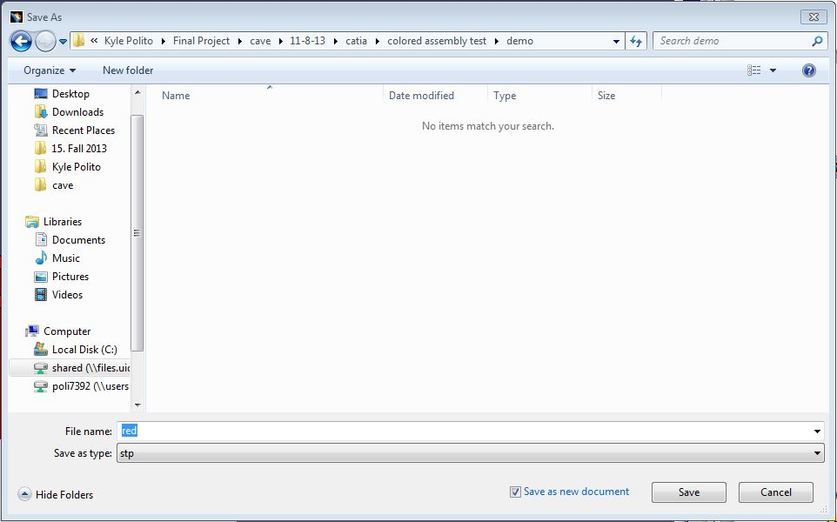

- Go to the black and yellow computer in Idaho Engineering Works (GJ 113) as it is the only one that has the file conversion software, Okino NuGraf, installed on it.
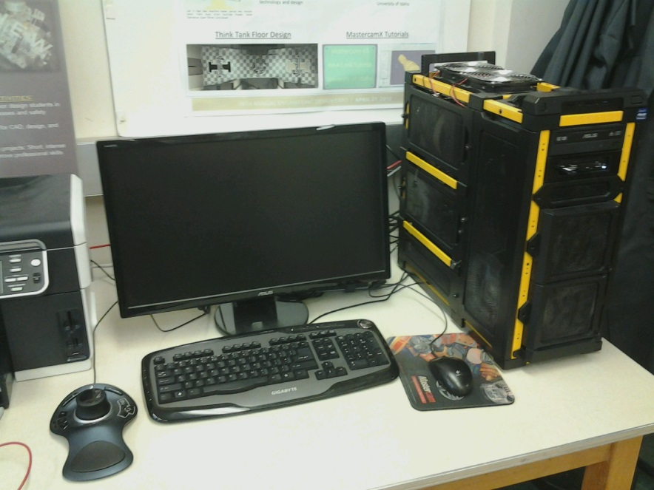

- Log on using your user account. Go Start > All Programs > Okino Computer Graphics > NuGraf64.

- Within NuGraf, go File > Import 3D Geometry > STEP (via PTC Granite. AP203, AP214) ASCIIfile…

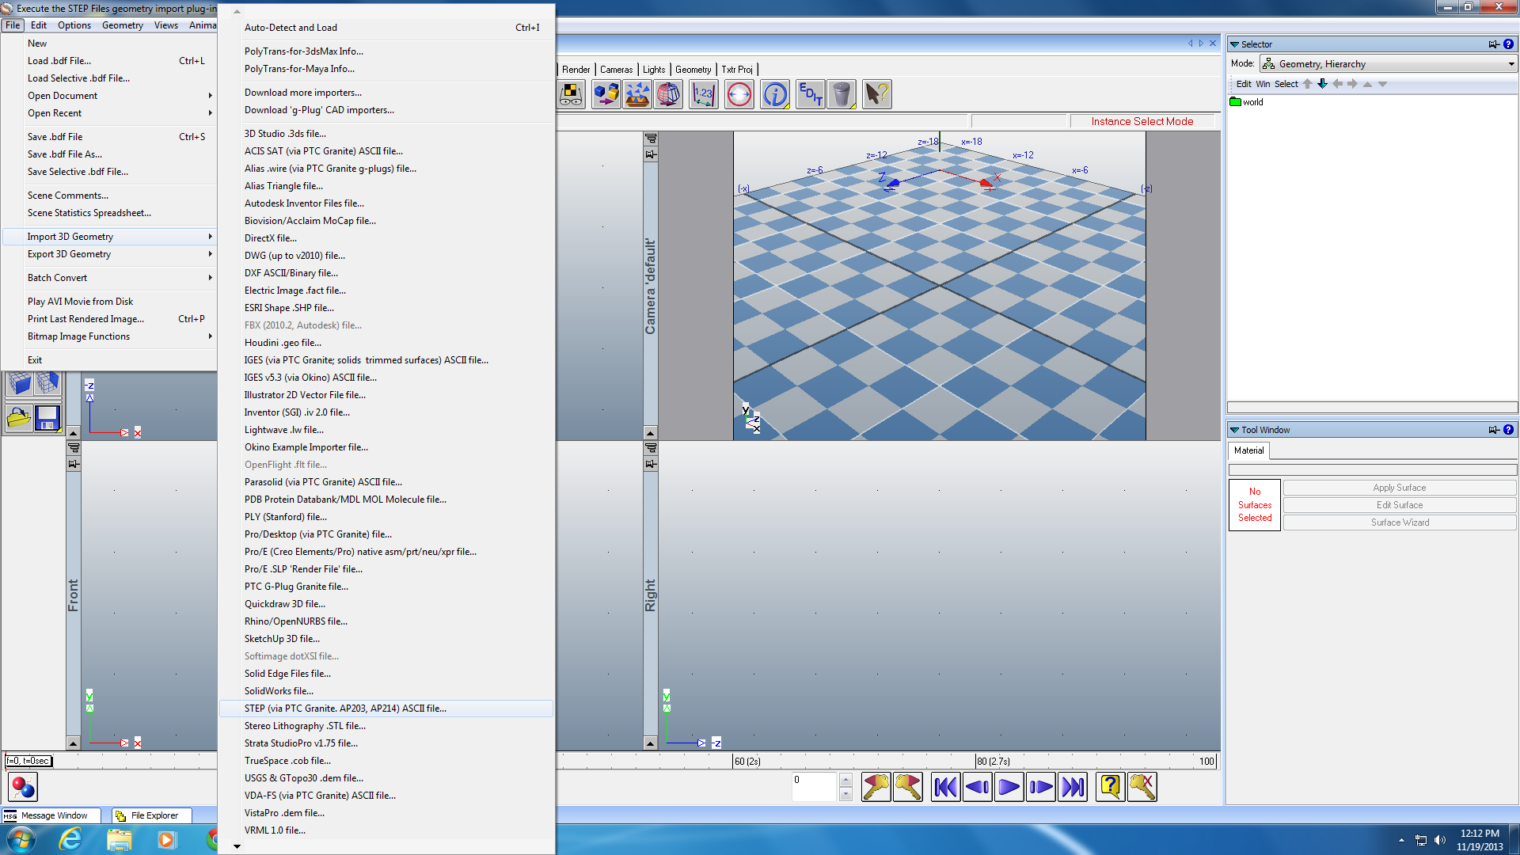
- Navigate to your saved STEP file and open it.
- Set the next several windows to match the images and then select Finish.
NOTE: Unless changed, you should be able to just click finish on this first page
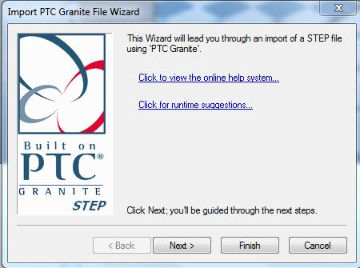
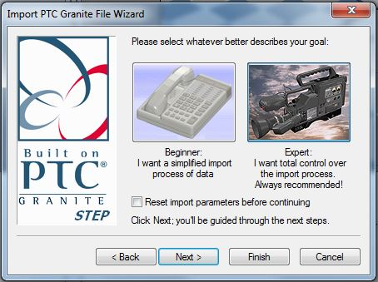
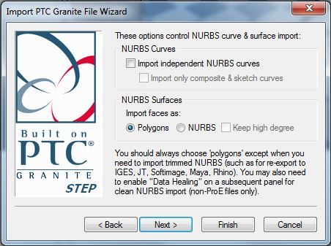
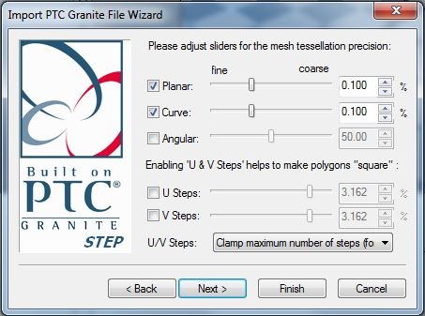
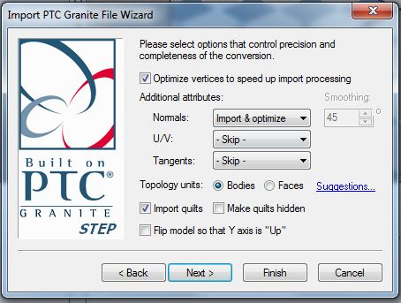
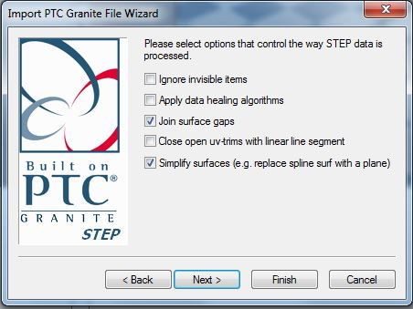
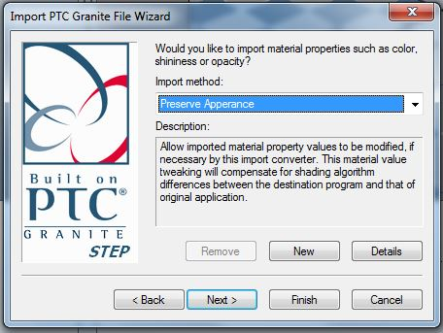
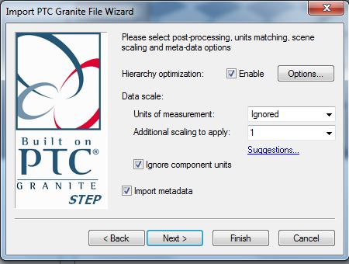
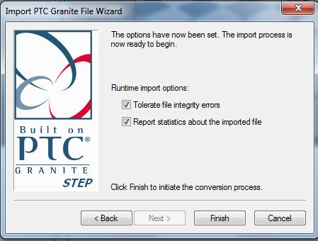
- After selecting finish you should see your part or assembly in NuGraf. Check that the model is positioned right and all the colors were transferred through. If not, double check the import parameters within NuGraf and the PartBody color designations within Catia.
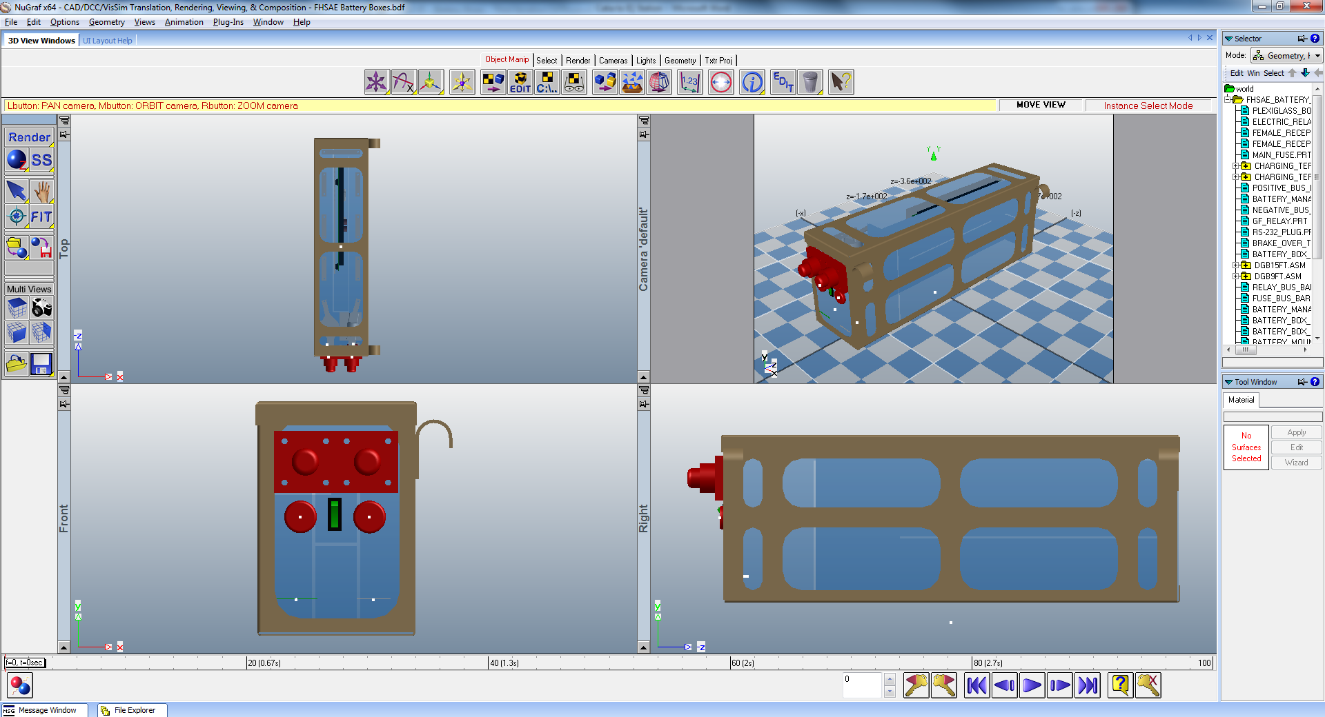
- Now go File > Export 3D Geometry > Wavefront OBJ File…
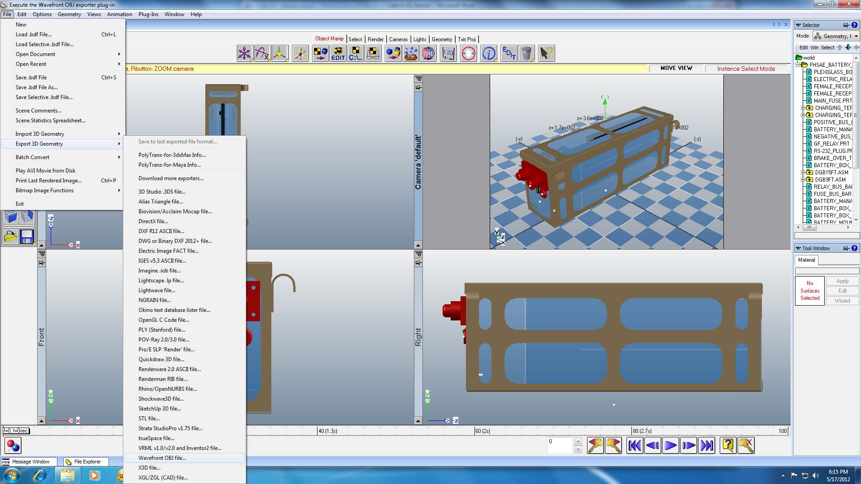

- Set all options to match and click OK
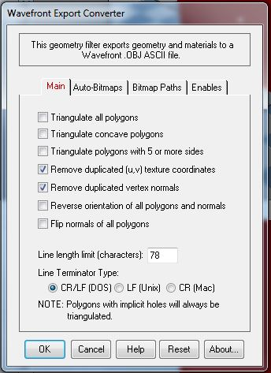

- Set the output destination to be your flash drive or network location.
Note: Shorter names make it easier to transfer the file to the IQ station
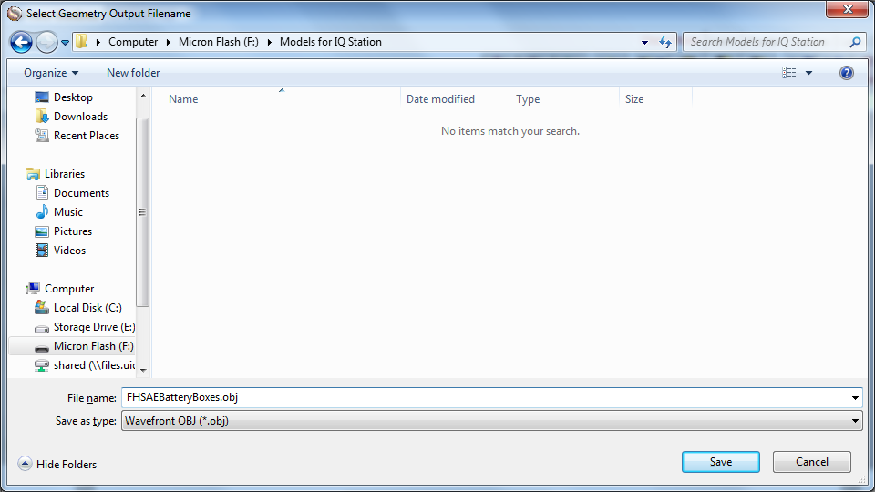
- You should end up with an object (.obj) and material (.mtl) file for your model
