Importing files to the IQ station
How to take models from Catia to an immersive, interactive environment.
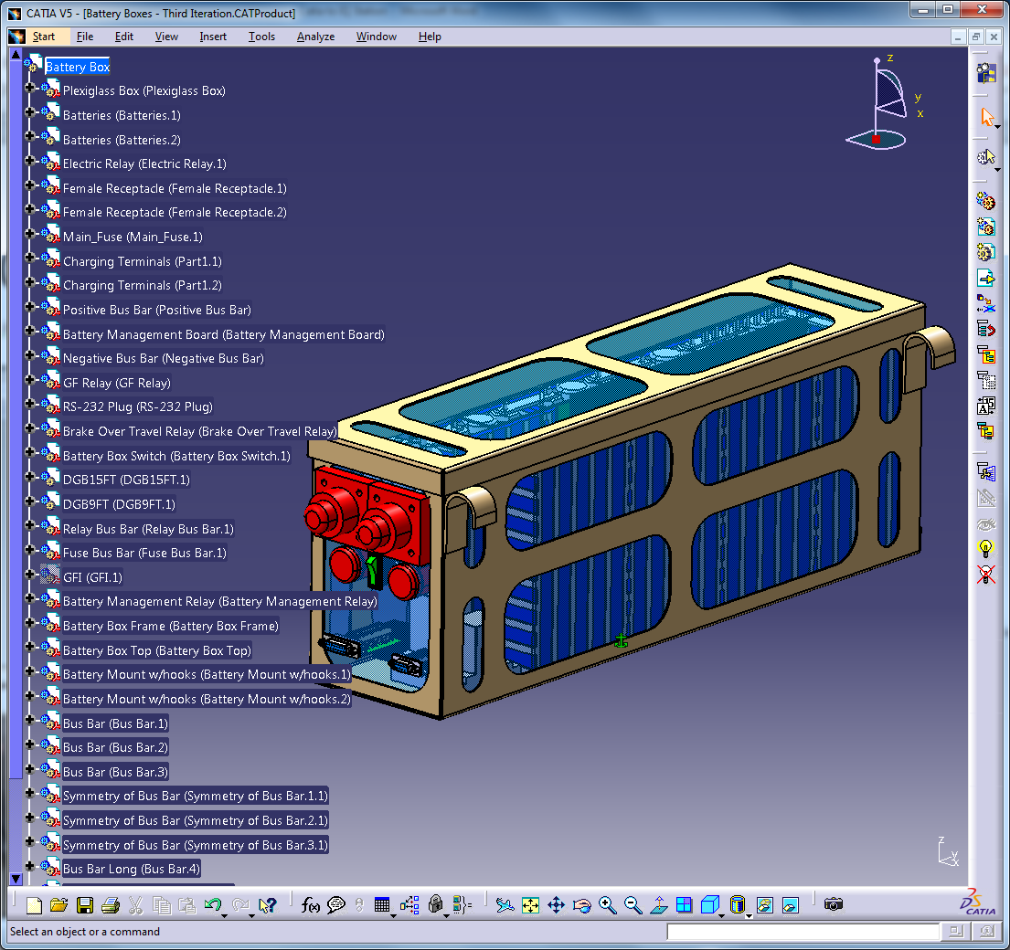
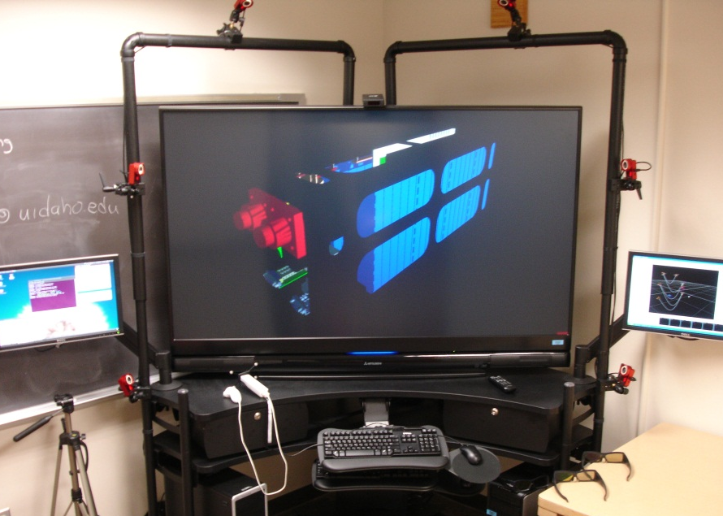
1. Use the monitor on the left and the keyboard and mouse on the top. Insert your flash drive into the front of the computer on the left. Open a File Browser.
You must be trained and certified to check out the IQ Station key from the Reserve Desk on the first floor. To get trained and certified, follow the instructions at http://www.lib.uidaho.edu/IQ/policies.html. You must also reserve your time slot to use the system. To reserve time, email iquadstation@gmail.com with your desired reservation time. Slots are available in two hour increments.

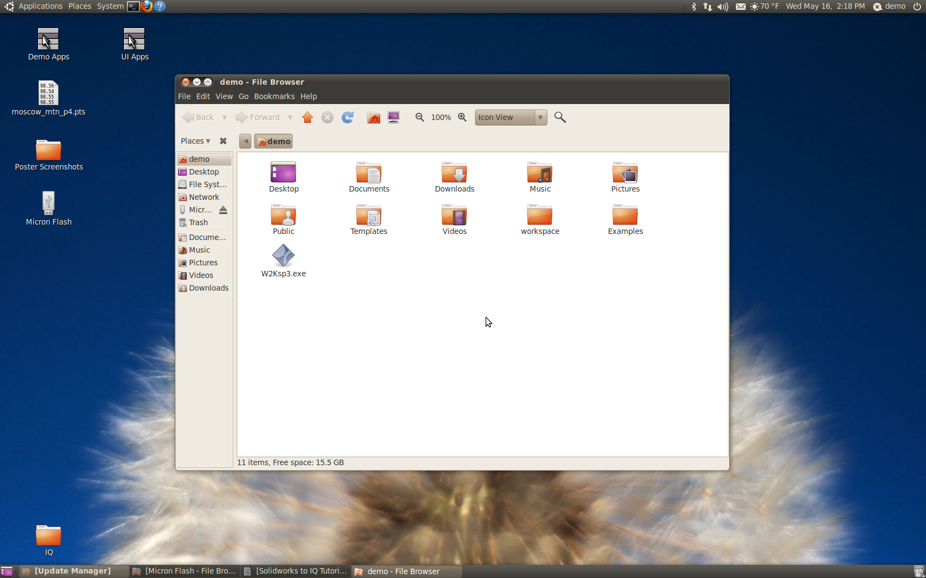

2. Navigate to demo > workspace > data and then click File > Create Folder. Rename the ‘untitled folder’ to match your model name. Then copy the .obj and .mtl files from your flash drive to this new folder.
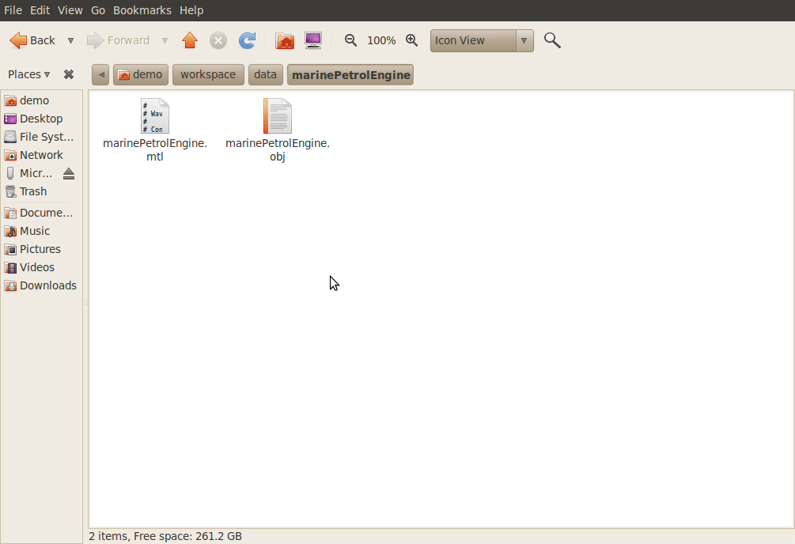

3. Next navigate to demo > workspace > VruiTemplate and copy the three folders within.

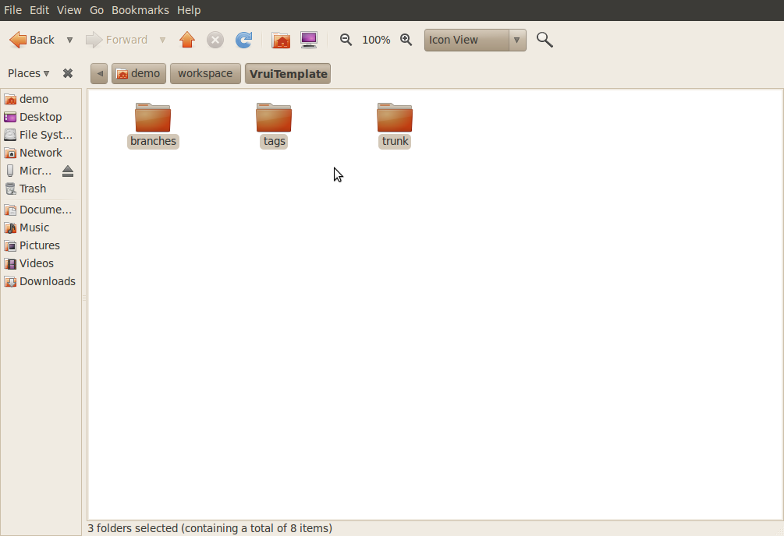

4 . Navigate back to demo > workspace and create a new folder named to match your model name. Paste the three folders from the template within this new folder.

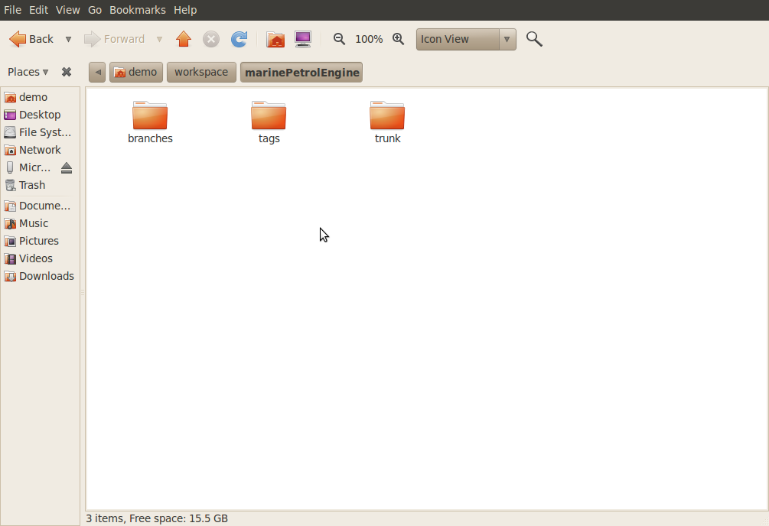

5. Keep navigating further in to demo > workspace > Your Folder Name > trunk > source > MODEL. Double click NPP.cpp.

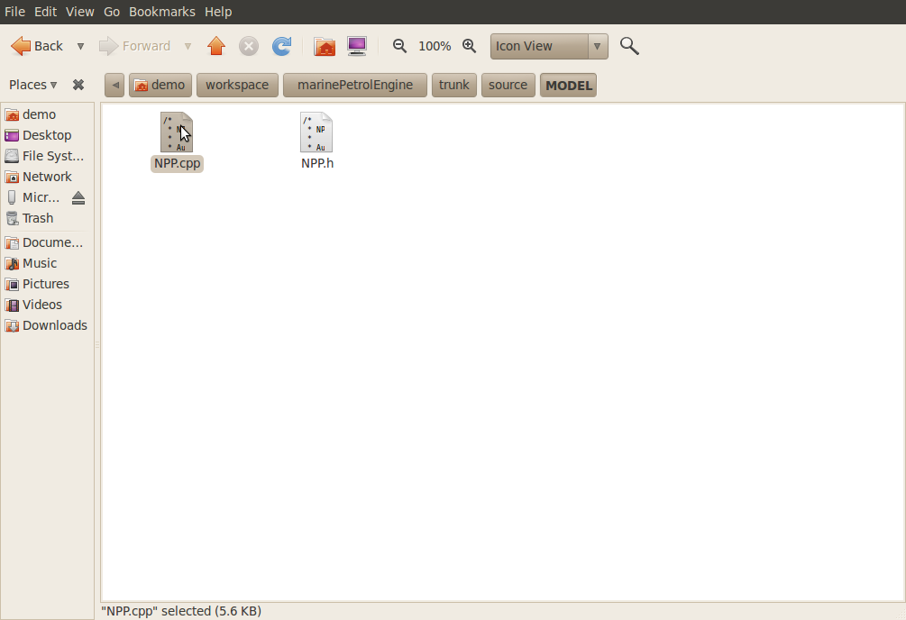

6. Scroll down to this section of the file. Replace the underscores in the LoadFile path with the path to your .obj file in the data directory.

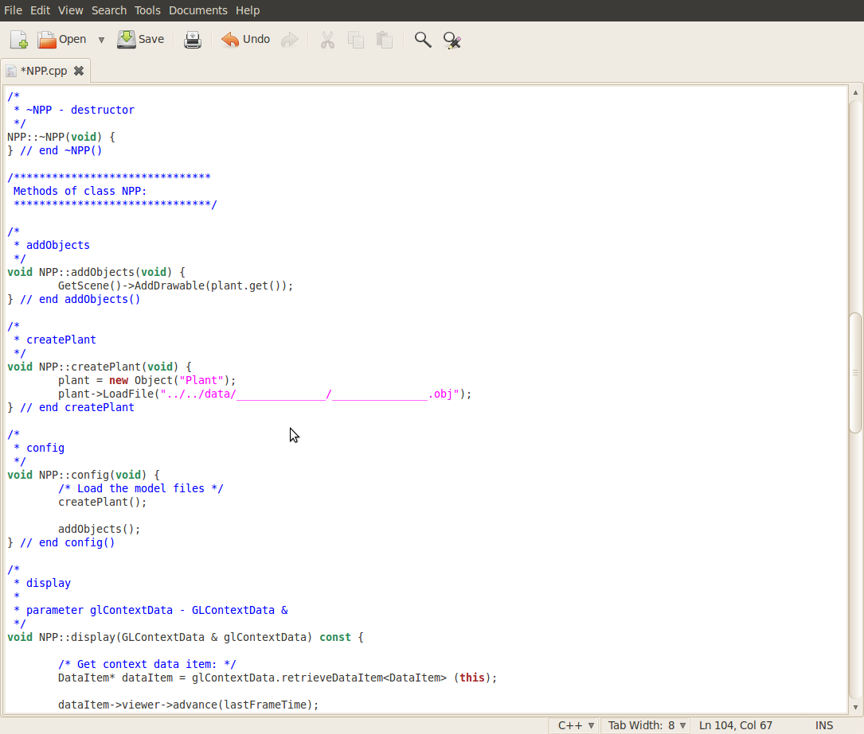

6. You should end up with a file that looks like this. Now save the file and exit out of it.

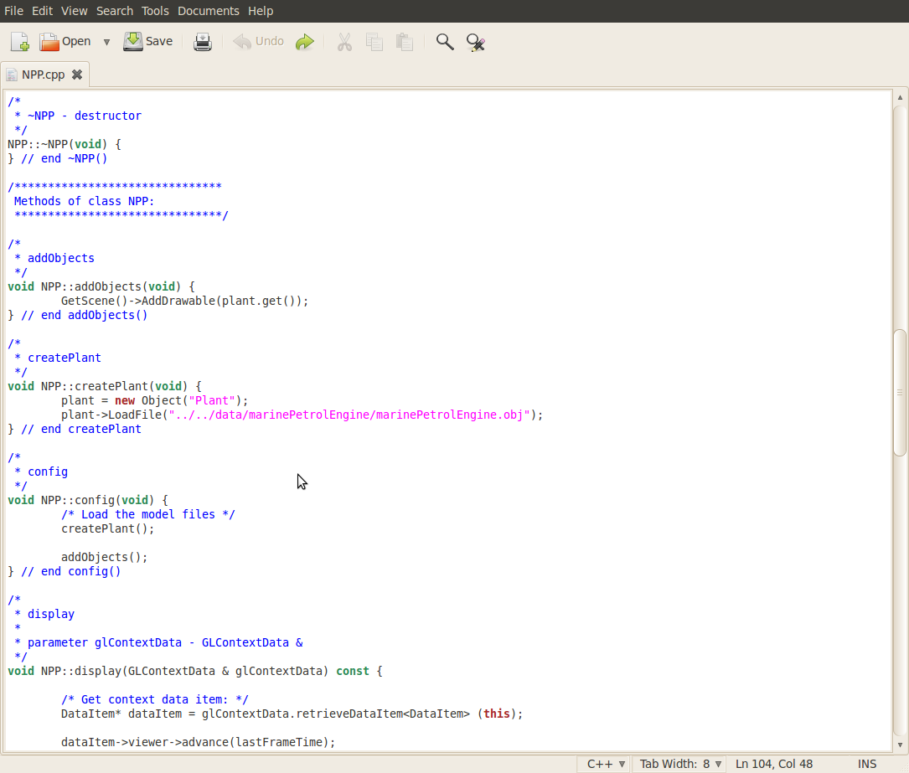

7. Navigate back to demo > workspace > Your Folder Name > trunk and double click ‘make.sh’

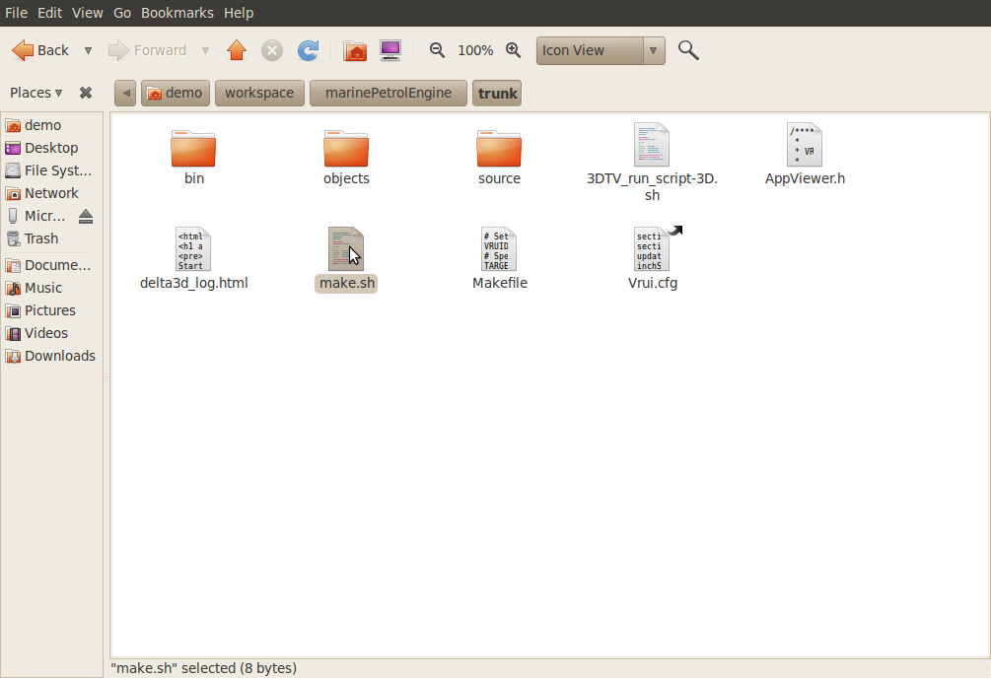
8. Select Run. This compiles and generates the executable files.

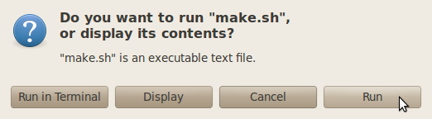

9. Now navigate to demo > workspace > VRMenu and double click UI_Apps.

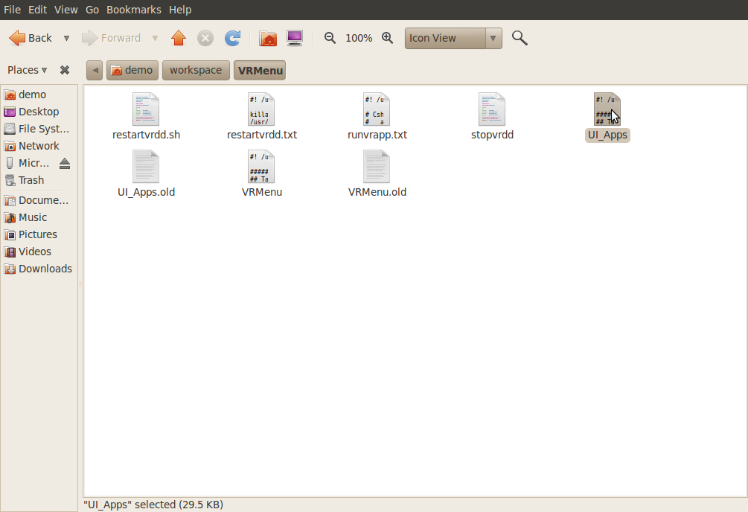

10. Scroll down to the section highlighted here, which is the template, then copy the highlighted section and paste it directly above itself.

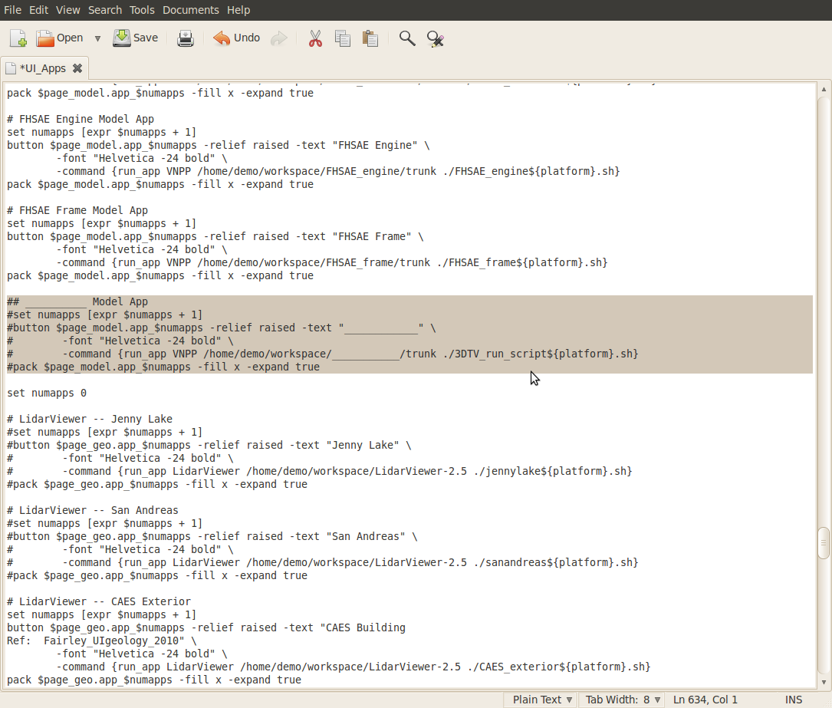

11. Remove the pound (#) signs in front of each line to activate the code. Fill in the underscores to match your model name, label and directory. Then save the file and exit out of it.

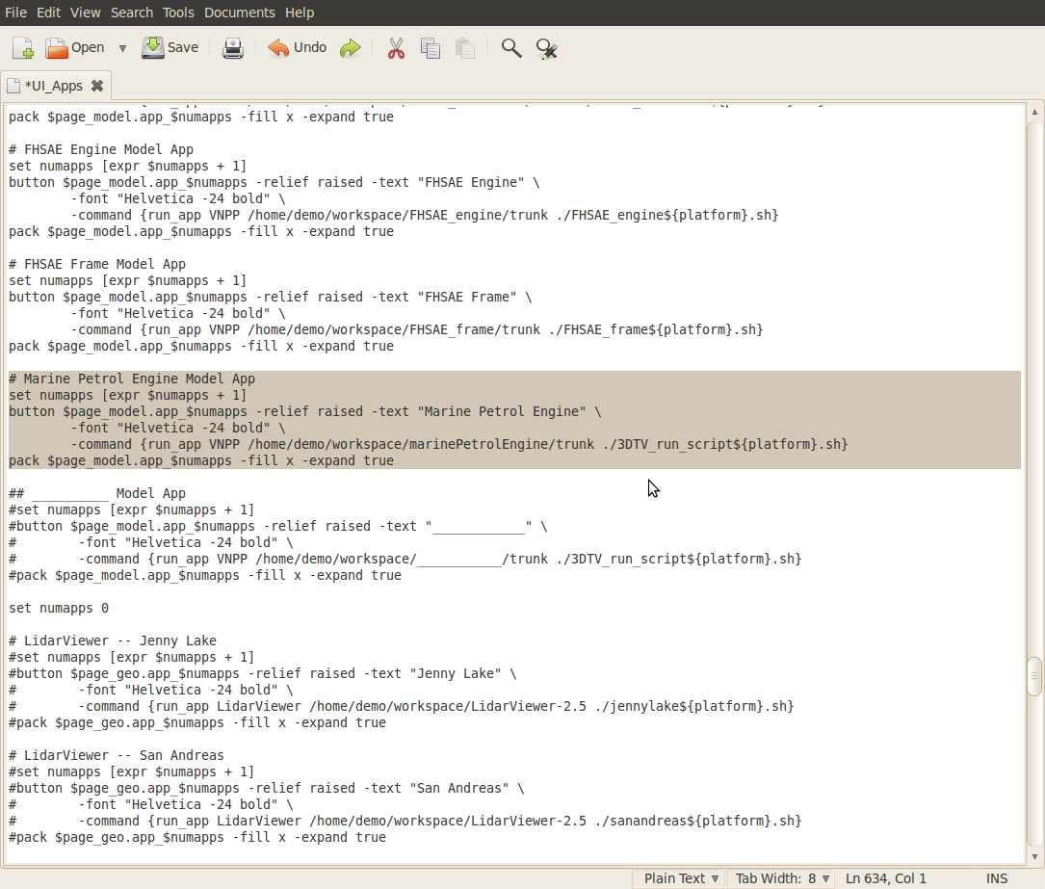

12. Now switch to the right side monitor and lower keyboard and mouse. This computer runs the tracking software. Select the Tracking Tools icon to begin the program.

13. Click Open Existing Project.

14. Double click the TrackingToolsProject file to open it.

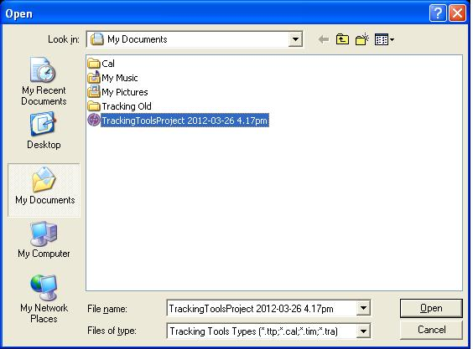
15. You should end up with the software running and tracking the motion of both wand and head.

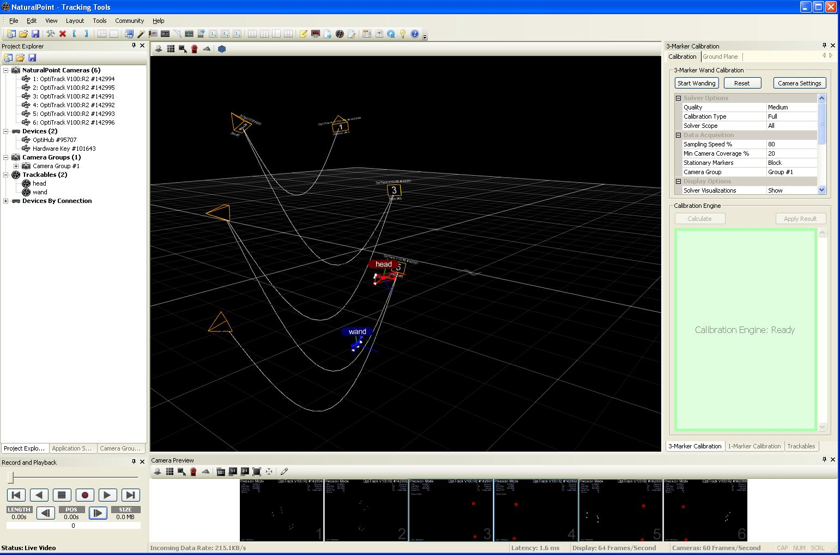
16. Now move back to the left side monitor and upper keyboard and mouse. Double click the UI Apps icon on the desktop to open a graphical interface.

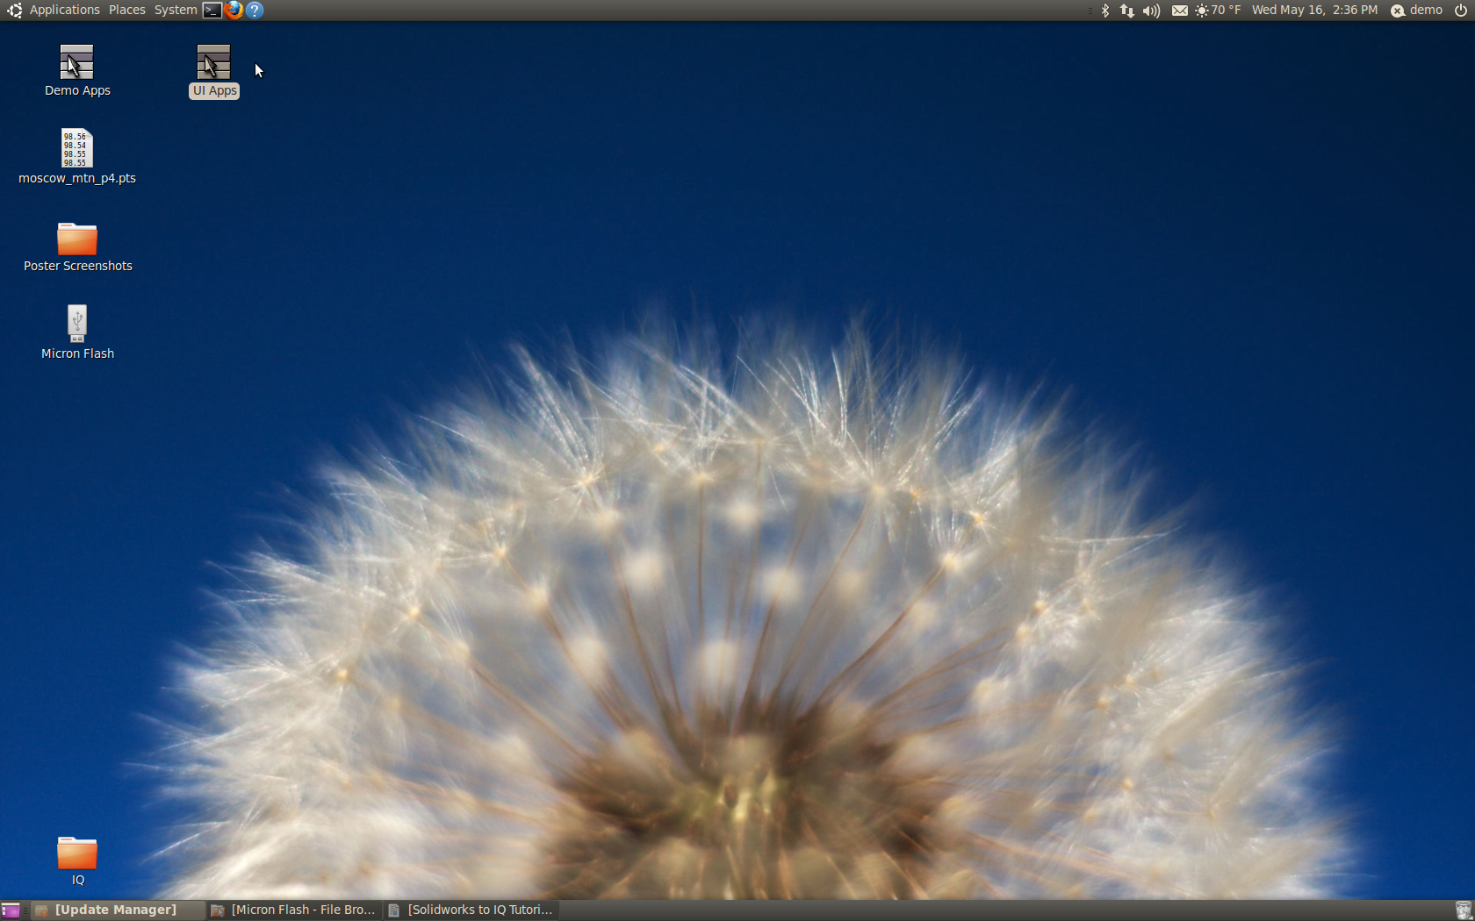

17. Click Start Device Daemon, then press buttons 1 and 2 on the Wiimote to initialize the connection.
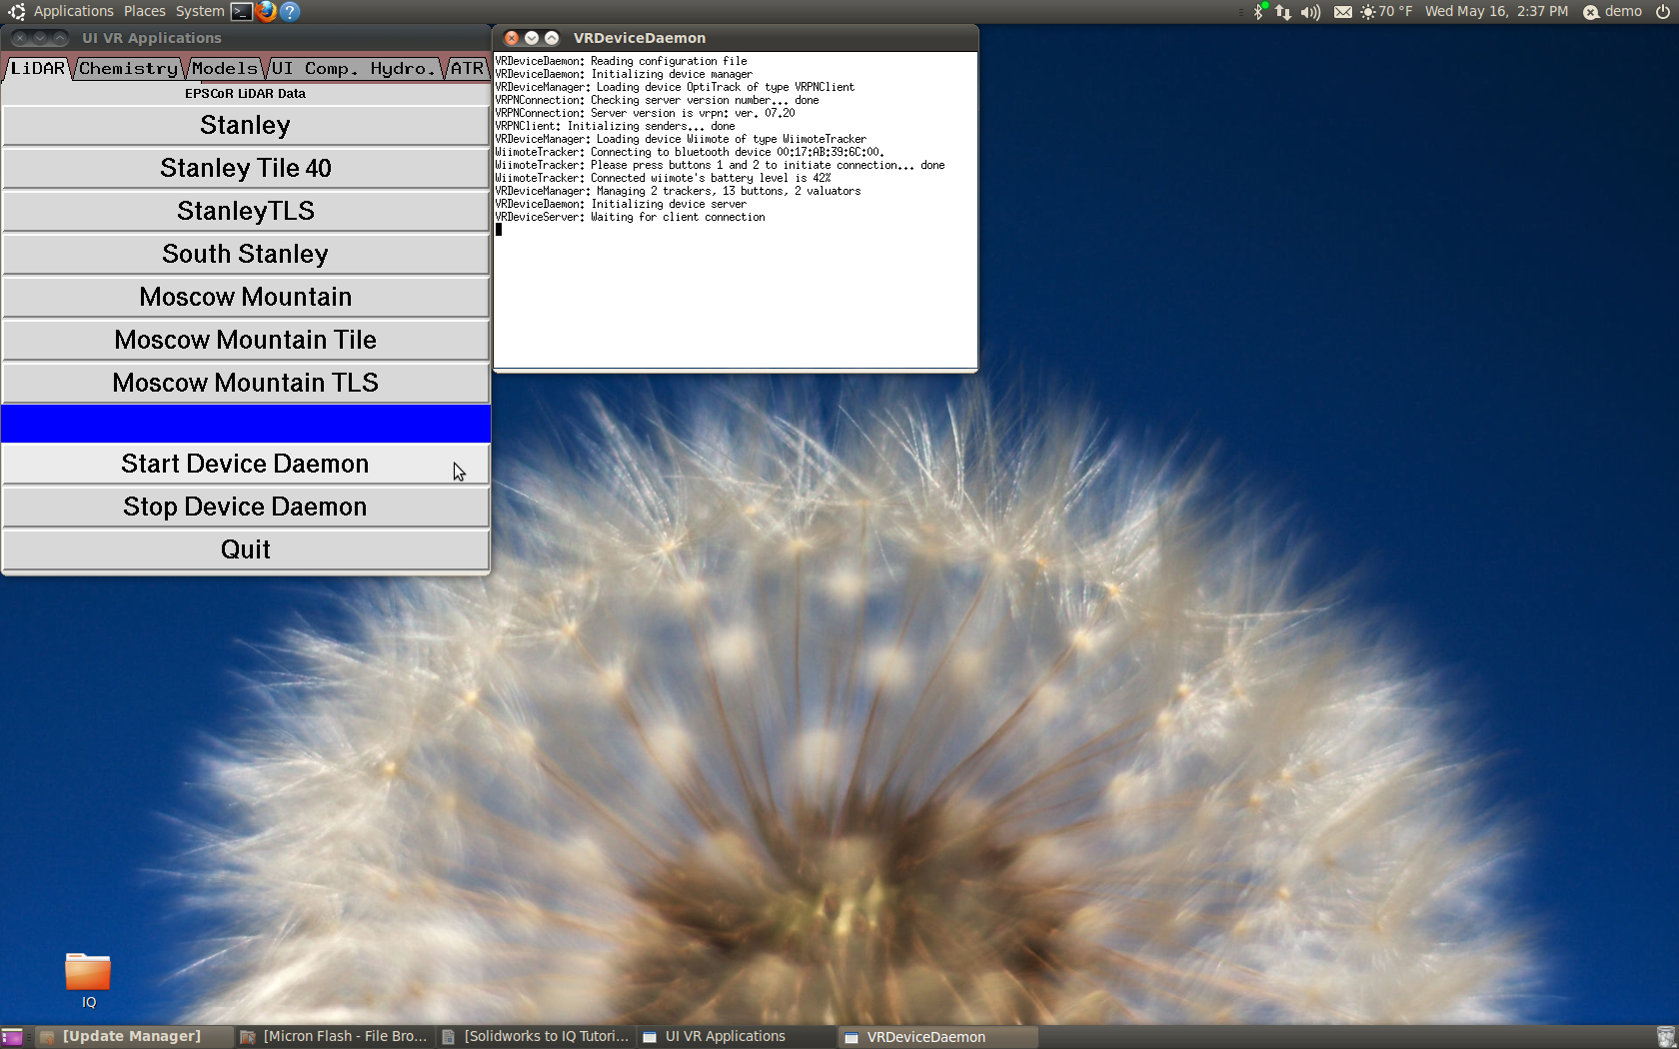

18. Go to the Models tab and select your model from the list to run it.

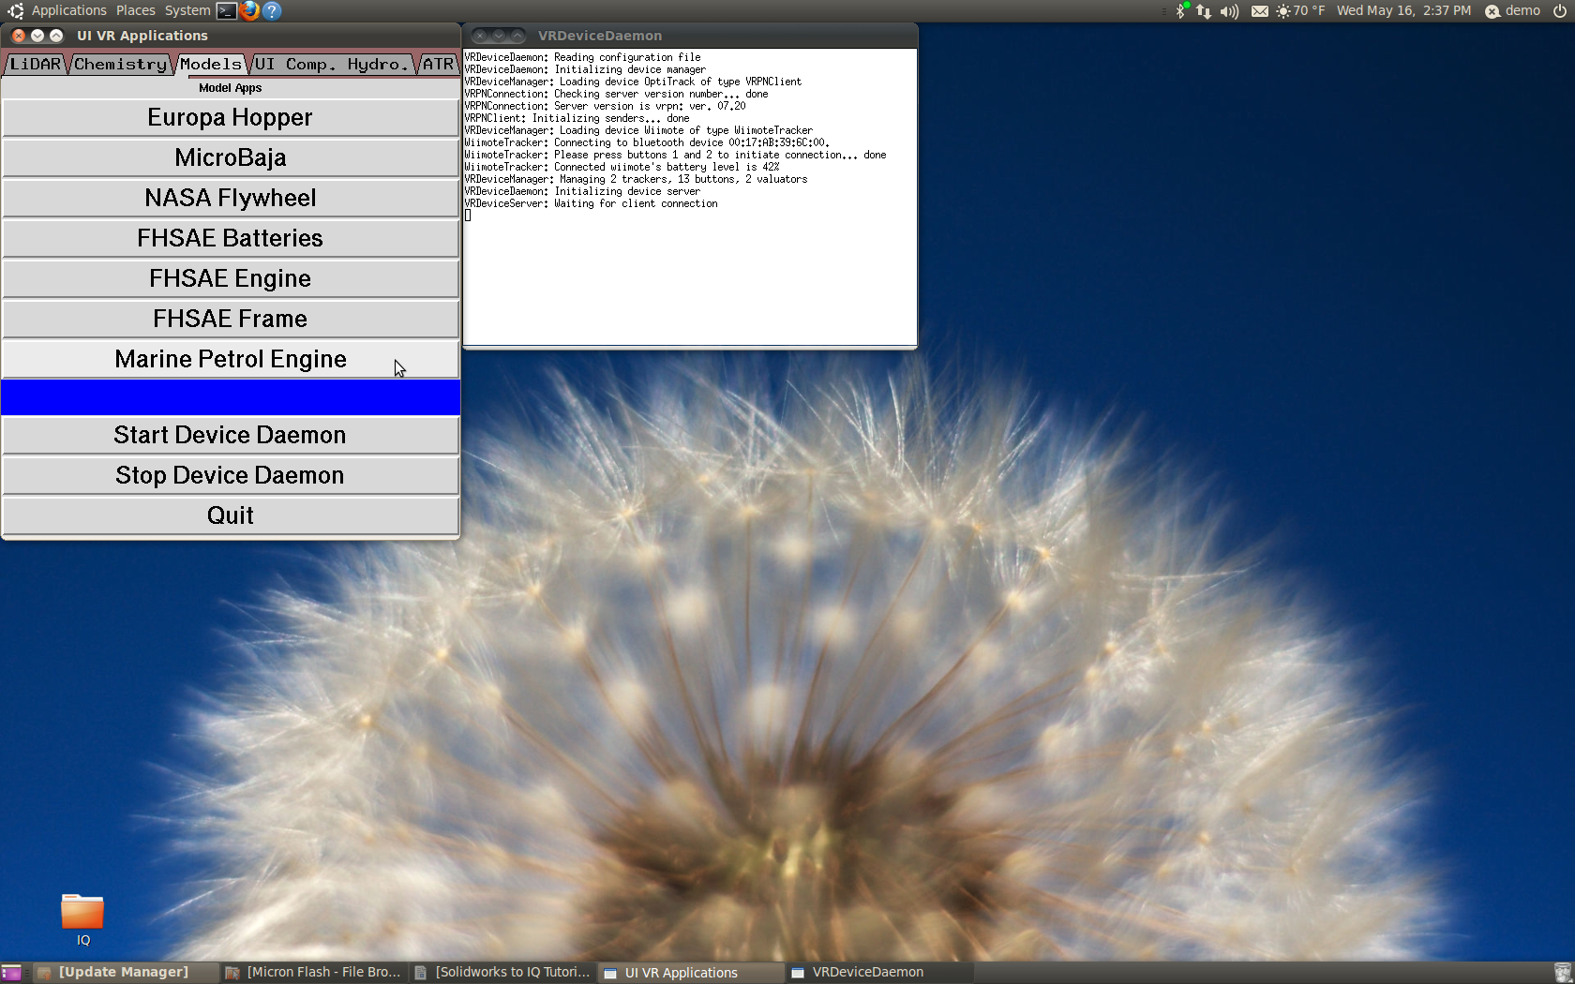
19. You should end up with a complete model that can be visualized, interacted with and thoroughly explored.
