ME529 Combustion and Air Pollution
Topic 14. Particulates

Physiological Impact of Particulates

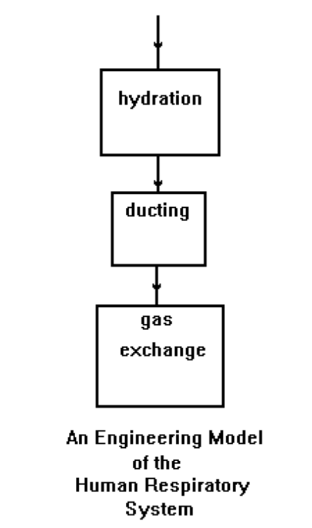

Size (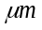) | Comments
1 - 20 | > 20 intercepted by nose
0.5 - 1 | many intercepted by respiratory tract
0.01 – 0.5 | deposited in lungs

The first defenses against the deposition of particles are the nose hairs. The nose intercepts particles > 20 in size. The passageway from the nose is not straight or smooth. Many protoplasmic extensions or protrusions - cilia - line the duct.
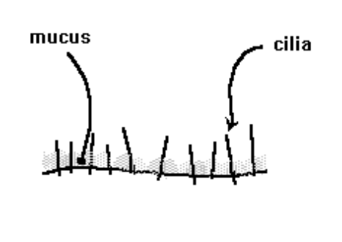
We will discuss the mucus belt and highway a little later.

As the particles that are < 20 pass into the nasal passages, some are trapped.

Size () | Fate
5 + | < 5% gravitational deposition
1+ | > 50% inertial impaction
0.5+ | > 50% direct interception

Particles captured by inertial impaction have too much inertia to negotiate a sudden change in direction. More than half of the small particles physically intersect the passageway.

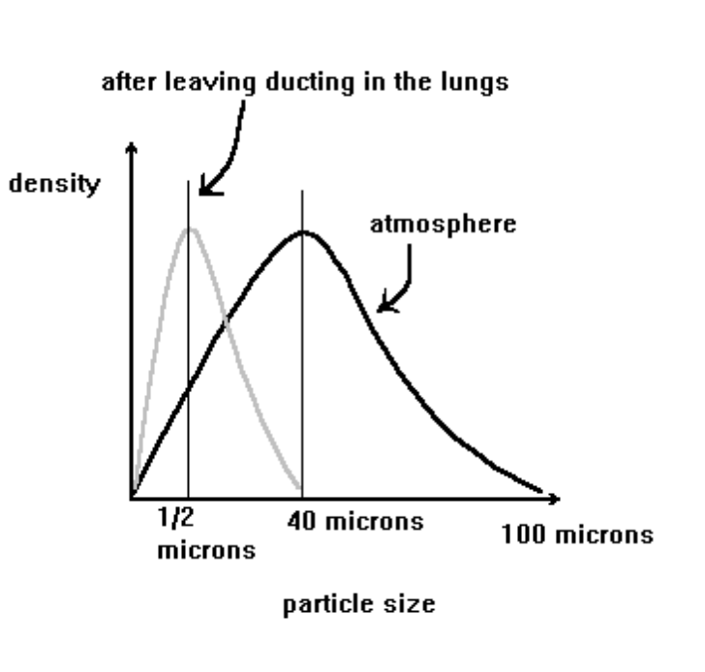
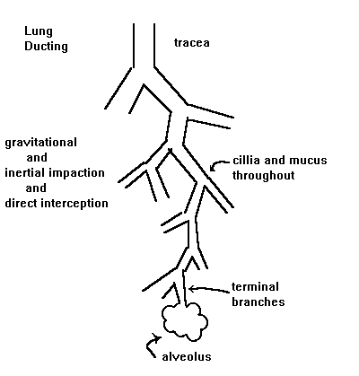
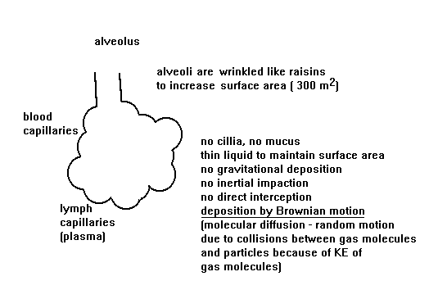
About 1/7 of the volume of an alveolus is exchanged with each breath. They are about 0.1 cm in diameter. Hence, the residence time of gases and particulates in the alveoli exceed 1/7 of the volume exchange. The velocity in the alveoli is VERY small so Brownian motion is still important during breathing. Only 150 ml of gas gets into the alveoli out of about 500 ml breathed in, so only 1/3 of the air we breathe is actually used for respiration; the other 2/3 fills up dead space.

Removal and deposition of particles in the respiratory system occurs simultaneously. Let’s return to the nose ducts.
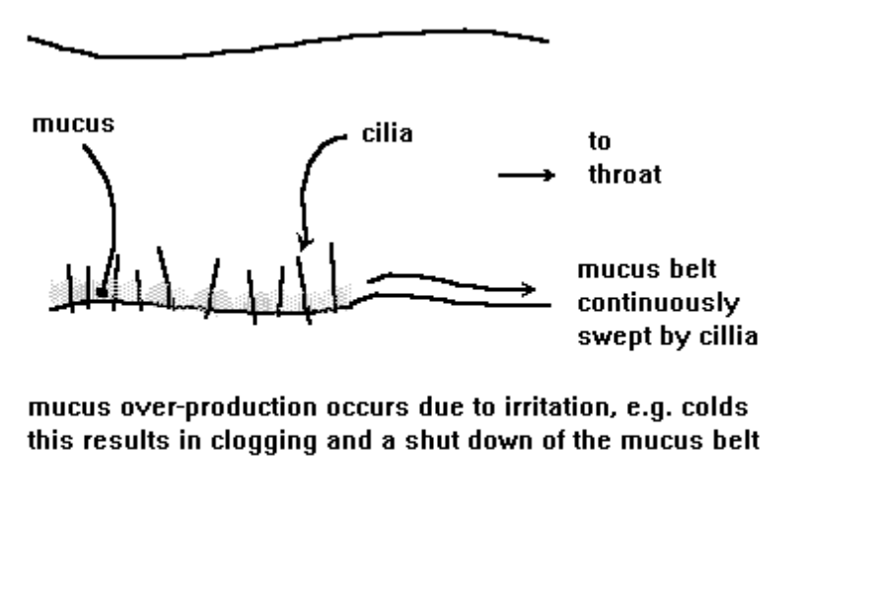
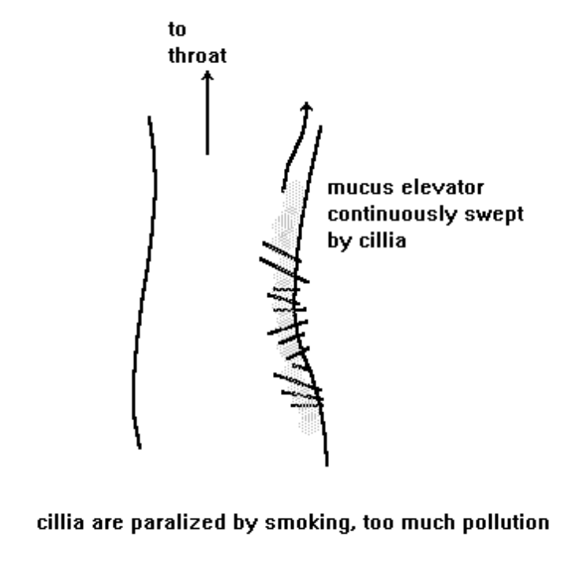

In the terminal branches in the alveoli, there are no mechanical removal processes. Instead, there are “sweeper” cells. The sweeper cells:

- may find their way to the mucus elevator
- may work through the alveolus wall into a) the lymph system - people who live in polluted cities have lots of metals in their lymph nodes - and may end up being passed in to the blood; or b) the blood system - where particles are cleaned out in the kidneys. Small particulates have been found imbedded in cardiac tissue – implying that they were able to migrate into and remain in the body.

Some particles remain imbedded in the sweeper cells. Others go directly to the lymph fluid or the blood. 50% of lead particles get into the blood because lead halides are very soluble.

Abnormalities form in the lungs because of particle overload.

Say that 10 particles per minute are deposited in an alveolus. 2 particles per minute are removed by sweeper cells. Hence, 5 sweeper cells per minute are needed in an alveolus to remove particles. The rate of sweeper cell production is adjusted accordingly by the body.

Now, 50 particles per minute are deposited. The need for sweeper cells rises to 25 per minute.

If the particle deposition increases to 500 particles per minute, 250 sweeper cells per minute are needed.

Then the particle deposition rate suddenly drops to 50 particles per minute. But because of the time lag of biofeedback to maintain homeostasis (balance), excess sweeper cells continue to be produced for a time. Eventually, the excess sweeper cells die in about 5 days.

The dead sweeper cells in the alveoli are solubilized by the enzyme trypsinase, a protein dissolver. Excess trypsinase is controlled by another enzyme, alpha-antitrypsinase. Inadequate alpha-antitrypsinase production leads to destruction of lung tissue. This causes scarring, thickening of the alveoli wall, loss of gas transport, loss of wall elasticity: emphysema. High levels of alpha-antitrypsinase in the blood can indicate emphysema.

In summary, it is the smaller particulates, < 0.5 microns or so, that are able to penetrate to the alveoli. Particles of this size, 0.1 to 1 micron, that are suspended in air are classified as aerosols. Note that the typical size range of particulates emitted from CI engines burning diesel fuel is 0.01 to 0.20 μm.

Aerosol Mechanics

An aerosol is a suspension of particles in a gas. The particles remain suspended over a time scale of interest.

The number density or aerosol density is the number of particles in a cc of gas.

number density (#/cm³) | comments
10³ | clean air
10⁵ | polluted air
10¹¹ | modified chemical vapor deposition

Compare the values in the table to the number density of an ideal gas at STP:

n_{g} = 10¹⁹ /cm³

Aerosols must be stable with respect to settling, i.e., the settling velocity is “small.”
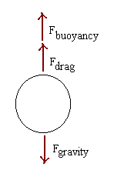

The buoyancy of a single particle is the weight of the fluid displaced by the particle:

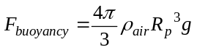

The drag on a single particle is calculated with

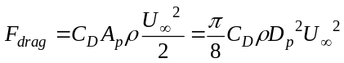 Stokes’ Law

where C_{D} is the empirically determined drag coefficient and U∞ is the particle velocity.

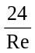 Re < 0.1 Stokes’ Law - most aerosols are in Stokes’ regime
C_{D} = 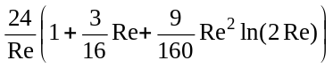 0.1 < Re < 2
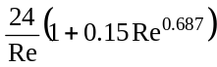 2 < Re < 500
0.44 500 < Re < 2E05

For spherical particles falling at their terminal velocity in air at STP:

D_{p} (μm) | Re
20 | 0.02
60 | 0.4
100 | 2
300 | 20

For particles smaller than about 20 microns in diameter, Stokes’ law is an accurate formula for the drag force exerted by the air.

Because aerosol particles are small, the particle diameter may be the same order of magnitude as the distances gas molecules travel between collisions. If this is true, the continuum transport equations need to be modified. The deciding factor for whether or not to correct the equations is the value of a dimensionless factor: the Knudsen number, Kn.

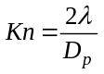

where is the “mean free path,” MFP, of the fluid, i.e., the average distance gas molecules travel between collisions with other gas molecules.

If the size of the particle is much greater than the MFP, Kn << 1, the particle is said to be in the continuum regime, and continuum mechanics applies.

When the particle is much smaller than the MFP, Kn >>1, the particle is said to be in the free molecular or kinetic regime, and the kinetic theory of gases is used to describe the transport of the particle.

When the MFP and the particle are the same order of magnitude, Kn ~ 1, the particle is in the transition regime, and corrections to the continuum equations are used.
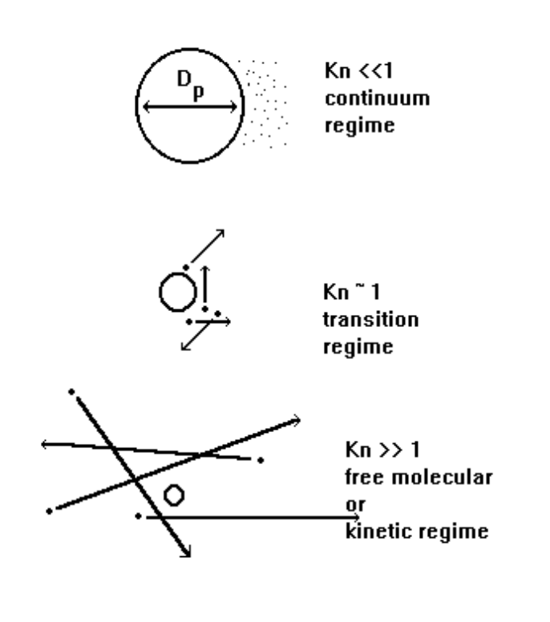
The MFP of a gas is calculated with

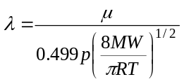

where is in m, p in Pascals, MW is the molar mass and is the gas viscosity. For air at 298 K and 1 atm, is 1.8E-05 kg/ms and

= 0.0651 m.

Hence, for particles in air, the transition regime holds for particles between 0.01 to 0.2 microns:

Particle Size | Transport Regime in Air
R_{p} ≤ 0.01 μm | free molecular
0.01 < R_{p} < 0.20 μm | transition
R_{p} ≥ 0.20 μm | continuum

To account for non-continuum effects when D_{p} ~ MFP (the resistive force of the fluid is smaller than that predicted by Stokes’ law), a “slip” correction factor is used. The term comes from small particles that can “see” the vacuum between gas molecules and “slip” between them. Hence, the resistance of the gas molecules to the particle’s motion is less and the drag force must be adjusted.

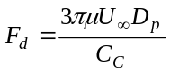

The slip correction factor, or Cunningham correction factor, C_{C}, is defined as

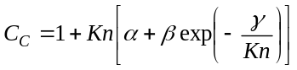

where

= 1.257
= 0.40
γ = 1.10

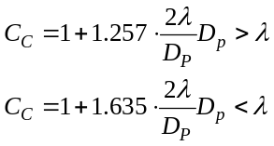

In air:
D_{p} (μm) | C_{c}
0.01 | 22.70
0.05 | 5.06
0.10 | 2.91
0.50 | 1.337
1.00 | 1.168
5.00 | 1.034
10.00 | 1.017

The slip correction factor is generally neglected for particles exceeding 10 μm in diameter.

The motion of particles due to external forces is important in the design of particulate collection devices. For example, electrostatic precipitators require knowledge of particle motion due to the action of electrical forces. We can calculate the terminal settling velocity of particles subjected to gravity, the time required for these particles to reach their settling velocity, and the trajectory of particles in separators such as cascade impactors.

