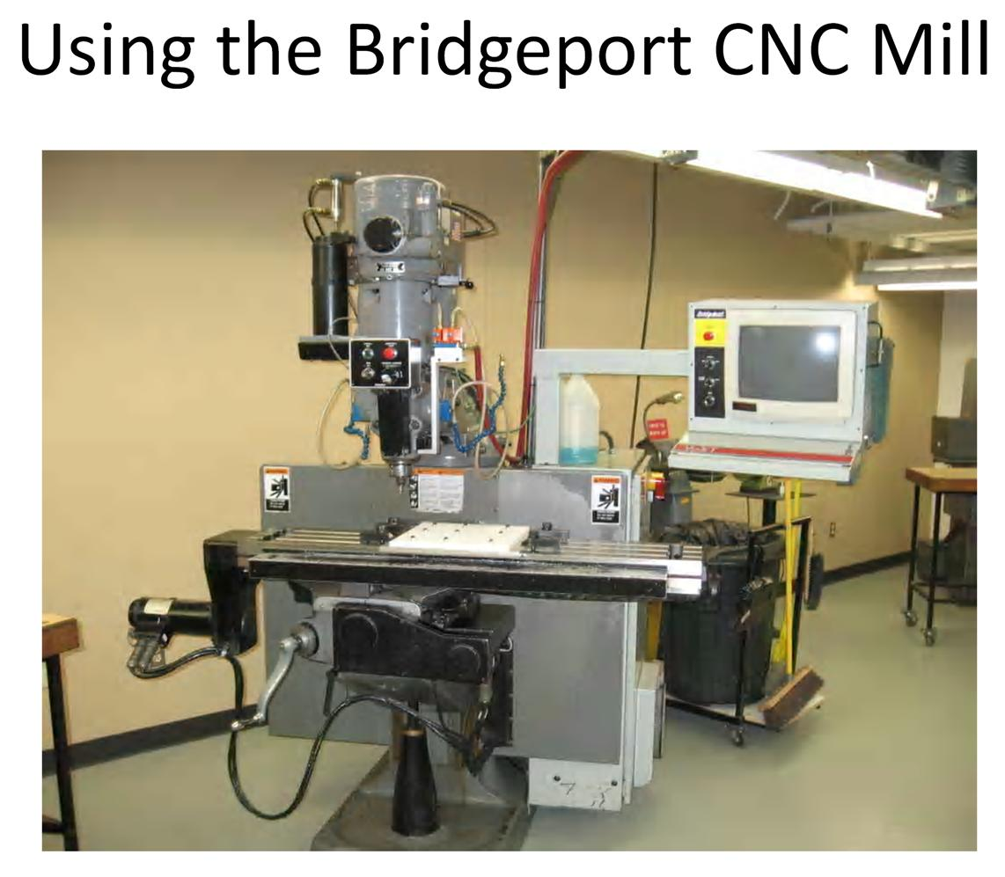

Using the Bridgeport CNC Mill

Making the part in MasterCam
1. Load SolidWorks file into MasterCam.
2. Begin selecting operations and defining them as described in MasterCam Instructions.
NOTE: Operations for the Bridgeport should have a home position defined in MasterCam
away from the part for tool changes.
3. After all operations have been defined, post the operations and save onto a floppy disk.

Setting Up the Mill
1. Flip switch on back of mill to “on.”
NOTE: The Bridgeport does not have a warm-up cycle for the spindle.
2. Press 7 to Enable the axes drives.
3. Press 8 twice to home the axes.
4. Set-up clamps and/or vise as desired for job.
5. Press 0 to enter the Basic menu
6. Press 9 to enter the Hand Jog menu.
7. (Z-axis) Zero each tool
NOTE: It may be necessary to use short mills since the Z travel is only 5 inches. It may be
helpful to Zero the longest tool first in order to avoid having to re-Zero all the tools.
a. Place holder into collet and rotate clockwise until tool slips up into collet.
b. Tighten collet by hand and tighten a fraction more with the collet wrench.
c. Hand jog the tool over the zeroing surface by pressing 1, 4, or 7 for the axis of motion and 2
or 3 for fast or slow jogging. Turn dial for positive or negative motion.
d. Bring Spindle down near surface.
e. To protect the surface, bring the spindle down onto a feeler gauge until the feeler gauge rubs
on the tool when passed underneath.
f. In Hand Jog menu, press F8.
g. Press * then the Enter key.
h. Enter the feeler gauge thickness. Press Enter.
NOTE: If using the same gauge thickness for each tool, skip step h for future tools.
i. Enter the tool number then press the Enter key.
NOTE: This number must correspond to the tool number in the G-code.
j. Enter the diameter of the tool. This number is for user reference only.
k. Press F9 to bring the spindle up.
l. Repeat steps a – g for each tool.
8. Press F6 to set the X-axis.
9. Press F7 to set the Y-axis.
NOTE: Account for the thickness of the edge finder like on the manual mills.
Loading the Program
1. Insert floppy disk in drive.
2. Press 0 in the Hand Jog menu to get to the Basic menu.
3. Press F7 to load the program.
a. In the new screen the mill will locate in the hard drive (C:), so press Esc twice to back out to a
new path.
b. Press A to locate the A: drive, then the Enter key twice.
c. Arrow down to your program and press Enter.
d. Press “Y” to overwrite the previous file.
4. In the Basic menu, press 5 and Enter to reset the program to beginning.

Running the Program
1. Twist the switch to “Start” on the console. The mill will go to the Home position defined in
MasterCam.
2. Twist the switch to “Spindle Enable” simultaneously designating High or Low. The mill will start the
spindle.
3. Twist the switch to “Start” again. The mill will adjust the spindle to the speed set in your program.
4. Twist the switch to “Start” again with one hand poised above the Feed Hold button. This will start
the program.

Advanced Features
- Press 4 in the Basic menu to find tool numbers in your code (reset the program first)
- Press F9 after emergency stop in order to access the Hand Jog menu.

