Data Transfer from Mastercam X2 to Bridgeport CNC Mill
(floppy disk is the only option)

PART ONE: Save the Code to 3.5” Floppy Disk
- Make sure MasterCAM is talking to the correct CNC machine. If you see “Generic” next to “Properties” then you are NOT connected to the correct machine.
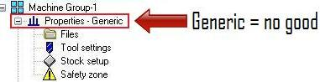
- To assign a specific machine to MasterCAM (for post-processing purposes) expand “Properties” under “Machine Group” and double click “Files”.

- To choose a specific CNC machine, click the “Replace” icon in the “Machine Group Properties” window. After you select “Replace” a new window appears titled “Open Machine Definition File”. Select the Bridgeport Mill file and then click “Open”.
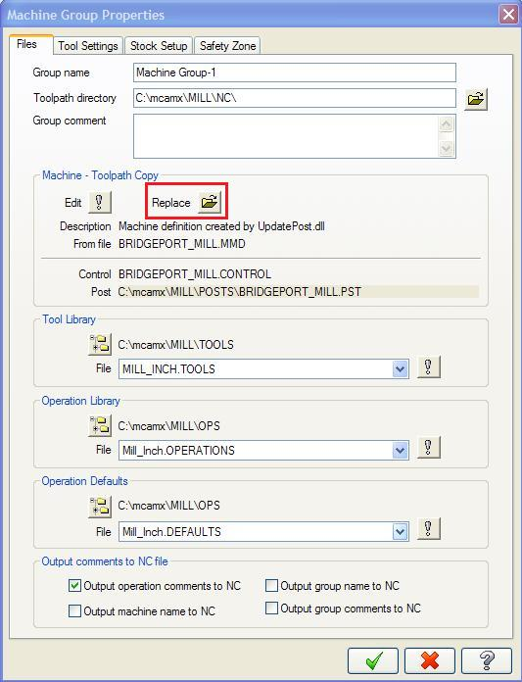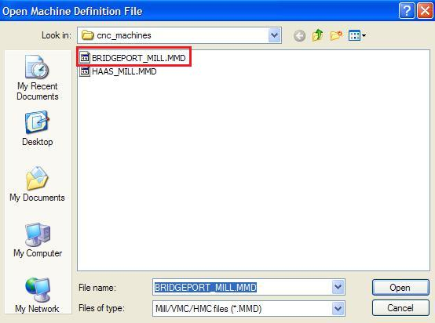
Select the “OK” button from the “Machine Group Properties” window to complete the machine assignment.
- In the “Toolpaths” window press the “Select All Operations” button. Then select the “Regenerate All Selected Operations” button.

- Select the “Post Selected Operations” button. This will bring up the “Post Processing” window shown below. Make sure the “Send to Machine” check box is NOT selected as shown below. 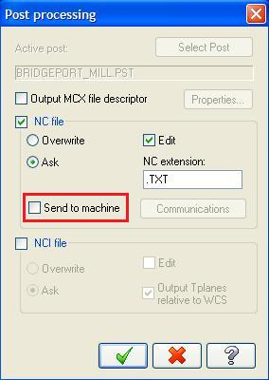

- Insert a 3.5” floppy disk into your computer station. Click the okay button in the “Post Processing” window. A new window will appear titled “Save As”. Select your floppy drive as the destination folder. Enter a file name that you will remember and click the save button when finished.
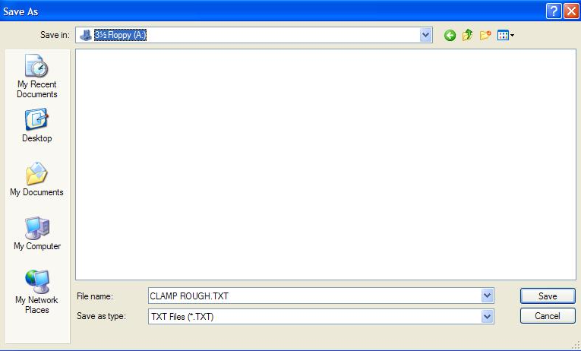

- After you save your TXT file a new window will appear showing all of the code that will be sent to the disk. When you close this window the data will be sent to the 3.5” floppy disk automatically.

PART TWO: Retrieving Code from the Disk on the Bridgeport Mill
- Insert the floppy disk into the Bridgeport’s floppy drive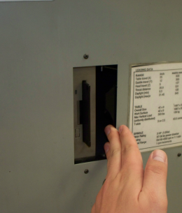.
- You may be asked if you want to overwrite an existing file that was previously loaded on the mill. Ignore this overwrite message and just press the escape key to get to the Basic Menu.
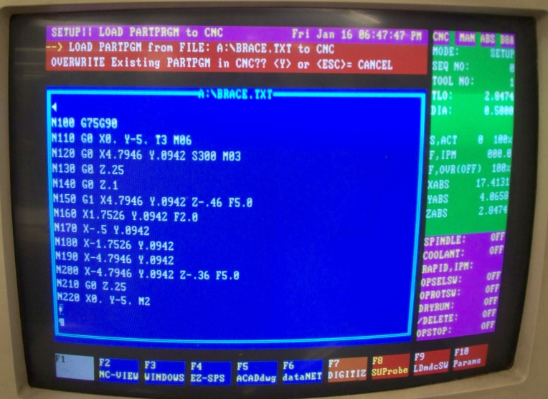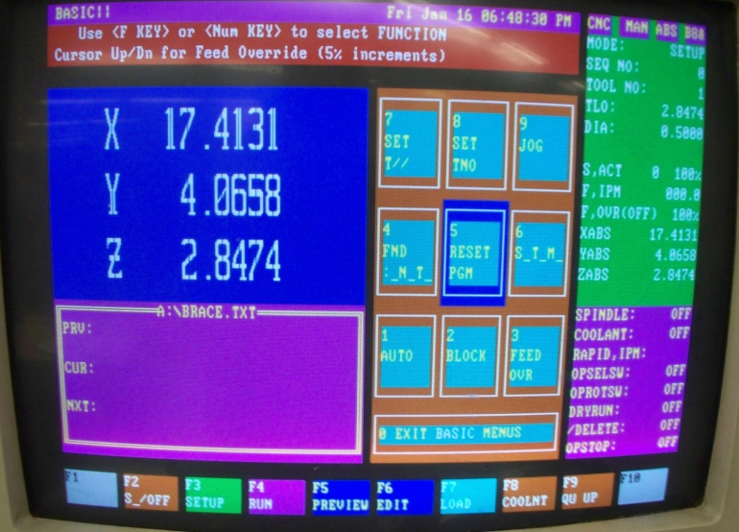
- Press the F7 key to load from the floppy disk. By default the program will point to the local C:\ hard drive. Press the escape key twice to specify the file path to the floppy disk. Press the letter A to specify the floppy drive and then press the Enter key twice. Use the arrow key to highlight the file you want to load and press the Enter key.
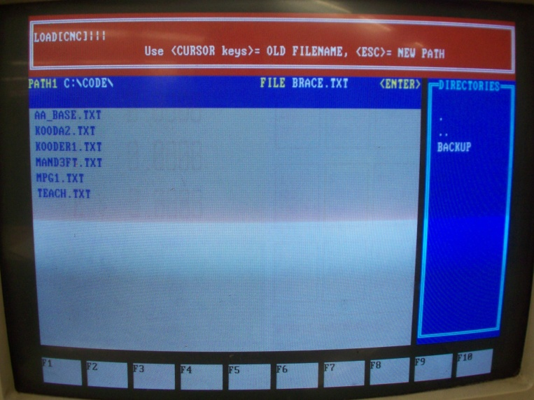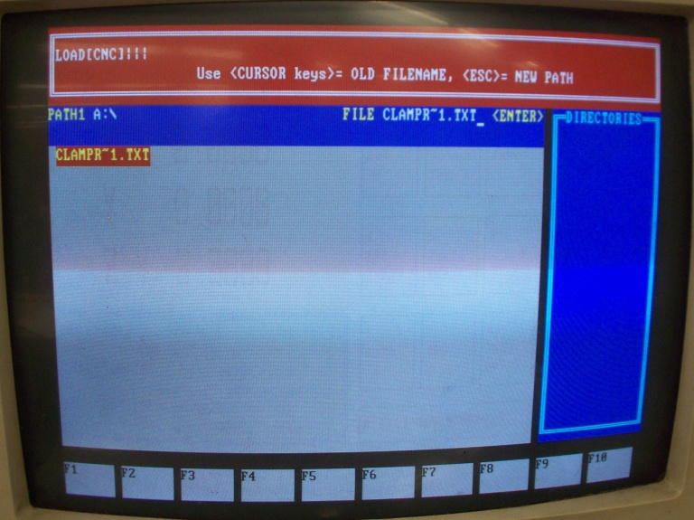
- A screen will ask you if you want to overwrite existing data. Press the “Y” key to confirm and overwrite. On the next screen press the number 5 and then Enter to reset the program. The Bridgeport is now ready to run the code.
