Practice Problems (8 points)

- Imagine that you have a very long tungsten wire being suspended from a high-altitude balloon. If tungsten has a weight density of 190 kN/m³, and ultimate strength (breaking strength) of 1500 MPa, calculate the following:
  - How high (meters) can the cable can get off the ground before breaking
  - What location will the cable likely break? Why?

- The figure below represents a pickup truck tailgate with a load on the end. There are actually two cables (one on either side of the tailgate), each having a cross-sectional area of 0.018 in². Do the following:
  - Draw a FBD of the tailgate (just the tailgate, not the whole assembly).
  - Assuming the crate is equidistant from each cable, calculate the tension force (lb_{f}) in each cable.
  - Calculate the normal stress (psi) in each cable.
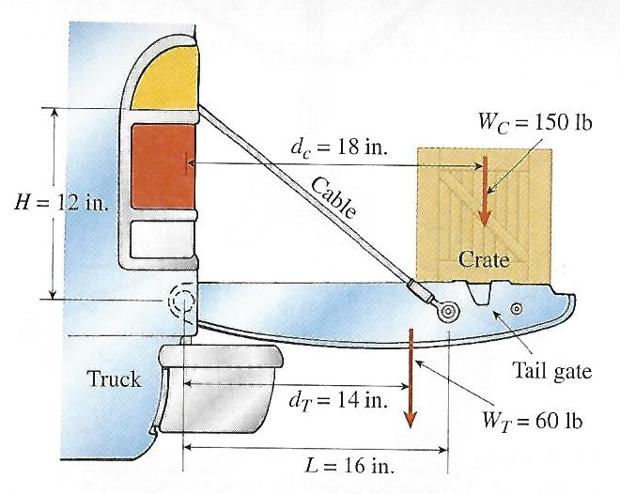

Preparation for Next Class Period (6 points)
Note: Write down enough to show that you’ve done the following things to prepare for our next class session. This part of your homework can all be on a single page. It can be typed up, hand-written, or a combination of both. Put this at the end of your homework packet.

- Practice Two-Bar assembly problems by reviewing MM Module M1.4, and doing the “Try One” exercise at the end to solve for P, F₁, and F₂. You only need to turn in your scratch paper work for solving the problem (not full engineering documentation)
- TB Reading 1.3 and 1.4
  - What are two real-world examples where you would prefer to have the max shear force of a pin be lower than the max shear force of the plates?
  - In Example 1.8 there are several types of stress states. Make a drawing that shows the surface area that corresponds to bearing stress on the pin.
  - Write down any questions you have about the materials from reading sections 1.3 and 1.4.
- Log in to vlab.uidaho.edu and see if you have access to TK Solver. If not, what is your favorite simultaneous equation solver? If you don’t have access, but would like to, mention this during the HW review next class period.

