Practice Problems (8 points)

- Look at the example problem M1.5 in the textbook (also in MM Module 1.5). Use this figure to calculate the following:
  - What is the normal stress [MPa] in the round aluminum rod AB?
  - If the pins at A and B also have a max shear stress of 50 MPa, and they are in single shear, what is the minimum diameter [mm] required?
  - If the support at C were in single shear, what is the minimum diameter [mm] required?

- The figure below represents a glued finger joint, and the thickness of the boards is 19 mm. The adhesive can hold a maximum shear stress of 950 kPa. If a = 20 mm, b = 260 mm, and you want the joint to withstand a tensile force of P = 5900 N, calculate the depth of fingers (d, in mm) necessary.
Note: The image below shows 7 shear surfaces. With the dimensions above there will be more fingers, and you should get more like 12 shear surfaces)
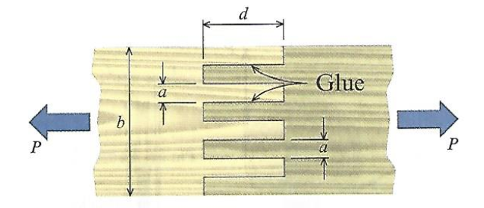

Abbreviated Practice Problems (4 points)
For these practice problems, only do steps 1-4 in the engineering documentation. Make sure your plan is descriptive and clear enough that any ENGR 350 student should be able to follow it and get to a correct answer.

- The figure below represents a bolted connection in double shear. If each bolt must stay below an average shear stress of 30 ksi, and the load P will be 180 kips, what is the minimum bolt diameter necessary?
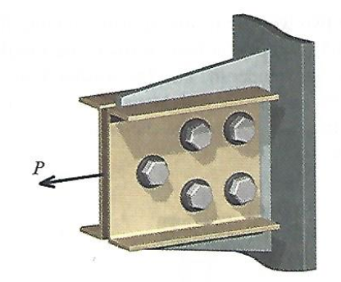

- The figure below shows two wooden boards connected by a bolt. The bolt is tightened such that there is a tensile stress of 10 kpsi in the bolt. The bolt has an outer diameter of 0.375 in. Each washer has an inside diameter (d) of 0.4375 in, and an outer diameter of 1.5 in. Calculate the bearing stress between the washer and the wood.
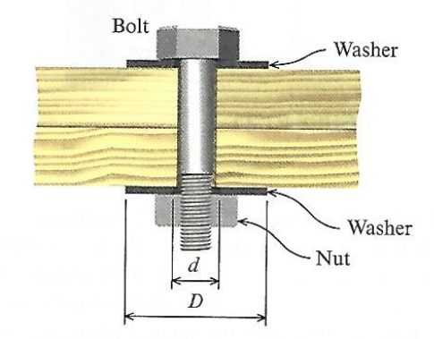

Preparation for Next Class Period (8 points)
Note: Write down enough to show that you’ve done the following things to prepare for our next class session. This part of your homework can all be on a single page. It can be typed up, hand-written, or a combination of both. Put this at the end of your homework packet.

- Review the various shear stress presentations in MM Modules 1.5 through 1.9. Make sure you have a solid understanding of how the average shear stress is calculated for the cases of:
  - Pinned Supports
  - Bolted Flanges
  - Single and Double Shear
  - Keyways
  - Punching Shear

- TB Reading 2.1 and 2.2
  - What Greek letter is used to represent normal strain? What Greek letter is used to represent shear strain? What is the equation for average normal strain?
  - What is the sign convention for normal strain?
  - Does strain have dimensions? If so, what are common dimensions for strain in English and SI units?
  - What is meant by a “rigid bar” in Mechanics of Materials?
- Review MM Modules 2.1, 2.2, and 2.4. Write down any questions you have from these modules and be ready to ask them in the next class.
- Complete the “Try One” exercises in M2.1 and 2.2. Attach the page(s) you used to solve these problems.

