Practice Problems – Short Documentation (12 points)
For these 3 problems, the Given, Find, and Solution are the only required documentation.

- In the figure below there are seven bolts in double shear used to connect the bar to the support. A tensile load of P = 1225 kN is applied to the end of the bar. The ultimate shear strength of each bolt is 320 MPa. Using a safety factor of 2.5 and ASD method, calculate the minimum diameter of the bolts (if all bolts are the same size)

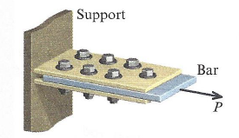

- A side and top view of two bars and two splice plates is shown in the figure below. The splice plates are much, much stronger than the bar and bolts. Each bar has dimensions of b = 0.625 in, and t = 0.25 in. The ultimate tensile strength of the bar material is 3,100 psi, and the ultimate bearing strength of the bar material is 2,000 psi. The bolts have a diameter of 0.375 in each, and an ultimate shear of 4,000 psi. If a safety factor of 3.5 is required, use the ASD method to calculate the maximum allowable force P. Remember to check tension, bearing, and shear stresses.

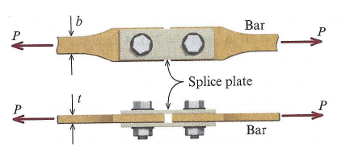

- A round steel rod is in tension supporting a dead load of 90 kN, and a live load of 120 kN. The yield strength of the steel material is 320 MPa.
  - Use the ASD method with a factor of safety of 2.0 with respect to the yield strength to calculate the minimum diameter of the steel rod.
  - Use the LRFD method to calculate the minimum diameter for the steel rod on the basis of yielding. Use a resistance factor of 0.9, a dead load factor of 1.2, and a live load factor of 1.6.

Preparation for Next Class Period (6 points)
Note: Write down enough to show that you’ve done the following things to prepare for our next class session. This part of your homework can all be on a single page. It can be typed up, hand-written, or a combination of both. Put this at the end of your homework packet.

- TB Reading sections 5.1 through 5.4.
  - Sketch a picture showing how Saint-Venant’s Principle can be used to treat a point load like a distributed load.
  - What is the force-deformation equation? What conditions need to apply for this equation to be valid?
  - Write down any concepts you find confusing or want to discuss during next class

- Review MM Modules M5.3 and M5.4 (don’t need to turn in anything for this review)

