Practice Problems – Short Documentation (8 points)
For these 2 problems, the Given, Find, and Solution are the only required documentation.

- The figure below shows three solid cylinders that have been welded together on a common axis. The rectangle base at A is fixed and rigid. All the cylinders have a modulus of elasticity of 40 GPa. The dimensions are:
L₁ = 1440 mm A₁ = 260 mm²
L₂ = 1680 mm A₂ = 130 mm²
L₃ = 1200 mm A₃ = 65 mm²
Calculate the magnitude of P so that the displacement at D will be 60 mm to the right.

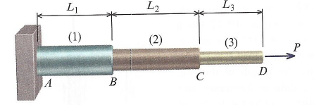

- A rectangular bar with a slot is shown below. Dimensions are L = 400 mm, b = 45 mm, E = 72 GPa, and the thickness is t = 8 mm. If load P is 18 kN, calculate total elongation of the bar.

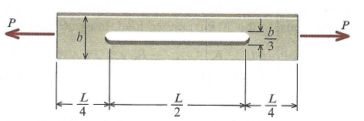

Practice Problem – Full Documentation (4 points)
For this problem, all 7 steps of the engineering problem-solving documentation are required (Given, Find, Expected Solution, Plan, Solution, Check, and Reflection).
- A homogeneous rod with length L and elastic modulus E is shown in the figure below. The diameter varies linearly from d₀ at one end to 2*d₀ at the other end. An axial load of P is applied to each end. Do the following (as functions of the variables given in the problem)
  - Determine the stress distribution of a cross-sectional area at arbitrary location of x (so long as x is between 0 and L).
  - Determine the total elongation of the rod.

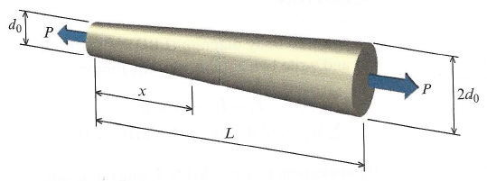

Preparation for Next Class Period (4 points)
Note: Write down enough to show that you’ve done the following things to prepare for our next class session. This part of your homework can all be on a single page. It can be typed up, hand-written, or a combination of both. Put this at the end of your homework packet.

- TB Reading sections 5.4 through 5.5.
  - How can you tell if a problem is statically determinate vs. statically indeterminate?
  - Review the solution methodology for statically indeterminate problems and write down any steps you don’t understand so they can be discussed during next class

- Preview MM Modules M5.5 and M5.10 (don’t need to turn in anything for this review)

