Practice Problems – Short Documentation (24 points)
For these 6 problems, the Given, Find, and Solution are the only required documentation.

I have posted my TK Solver file on the Mindworks site (as a *.zip). You should be able to unzip this to a *.tkw file, and open that in the TK Solver software. However, you are free to use your calculator, or your favorite equation solver to solve these problems.

For the next four problems, determine the normal stress in the n and t directions, and the shear stress in the nt direction. For each problem make sure to document your input values for:
σ_{x} = ___, σ_{y} = ___, τ_{xy} = ___ , and θ = ___

Then show your calculated values for: σ_{n} = ___, σ_{t} = ___, and τ_{nt} = ___

- 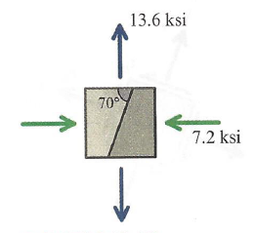
- 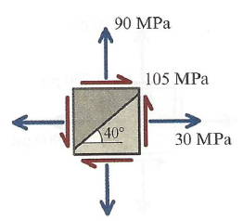

- 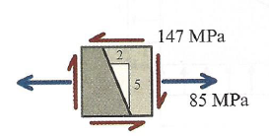
- 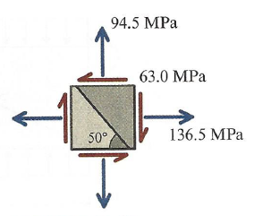

For the next two problems, starting with the given stress state on the left, determine the values of σ_{n} , σ_{t} , and τ_{nt} in the orientation shown to the right.

- 

 