Practice Problems – Short Documentation (23 points)
For these 8 problems, the Given, Find, and Solution are the only required documentation.

- (15 points)Play the Mohr’s Circle game (MM Module 12.11). You will have three rounds of five questions each. When finished, type in your name and print your results.

For the next two problems (4 points each), draw a Mohr’s Circle on the sheet provided. On your circle calculate the value and label the following parameters:
- Stress on x-face
- Stress on y-face
- σ_{p1}, and σ_{p2}
- 2θ_{p} (including direction)
Also, show your calculated values for:
- Center
- Radius
- σ_{p1}, and σ_{p2}
- θ_{p}
- τ_{max (in-plane)}
- σ_{ave}

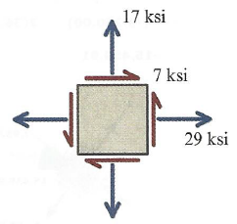
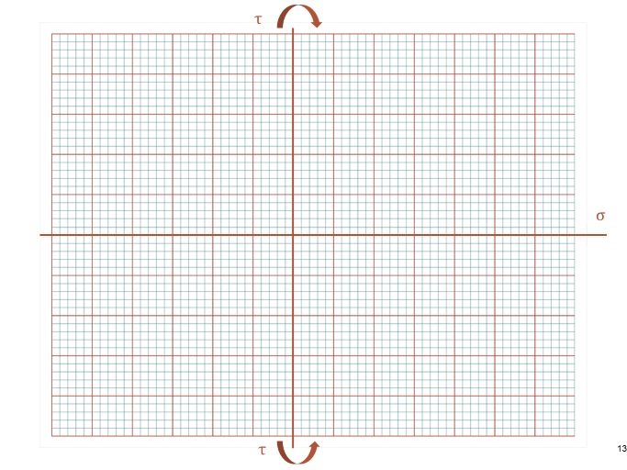

- Center =
- Radius =
- σ_{p1} =
- σ_{p2} =
- θ_{p} =
- τ_{max (in-plane)} =
- σ_{ave} =

ENGR350, HW19, Problem 2

Name: _____________________________

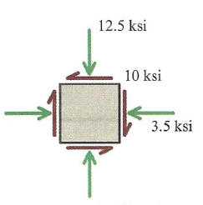
ENGR350, HW19, Problem 3

Name: _____________________________

- Center =
- Radius =
- σ_{p1} =
- σ_{p2} =
- θ_{p} =
- τ_{max (in-plane)} =
- σ_{ave} =

