Practice Problems – MecMovies (10 points)
Make sure you do this assignment at a machine that can print your final page.

MM Module 6.1 has a bunch of concept checkpoints to help you check your understanding. Make sure you have a solid understanding of:
- Finding the torque on a shaft with multiple torque inputs (including sign convention)
- Calculating shear stress on a shaft
- Calculating angle of twist on a shaft

Complete the ten problems in the M6.1 Torsion Concepts module. At the end, type your name and print out the sheet as part of your assignment.

Practice Problems – Short Documentation (4 points)
For this problems the Given, Find, and Solution are the only required documentation.

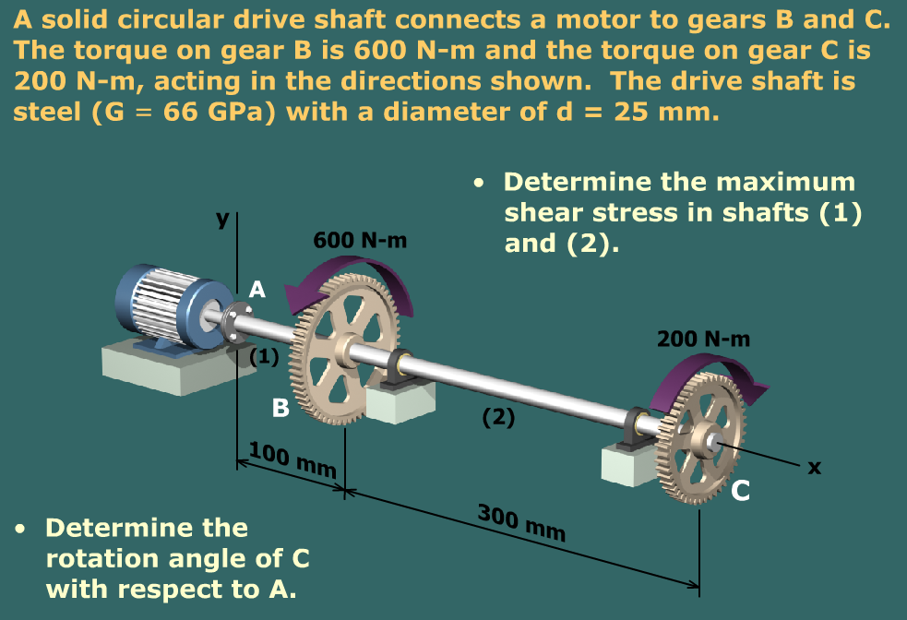

Pre-Class Preparation (0 points)
- In your textbook, read the sections about shear and moment diagrams (Section 7.1 to 7.3 in the 4th edition)

