Practice Problems – MecMovies (0 points)
Make sure you do this assignment at a machine that can print your final page.

- In preparation for next class, go through MecMovies M9.3 and play the game (Rounds 1 – 4). Make sure you’re confident enough in this topic to score:
  - A 160 in Round 1
  - A 210 in Round 2.

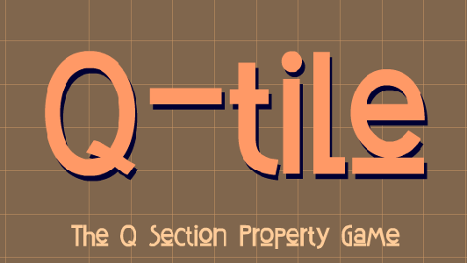

Yes, it is April Fools today, but this homework assignment is legit. There is nothing you need to turn in, and no points associated with it.

