Practice Problems – Short Documentation (16 points)
For these problems, the Given, Find, and Solution are the only required documentation.

- Cylindrical boiler has an outside diameter of 1.85 m, a wall thickness of 12 mm, and a yield strength of 75 MPa. Calculate the following:
  - If internal pressure is 1.76 MPa, find maximum normal stress
  - If internal pressure is 1.76 MPa, find maximum shear stress
  - If a factor of safety of 2.5 with respect to yielding must be maintained, find the maximum allowable pressure inside the tank

- The pressure tank on the South end of GJ is roughly 17 ft long, has a 6.5 ft diameter, and a wall thickness of 0.4375 in. The tank is rated to hold 130 psi inside. The tank is made of steel with elastic modulus of 30 ksi, and Poisson’s ratio of 0.3. Calculate the strain (microstrain) in two directions:
  - One direction oriented in direction of hoop stress
  - One direction oriented in direction of longitudinal stress

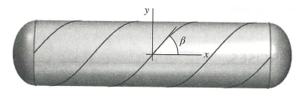
- Pressure tank shown above is fabricated from spirally wrapped metal plates with an orientation of β = 65°. The ID of the tank is 1.25 m, and wall thickness is 12 mm. If the gage pressure inside the tank is 2.15 MPa, calculate (in-plane):
  - Normal stress perpendicular to the weld
  - Shear stress parallel to the weld

- Work the “Try One” exercise at the end of MM M8.20. When finished, type in your name and print out the sheet with your result.

