Step 1: Verify your user information.
You will receive an email (if not in your inbox, check your junk mail).
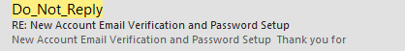

Please open the email and click on the verify email set password.
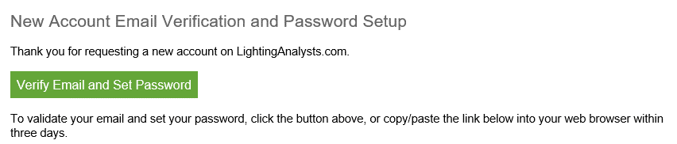

Step 2: Obtain the software download and install.
Visit Lighting Analysts, Inc. homepage at www.lightinganalysts.com.
Scroll down one page to find the product lineup.
Click on the ‘Try’ Button to obtain the download.
Run the installer and find the application icon on your desktop.

Step 3: Activate your subscription.
Run the application and the License Manager will open.
Instructions for activating are linked in the License Manager.
Click on ‘Activate Subscription’
Enter your email address (verified above)
Enter your University LAI account number: LAI3206EDU
Enter your name
Submit

The License Manager will inform you about a Pending Email.
Please check your email (if not in your inbox, check your junk mail).
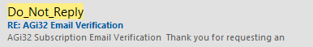

You MUST open this email and click on the Verify Email link.
