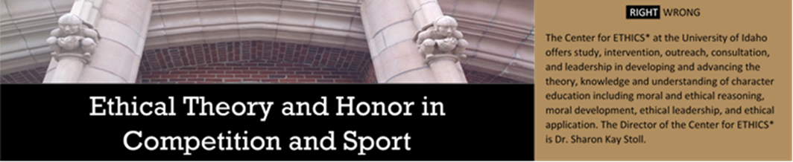
Dr. Aubrey Shaw, Dr. Stoll’s 38th doctoral student, reviewed an article for Sport Coach America.

Dr. Stoll and her 47th doctoral student, Amanda Palmer, presented virtually at the 2022 Commission on Sport Management Accreditation Conference.

Palmer, A. C., & Stoll, S. K. (2022, February 3). Development of the Sport Management Values Inventory: A measurement instrument for evaluating the impact of sport ethics curriculum requires for COSMA accreditation [Conference session]. 2022 COSMA Conference. Commission on Sport Management Accreditation.

Dr. Aubrey Shaw was a guest speaker for ED 680, Writing for Publication. University of Idaho, College of Education.

Shaw, A. H. (2022, January 27). Why publish within the doctoral program and what does it take? University of Idaho.

Dr. Aubrey Shaw, Dr. Stoll’s 38th doctoral student, is continuing her role as an editorial board member for Physical and Health Education America for the year 2022.

Dr. Stoll and her 38th doctoral student, Aubrey Shaw, submitted a second review for their article in the Journal of Physical Education, Recreation, and Dance.

Shaw, A. H., & Stoll, S. K. (2nd review). Limitations of the law and regulations for including students with physical disabilities in physical education. Journal of Physical Education, Recreation, and Dance.
Dr. David Brunner, Dr. Stoll’s 18th doctoral student, is advancing his human performance work to focus upon biometric data collection and analysis in real time concurrent with the development of his Human Performance Virtual Reality Lab which provides education and training drills in cognitive enhancement related primarily to the management of attention-energy and thoughts. Dr. Brunner is with the United States Army.

Dr. David Brunner’s, Dr. Stoll’s 18th doctoral student, article was published in Sport Coach America.

Brunner, D. (2021, July 21). Always be coaching: Maximizing opportunties to teach your athletes. Sport Coach America. Retrieved from https://sportcoachamerica.org/always-be-coaching-maximizing-opportunities-to-teach-your-athletes/

Upcoming Events
Dr. Stoll will be a panelist, Legacy of Title IX, for an upcoming program on Celebrating Fifty Years of Title IX at LCSC, March 7, 2021. Flyer attached.

Dr. Stoll, a former postdoc student, Heather Van Mullem, PhD, and Dr. Stoll’s 38th doctoral student, Aubrey Shaw’s, PhD, journal article in Frontiers in Sports and Active Living will be submitted in March 2022.

Van Mullem, H., Shaw, A., & Stoll, S. (accepted). Women are not monolithic: Challenges and barriers of women with physical disabilities in sport. Frontiers in Sport and Active Living.
Dr. Stoll, her 2nd doctoral student, Jennifer Beller, PhD, and her 38th doctoral student, Aubrey Shaw, PhD, will be presenting at the 2022 Shape America National Convention and Expo which will be held in New Orleans in April.
Shaw, A. H., Stoll, S. K., & Beller, J. (accepted). Was Oliver, right? Do university instructors support physical disability inclusion? [Conference session]. 2022 Shape America National Convention and Expo.
Dr. Stoll and her 38th doctoral student, Dr. Aubrey Shaw, will be presenting for the 2022 “By You, For You” SHAPE America Webinar Series which will occur in May 2022.

Shaw, A. H., & Stoll, S. K. (accepted). Include students with physical disabilities? Have the right attitude [Webinar session]. By You, For You SHAPE America Webinar Series.

Dr. Stoll and her 38th doctoral student, Dr. Aubrey Shaw, will be presenting at the Thirteenth International Conference on Sport and Society which will be held in June 2022 in Denmark.

Shaw, A. H., & Stoll, S. K. (accepted). Why otherly has meaning and power [Conference session]. Thirteenth International Sport and Society Conference.

Dr. Stoll and her 41st doctoral student, Elaine Foster, will be presenting at the Thirteenth
International Conference on Sport and Society which will be held in June 2022 in Denmark.

Foster, E., & Stoll, S. K. (accepted). Unlocking purpose, meaning, and motivation through embodiment and the aesthetic sport experience [Conference sesson]. Thirteenth Conference on Sport and Society.

