Dr. Stoll has been appointed by University of Idaho President Scott Green to serve as a member of the University of Idaho Committee for Ethical Guidance and Oversight. She will serve a three-year term in this position.

Dr. Stoll, her 38th doctoral student, Aubrey Shaw, PhD, and her postdoc student, Heather Van Mullem, PhD submitted an article for publication to The International Journal of Sport and Society.

Shaw, A. H., Stoll, S. K., & Van Mullem, H. (submitted). Women are not monolithic: Challenges and barriers for women with physical disabilities in sport. The International Journal of Sport and Society.
Mark Sowa, Dr. Stoll’s 39th doctoral student, will be presenting his dissertation proposal to his committee on May 25, 2022 at 1:00 pm in the College of Education Building Room 141. His dissertation proposal will be open to the public.

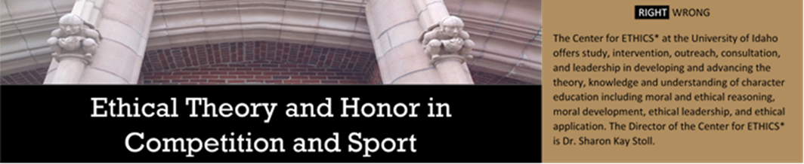
Sowa, M. (2022). Existential coaching education: A pedagogical pathway to alleviate anxiety and increase coping skills of collegiate female swimmers [Dissertation proposal]. University of Idaho.
Dr. Stoll’s, 45th doctoral student, Samantha Lewis, published an article within PHE America. You can read the article at: https://www.pheamerica.org/2022/where-are-all-the-female-track-field-coaches/

Lewis, S. (2022, April 13). Where are all the female track and field coaches? Physical and Health Education America. Retrieved from https://www.pheamerica.org/2022/where-are-all-the-female-track-field-coaches/

Upcoming Events
Dr. Stoll and her 38th doctoral student, Dr. Aubrey Shaw, will be presenting for the 2022 “By You, For You” SHAPE America Webinar Series which will occur in May 2022.

Shaw, A. H., & Stoll, S. K. (accepted). Include students with physical disabilities? Have the right attitude [Webinar session]. By You, For You SHAPE America Webinar Series.
Dr. Stoll and her 38th doctoral student, Dr. Aubrey Shaw, will be presenting virtually at the Thirteenth International Conference on Sport and Society which will be held in June 2022.

Shaw, A. H., & Stoll, S. K. (accepted). Why otherly has meaning and power [Conference session]. Thirteenth International Sport and Society Conference.
Dr. Stoll and her 41st doctoral student, Elaine Foster, will be presenting virtually at the Thirteenth International Conference on Sport and Society which will be held in June 2022.

Foster, E., & Stoll, S. K. (accepted). Unlocking purpose, meaning, and motivation through embodiment and the aesthetic sport experience [Conference sesson]. Thirteenth Conference on Sport and Society.
Dr. Stoll, her postdoc student, Heather Van Mullem, PhD, and her 38th doctoral student, Aubrey Shaw, PhD, will be presenting virtually at the Thirteenth International Conference on Sport and Society which will be held in June 2022.

Van Mullem, H., Shaw, A., & Stoll, S. (accepted). Women are not monolithic: Challenges and barriers for women with physical disabilities in sport [Conference Session]. 2022 International Sport and Society.
Dr. Stoll, her 38th doctoral student, Aubrey Shaw, PhD, and her postdoc student, Heather Van Mullem, PhD will be presenting at the National Consortium for Physical Education for Individuals with Disabilities 2022 Conference which will be held virtually in July.

Shaw, A., Stoll, S., & Van Mullem, H. (accepted). Being abled may limit your ability to teach those with physical disabilities [Conference session]. 2022 National Consortium for Physical Education for Individuals with Disabilities.

