THE EFFECTIVENESS OF STATIC STRETCHING AND MYOFASCIAL
FOAM ROLLING ON HAMSTRING FLEXIBILITY IN
NCAA DIVISION I FEMALE SOCCER PLAYERS

Submitted in partial fulfillment of the requirements for the

MVSC class 580

in the

College of Graduate Studies

at the

University of Idaho

By: Christopher J. Walsh

May 2015

Major Professor: Sharon Stoll Ph.D.

Table of Contents
Abstract iv
Chapter One 7
Introduction 7
Statement of the Problem 8
Statement of Sub-Problems 8
Hypothesis 9
Assumptions 9
Limitations 9
Definition of Terms 9
Variables 10
Need for Study 10
Chapter Two 12
Literature Review 12
Hamstring Strain in Sports 12
Industry Standard 13
Static Stretching 14
Myofascial Foam Rolling 15
Chapter Three 17
Methodology 17
Statement of Problem 17
Participants. 17
Apparatus 17
Figure 1: Foam Roller 18
Procedures 19
Data Collection Procedures / Instrumentation 22
Design and Analysis 22
Chapter 4 24
Results 24
Statement of the Problem 24
Chapter 5 26
Discussion 26
Appendix A 28
Consent Form 28
Appendix B 30
National Institutes of Health Certificate of Completion 30
Appendix C 31
IRB Approval Letter 31
References 32

Abstract
The purpose of this quasi experimental study was to examine the effect of three different hamstring stretching protocols: 1) static stretching only 2) myofascial foam rolling only and 3) static stretching and myofascial foam rolling on hamstring flexibility in selected NCAA Division I female soccer players. Sixteen individuals were recruited for this study from the University of Idaho Women’s soccer team. All participants were female and between the ages of 18-22. Two groups of five and one group of six was then randomly selected from the pool of sixteen study participants. The participants also read and signed an informed consent form prior to participation in the IRB approved study.
Group 1 was assigned a static stretching only routine that was performed on their hamstring muscle group. The assigned stretching protocols were completed following the soccer team’s pre-practice dynamic warm-up held at the beginning of organized practice sessions over a two week period during the spring soccer season. Subjects completed the assigned static stretch 3 times for 30 seconds each time on the left leg with a 10 second rest in between each 30 second stretch, and then repeated the same stretching procedures on the right leg.
Group 2 was assigned a myofascial foam roll stretching protocol that was performed on their hamstring muscle group. The assigned myofascial foam roll stretching protocol was completed following the soccer team’s pre-practice dynamic warm-up held at the beginning of organized practice sessions over a two week period during the spring soccer season. The foam rolling protocol consisted of 3 one minute sessions of following the 1 second inferior / 1 second superior movement pattern, with a 30 second rest following each repetition (C.L. Goad, 2004), the sane foam roll hamstring stretching protocol was then repeated on the right leg.
Group 3 was assigned a myofascial foam roll stretching protocol and a static stretching protocol. The assigned stretching protocols were completed following the soccer team’s pre-practice dynamic warm-up held at the beginning of organized practice sessions over a two week period during the spring soccer season. Subjects in Group 3 began by completing the identical supine static stretch protocol given to Group 1. Following the completion of the supine static stretch protocol, subjects were then provided foam rollers to complete the identical assigned myofascial foam rolling protocol given to Group 2.
The data collected from this study showed a significant difference in time (regardless of stretching group) on hamstring flexibility as measured by the standard sit and reach test Wilks Lambda (1, 10) = 27.45, p = .0001 (Table 1). All three groups significantly increased their flexibility over the 2 week time period. There was no difference found by group on hamstring flexibility as measured by the standard sit and reach test F (2,10) = .527, p = .60. There was no significant difference found with the interaction of group by time on hamstring flexibility as measured by the standard sit and reach test Wilks Lambda F (2, 10) = .427, p = .6. All three groups increased in flexibility by a mean total of 1 inch. Group 3 (combined static stretching and foam rolling) showed the most improvement in flexibility with mean increase of 1.25” while Group 2 (foam roll only) showed the least improvement with a flexibility increase of only .81”. While this study found significant increases in hamstring flexibility in all groups, the differences between the three stretching protocols was not statistically significant enough to determine which protocol was most effective in increasing hamstring flexibility. One participant was unable to complete the study due to injury, and two other participants were unable to complete the study due to scheduling conflicts. THEREFORE WHAT?
Leadership Program Faculty: S. Stoll, J. Beller (Statistics/Measurement, WSU Consultant)

Chapter One

Introduction
There is no questioning the fact that injuries and sport go hand and hand. While injuries are found to be detrimental to sport participation, athletic trainers and fitness experts are left to investigate and implement training techniques that will assist in the prevention of sport related injuries. Hamstring muscle strains have historically been one of the most common injuries affecting collegiate and professional athletes. “Over a 10-year span among the players of one National Football League team (1998–2007), the occurrence of hamstring strain injuries (n = 85) was second only to knee sprains (n = 120)” (Barnes, et al., 2008). Despite recent advances within the fields of strength and conditioning and biomechanics, hamstring muscle strains continue to plague athletes of all ages. Preventative stretching techniques and routines vary greatly within the world of fitness and athletics. Even with today’s modern day advances in exercise based research, healthcare professionals and fitness experts have been unable to determine and agree upon which stretching techniques are most effective in the prevention of hamstring muscle strains. Researchers point to the fact that current rehabilitation programs are primarily developed anecdotally and lack support from prospective, randomized research (Best & Sherry, 2004).
Hamstring muscle strains are unlike most injuries due to the fact that re-injury rates are much higher compared to other athletic related injuries. A study that tracked the recurrence rate of 858 reported hamstring strains of Australian Football players found that the cumulative risk of re-injury at 22 weeks post recovery was 30.6% (Orchard & Best, 2002, p. 4). As researchers continue to seek solutions that will assist in reducing the rate of hamstring strains in athletes, the use of myofascial foam rollers has become the method of choice found throughout much of the fitness and sports world today. The majority of physical therapy clinics, athletic training rooms, and fitness facilities incorporate myofascial foam rolling into their pre-activity stretching and warm up routines. Despite its sudden popularity very few research studies have been conducted in order to determine whether or not myofascial foam rolling effectively increases hamstring flexibility which would then theoretically reduce hamstring muscle strain injuries.

Statement of the Problem
The purpose of this quasi experimental study was to examine the effect of three different hamstring stretching protocols on hamstring flexibility in selected NCAA Division I female soccer players.

Statement of Sub-Problems
- What is the effect of stretching technique on hamstring flexibility as measured by the standard sit and reach test?
- What is the effect of stretching technique by group on hamstring flexibility as measured by the standard sit and reach test?
- What is the effect with the interaction of group by stretching technique on hamstring flexibility as measured by the standard sit and reach test?

Hypothesis
- No difference exists by Time on hamstring flexibility as measured by the standard sit and reach test.
- No difference exists by group on hamstring flexibility as measured by the standard sit and reach test.
- No difference exists with the interaction of group by time on hamstring flexibility as measured by the standard sit and reach test.

Assumptions
- The standard sit and reach test is a valid way of testing hamstring flexibility.
- All participants have learned how to stretch affectively.
- All participants have learned how to myofascial foam roll affectively.
- The physical capacities for all participants are within the normal range of college athletes.

Limitations
- The sample size is somewhat small making it difficult to collect statistically significant data from the study.
- The sample population is limited to collegiate soccer athletes making it hard to compare to the general athletic population.
- The sample population is limited to college soccer athletes at the University of Idaho making it hard to compare to other university populations.

Definition of Terms
- Static stretching is the elongation of a muscle to tolerance and sustaining the position for a specific length of time.
- Myofascial foam rolling is a stretching practice used to relax a muscle upon development of high tension thus improving soft tissue extensibility, relaxing the muscle and allowing the activation of the antagonist muscle.
- Flexibility is the ability of a muscle or extremity to relax and yield to stretch and stress forces.
- Intercollegiate athlete is an athlete who plays on an organized competitive college team.
- Hamstring strain is an acute injury that occurs as a result of a rapid contraction or violent stretch of the hamstring muscle group which causes various degrees of rupture within the musculotendinous unit.
- Sit and reach test measures the extensibility of the hamstrings muscle group by evaluating the maximal reach an individual can reach in a seated position.

Variables
Independent variable is the static and myofascial foam rolling stretching techniques
Dependent variable is the actual flexibility of the hamstring muscle group
Sampling will be a convenience, selected sampling group

Need for Study
Pre-activity warm up and muscle stretching routines are very important elements of a workout routine. Over the years much debate has centered around which stretching techniques are most beneficial in reducing muscle strains. Stretching is used to activate and elongate specific muscles involved in a given activity which then will theoretically reduce the rate of muscle strain injuries involving physical activity. Static stretching is the most commonly used stretching technique, but as the fitness industry continues to grow new stretching trends often challenge the effectiveness of static stretching. Over the last decade myofascial foam rolling has become a favored stretching technique throughout the fitness industry. Despite the popularity of myofascial foam rolling, very little research has been conducted in regards to its effectiveness upon pre-activity muscle elongation. This study sought to determine the effectiveness of myofascial foam rolling on hamstring flexibility when compared to the standard static stretch. The research data gathered in this study is beneficial to any physically active individual who is seeking to determine the most effective pre-activity stretching technique.

Chapter Two

Literature Review
The purpose of this quasi experimental study is to examine the effect of three different hamstring stretching protocols on hamstring flexibility in selected NCAA Division I female soccer players.

Hamstring Strain in Sports
In 2012 over 450,000 college students participated in NCAA governed athletics (Irick, 2012). With the increasing popularity of sports in today's society, the pressures of winning at all costs is being placed on the shoulders of young athletes like never before. With the increasing pressure to win, athletes are physically pushing their bodies to the limit. The bigger, faster, stronger training mentality is the new norm in training rooms and gyms throughout America. Collegiate athletes are taught to embrace this training ideal in preparation for competition. As participation rates in competitive sports continues to grow, acute muscle strains are occurring at higher rates than seen in the past. Hamstring strains are the third most common injury following knee and ankle injuries (Canale, Cantler, Sisk, & Freeman, 1981). Any sport requiring an athlete to kick will automatically pre-dispose them to greater risk of hamstring strains when compared to non-kicking sports. In a kicking motion, hamstring muscles will contract in order to decelerate the forward motion of the leg creating a strong eccentric contraction which can in turn lead to gross muscle tears within the hamstring muscles (Brockett, 2000). Hamstring tightness is considered a risk factor for muscle strains. Doctors Chaitlow and Liebenson suggest that decreased hamstring flexibility is the single most important characteristic of hamstring injuries seen athletes (Waseem, Nuhmani, & Ram, 2009). An injury audit that tracked 91 professional English professional football teams over two seasons discovered that hamstring strains accounted for 12% of the total injuries, with an average of five hamstring strains occurring per club per season (Woods, et al., 2004).

Industry Standard
In order to increase flexibility and decrease muscle strains, fitness and sport medicine professionals constantly search for new ways to improve stretching techniques to prevent injuries. Even though the methods for increasing muscle and tendon flexibility over a relatively long time is debatable, passive static stretching remains a popular method used in a pre-exercise warmup routines (Young & Behm, 2002, p. 33). Within the last ten years myofascial foam rolling has become one of the most preferred pre and post workout stretching techniques used in the athletic and fitness industry. In the last decade self-myofascial release by use of foam rollers has become an increasingly common modality to supplement traditional methods of treating the soft-tissue (Healey, Dorfman, Riebe, Blanpied, & Hatfield, 2011). It is a common belief that foam rolling helps your muscles relax by activating the sensory receptors connecting your muscle fibers to your tendons providing better blood circulation, which in turn speeds workout recovery and boosts performance (Men's Health, 2014). Even though the claimed benefits of foam rolling are touted and accepted throughout the athletic and fitness industry, very little experimental research has been conducted in order to determine whether or not foam rolling is truly beneficial.
Muscle relaxation and flexibility are the most widely claimed benefits of myofascial foam rolling. Traditional flexibility exercises such as static stretching is a well-known and a widely accepted technique within the fitness and athletic training profession. Studies spanning decades of research have been conducted in order to reveal the benefits of static stretching in regards to flexibility. How then has the unfounded practice of foam rolling become the new standard for stretching and flexibility? In order to gain a better understanding of the effectiveness of foam rolling and its potential benefits more research must be conducted in order to determine its effectiveness.

Static Stretching
Throughout the years a number of different stretching methods and practices have been developed, yet research findings differ based upon testing methods. Static stretching prior to physical activity is widely practiced and generally regarded as an essential component of a warm-up routine (Sim, Dawson, Guelfi, Wallman, & Young, 2009). A study conducted by researchers at the University of Central Arkansas attempting to measure the effectiveness of eccentric training and static stretching on hamstring flexibility found that static stretching significantly increased hamstring flexibility over a six week stretching period when compared to a non-stretching control group (Nelson & Bandy, 2004). In a study of professional Premier League soccer players, researchers found that improvements in active range of motion could decrease injury risk, recommending that limitations in less flexible athletes should be addressed through static stretching (Henderson, Barnes, & Portas, 2010). Until recently static stretching has been the most widely practiced method of stretching within athletics. Despite its popularity the question still remains, is static stretching effective in preventing injuries? A research study of Japanese military recruits found that injury rates in recruits who conducted static stretching prior to activity were significantly lower when compared to the recruits who did not stretch (Amako, Campisi, Masuoka, Oda, & Yokoi, 2003), concluding that static stretching may prevent muscle strain injuries.
In a separate study conducted with Division III collegiate football players, Cross and Worell incorporated a season long pre-practice static stretching program which resulted in a reduction of musculotendinous strains by 48.8% when compared to previous seasons that did not incorporate a stretching program (Cross & Worrell, 1999). Despite the positive results of this study researchers suggested that other contributing factors such as offseason strength and conditioning programs, fitness, and nutrition may have also been a factor in the decline of injuries (Cross & Worrell, 1999, p. 13). Henderson, Barnes, & Portas in research following English Premier League soccer players discovered that the odds of sustaining a hamstring injury increased x1.29 for each degree of decrease in active hip flexion (Henderson, Barnes, & Portas, 2010, p. 397). While most research has centered on the benefits of pre-activity static stretching routines in relation to hamstring injuries, limited research exists directly relating hamstring flexibility to injury rates in athletes.

Myofascial Foam Rolling
SMR also known as Self Myofascial Release has been used in massage for hundreds of years. Only within the last ten years has foam rolling seemed to have taken over the health and fitness world. Fitness instructors, athletic trainers and coaches have begun using foam rollers within in order to increase the flexibility and power of their clients, patients, and players.
Healey, Dorfman, Riebe, Blanpied, & Hatfield studied the use of myofascial rollers before athletic testing could enhance performance and found that 30 seconds of foam rolling on each of the lower-limbs and back had no effect on testing performance, failing to show any benefit to foam rolling in regards to increase of athletic performance based on test results (Healey, Dorfman, Riebe, Blanpied, & Hatfield, 2011). In addition to the unfounded benefits that foam rolling has on increasing athletic performance, foam rolling has also been used as a tool to help decrease muscle tightness by increasing flexibility. An eight week study that set out to determine if foam rollers were beneficial in increasing range of motion in the hamstring muscle group resulted in no improvement in range of motion associated with foam rolling, further suggesting that foam rollers may not be an effective technique for increasing range of motion in this muscle group (MIller & Rockey, 2006).
Muscle tightness is one of many factors related to muscular strain injuries. Studies conducted up to this point suggest that static stretching is minimally effective and myofascial foam rolling is non-effective in increasing flexibility. Until more studies are conducted the question still remains, “Is myofascial foam rolling an effective way to stretch out muscles, and if so does it reduce the potential for muscle strain injuries.”

Chapter Three

Methodology

Statement of Problem
The purpose of this quasi experimental study is to examine the effect of three different hamstring stretching protocols on hamstring flexibility in selected NCAA Division I female soccer players.

Participants.
Individuals in this study were selected from the collegiate NCAA Division I University of Idaho Women’s Soccer Team. Put in your IRA number here, see APPENDIX? All participants were informed of the purpose of this study and the risks involved. All participants read and signed an informed consent form prior to participation in this study (see appendix A). Participants who are not medically cleared for full sport participation were excluded or removed from this study. All participants in this study were female and between the ages 18-22. A random sampling method was used to assign participants into three separate groups.

Apparatus
There were two apparatuses used in this quasi experimental study. A standard sit and reach box was used to measure the hamstring flexibility of all study participants and a foam roller was used during the myofascial foam rolling stretching protocol performed by Group 2 and 3. A foam roller was passed out to each subject in Group 2 and 3 prior to the start of each myofascial foam rolling routine. ANY REFERENCES TO THESE?
Over the last decade foam rollers have become an important part of pre and post activity warm ups and cool downs. A foam roller is a cylindrical piece of hard-celled foam that is used for self-myofascial release. The foam rollers (Figure 1) that were used in this study were identical and were manufactured by GoFit, model GF-PROFR (IN REFERENCES) , with dimensions of 24” length, by 6” diameter. The sit and reach box (Figure 2) that was used in this study to measure hamstring flexibility was manufactured by Baseline, model 12-1085.

Figure 1: Foam Roller
Product: Myofascial foam roller
Manufacturer: GoFit
Model: GF-PROFR
Dimensions: 24” length by 6” diameter
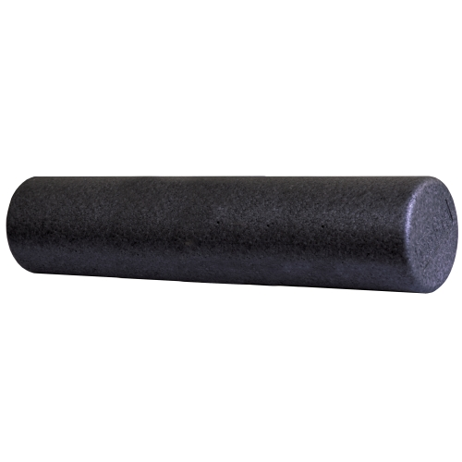

Figure 2: Sit and Reach Box
Product: Sit and Reach Box
Manufacturer: Baseline
Model: 12-1085
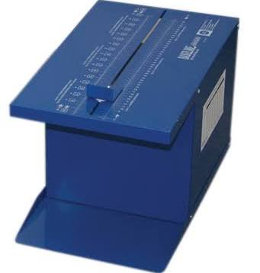

Procedures
All eligible study participants were asked to read and sign an informed consent form (see appendix A) prior to the start of the study. After all forms were completed and returned, a thorough review of the signed consent forms was conducted by the experimenter in order to identify missing signatures. All subjects who were eligible and had read and signed the informed consent form were formally accepted to take part in the study. All subjects were then verbally informed of the purpose of the study and any risks that may have been involved as a result of the study. Upon being selected for the study each participant completed a standard sit and reach hamstring flexibility assessment in order to collect baseline measurements prior to the start of the study. The baseline standard sit and reach hamstring flexibility measurements were conducted following the standard pre-practice dynamic warm-up. Two groups of five and one group of six was then randomly selected from the pool of sixteen study participants. Upon group assignment, each group was given a stretching protocol. Group 1 was given a static stretching only protocol, Group 2 was given a myofascial foam rolling only stretching protocol, and Group 3 was given a myofascial foam rolling protocol and a static stretching protocol. On the first day of testing, each group was given an instructional lesson by the experimenter on how to perform their assigned stretches and/or myofascial foam rolling correctly. The experimenter was present during all stretching sessions to ensure stretches were performed properly and within the given time parameters.
Group 1 was assigned a static stretching only routine that was performed on their hamstring muscle group. The assigned stretching protocols were completed following the soccer team’s pre-practice dynamic warm-up held at the beginning of organized practice sessions over a two week period during the spring soccer season. Subjects in Group 1 began their stretching protocol at the direction of the examiner. Subjects were instructed to find a partner in order to assist with them stretching. Subjects were instructed to lie on the ground in a supine position. Subjects were then instructed to lift their left leg in the air, keeping their knee locked and their leg straight while their non-stretching (right) leg remained flat on the ground. The subjects stretching partner was instructed to increase the hip flexion angle until the subject felt a stretch on their hamstring muscle group. When the subject no longer felt a stretch on their hamstring muscle group, the stretching partner was instructed to adjust the flexion angle until the subject felt a stretch on their hamstring muscle group. Subjects completed the assigned static stretch 3 times for 30 seconds each time on the left leg with a 10 second rest in between each 30 second stretch, and then repeated the same stretching procedures on the right leg.
Group 2 was assigned a myofascial foam roll stretching protocol that was performed on their hamstring muscle group. The assigned myofascial foam roll stretching protocol was completed following the soccer team’s pre-practice dynamic warm-up held at the beginning of organized practice sessions over a two week period during the spring soccer season. Subjects in Group 2 were instructed to begin their stretching protocol at direction of the examiner. Subjects used the provided foam rollers to complete the assigned myofascial foam rolling protocol. Upon direction of the examiner, subjects were instructed to place the foam roller underneath their right leg between their ischial tuberosity and the ground surface, with their legs remaining in an extended position, subjects were instructed to support their body weight with their arms in an extended position in order to place direct pressure between the hamstring muscle group and the floor (C.L. Goad, 2004). Subjects were then instructed to actively move the foam roller at a cadence of 1 second in an inferior direction until they reach the popliteal region and then 1 second in a superior direction until they reach the ischial tuberosity. The foam rolling protocol consisted of 3 one minute sessions of following the 1 second inferior / 1 second superior movement pattern, with a 30 second rest following each repetition (C.L. Goad, 2004), the sane foam roll hamstring stretching protocol was then repeated on the right leg.
Group 3 was assigned a myofascial foam roll stretching protocol and a static stretching protocol. The assigned stretching protocols were completed following the soccer team’s pre-practice dynamic warm-up held at the beginning of organized practice sessions over a two week period during the spring soccer season. Subjects in Group 3 began their stretching protocol at the direction of the examiner. Subjects in Group 3 began by completing the identical supine static stretch protocol given to Group 1. Following the completion of the supine static stretch protocol, subjects were then provided foam rollers to complete the identical assigned myofascial foam rolling protocol given to Group 2.
The stretching protocols were conducted on four separate occasions over a 2 week time span. Each participant completed a standard sit and reach hamstring flexibility test one week prior to the start of the stretching protocols following the soccer team’s pre-practice dynamic warm-up.

Data Collection Procedures / Instrumentation
Stretching protocols performed in this study were monitored by a certified athletic trainer, who is experienced in various common stretching protocols used in athletics. The only data collected and measured throughout this study was baseline and post-test hamstring flexibility measurements. The hamstring flexibility measurements were gathered using a standard sit and reach box. During both baseline and post-test hamstring flexibility measurements, subjects were instructed to remove their shoes and sit flat on the floor with their legs stretched out straight ahead. Subjects were instructed to place the soles of their feet against the sit and reach box with both knees locked and pressed flat to the floor. Subjects were then instructed to reach forward along the measuring line pushing the measuring slide as far as possible with their palms facing down and one hand on top of the other. Each subject was instructed to perform three consecutive reaches. The highest of the three reach measurements was recorded as the official measurement. Measurements were recorded by the experimenter and rounded to the highest quarter inch.

Design and Analysis
This study’s design was descriptive. Data was analyzed using ANOVA techniques. Tukey’s post hoc procedures were used to examine significant findings where appropriate. Alpha was set at p<.05. Categorical variables were technique and group. Dependent variable was hamstring flexibility. The participants (N=13) were female collegiate soccer players currently on the active roster of the a Division I women’s soccer team. The participants were between the ages of 18 and 22 and were selected by a convenient sample. The independent variable in this study was the stretching techniques. The dependent variable was the actual flexibility of the hamstring muscle group.

Chapter 4

Results

Statement of the Problem
The purpose of this quasi experimental study was to examine the effect of three different hamstring stretching protocols: 1) static stretching only 2) myofascial foam rolling only and 3) static stretching and myofascial foam rolling on hamstring flexibility in selected NCAA Division I female soccer players. Analyzation of data showed a significant difference time (regardless of stretching group) on hamstring flexibility as measured by the standard sit and reach test Wilks Lambda (1, 10) = 27.45, p = .0001 (Table 1). All three groups significantly increased their flexibility over the 2 week time period. There was no difference found by group on hamstring flexibility as measured by the standard sit and reach test F (2,10) = .527, p = .60. There was no significant difference found with the interaction of group by time on hamstring flexibility as measured by the standard sit and reach test Wilks Lambda F (2, 10) = .427, p = .6.
All three groups increased in flexibility by a mean total of 1 inch. Group 3 (combined static stretching and foam rolling) showed the most improvement in flexibility with mean increase of 1.25” while Group 2 (foam roll only) showed the least improvement with a flexibility increase of only .81”. While this study found significant increases in hamstring flexibility in all groups, the differences between the three stretching protocols was not statistically significant enough to determine which protocol was most effective in increasing hamstring flexibility. One participant was unable to complete the study due to injury, and two other participants were unable to complete the study due to scheduling conflicts.
With a limited number of participants available for this study, future studies with more participants could provide more significant results. The purpose of this study was to determine the most effective pre-activity hamstring stretching technique in order to reduce the risk of hamstring muscle strains in athletes. The actual effect of the stretching techniques used in this study was to increase hamstring flexibility as a result of increased pre-activity stretching.
Table 1. Descriptive Statistics for Stretching Techniques
 | Group | Mean | Std. Deviation | N
Baseline Sit and Reach Mesurement (inches) | static only | 20.50 | 1.346 | 5
 | Foam only | 21.19 | 2.135 | 4
 | combined | 21.31 | .625 | 4
 | Total | 20.96a | 1.410 | 13
Post Test Measurement (inches) | static only | 21.45 | 1.504 | 5
 | Foam only | 22.00 | 1.990 | 4
 | combined | 22.56 | .315 | 4
 | Total | 21.96b | 1.414 | 13
Note 1. Means with different subscripts differ significantly at p<.05

Chapter 5

Discussion
The purpose of this study was to determine the effectiveness of pre-activity myofascial foam rolling in increasing hamstring flexibility when compared to static stretching in female collegiate soccer players. The results of this study found that static stretching, foam rolling, and combined static stretching/foam rolling techniques were all effective in increasing hamstring flexibility following the study’s two week time period. This study confirms Nelson and Bandy’s REFERENCE previous study that found static stretching to be an effective technique in increasing hamstring flexibility. WHOSE? Study results also determined that myofascial foam rolling had a similar effect on increasing hamstring flexibility when compared to the flexibility increases gained by use of the static stretching technique. This information contradicts Miller and Rockey’s (DATE) previous study that found no improvement in range of motion following the use of foam rollers. The results of this study WHOSE? did not determine which stretching protocol was most effective in increasing hamstring flexibility. Despite being unable to determine a difference in effectiveness, the significant increases found in all stretching groups over time tells us that all stretching protocols used in this study are effective in increasing hamstring flexibility.
This study was limited to the effects of myofascial foam rolling and static stretching on flexibility of hamstring muscle groups. Future studies using the same stretching protocols on different muscle groups would be beneficial in determining the effectiveness of the prescribed stretching techniques on other muscle groups throughout the body. Another limitation in this study was the lack of a control group ( BUT DIDN”T YOU USE THEM AS THEIR OWN CONTROL) or NOT? . Due to the activity levels of the participants, it was decided that a non-stretching control group would not be used due to increased risk of injury. Since all three stretching groups were found to effectively increase hamstring flexibility over time, a control group would have eliminated the possibility that contributing factors associated with training effects may have impacted the results. In order to determine the effectiveness of hamstring flexibility gained through myofascial foam rolling and static stretching, future studies should focus on determining the relationship between hamstring flexibility increases and injury rates in soccer players over an extended period of time. Finally, in order generalize the results found in this study, future studies should involve non-athletes so that the potential benefits of increased hamstring flexibility can be applied to the general public.
How many subjects did you have? Was that an issue?
Where the tests of flexibility good enough?
Should you have started earlier? Done the study longer?

Appendix A

Consent Form
1. The University of Idaho Institutional Review Board has approved this non-exempt project.
2. The purpose of this study is to examine the effects of three different hamstring stretching protocols on hamstring flexibility in selected NCAA Division I female soccer players.
3. You will be asked to perform three standard sit and reach hamstring flexibility assessments and pre-activity stretching protocols. This study should take approximately 2.5 hours to complete over a two week period.
4. There are minimal risks associated with this study. These risks include stretching or straining or pulling muscles, however, a certified athletic trainer will be present at all times in order to provide treatment if an injury occurs.
5. You will benefit from this study by helping us to determine which stretching methods are most effective on hamstring flexibility, society will benefit because results of this study will provide data to health and fitness experts as to which stretching protocols are most effective and should be used throughout the industry.
6. If we find that the stretching protocols are too difficult for you to complete we will allow you to discontinue participation in the study.
8. All information that is gathered will be placed on a locked computer with access only available to myself.
9. If you have questions about the study, you can ask the investigator during the study, when the study is complete or at a time you feel is appropriate.
Investigator Faculty Sponsor
Christopher Walsh, ATC Dr. Sharon Stoll
University of Idaho University of Idaho
Athletic Training Services Department of Movement Sciences
Moscow, ID 83844-0000 Moscow, ID 83844-1234
Ph. 206-856-5261 Ph. 208-885-2103

10. During the course of this study, you may stop at any time with no penalty.
11. Participation in this research study is voluntary. You have the right to refuse to participate in this study entirely without any impact on your standing on the team or relationships associated with being on the team.
12. If you do stop your participation in the study, there will be no penalties associated with your withdrawal. All you need to say is that I no longer wish to participate and you may return to your own stretching routine.
I am 18 years old or older and have reviewed this consent form and understand and agree to its contents.
Participant Name ______________________________________ Date _________________
Experimenter Name ____________________________________

Appendix B

National Institutes of Health Certificate of Completion
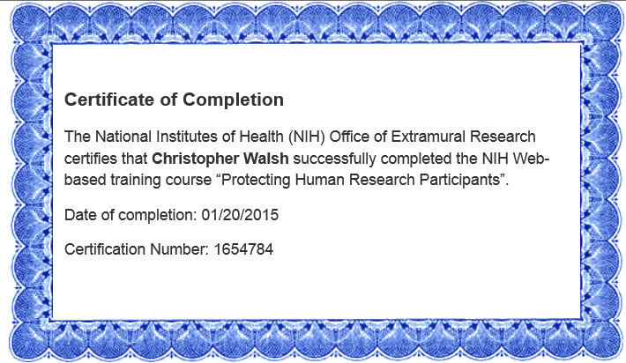

Appendix C

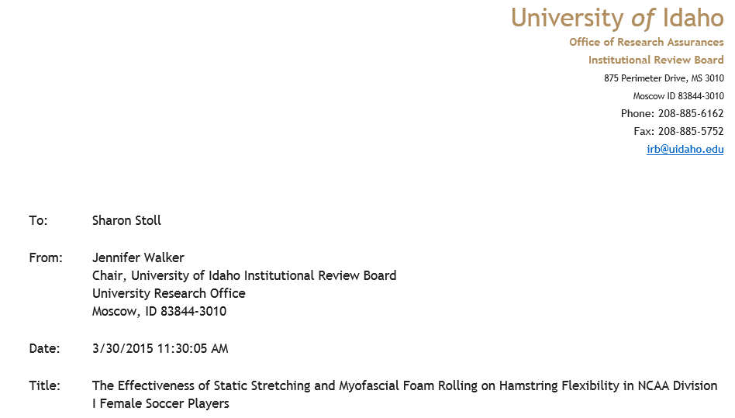
IRB Approval Letter

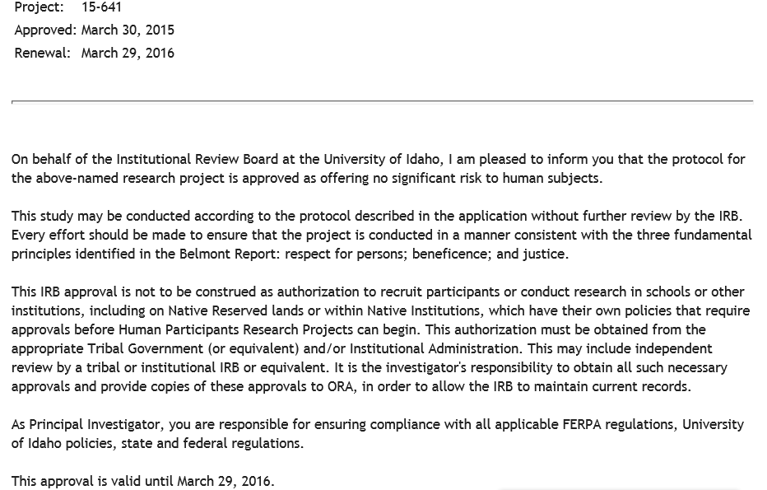

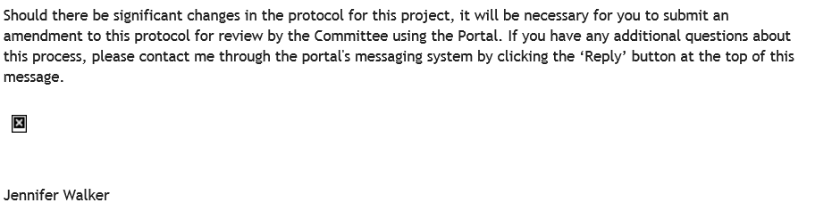

References

Amako, M., Campisi, P., Masuoka, K., Oda, T., & Yokoi, K. (2003). Effect of static stretching on prevention of injuries for military recruits. Military Medicine, 168(6), 442-446.
Barnes, R. P., Feeley, B. T., Kellly, B. T., Kennelly, S., Muller, M. S., Rodeo, S. A., & Warren, R. F. (2008). The Epidemiology of National Football League training camp injuries from 1998 to 2007. American Journal of Sports Medicine (36), 1597-1603.
Best, T. M., & Sherry, M. A. (2004). A comparison of 2 rehabilitation programs in the treatment of acute hamstring strains. Journal of Orthopaedic & Sports Physical Therapy(34), 116-125.
Brockett, C. (2000, August). Taking the hurt out of hamstring strains. Australasian Science, 21(7), p. 38.
C.L. Goad, B. L. (2004). Effect of foam rolling and static stretching on passive hip-flexion range of motion. Journal of Sport Rehabilitation(23), 296-299.
Canale, S. T., Cantler, E. D., Sisk, T. D., & Freeman, B. L. (1981). A chronicle of injuries of an american intercollegiate football team. American Journal of Sports Medicine(9), 384-389.
Cross, K. M., & Worrell, T. W. (1999). Effects of static stretching program on the incidence of lower extremity musculotendinous strains. Journal of Athletic Training, 34(1), 11-14.
Healey, K., Dorfman, L., Riebe, D., Blanpied, P., & Hatfield, D. (2011). The effects of foam rolling on myofascial release and performance. Journal of Strength and Conditioning Research(25), S30.
Henderson, G., Barnes, C. A., & Portas, M. D. (2010). Factors associated with increased propensity for hamstring injury in English Premier League soccer players. Journal of Science and Medicine in Sport, 13, 401.
Irick, E. (2012). NCAA Sports Sponsorship and Participation Rates Report 1981-82 – 2011-12. Indianapolis: National Collegiate Athletic Association.
Men's Health. (2014). Retrieved from Men's Health: http://www.menshealth.com/best-life/foam-rolling
MIller, J. K., & Rockey, A. M. (2006). Foam rollers show no increase in the flexibility of the hamstring muscle group. UW-L Journal of Undergraduate Research IX, 1-4.
Nelson, R. T., & Bandy, W. D. (2004). Eccentric training and static stretching improve hamstring flexibility of high school males. Journal of Athletic Training, 254-258.
Orchard, J., & Best, T. M. (2002). The management of muscle strain injuries: an early return versus the risk of recurrence. Clinical Journal of Sport Medicine, 12(1), 3-5.
Sim, A. Y., Dawson, B. T., Guelfi, K. J., Wallman, K. E., & Young, W. B. (2009). Effects of static stretching in warm-up on repeated sprint performance. Journal of Strength and Conditioning Research, 2155-2162.
Waseem, M., Nuhmani, S., & Ram, C. S. (2009). Efficacy of muscle energy technique on hamstring muscles flexibility in normal Indian collegiate males. Calicut Medical Journal, 1.
Woods, C., Hawkins, R. D., Maltby, S., Hulse, M., Thomas, A., & Hodson, A. (2004). The football association medical research programme: an audit of injuries in professional football-analysis of hamstring injuries. British Journal of Sports Medicince, 36-41.
Young, W. B., & Behm, D. G. (2002). Should static stretching be used during a warm-up for strength and power activities? National Strength & Conditioning Association, 33-37.

