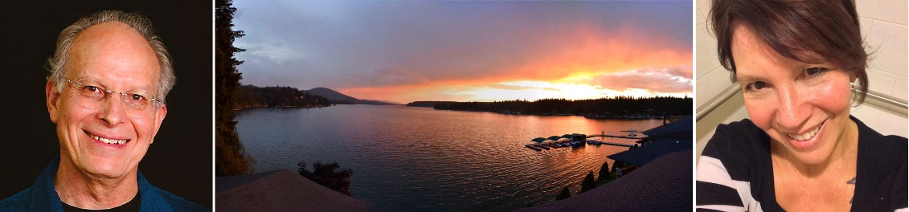

The 2nd Annual
Power of Authentic Connection Retreat
October 4-7, 2018
with Dave Potter & Jamie Derrick

Description:
This retreat, like the one last year, is designed to deepen not only our connection with ourselves but also our connection with others. It will include not only silent meditation (walking and sitting), but also small- and large-group discussions, and opportunities for yoga and/or Qi Gong. In our activities, we will balance time for silent inner reflection with time for interaction with other participants. The following quote by Parker Palmer describes perfectly our intention in holding this retreat: to deepen our connection both with ourselves and others:

… we need solitude and community simultaneously: what we learn in one mode can check and balance what we learn in the other. Together, they make us whole, like breathing in and breathing out. …

Solitude does not necessarily mean living apart from others; rather, it means never living apart from one’s self. It is not about the absence of other people – it is about being fully present to ourselves, whether or not we are with others. Community does not necessarily mean living face-to-face with others; rather it means never losing the awareness that we are connected to each other. It is not about the presence of other people, it is about being fully open to the reality of relationship, whether or not we are alone.
– Parker Palmer, A Hidden Wholeness

Prerequisites:
Graduation from the Palouse Mindfulness course and/or have an established meditation practice. There will be multiple meditations per day so you should be comfortable with 20-30 minute periods of silent meditation.
Location & Schedule:
MiVoden Retreat Center is in a stunningly beautiful location on Hayden Lake with its own dock and an enclosed swimming pool. There will be a few free hours each afternoon, which can be used for rest, exercise, or walking on the miles of trails surrounding the retreat center. The retreat center is not close to shopping or restaurants, so you should plan to remain at MiVoden from Thursday night to Sunday noon.

Accommodations:
Rooms are rustic but adequate. Bathrooms are shared (each cluster of 5 rooms share 2 bathrooms with a total of 2 showers and 4 toilet stalls), but everyone will have a room to themselves. NOTE: There are only a few rooms with private baths which will be reserved for couples at an additional cost and only a few rooms that don’t have stairs leading up to them. These will be allocated first-come, first-served.

Meals:
All meals, from dinner on Thursday to lunch on Sunday, are included. Accommodations can be made for special dietary needs.
Beginning and Ending times:
Check-in at MiVoden will be 4 to 6pm Thursday, October 4. Dinner will be at 6pm with an orientation following. Lunch on Sunday will be available from noon to 1pm. The last few hours of the retreat are critically important, so please plan to leave no earlier than noon on Sunday. This means that if you are flying, your arrival into Spokane should be no later than 4pm on Thursday and your departure no earlier than 3pm on Sunday.

IMPORTANT TRAVEL NOTES:

For those flying out of Spokane and who cannot find flights leaving after 3pm on Sunday:
As an option, you can stay an extra night at MiVoden and leave Monday morning. The cost for the extra night, including dinner Sunday and breakfast Monday, will be $65. Although the retreat will be formally over at noon on Sunday, we are planning an optional activity for those who decide to stay the extra night.

For those who have to fly into Spokane on the 4th:
We recommend that you stay in Spokane overnight because MiVoden has another group and can’t take you a day early. If you need to do this, I have some recommendations about where to stay on the 4th and what to see/do in Spokane before you leave for MiVoden.

Closest airport:
Spokane, Washington. A shuttle service is available at the Spokane, Washington airport for the 55 mile trip from the airport to MiVoden. It takes about 75 minutes (some of the trip is along country roads) and costs $65 one way, but we may be able to arrange for sharing with others which would make this less expensive, and it’s likely that one of the other retreatants will be able to get you back to the airport on Sunday or Monday. The shuttle service is Payless Airport Shuttle, (888) 870-7433, but they won’t be able to book a reservation until three weeks beforehand.

To allow sufficient time for retrieving luggage and travel to MiVoden, your flight arrival into Spokane should be no later than 4pm on Thursday and your return flight should be no earlier than 3pm on Sunday.

Cost:
The cost is $290 for single rooms, and $317 per person for couples who reserve a room with a private bath. Included are all meals, lodging for 3 nights, a stipend for Jamie and the yoga/QiGong teachers, and anything left after expenses will be donated to the Palouse Mindfulness operating fund (you won’t have to budget extra money for teachers). For those departing on Monday instead of Sunday, there will be an extra $65 to cover lodging, dinner on Sunday, and breakfast on Monday.

To register, go to https://palousemindfulness.com/retreat/2018-register.html

