Improving the Professional Skills of Engineering Graduate Students through Capstone Project Mentoring in IEWorks

Dan Gerbus, Dan Cordon, Matthew Walker, Robert Drew,
Edwin Odom, Steven Beyerlein, Karl Rink
University of Idaho
Mechanical Engineering

Abstract

Traditional engineering graduate programs focus on coursework and thesis research, which may or may not adequately develop students’ professional skills for engineering positions in industry. This paper describes an alternative graduate program developed at the University of Idaho called the Idaho Engineering Works (IEWorks). IEWorks is focused on developing leadership, creativity, communication, and time management skills in addition to traditional course and thesis work. This paper compares the IEWorks experience to other student experiences using surveys of current and future graduate students, alumni, and faculty. The results of the surveys suggest the increased workload in IEWorks interferes with thesis research and coursework. However, the data also suggests the professional skills developed in the program are highly valued by the majority of the graduates and offset the additional workload.

Introduction

With downsizing, the growing global marketplace, and faster new product releases, competitive corporations have to become more efficient and flexible. In order for the corporation to be efficient, its employees must operate efficiently. In response to this movement, academia is being asked to take more responsibility in the overall development of engineers beyond technical skills.^{1,2} Academia is changing undergraduate curriculums to address these issues.³ However, graduate programs also need to change to accommodate the changing industrial demands.

Typical graduate programs in engineering are organized into functional areas similar to the traditional corporate business structures. In mechanical engineering, these functional areas include thermodynamics and solid mechanics. Graduate research groups are generally associated with a particular functional area. Studies have shown this structure inhibits innovation and efficiency.^{4,5,6,7} Several researchers have proposed using a cross functional structure where the team members have varying backgrounds and expertise. Ideally these backgrounds should be from across the spectrum of disciplines. This diversity provides various perspectives that aid in stimulating innovation and promoting efficiency in additional to having expertise in nearly all areas that pertain to the project.

In order to be competitive, engineers must possess skills above and beyond technical skills. Valenti has surveyed firms and academia in mechanical engineering and compiled a list of desired skills¹ for entry-level engineers. Table 1 lists the top ten skills for entry-level engineers
identified by academia and industry. The professional skills listed are both technical and non-technical skills. Those non-technical skills include teams/teamwork, communication, professional ethics, and creative thinking.

Table 1: Professional Skills of Emerging Engineers
Rank | Skill
 | Industry | Academia
1 | Teams/Teamwork | Teams/Teamwork
2 | Communication | Communication
3 | Design for Manufacture | Creative Thinking
4 | CAD Systems | Design Reviews
5 | Professional Ethics | CAD Systems
6 | Creative Thinking | Sketching/Drawing
7 | Design for Performance | Professional Ethics
8 | Design for Reliability | Design for Performance
9 | Design for Safety | Design for Safety
10 | Concurrent Engineering | Manufacturing Processes

The change from a defense driven to a civilian driven economy and the coming of the global marketplace has forced this change in education paradigm according to Valenti. The Society of Manufacturing Engineers (SME), in its Manufacturing Education Plan,⁸ surveyed corporations that employ manufacturing engineers or manufacturing technologists to review the professional and technical competencies of newly hired graduates. From the survey results, SME identified project management, written/oral communication, and business knowledge/skills as some of the competency gaps present in newly hired engineers.

To further support this notion of the softer side of engineering being as important as the hard biting technical, Krackhardt and Hanson claim the informal organization is what makes or breaks companies.⁹ The purpose of the informal component of the organization is to handle the unexpected, where the formal component is too rigid to adjust for the unexpected. The skill of communication with individuals outside of one’s expertise, such as customers, is paramount in order to establish and become a component of the informal organization. Therefore new graduates in engineering would need to have good communication skills in order to access this informal network.

Kelley and Caplan examined the engineers at Bell Laboratories to determine what traits the star performing engineers possessed.¹⁰ They discovered that neither IQ nor GPA indicated which engineer would be highly productive. Instead, the approach the engineer used is what set the stars apart from the mediocre. The consensus from star engineers at Bell Laboratories shows that essential skills to be a star may be categorized into 3 tiers of importance shown in Figure 1. In order for engineers to be star performers, they must take initiative, and possess technical competence. The second tier includes strategies such as leadership, followership, and networking. These strategies are also important but do not need to be developed as quickly as the first tier strategies. The third tier skills are considered by the star performers at Bell Laboratories as “icing on the cake.” Well-developed third tier strategies are helpful for those in managerial positions, but were not the focus of attention in the star performers at Bell Laboratories. This research provides a valuable insight into what a recent graduate from engineering graduate school should focus upon in order to be a star performer. To be competitive or even have an advantage in the new hire job market would be to have the first tier and portions of the second tier well developed.

Taking Initiative
Technical Competence
Self-Management
Networking
Leadership
Teamwork Effectiveness
Followership
Perspective
Organizational Savvy
Show-and-Tell
Tier 1
Tier 2
Tier 3

Figure 1: Bell Labs 3 Tier Strategy

Goleman has found effective teams have members who exhibit strong interpersonal skills or intelligence.¹¹ The measure of interpersonal intelligence comes from how well one manages a network of people, be it formal or informal. While academia prepares students for technical skills, it does not adequately develop these interpersonal/soft skills outside of the undergraduate curriculum. These skills are typically left to be developed on the job or by the students and many times developed poorly else these would not be problems occurring in industry. These professional skills are addressed and unsystematically developed through group projects and necessity. Seldom are projects or development lessons directly addressing these skills conducted where effective approaches may be learned. The skills are considered byproducts of group projects. An engineer with a graduate degree is expected to have all of these skills, yet graduate programs do little to develop these skills directly.

To address these issues and to improve the graduate experience, a relatively informal group, Idaho Engineering Works (IEWorks or IEW),¹² was developed at the University of Idaho under the guidance of Dr. Edwin Odom in 1994. This group was molded after Kelly Johnson’s design of the Skunk Works¹³ at Lockheed in the 1940’s. Today, IEWorks consists of students involved in the Mechanical Engineering senior capstone design classes, graduate student mentors, and several faculty members involved in engineering design. This paper will focus on the graduate student experience in IEWorks.

The IEWorks graduate students are funded as capstone senior design team mentors and, in addition to the typical course load, work together on various projects to challenge the student to develop these softer skills. With these daunting challenges, much time is spent by the student to work on the projects in addition to courses, research and socializing. Some may think these extra efforts are not worthwhile and are not the purpose of graduate school. Instead, the focus in graduate school should be learning about being an engineer. IEWorks provides an environment in which these soft skills are allowed to be implemented and assessed. Research is conducted on the various methods of practicing these skills.

The benefits IEWorks has been valuable to students. According to graduate alumni, the skills gained through the experience are well worth the added work. The extra work to develop the skills in a safe environment, where career integrity is not at risk, is justifiable and better than the trial by fire method in industry and classes. However, the workload has changed significantly in IEWorks and some opinions have changed as a result.

Idaho Engineering Works

The original purpose of IEWorks was to make graduate school more meaningful than a research project and a thesis. As described in the previous section, engineers need more than just the technical know-how taught in academia. Most engineering graduate programs have the same format. The student is partnered with a graduate faculty member to work on a research project that is of interest to both. The student is tasked with research work as well as coursework. In this model, little opportunity arises in which to practice the professional skills and strategies in Table 1 and Figure 1. Graduate students are not encouraged to operate as a team. Communication is developed only to the extent of interacting with thesis committees and research related personnel. Creative thinking is permitted provided the idea is supported under the research project description.

To addresses particular skill sets, a semesterly directed study course is offered at varying credit levels. In these classes, the students review literature on leadership, creativity, and other non-engineering curriculum topics. This works to give the student more insights into these skills. To challenge the students, difficult projects are assigned which strive to stretch the capacity of each student involved. All of this is above the typical class load and research work undertaken by a graduate student. The stretch goal¹⁴ challenges the student, thereby pushing him or her to truly learn and understand the skills being taught through application. Furthermore, coming together as a team to accomplish these projects develops trust between members and strengthens the team.¹⁵

IEWorks is currently tasked with assisting Senior Capstone Design. Figure 2 shows the process undertaken by seniors in the Capstone Design course. In this capacity, IEWorks members work as design team mentors, aiding seniors in problem formulation, communication, manufacturing issues, machine shop training and use, as well as technical consultation. The power of mentoring is well described by Healy and Welchert:

There are two essential goals of mentoring: transformation and reciprocity. Both individuals are changed and enlarged by the experience. Both people learn and grow. Ultimately one cultivates within the protégé, qualitative changes in his/her approach to tasks and to initiatives. The clear goal of the transformation in mentoring should be for the mentee or protégé to no longer be an understudy, but to become a peer.¹⁶

Through mentoring, IEWorks members are able to practice team leadership skills as well as interpersonal skills such as inspiring motivation and effective communication. This provides a practicing area for the skills that industry has identified as important skills for new hires.
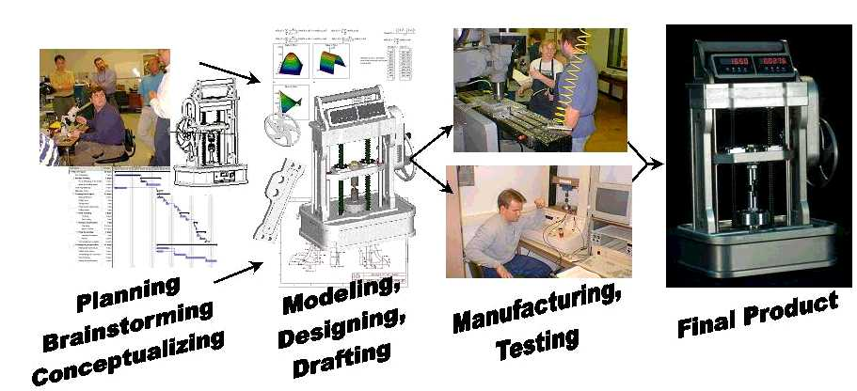
Figure 2: Senior Capstone Design Process

For example, the IEWorks group members manufactured heat sinks of various exotic materials for a leading computer chip manufacturer for performance testing shown in Figure 3A. The timeline and exotic materials made the task challenging to the students. Another stretch goal was to design and fabricate an aluminum yo-yo, shown in Figure 3B, that had the same shape, polar moment of inertia, and performance as a Tom Kuhn Roller Woody Yo-Yo.¹⁷ This project included learning the CNC programming for the lathe and manufacturing setups for production. The most recent challenge was to reengineer the MIT Stirling Engine Project¹⁸ to fit within the fee structure and machine shop resources available to the University of Idaho.¹⁹ The IEWorks team and all of the 1652 parts that they machined are shown in Figure 3C. In order for the tasks to be accomplished on time, scheduling, costing, customer communication, and the manufacturing processes had to be mastered by the team. These high energy, short term projects challenge each IEWorks member to interact effectively in a team. Without excellent teamwork, these challenges would overwhelm an individual. Projects provide a venue to discover and identify both good and poor engineering teamwork practices.

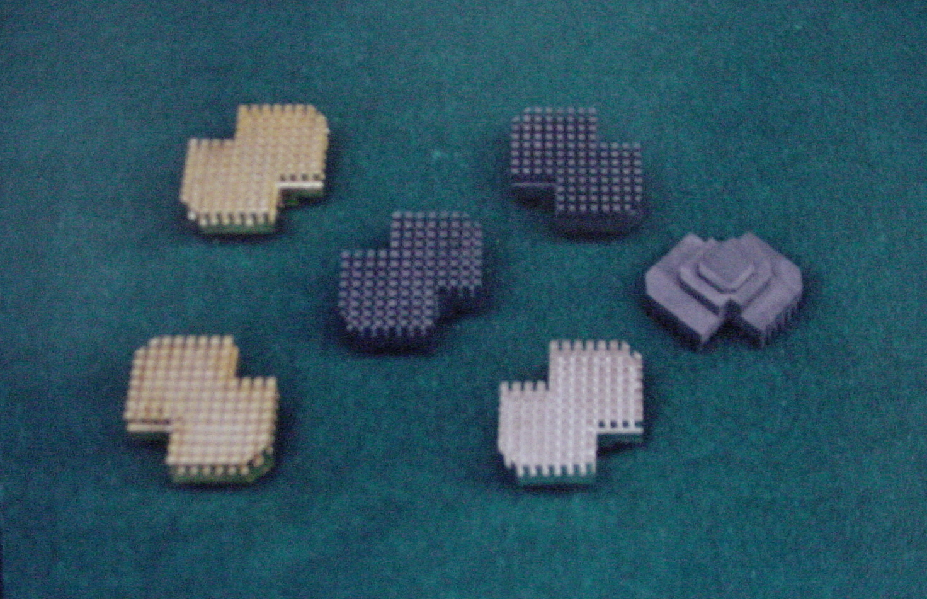  A | 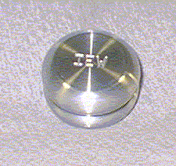B | 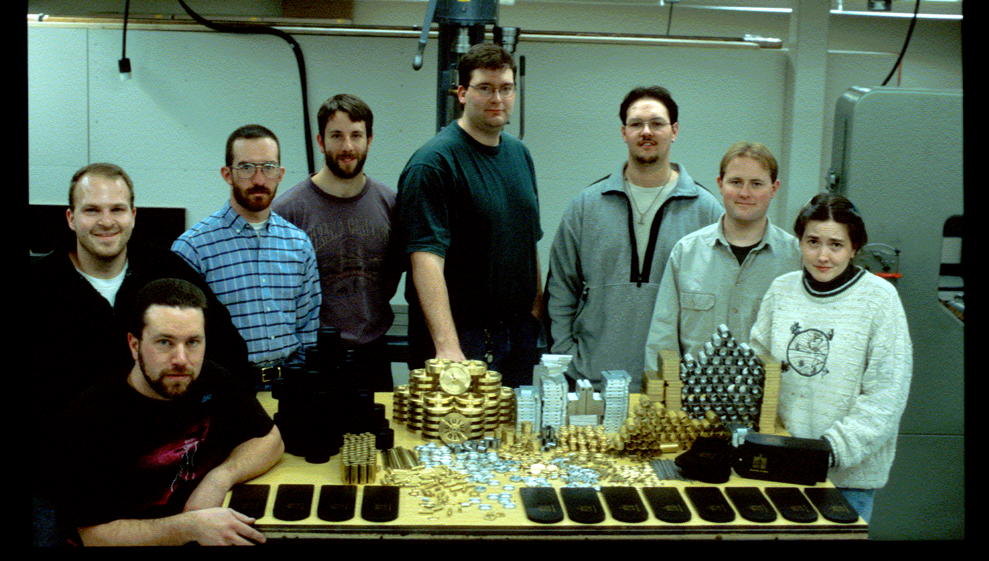  C
Figure 3: Heat Sink Project (A), Yo-Yo Project (B), Stirling Project (C)

IEWorks operates as a heavyweight project team.²⁰ The heavyweight team structure puts the responsibility for the work in the hands of the project manager. In heavy weight team structures, personnel from functional areas are placed on the team under the guidance of a project manager. Frequently, heavyweight team members are physically collocated to provide for frequent interaction between members. This environment gives the team member a great deal of ownership in the group. Through this feeling of ownership, the team members are typically well motivated.^{21,22}

In IEWorks, the project manager position is rotated between student members for the various projects. Ideally a the project manager position will change for each project such that each student will have an opportunity to managed a group level project. Generally the more senior member is given the task of project management while showing a newer IEWorks member what needs to be done. This provides students with the opportunity of managing a team and honing the skills learned in the directed study course.

In addition to group projects, each member has a major professor who may or may not be actively involved in IEWorks. Considering the heavyweight team analogy, each major professor would be considered the functional group manager and each member a functional group. This is the beauty of IEWorks. In IEWorks, students from various categories of mechanical engineering are working together. This provides a variety of perspectives on projects since it mirrors the advantages of a cross functional team. However, to be truly cross functional, members from disciplines outside of mechanical engineering are needed.

Data Collection Method

Evaluation of IEWorks was conducted through surveys. Current members and IEWorks alumni were surveyed in addition to mechanical engineering faculty, seniors, and alumni. The surveys were structured to indicate traits or skills the participants consider important for an engineer in addition to their opinions of IEWorks, its principles, and effectiveness.

The faculty, mechanical engineering alumni, and IEWorks alumni surveys were conducted over the Internet. All of the IEWorks alumni were solicited by email. Twelve mechanical engineering alumni who were not members of IEWorks were directly solicited through email. The participants were instructed to forward the survey on to other alumni who have graduated in the last three years who were not included in the original solicitation. All faculty members of the mechanical engineering department were solicited. Current seniors and IEWorks members were solicited in person and completed hardcopy surveys.

Each survey group was given different surveys, which are listed in the Appendix. All of the surveys had common questions. The common questions of interest to this discussion deal with what the participants considered the 4 most important professional skills and how IEWorks affects the development of these skills. The business specific questions on the surveys related to job experience, graduation, and participant’s background. Only the questions common to all surveys are discussed in this paper.

Results

Ninety-three survey candidates were solicited to participate in the survey. Sixty-four candidates participated. Figure 4 shows the distribution of the surveys by group. The Results section is divided into five subsections corresponding to each survey group.

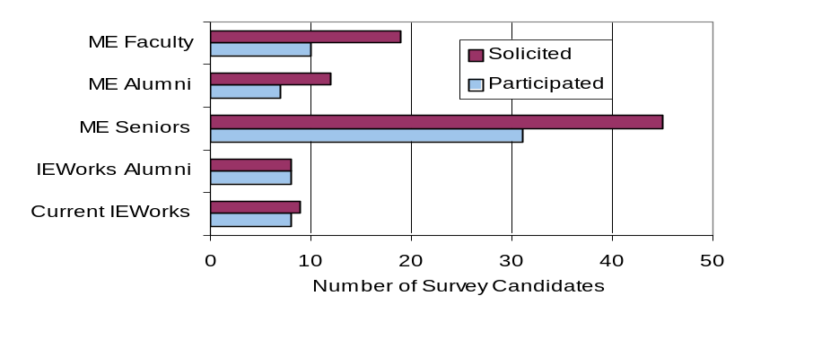
Figure 4: Survey Candidate Solicitation and Participation by Group

Current IEWorks Members

Eight IEWorks members participated in the survey. All members found IEWorks either very or somewhat important to them. With the exception of one participant, all found the added work involved in IEWorks does result in developing the professional skill sets. Figures 5 through 8 show the survey results from the current members.

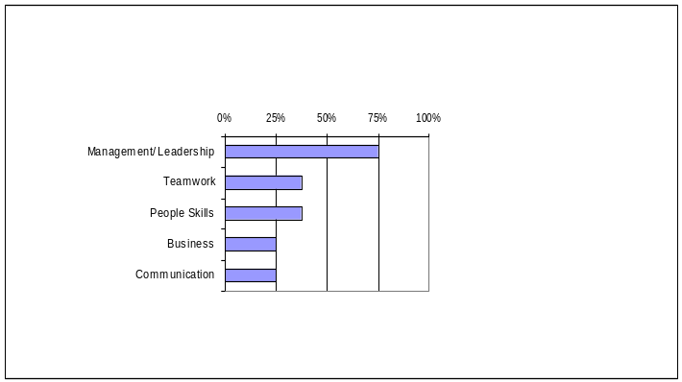  Figure 5: Top Professional Skills Identified by  Current IEWorks | 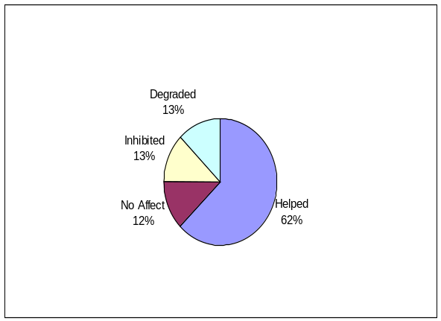Figure 6: Effect of IEWorks  Involvement on GPA
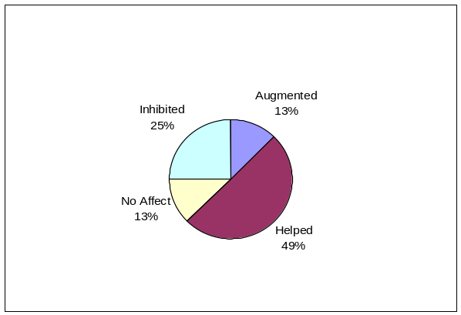  Figure 7: Effect of IEWorks Involvement on  Research | 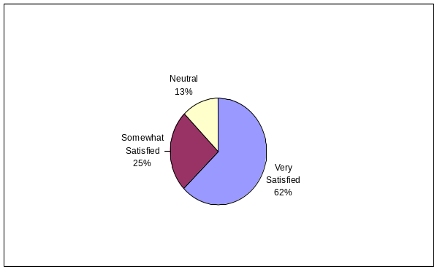  Figure 8: Satisfaction with  Graduate Experience

A study was performed in the mechanical engineering department comparing a graduate student’s undergraduate and graduate GPA’s from 1995-1997. The undergraduate and graduate GPA’s of 12 non-IEWorks students and 8 IEWorks students were compared. All students in the study completed their undergraduate degrees at the University of Idaho and were enrolled or graduated from the mechanical engineering graduate program in 1997. The student sample population included all graduate degrees in the Mechanical Engineering program: M.S.M.E., M.E.M.E., and Ph.D. The average GPA of IEWorks students improved 17%, while the average non-IEWorks student GPA improved only 7%. The results of this study add support to survey results shown in Figure 6.

IEWorks Alumni

Seven IEWorks alumni participated in the survey. Of the 7 participants, all found IEWorks to be an important experience to them now while in the industrial setting. Prior to graduation however, these participants found their IEWorks experience somewhat important and 6 found IEWorks very important. All found involvement in IEWorks helped develop professional skills, but one recent graduate felt it hindered research work. Figures 9 through 11 show the results from the IEWorks alumni.
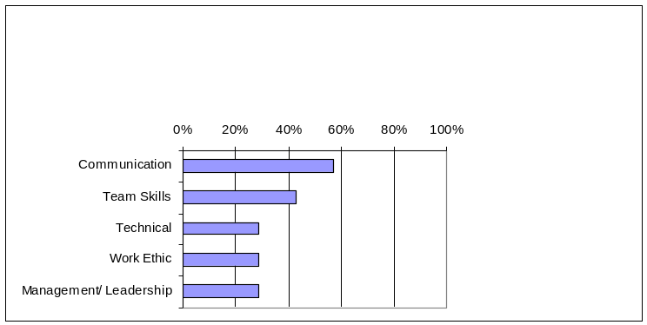  Figure 9: Top Professional Skills identified by  IEWorks Alumni | 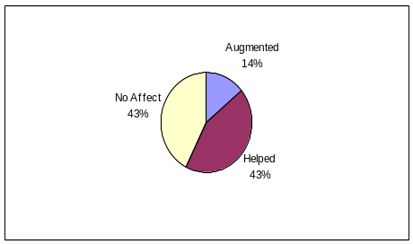  Figure 10: Effect of IEWorks  Involvement on  GPA
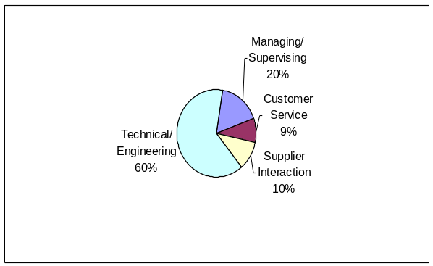
Figure 11: Distribution of Time on the Job as identified by IEWorks Alumni

Mechanical Engineering Seniors

Thirty-one seniors participated in the survey. All of the participating seniors were currently enrolled in the first semester of the two semester Senior Capstone Design course. Survey results are shown in Figures 12 and 13. Several of the participants indicated they were either unsure of what IEWorks does or saw IEWorks only as a manufacturing support group. Twenty-eight seniors felt that the professional skill may be developed through other means such as campus clubs and organizations.

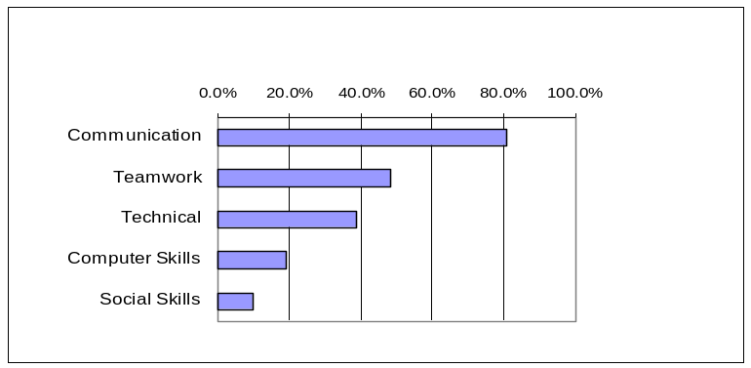 Figure 12: Top Professional Skills identified by ME  Seniors | 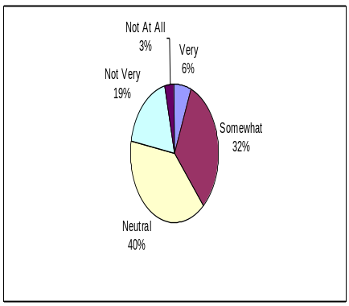  Figure 13: How IEWorks assists  in Developing Skills

Mechanical Engineering Alumni

Eight alumni who were not members of IEWorks participated in the survey. Six of the participants are currently in engineering positions, and 2 are in engineering management positions. The earliest graduate is from 1986, and the most recent is from 2001. One participant has a M.S.M.E. while the rest have B.S.M.E. degrees. Three of the participants found IEWorks helped develop the professional skills. Two felt IEWorks had some affect, but did not adequately develop the skills, and two participants did not describe how IEWorks helped develop the professional skills.

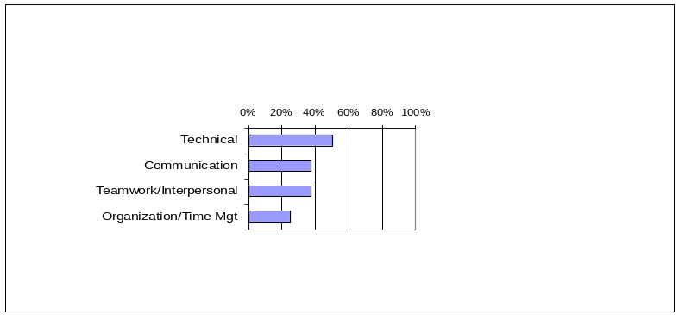Figure 14: Top Professional Skills identified by ME  Alumni | 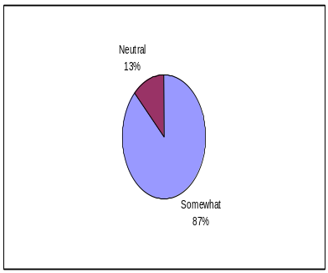  Figure 15: How IEWorks assists in  Developing Skills
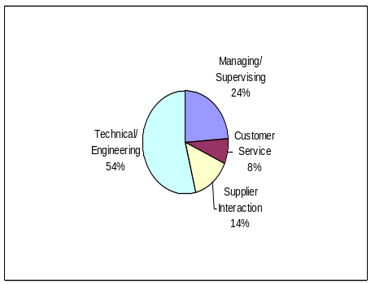
Figure 16: Distribution of Time on the Job as identified by ME Alumni

Mechanical Engineering Faculty

Ten faculty members completed the survey. All faculty participants felt graduate school helped develop the professional skills. Six participants interacted with current IEWorks members weekly, 3 rarely interact, and one interacts monthly. These interactions ranged from research to social in nature. The faculty survey results are shown in Figures 17-20.

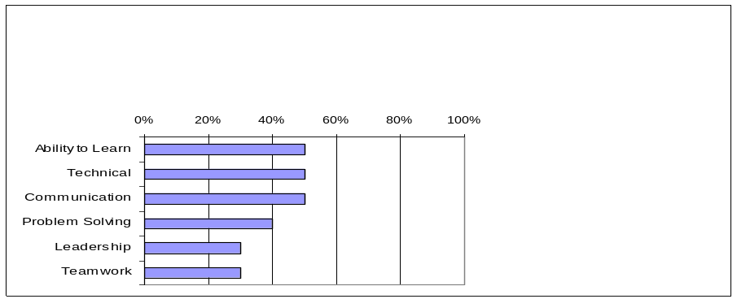Figure 17: Top Professional Skills identified by  Faculty | 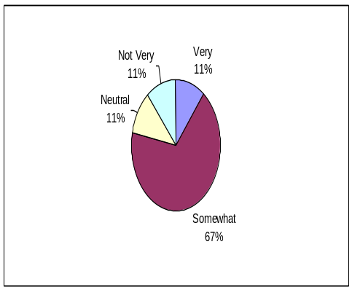  Figure 18: Satisfaction with Current  Graduate Students

The faculty participants had interesting responses to the question regarding the value of the extra workload in IEWorks. One professor did not consider the workload to be larger than any other graduate student’s and felt the assistantship compensation adequately compensates for the work. Three participants believed the added workload weakens research and overloads students. Four participants felt the added workload results in highly valued skill development.

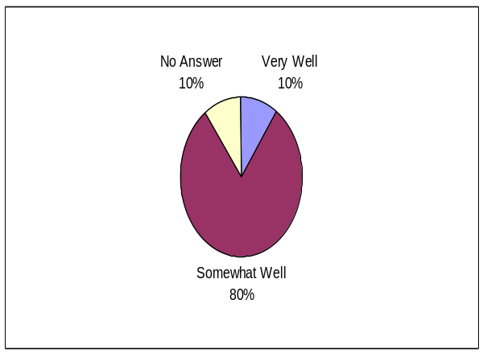  Figure 19: Ability of Graduate School to  Develop Skills | 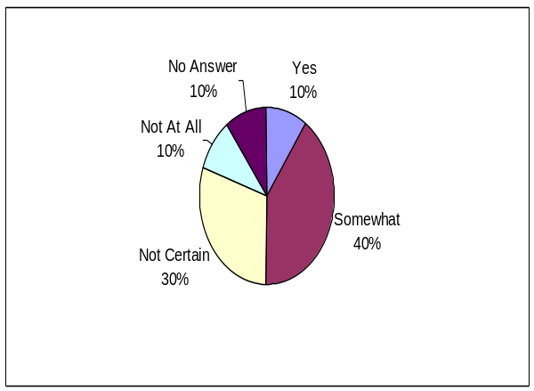Figure 20: Is IEWorks Workload Too  Much?

Discussion

Considering the small sample size of the surveys, the results do not have enough statistical validity to form well supported conclusions. However, the data is substantial enough to indicate trends and general opinions. The results also serve to generate guidelines for how to compose subsequent surveys for the purpose of evaluating IEWorks.

There are noticeable differences in the responses from current and past IEWorks members. Figures 6 and 10 show the past members did not find the extra workload of IEWorks to noticeably interfere with or degrade research and GPA. One forth of the current members feel the workload interferes with research and GPA. Half of the faculty, according to Figure 20, indicate the current workload is too much. The change in views on the effect of workload between IEWorks alumni, current faculty, and current IEWorks members may be attributed to actual changes in the workload. The workload has increased to accommodate changes in course structure in Capstone Design, and expanding responsibilities of IEWorks. The design projects in the Capstone course have grown in complexity and depth, which places greater manufacturing demands on the mentors. In the last several years, members of IEWorks have been called upon to provide course instruction in the department’s solid modeling course as well as provide assistance to sophomore and junior level design courses. Currently the members of IEWorks have had responsibilities for Capstone Design mentoring, shop support and mentoring for various team projects such as Formula SAE, teaching a solid modeling class, infrastructure development, laboratory equipment procurement, and teaching the advanced strength of materials class. The professors who are not actively involved in IEWorks may not fully understand the process of IEWorks and serve to interrupt and overload the student. One current member in IEWorks mentioned having particular difficulty managing the extra work and maintaining grades. From the responses to the question of whether the participant would recommend IEWorks to a new graduate student, some of the current IEWorks members’ suggest a certain personality or attitude is needed to fully benefit from the experience.

It is interesting to note that the graduate student alumni and undergraduate alumni tend to distribute their time in similar manners according to Figures 11 and 16. For both groups, the majority of time is spent in engineering functions. The researchers of this paper expected the graduate alumni to spend more time in managing/supervisory functions. This may become the case when more time has elapsed after graduation.

Referring to Figure 13, 38% of the senior participants felt IEWorks was helpful in developing the professional skills. The remaining senior participants felt that either IEWorks was not helpful or had no effect on developing professional skills. They stated the professional skills could be developed elsewhere such as in clubs and organizations. It is important to note that these seniors were surveyed halfway through a 2-semester Capstone Design course. At this point in the class seniors are still learning what IEWorks is and how to incorporate into their design group.

The faculty responses indicated there are several misunderstandings in what IEWorks involves. Three of the faculty appear to view IEWorks as merely a group of teaching assistants. Unlike a lab teaching assistant whose responsibilities are report grading and conducting lab sessions, IEWorks members are responsible for mentoring the Capstone Design seniors in developing team structure, manufacturing, and time management among other skills. This involves much one on one time with the students in addition to the IEWorks member taking the directed study courses in IEWorks. Other faculty respondents find IEWorks to be invaluable in the development of a graduate student. One faculty participant stated:

Additional responsibilities/workload are required but unique experiences/personal benefits are born of this commitment. Even students who are not directly involved in IEW benefit slightly through conversation/association with IEW members.

Half of the faculty participants indicated the mentoring aspect of IEWorks aids in developing the professional skills. The other participants could not justify the extra workload.

Of the faculty participants, 60% would consider becoming involved in IEWorks and 40% did not want to be involved. Those who did not want to be involved did not consider the extra skills developed in IEWorks to be of value to a graduate student while in school and believed the involvement would take away from the more important research. In contrast, the consensus from the IEWorks alumni participants shows the challenges in IEWorks, such as dealing with daily interruptions while trying to accomplish one’s own tasks, emulates the professional work place. They value the skills learned through IEWorks and indicate that these skills would not be as well developed if they had to develop them elsewhere. Being involved in IEWorks demands that one balances the workload and communicates with people of multiple backgrounds.

Referring to Figures 5, 9, 12, 14, and 17, all survey groups listed communication, teamwork, and technical skills in the top professional skills. These skills are also found in the professional skills discussed in the literature and listed in Figure 1 and Table 1. This shows that all the survey groups value these skills. Ranking the skills listed by the participants to identify the top five skills was difficult due to the survey size. The mechanical engineering alumni have only 4 top skills since the remaining skills listed by the participants were evenly ranked. The faculty list has six skills since leadership and teamwork tied for the fifth position. The remaining groups’ top five skills were easily identified through ranking.

One of the difficulties in comparing different years of IEWorks is the continual change in the group membership. Most of the members are pursuing their Masters of Science degree and will be in the group 3 to 4 semesters. Half of this time is generally spent understanding how the group operates and what one’s role is in the group. Therefore a rookie member may spend the first year learning about the group. There has been several times when all but one IEWorks member graduates. This results in an IEWorks team with little experience mentoring seniors and performing the various other tasks. This change in IEWorks’ membership can have great effects on how well the group functions in a given year and may be reflected in the perspectives of students and alumni.

Conclusions

The results suggest the development of the professional skills listed in Figure 1 and Table 1, and identified in the literature does occur in IEWorks. However, there is a cost to the development. The added workload appears to provide interference with other graduate work such as courses and research. Depending on the individual, the professional skills developed in IEWorks may or may not be of value to the student during graduate school. The organizers of IEWorks will need to evaluate the work screening process in which extra jobs or duties are evaluated before being assigned to IEWorks. Also the newer faculty members in IEWorks become more active in the planning and decision-making activities of the group may help alleviate the high workload.

From the faculty and senior responses, it is apparent few fully understand or appreciate what IEWorks entails. More work is needed to explain what IEWorks does and how it operates. This paper should prove valuable in explaining some of the inner workings of the group and its capabilities. The challenges of balancing the workload, answering to students and faculty, and managing time appear to prepare the IEWorks student well for the same challenges in industry.

To improve the results for future work, it is suggested that the survey sample size increase. Due to the small size of IEWorks there are a limited number of graduates to survey from IEWorks since its inception in 1994. An interesting perspective that may provide a larger sample size would be from the employers of IEWorks alumni. Since they are the primary customers of our graduate students, their unbiased input would be valuable in a side by side comparison of an IEWorks alum to a non-IEWorks graduate student. As IEWorks continues to grow and develop, it will be interesting to see how the alumni from the group will perform and advance in their careers. Surveying the current seniors at the conclusion of the Capstone Design course and after several years in industry would provide valuable insights into how their perspectives change with time. This would also eliminate error that occurs in comparing various groups of IEWorks members.

References

- Valenti, M. “Teaching Tomorrow’s Engineers,” Mechanical Engineering 118(7), July 1996: pp. 64-69.
- Duncan-Hewitt, W.C., Mount, D.L., Beyerlein, S.W., Elger, D.F., Steciak, J “Using Developmental Principles to Design Mentoring Experiences for Graduate Students.” Proceedings of 2001 Frontiers in Education Conference.
- Gerbus, D., Odom, E., Beyerlein, S., “Applying Theory of Constraints to Solicit Feedback and Structure Improvements to a Capstone Design Experience.” Proceedings of the 2001 American Society for Engineering Education Annual Conference and Exposition, June 2001.
- Bohn, R. “Stop Fighting Fires” Harvard Business Review 78(4), 2000: pp. 82-91.
- Doll, W.J., Vonderembse, M.A., “The Evolution of Manufacturing Systems: Towards the Post-Industrial Enterprise.” Omega 19(5), 1991: pp. 401-411.
- Tekeuchi, H., Nonaka, I., “ The New New Product Development Game.” Harvard Business Review 64(1), 1986: pp. 37-146.
- Iansiti, M., MacCormack, A., “Developiing Products on Internet Time.” Harvard Business Review 75(5), 1997: pp. 108-117.
- Society of Manufacturing Engineers, “Competency Gaps and Criteria for 2001.” http://www.sme.org/cgi-bin/smeefhtml.pl?/foundation/fgmgap.htm&&&$enter&, Nov 2000.
- Krackhardt, D., Hanson, J. R., “Informed Networks: The Company behind the Chart,” Harvard Business Review 71(4), 1993: pp.104-111.
- Kelley, R., Caplan, J., “How Bell Labs Creates Star Performers,” Harvard Business Review 71(4), 1993: pp.128-139.
- Goleman, D. Emotional Intelligence. New York: Bantam Books, 1995: pp. 155-163.
- Odom, E., S. Beyerlein, B. Tew, R. Smelser, D. Blackketter, “Idaho Engineering Works: A Model for Leadership in Design Education.” Proceedings of 1999 Frontiers in Education Conference.
- Rich, B. R., Janos, L. Skunk Works. New York: Little, Brown and Company, , 1994.
- Collins, J.C., Porras, J.I. Built to Last: Successful Habits of Visionary Companies. New York: HarperCollins, 1994.
- Katzenbach, J.R., Smith, D.K. The Wisdom of Teams. New York: HarperBusiness, pp.109-130, 1994.
- Healy, C.C. and Welchert, AJ., "Mentoring relations: A definition to advance research and practice," Educ Res., vol. 19, 1990, 17-21.
- Dixies Yo-Yos, “Tom Kuhn Roller Woody & Sleep Machine Ball Bearing YoYos.” http://www.dixiesyoyos.com/Rollerwoody.html Jan 2002.
- Massachusetts Institute of Technology, “2.670 Mechanical Engineering Tools.” http://me.mit.edu/2.670 Jan 2002.
- Allen, N.B., Cunnington, J.M., Westra, L.J., Klein, M.K., Odom, E.M., Smelser, R.E. “Adopting the MIT Stirling Engine Project into the University of Idaho, a Land Grant Institute.” Proceedings of the 2002 American Society for Engineering Education Annual Conference and Exposition, submitted.
- Clark, K.B., Wheelwright, S.C., “Organizing and Leading ‘Heavyweight’ Development teams.” Strategic Management of Technology and Innovation. 3rd Ed. Eds. Burgelman, R.A., Maidique, M.A., Wheelwright, S.C. Boston: McGraw-Hill, 2001. pp. 810-822.
- Bennis, W., “Rethinking Leadership,” Executive Excellence, Feb 1998.
- Jassawalla, A.R., Sashittal, H.C., “Strategies of Effective New Product Team Leaders” California Management Review 42(2), 1999: pp. 34-51.

DAN GERBUS
Dan Gerbus is a doctoral student at the University of Idaho. He received his B.S.M.E. at the University of Cincinnati and M.S.M.E. at the University of Idaho. During the past four years he has served as a mentor for Senior Capstone Design, taught solid modeling and the intermediate mechanics of materials class. From internship experiences, he has provided design and manufacturing assistance to senior and other graduate student projects.

DAN CORDON
Dan Cordon received his B.S.M.E. at the UI and will begin his doctoral work when he finishes his M.S.M.E. Dan’s research involves converting on the road vehicles to operate on water-ethanol fuels. In addition to his research, he has made major contributions to the development of an electric powered Camaro for the 1999 EVCT race in Phoenix, and the conversion of a 2000 Chevrolet Suburban for the FutureTruck Competition.

MATTHEW WALKER
Matthew Walker received his B.S.M.E. at the UI where he is currently pursuing his M.S.M.E. His research involves modifying small engines for use of aviation fuels via catalytic ignition. For 2 years he has aided sophomore design students in the design, modeling and construction of miniature rockets, as well as instructed high school science camps on a variety of engineering subjects.

ROBERT DREW
Robert Drew received his B.S.M.E. at the UI as well and is beginning work on his M.S.M.E. Robert has made major contributions to the development of the University’s 2001 Formula SAE vehicle, which received the Rookie of the Year Award.

DR. EDWIN ODOM
Dr. Edwin Odom has taken an active interest in the ME Machine Shop as a key element in design education since joining the University of Idaho eleven years ago. Dr. Odom maintains an avid interest in the literature of creativity and management and is especially well versed on the subjects of team dynamics and leadership styles. He was recognized for his role in development of the IEWorks by a university teaching award in 1998.

DR. STEVEN BEYERLEIN
Dr. Steven Beyerlein is a leader in the design implementation of process-oriented engineering curricula that stresses cooperative learning, computer technology, and mini-projects. Since joining the UI fifteen years ago, he has regularly taught introductory courses, shaped the senior laboratory course, and collaboratively taught senior design. He was recognized for his faculty development and outreach activities by a university teaching award in 2001.

DR. KARL RINK
Dr. Karl Rink recently joined the Department of Mechanical Engineering at the UI after spending 10 years in industry researching the combustion and thermodynamic behavior of gaseous, liquid, and solid phase propellants and explosives. He holds 33 U.S. patents with an additional 10 applications under examination. He has received the PACE Award from one patent and is the youngest recipient of Purdue’s Outstanding Mechanical Engineer award.

Appendix

 | Faculty Survey
1 | Name the 4 most important skills in your opinion that a graduate with an MS needs to be competitive in today’s market:
2 | How well is graduate school developing the skills listed in 1?
 | Very | Somewhat | Neutral | Not very | Not at all
 | Briefly describe how these professional skills are being developed:
3 | How satisfied are your with your current graduate students?
 | Very | Somewhat | Neutral | Not very | Not at all
4 | Briefly describe your current working relationship:
5 | How often do you interact with your graduate students about research work and other projects?
 | Daily | Weekly | Monthly | Semesterly | Rarely
6 | How often do you interact with fellow engineering faculty about research work and other projects?
 | Daily | Weekly | Monthly | Semesterly | Rarely
7 | How often do you interact with IEWorks members?
 | Daily | Weekly | Monthly | Semesterly | Rarely
8 | What is the nature of the interaction if any?
 | Social | Class Work | Shop assistance | Research | Other (describe)
9 | From the interaction that you do have, describe your perspective on what IEWorks is:
10 | Do you consider IEWorks to be too much of a workload for a graduate student?
 | Yes | Somewhat | Not certain | Not very | No
11 | Considering the work mentioned in 10, do you see any advantage to the extra work? Please elaborate:
 | Yes | Somewhat | Not certain | Not very | No
12 | Would you consider becoming or are you involved in IEWorks? |  |  | Yes | No
13 | Why or why not:

 | Capstone Senior Design Survey
1 | When do you expect to receive your Bachelor's?
 | Immediate career goal
2 | What type of job do you intend to have after graduation:
 | Engineering | Business | Eng. Grad School | Bus. Grad School | Other
3 | Have you had an internship? If so, what type?
4 | Name the 4 most important skills in your opinion that you will need to be competitive in today’s market:
5 | How much does IEWorks assist you in developing professional skills through your senior design project?
 | Very | Somewhat | Neutral | Not very | Not at all
6 | Could you develop the skills listed in 4 through some other mechanism outside of the IEWorks involvement in senior design while in college (i.e. class, club org, Greek system, etc)?
7 | Would you recommend IEWorks continue to provide mentoring in senior design?
 | yes | no | maybe, provided the following conditions exist:
8 | How important is IEWorks to you now?
 | Very | Somewhat | Neutral | Not very | Not at all
9 | If you were staying for graduate school, would you want to be part of IEWorks? Why or why not?

 | Capstone Design Alumni Survey
1 | When did you receive your Bachelor's?
2 | What is your highest degree?
3 | Have you been employed since graduation
 | Current/most recent Position info:
4 | What best describes the position:
 | Engineer | Eng Mgt | Operations | Operations Mgt | Other
5 |  | How long were you in this position__
6 |  | Percent time spent on following operations:
7 |  |  | Managing/supervising ____
8 |  |  | Customer service___
9 |  |  | Supplier interaction___
10 |  |  | Technical/engineering ___
11 | How important is IEWorks to you now when you look back upon your undergraduate experience?
 | Very | Somewhat | Neutral | Not very | Not at all
12 | While in senior design, did you know how important IEWorks would be to you as you defined it in 11?
 | Very | Somewhat | Neutral | Not very | Not at all
13 | How much did IEWorks assist you in developing professional skills through your senior design project?
 | Very | Somewhat | Neutral | Not very | Not at all
14 | How did IEWorks involvement affect your senior design project?
 | Augmented | Helped | No affect | Inhibited | Degraded
15 |  | If IEWorks involvement helped you in coursework and/or research, please describe
16 | Name the 4 most important skills in your opinion that a graduate in mechanical engineering needs to be competitive in today’s market:
17 | Did IEWorks help you develop these skills? If no, could you have developed the skills listed in 16 through some other mechanism outside of the IEWorks involvement in senior design while in college (i.e. class, club org, greek system, etc)?
18 | Would you recommend IEWorks continue to provide mentoring in senior design?
 | yes | no | maybe, provided the following conditions exist:

 | IEWorks Member Survey
1 | How long have you been involved in IEWorks
2 | When will you graduate
3 | How important is IEWorks to you now?
 | Very | Somewhat | Neutral | Not very | Not at all
4 | How much does IEWorks interfere with the academic portion of your graduate experience, coursework, thesis research, etc?
 | Very | Somewhat | Neutral | Not very | Not at all
 | 5 | How long will your involvement in IEWorks delay your graduation?
 |  | 0 | 1 semester | 2 semester | 3 semester | >3 semester
 | 6 | How does IEWorks involvement affect your research?
 |  | Augmented | Helped | No affect | Inhibited | Degraded
 | 7 | How does IEWorks affect your GPA?
 |  | Augmented | Helped | No affect | Inhibited | Degraded
 | 8 | If IEWorks involvement has helped you in coursework and/or research, please describe
9 | Name the 4 most important skills in your opinion that a graduate with an MS needs to be competitive in today’s market:
10 | How well is graduate school developing the skills listed in 9?
 | Very | Somewhat | Neutral | Not very | Not at all
11 | Briefly describe how these professional skills are being developed:
12 | How would you have developed the skills listed in 9 outside of the IEWorks group while taking classes and research?
13 | How satisfied are your with your current graduate experience?
 | Very | Somewhat | Neutral | Not very | Not at all
14 | Briefly describe your current state of satisfaction:
15 | How often do you interact with your major professor about research work and other projects?
 | Daily | Weekly | Monthly | Semesterly | Rarely
16 | How often do you interact with fellow engineering graduate students about research work and other projects?
 | Daily | Weekly | Monthly | Semesterly | Rarely
17 | If you were entering grad school next semester and had a choice between a position in IEWorks and another funded research position, which would you choice? Why?
18 | Would you recommend IEWorks to an individual entering grad school?
 | yes | no | maybe, provided the following conditions exist:

 | IEWorks Alumni Survey
1 | How long were you involved in IEW
2 | When did you graduate
3 | Have you been employed since graduation
 | yes | no
 | Current/most recent Position info:
4 | What best describes the position:
 | Engineer | Eng Mgt | Operations Mgt | Other
5 |  | How long were you in this position__
6 |  | Percent time spent on following operations:
7 |  |  | Managing/supervising ____
8 |  |  | Customer service___
9 |  |  | Supplier interaction___
10 |  |  | Technical/engineering___
11 | How important is IEW to you now when you look back upon your graduate experience?
 | Very | Somewhat | Neutral | Not very | Not at all
12 | While in IEW, did you know how important the experience would be to you as you defined it in 11?
 | Very | Somewhat | Neutral | Not very | Not at all
13 | How much did IEW interfere with the academic portion of your graduate experience, coursework, thesis research, etc?
 | Very | Somewhat | Neutral | Not very | Not at all
14 |  | How long did your involvement in IEW delay your graduation?
 |  | 0 | 1 semester | 2 semester | 3 semester | >3 semester
15 |  | How did IEW involvement affect your research?
 |  | Augmented | Helped | No affect | Inhibited | Degraded
16 |  | How did IEW affect your GPA?
 |  | Augmented | Helped | No affect | Inhibited | Degraded
17 |  | If IEW involvement helped you in coursework and/or research, please describe
18 | Name the 4 most important skills in your opinion that a graduate with an MS needs to be competitive in today’s market:
19 | Did IEW help you develop these skills, if so which one(s) and did these skills offset the interference stated in 13?
20 | How would you have developed the skills listed in 18 outside of the IEW group while taking classes and research?
21 | How much industry experience in years would you estimate the IEW experience is equivalent to?
 | 0 | 1/2 | 1 | 1-1/2 | 2
22 | If you were entering grad school next semester and had a choice between a position in IEW and another funded research position, which would you choice? Why?
23 | Would you recommend IEW to an individual entering grad school?
 | yes | no | maybe, provided the following conditions exist:

