Sketch Tracer Setup
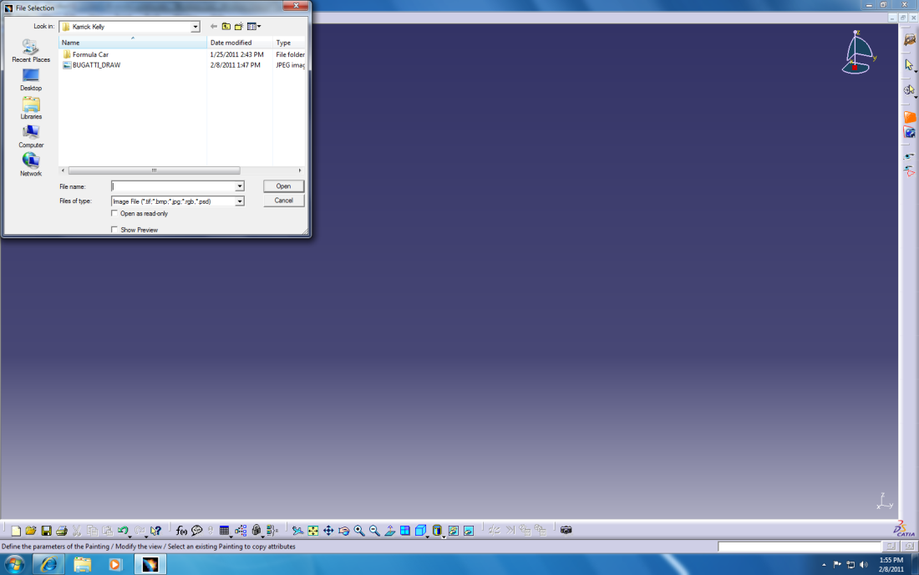

- Open the Sketch Tracer workbench under the Shape Pallet.
- Select your view orientation by selecting F(front) on your 3D mouse.
- Change your material view from shading with edges to shading with material
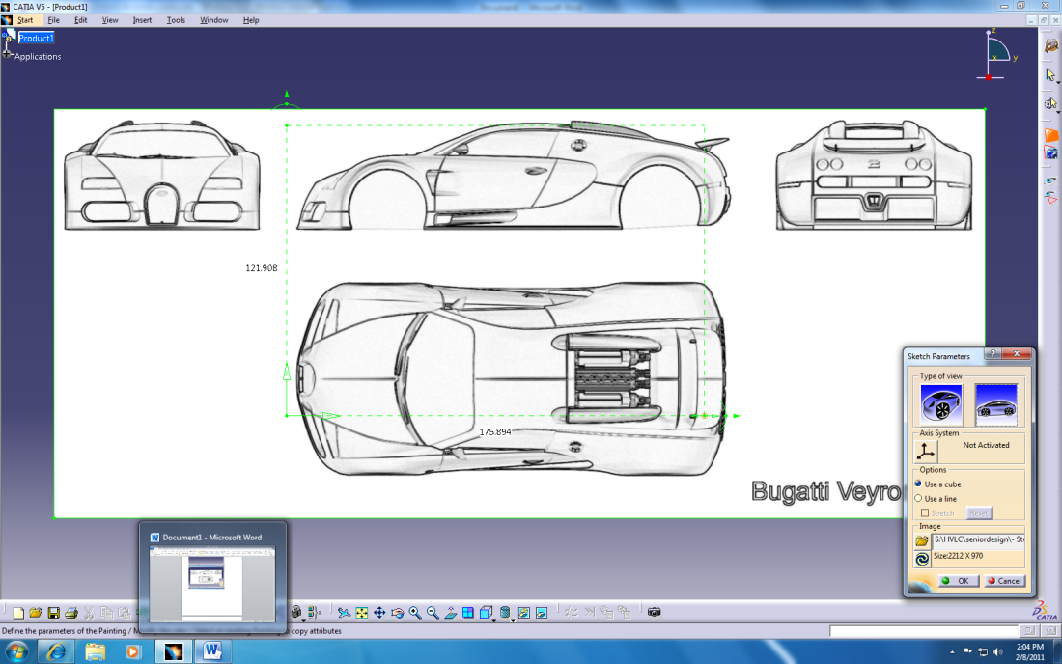
- Click the photo import button and browse to the 3D photo. You must have the material view selected to see the photo.

- Drag green box to desired front view. Move the box origin to the desired origin and the axes to their location. Crop the photo using the outer green selection box.

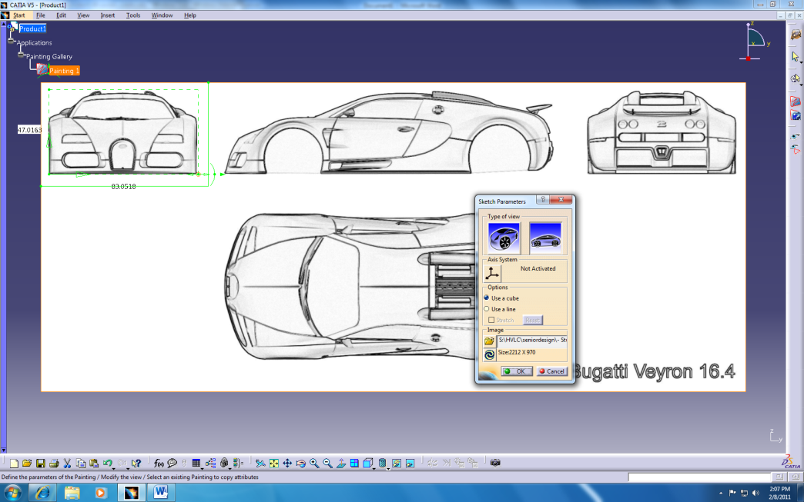

- Click okay to define the view.
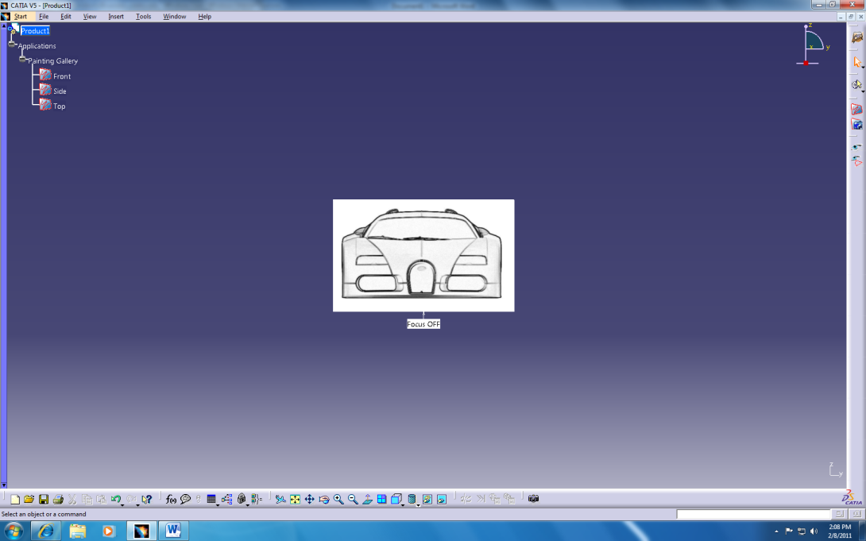

- Repeat steps 2 through 6 only changing to the top and side views respectively.
- By double clicking on a view, one has the ability to edit that view.
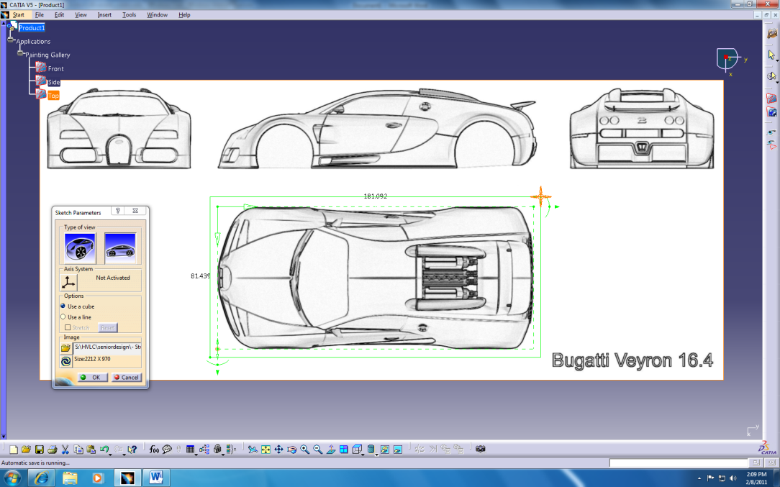
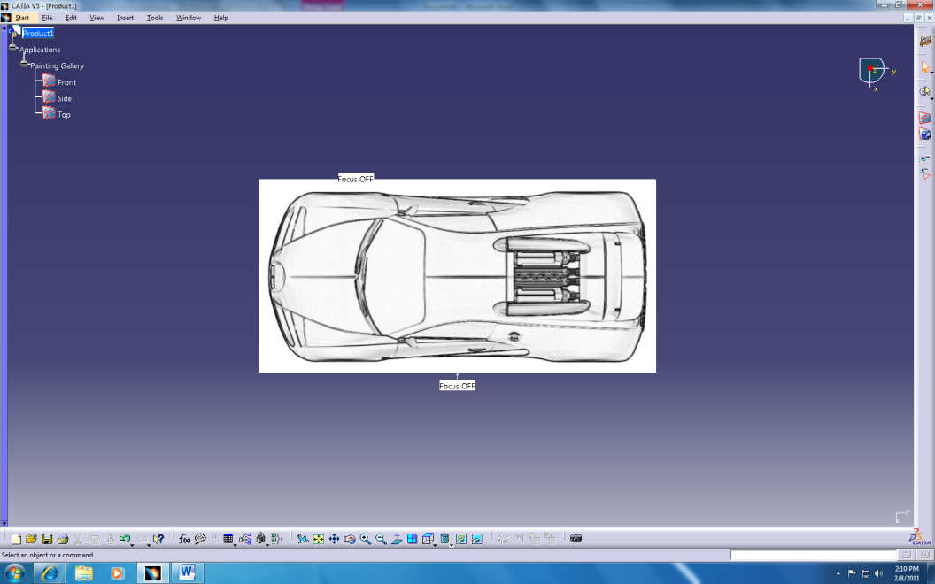

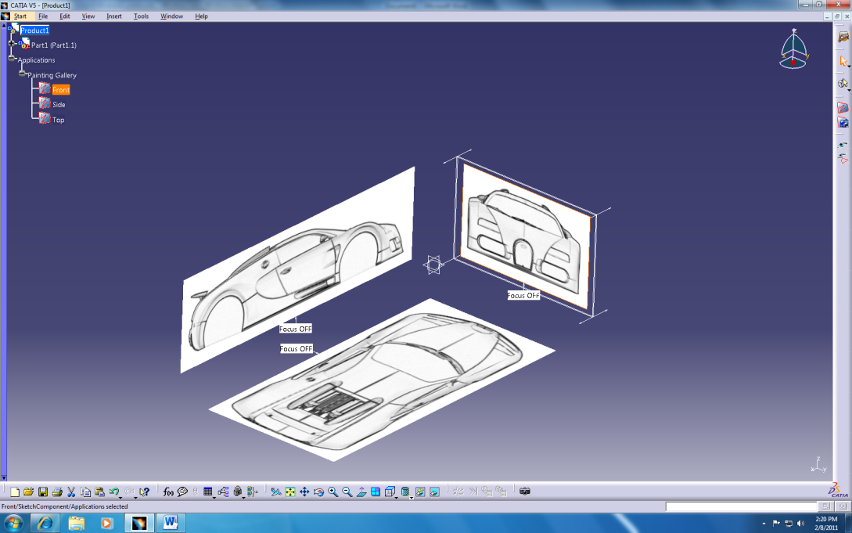

- Once you have completed the views, you can click then drag the views to the desired location using the compass as you would a part.

Notes:
- If the origin of the sketch isn’t where you want it, then adjust it under the specific painting that needs the adjustment.
- If the axes are backward, then you can rotate the inner green box which rotates the axes to change this. The solid green box is the cropping box while the dashed box is the origin and axis box. If a painting is in an incorrect orientation, then the dashed green box is the one you need to adjust. If the origin is in the correct corner, then the vertical and horizontal axis is what needs to be changed. You can rotate the axis to change the orientation of the painting. For example rotate the vertical axis bar to the horizontal position and replace its position with the old horizontal axis.

