Haas 4 Axis: Rotary Machining Tutorial
By Jeffrey Tracy and Rory Lilley

This tutorial is meant to demonstrate how to use the fourth axis capabilities of the HAAS Mill. The tutorial will walk you through how to set up the tool paths needed to create the part shown above using Master Cam 6.

- First you will need to create the part using Solid works. The part should have a dia. of 4 in and length of 10 in. The slots that are cut into the length of the shaft should have a diameter of 3/8 in. and have 12 instances; Figure 2 shows the initial sketch of the part prior to being extruded. The origin of the part should be located at the center of the shaft on the right side, this is important because Master Cam will incorporate this information when the file is uploaded.
- After you’ve made the solid works part you need to save the part as an IGES (.igs) file, but before saving, you need to go into Options located just below the file name and file type entry fields on the pop up window. In the options menu make sure that the IGES wireframe (3D curves) option is selected. Click Ok at the lower right of the window and Save in the save as window.

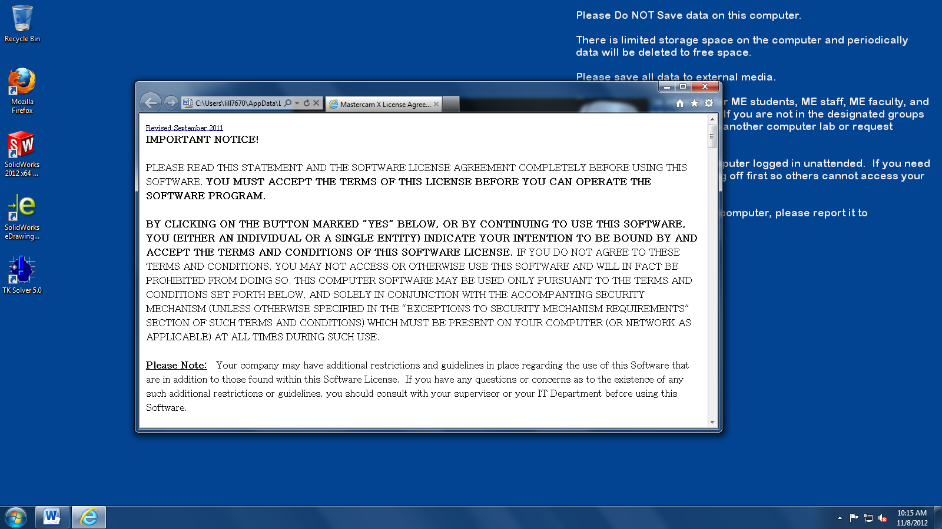
- Now you need to open up Master Cam 6. The license agreement may appear in your browser, if this happens just close the widow and click the check mark to agree to the license and Master Cam should finish booting up.

- Next open up the IGES (.igs) file you made of your Solid works Part.

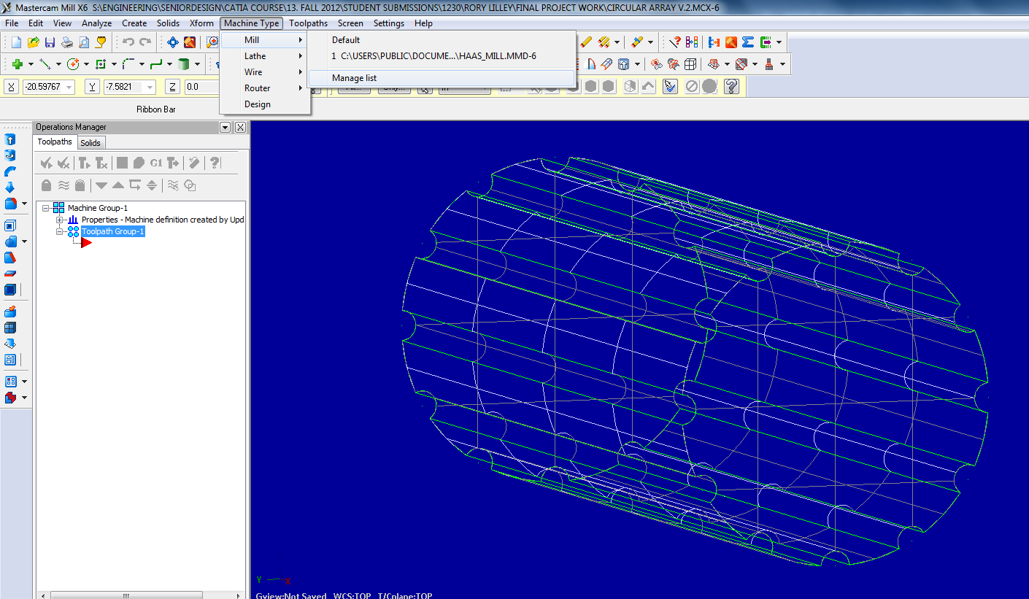
- When the file is open you need to specify the Machine that you want to use to create your part. For our purposes we will want to use the HAAS Mill. To do this you open up the Machine type dropdown menu and hover over the Mill option. If the list of Mills is unpopulated click on the Manage List option in the Mill menu. In the Machine Definition Menu Management Window you select the Haas Mill and click the add button and select ok. Then you need to over the first portion of this step and select the HAAS Mill. The Operations Manager Widow or design tree on the right will then become populated by Machine Group 1 as seen in figure 5.

Figure 5 shows this step, however the Haas Mill is already in the list.

- After selecting the Machine to be used for the part you need to set the stock size so that Master Cam knows what shape and size it is starting with. To do this, expand the ‘Properties’ in the ‘Operations Manager’ and click on ‘stock setup’. The Machine Group Properties window should open up on the screen. Under the Machine Group Properties window select Cylindrical and input the overall size of the stock needed. For this tutorial you will set the stock to 4 in dia. and 10 in long.( IMPORTANT ) Make sure the length of the stock sits in the negative x direction, leaving the origin on the right side of the stock part, this is done due to the setup of the HAAS Mill.
- Check the stock is correct by clicking on the show/hide stock button the stock should appear as red dashed lines in a wireframe display. To see a sold part click on the Turn stocks shading on/off button just the left of the show/hide stock button.

- Now with the stock set you can start adding tool paths for cutting operations. To do this right-click on Toolpath Group-1 and go to Mill Toolpaths and then Contour. At this point a window will appear to name the cut, select the check mark.

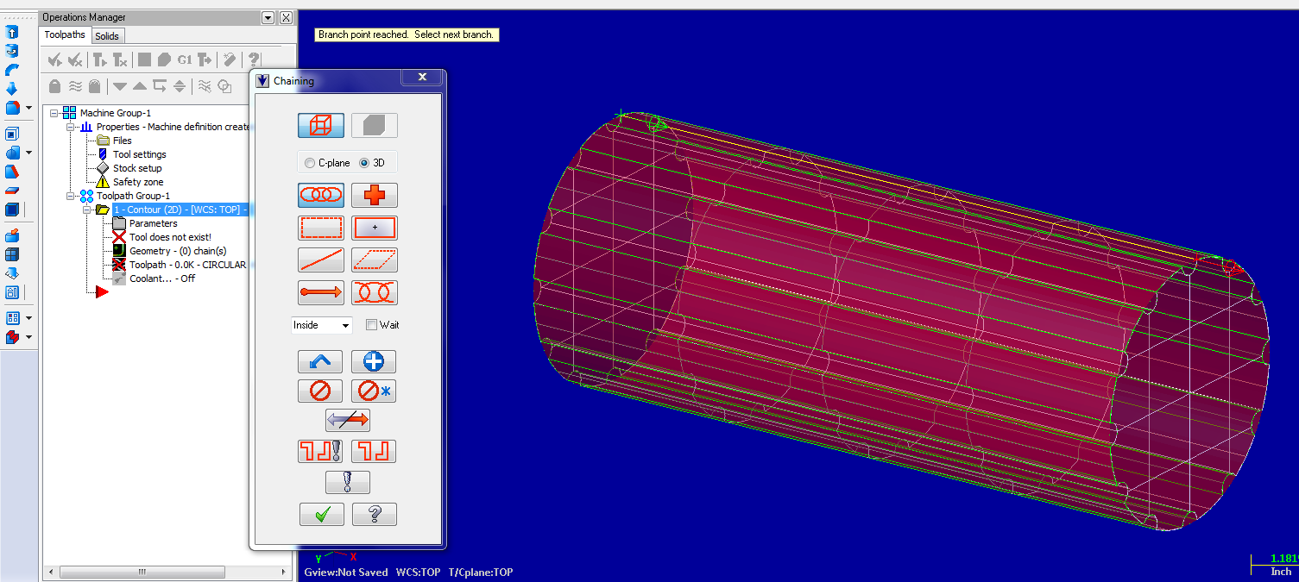
- The Chain window should pop up next Select the options shown ( 3D option and Chain) and now you need to select one of the edges of the slots on the origin side of the part.( Also be careful to select the edge of the slot on the top of the part relative to the axis may also help to toggle axis using F9.) This will affect which direction the cut takes place as shown by the green and red arrow shown on the part. The green area shows the start and red the end. When everything is set click the check mark.

- Immediately after closing the previous window the 2D Toolpaths-Contour should appear.
The contour toolpath should already be selected. First open up the tool window using the tree on the left. For this tutorial we will select a 3/8 ball end mill. To find the tool open up the library by clicking Select Library Tool. When the library opens up find the desired tool for this tutorial will be a 3/8 in ball end mill.

- Now go down to Linking Parameters on the tree on the left in the 2D Toolpaths-Contour window.
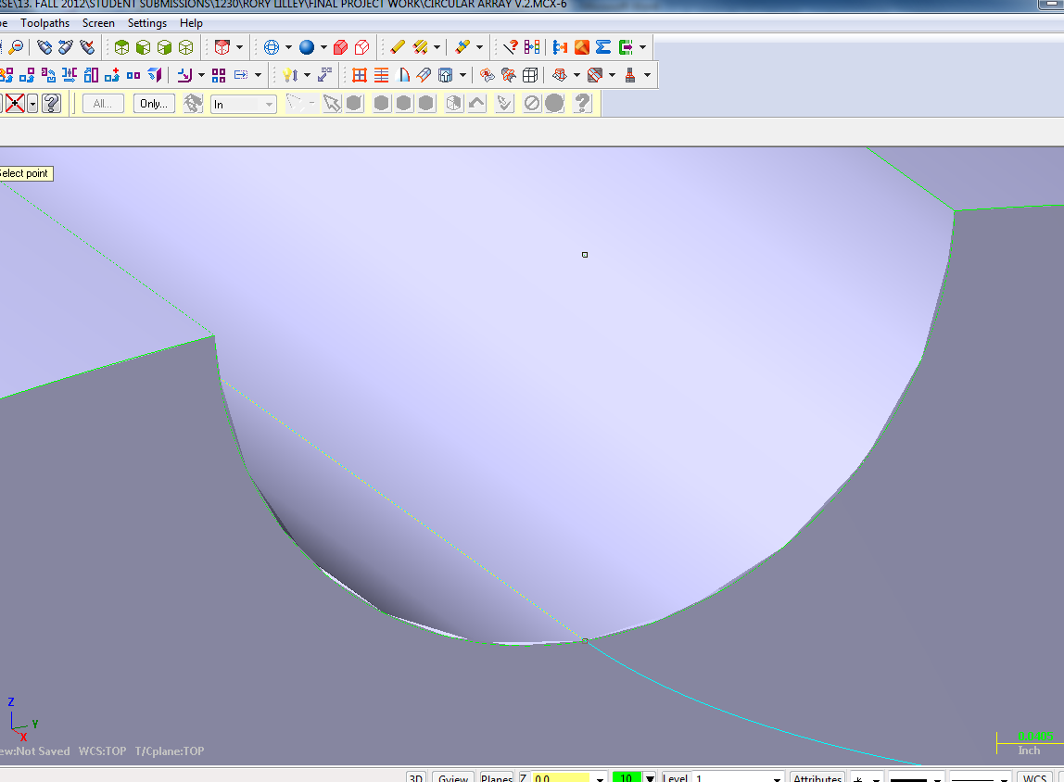
In this window we can set the depth and top of stock along with how far the tool is retracted after cutting. For this tutorial we will only be concerned with the depth and top of stock. The top of stock should be 2 in (radius of stock) and to set the depth you need to check the absolute option and then click on depth button. The window should close and you go into the part and select the lowest point on the slot you picked to machine.
After click the lowest point the 2D Toolpaths-Contour Window should pop up and the depth of the cut should be set. Then click on the check mark. Note To see the part in a shaded view click on the shaded button.

- Next you need to check the cut. This is done by clicking on the Regenerate all selected operations which looks like a bolt with a green play button arrow next to in located just above the operations tree. Then clicking on the Verify Selected Operations button which is located just above the operations tree and looks like a block with a quarter circle cut out of one corner.
The verify window should pop up giving you a VCR set up, just hit play to simulate the cut on the stock if everything works click the check mark.

- Next we are going to add the rest of the pattern cuts using the Transform Tool Path. To start right click the red arrow in the operations tree in the operations manager window on the left side of the screen. Go to Mill Toolpaths in the menu and then down to the Transform tool path and left click.

- The Transform Operations Parameters window should open up automatically. Under the type section select Rotate, and under the Methods section select Tool Plane and make sure the Include Origin option is checked. In the Source Operations window all the Toolpaths are displayed, for us there should only be one. Expand the contour folder for Toolpath Group-1 and select the Toolpath.

- Next select the rotate tab.

Here we set the number of instances to be 11 because we should already have one cut. We need to select the Total Sweep option so that the pattern is over the entire parameter of the profile. Next you set the starting angle, which for us is 30 deg. and then next entry field we need to input the angle over which our instances will be placed which is 330 deg. Also you may need to set the Rotation view, for us we needed to select the left view, the view you will need is the view the original sketch was made in. When everything is entered click the check mark.

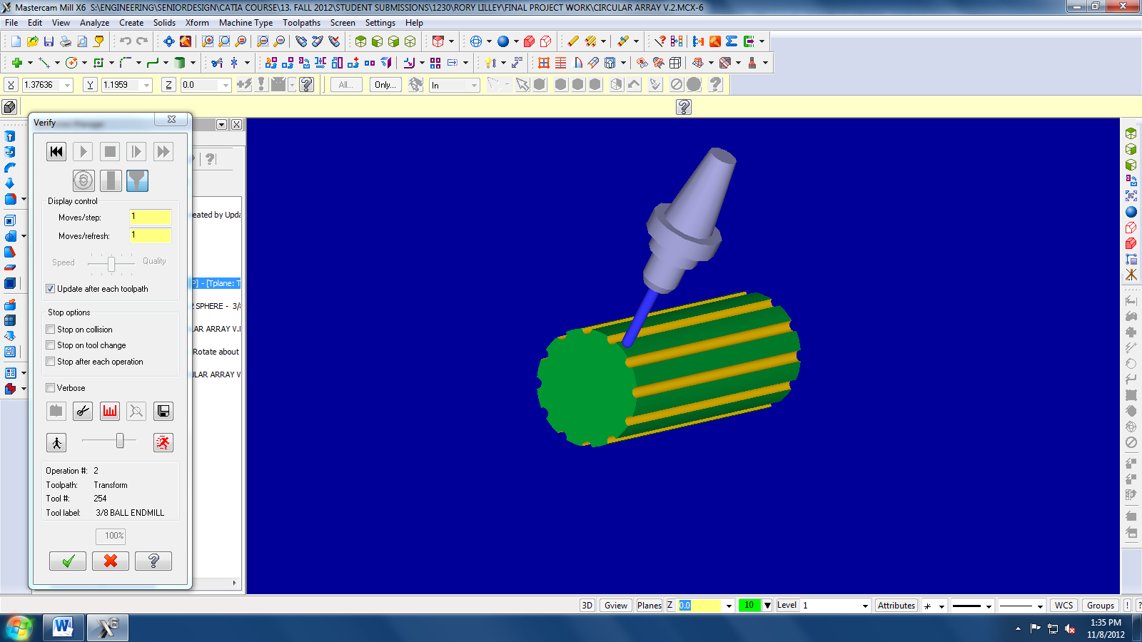
- Now that all the Toolpaths are generated we need to see if the code works. To do this we go over to the Operations Manager and click the Regerate All Selected Operations button and the Verify Selected operations button just like in step 12. This should show the part being machined.

