Story Board:
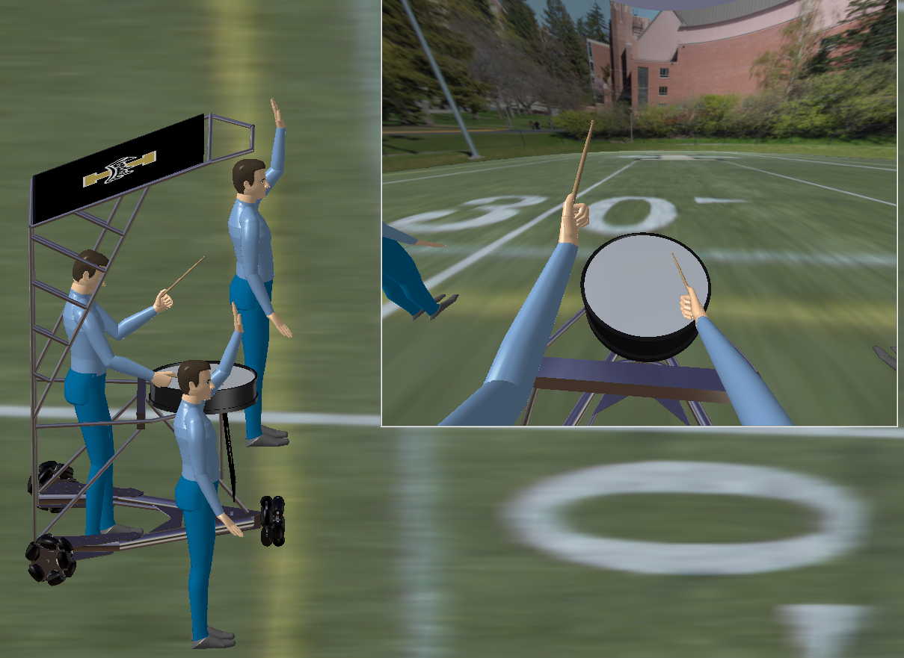
- Scene opens with Drummer and band members ready to perform
- Music (Thunderstruck) begins
- Drummer plays to beat as the Bandbeesten leads the way
- Drummer stops midfield
- Drum Solo occurs
- Bandbeesten and drummer turn 180 degrees
- Marches back towards band members
- Camera Pans to side shot
- Fade into real life Bandbeesten

Lessons Learned:
- Create tracks in human builder to utilize full functionality of workbench
- A sequence cannot be compiled in the Human Builder workbench
- Use DMU Navigator workbench to compile tracks into sequence and create video
- Generate video: Select Tools Simulation Generate Video
- Catia V5 Human Builder is idealized for simulation
- Simulation is too restrictive for this Bandbeesten Experience

Challenges to consider:
Tracks can be compiled and merged in the same dialogue box. Merging allows for simultaneous motion to be choreographed. Merging shuttles with manikin movements did not produce the desired results. Shuttling is apparent in the resulting sequence while manikin movements are suppressed. The conclusion is shuttling and manikin motion cannot be sequenced simultaneously with Catia V5 Human Builder.
The manikin vision is run adjacent to the global screen or selected camera angle. A method for animating only the manikin vision was not found.
Video Replay:
A video has been created. Please see following Catia product file located on the shared drive
Fall 2014.

A video replay is available in the design tree under applications. This short video shows the current state of sequencing. The drummer marches and drums in place. Tracks may be edited and new sequencing created as discoveries are made.

