Final project
1967 Shelby GT 500

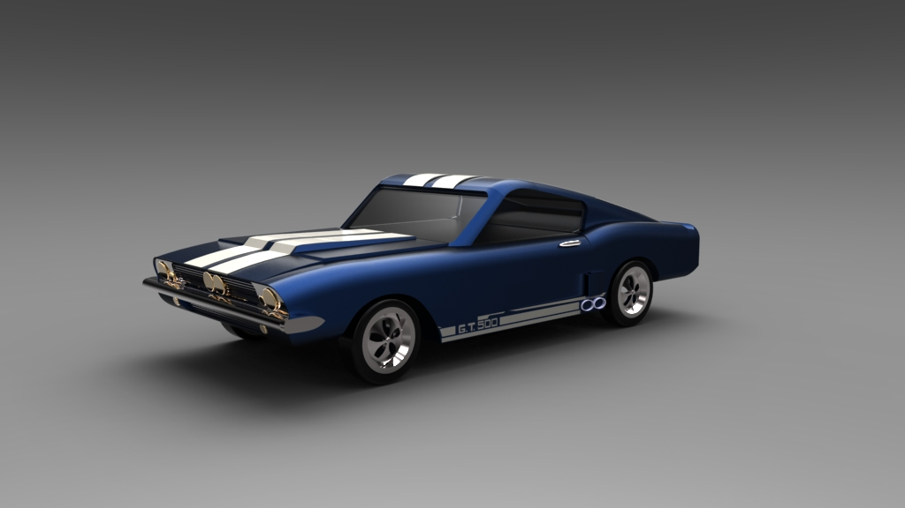

Faisal Alqudairi
Mshari Aldossary
Fawaz Alharbi

1967 Shelby GT 500
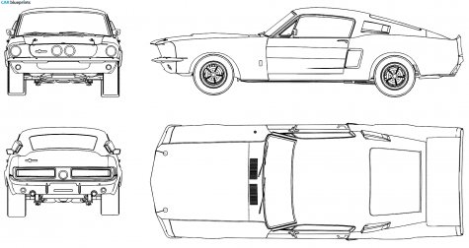
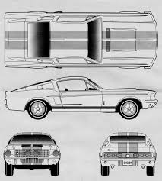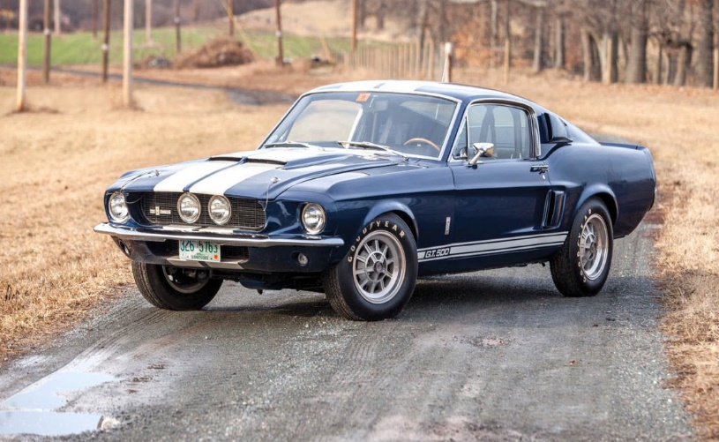
The product needed to be designed was Mustang 1967 Shelby GT 500 Car. I used internet search to find the right design to design it based on its dimensions. I used dimensioning tool to estimate the dimensions of each parts within the car. I acquired list of parts in the mustang ford from mustang official site to ensure the assembly. Each part was designed based on its estimated dimensions which then were adjusted according to the assembly fitting.

- Front Part:
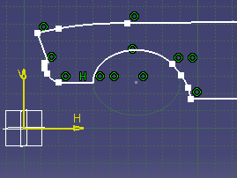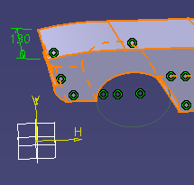
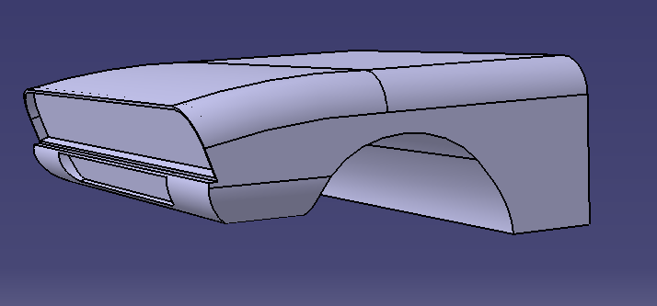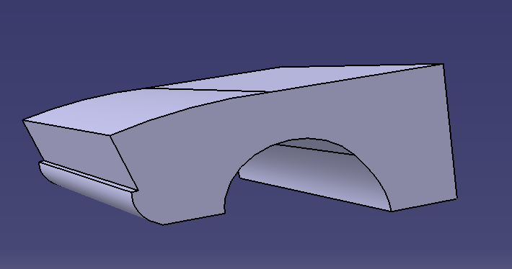
For front part I moved to front view and using the concept of tracing, with the help of spline trace the frontal body portion as shown in figure, then I just extrude it using pad tool. Then make different sections and remove that extruded section from main body in order to give it a final 3D car shape.

- Back part of the car body:
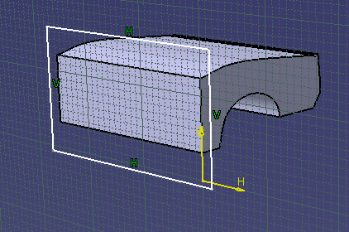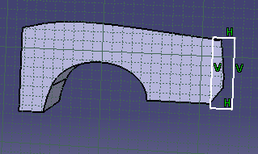

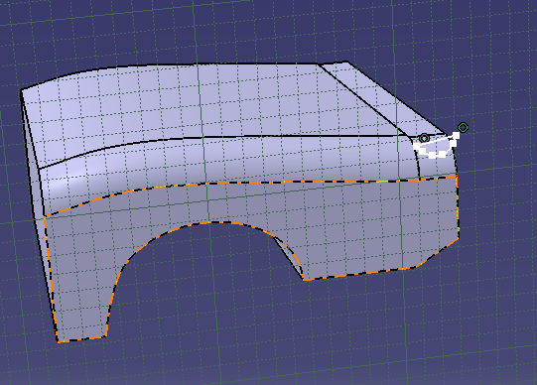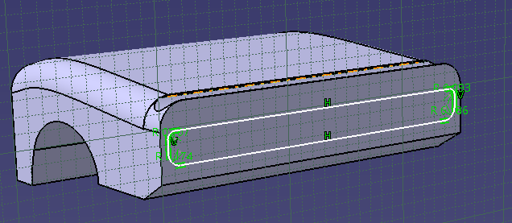
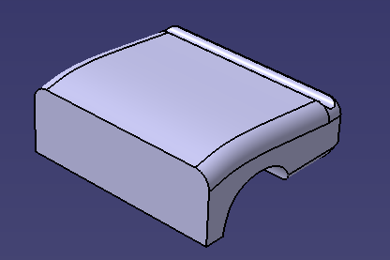

Using the same steps of procedure as done for frontal portion, trace then extrude to a height. Then for further shaping different sections are removed from the main body.

- Mid part:
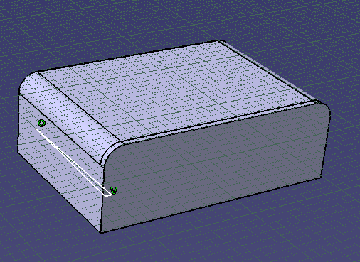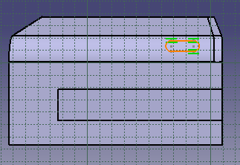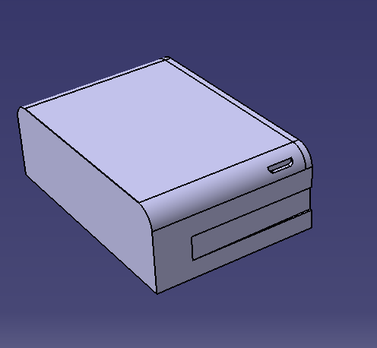
Similarly, as done above using the concept of tracing, with the help of spline trace the frontal body portion as shown in figure, then I just extrude it using pad tool. Then make different sections and remove that extruded section from main body to give it a final look.

- Frame:
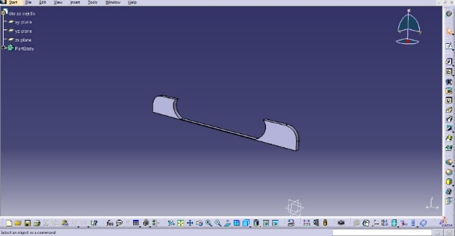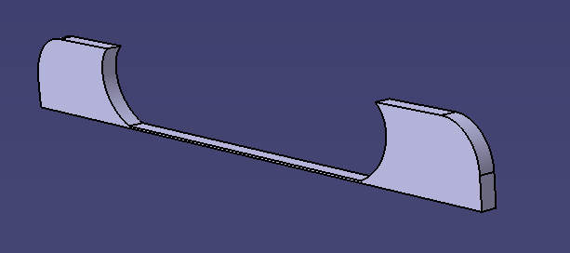
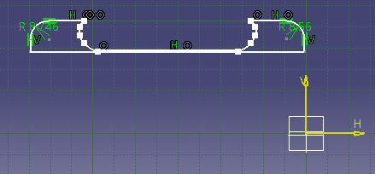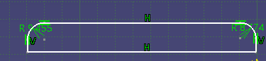
With the same flow and steps as done above, trace the frame structure with a spline and then extrude with a pad command to a desired thickness. Then different sections were removed from the main frame.

- Hood:
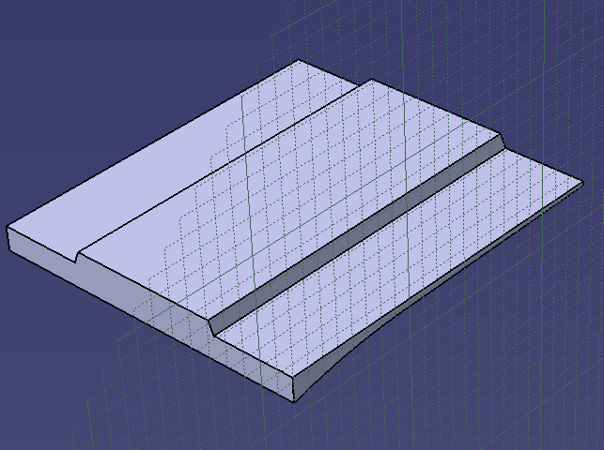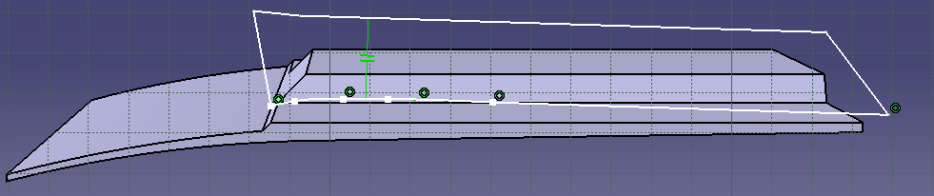
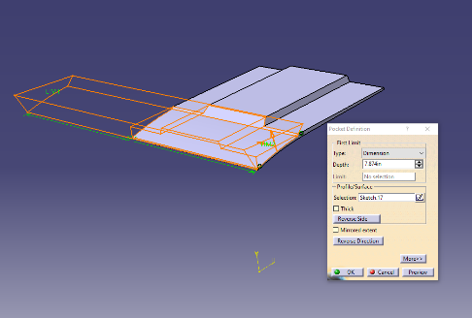 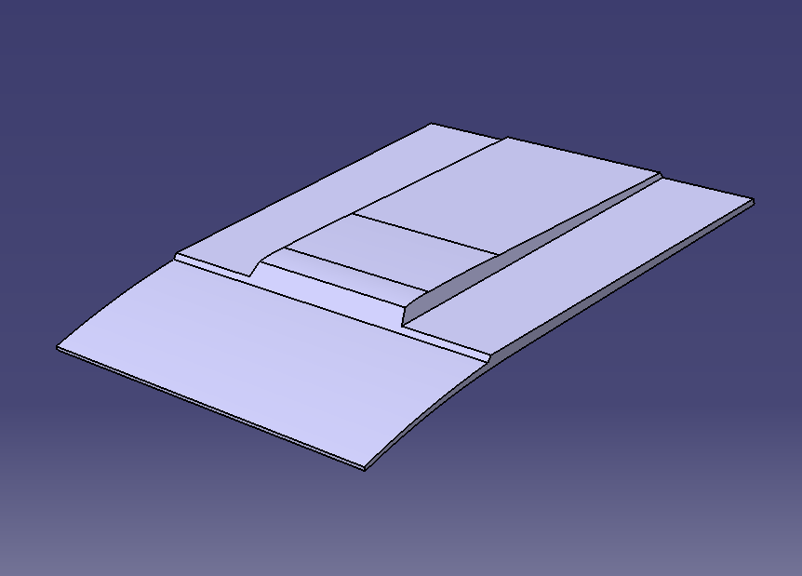Trace, extrude and then different section are removed from main hood body. Hood is the main portion where we have taken care of shape most. So, form where side section are removed in order to give it a final hood shape.

- Grid:
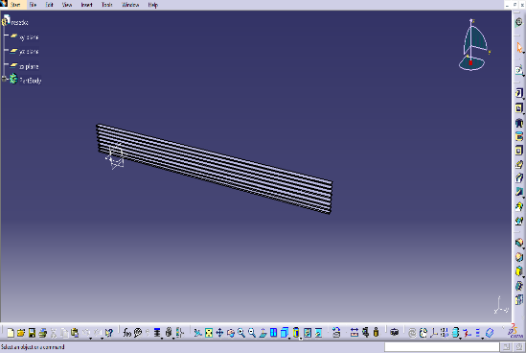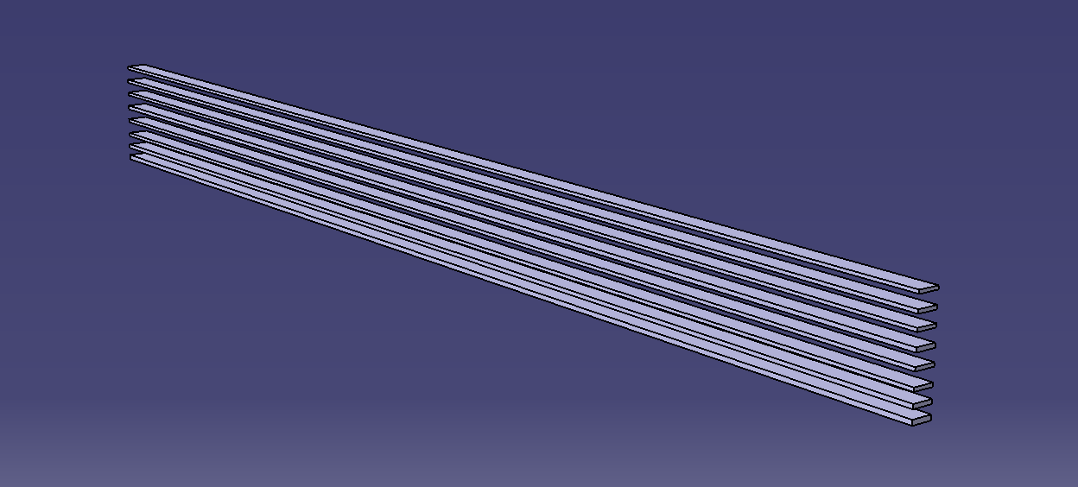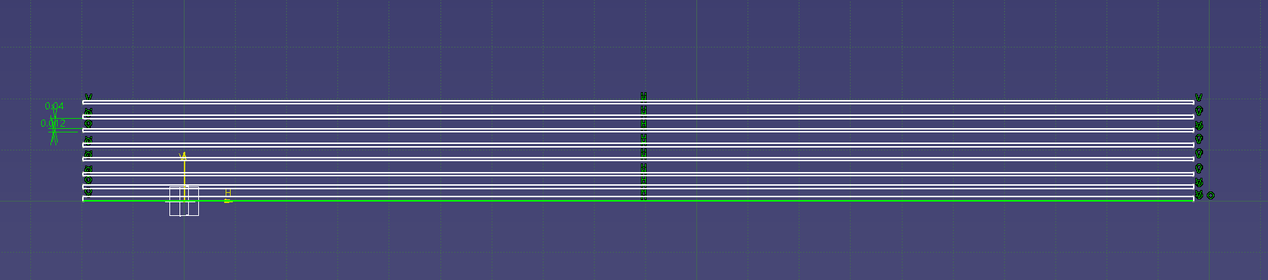
- Light:
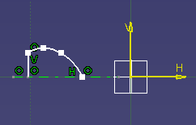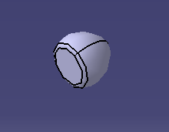
In order to give a realistic look, realistic features are introduced like have work most on the light for the design realistic gesture. For which I give a path to a light as shown above and then light command is used to give the realistic look.

- Roof:
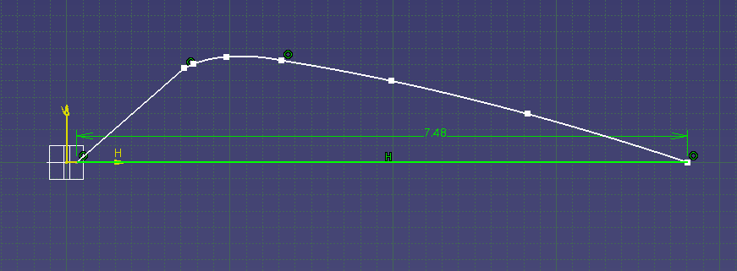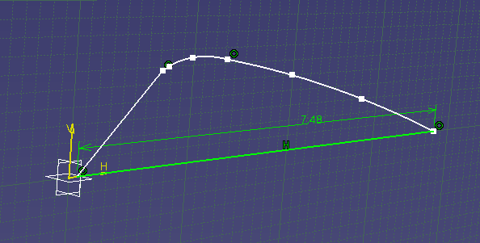
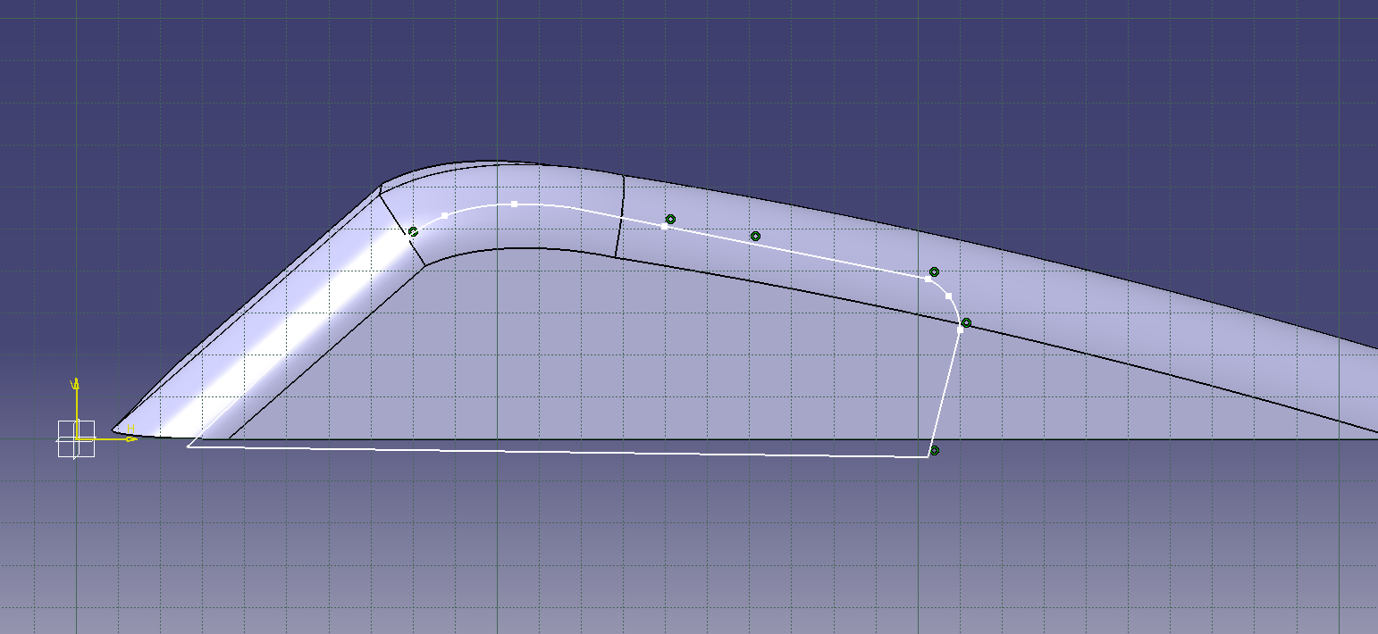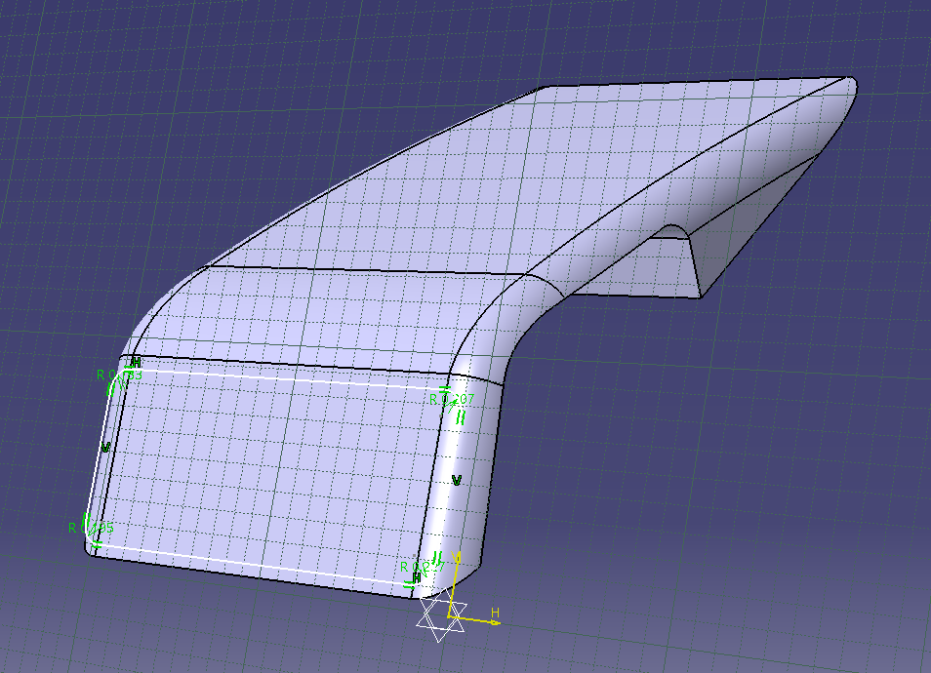
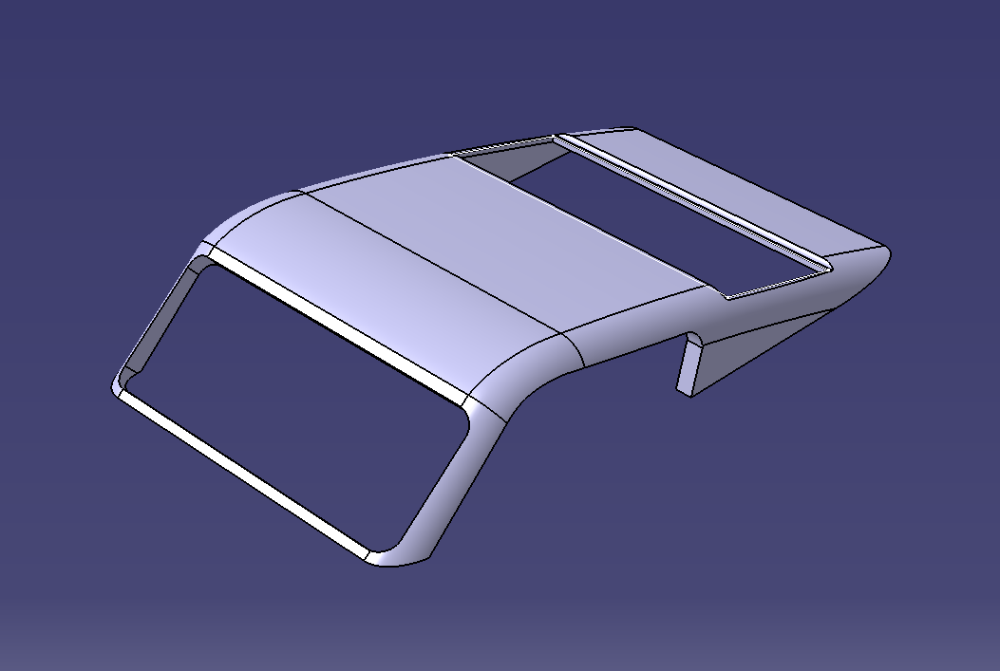
Using the same previous method, trace in a frontal view with a spline and then removed the different sections as shown to give the final roof shape.

- Exhaust:
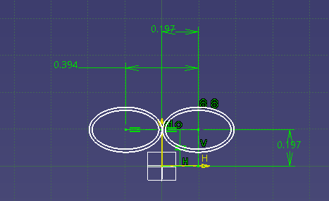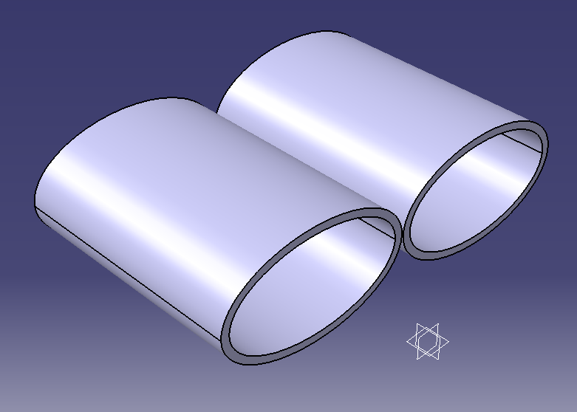
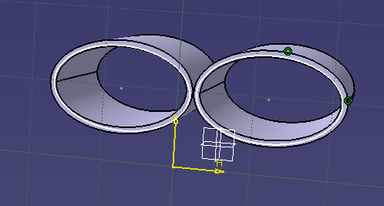

For the exhaust, first sketch the pair of two concentric circles attached with each other having radius of 0.197 and distance between them is of 0.394. Then it’s extruded to the height of 8 that is the length of the pipe.

- Rim:
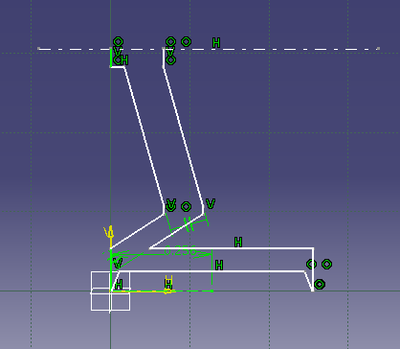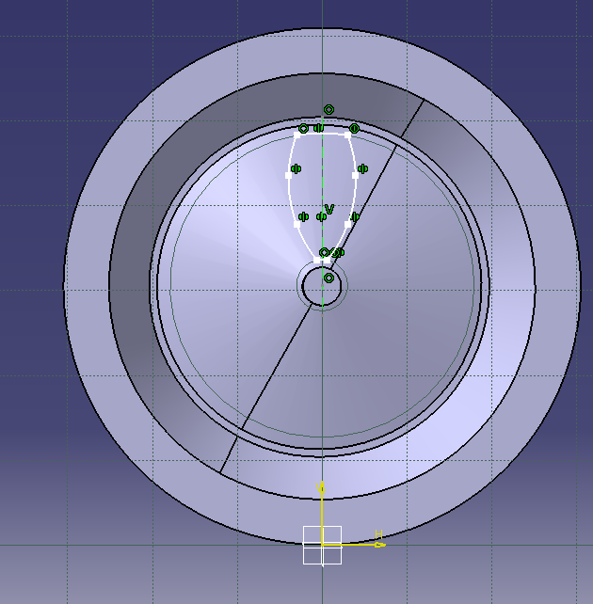
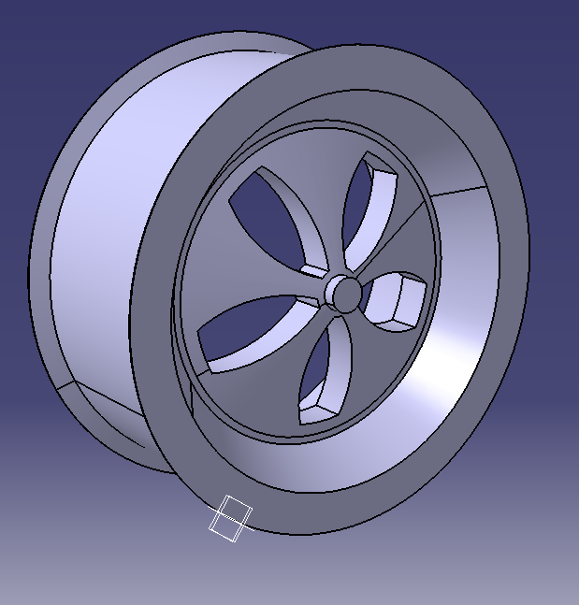
For rim I sketch in a 2D front view as shown, then a datum line is used in order to orbit or simple what we call it as rotate it around that axis, to have a rim shape, then further section are sketch and extrude and removed from base rim body.

- Tire:
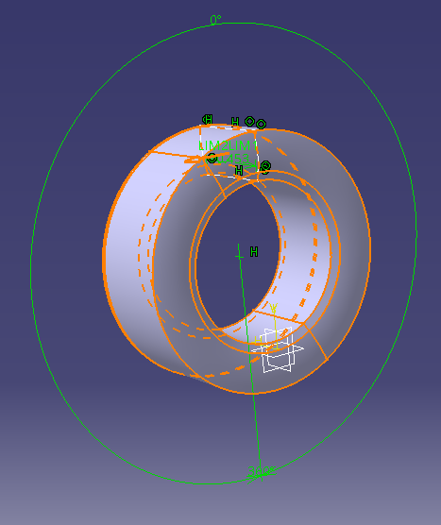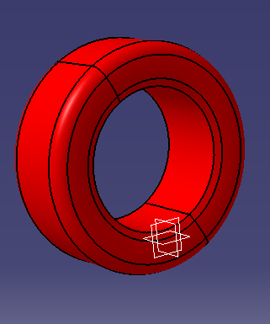
For tire same methodology of designing used as done for rim, sketch is made in a 2D and then its revolve around axis to have a circular tire like shape.

- Wing:
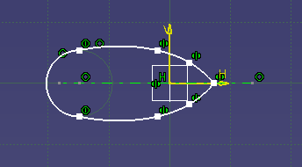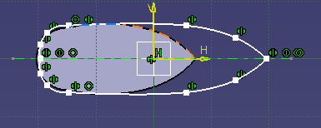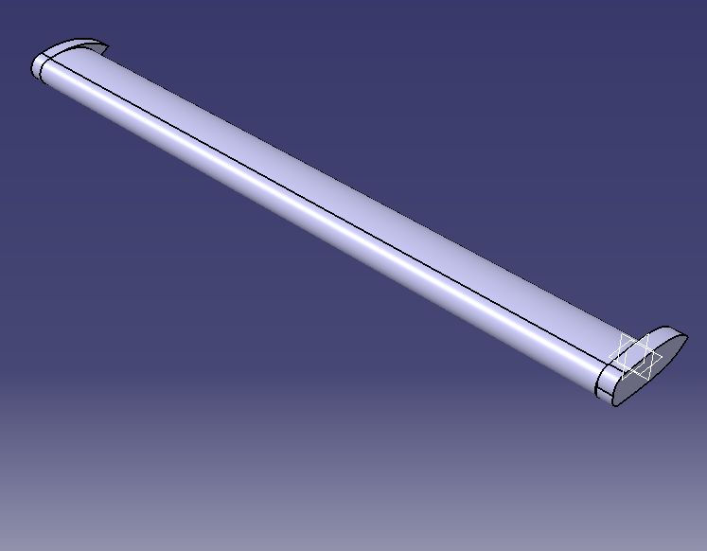
For wing sketch it, extrude and then in side view again sketch and extrude it with a pad command to give it final shape.

- Side strip:
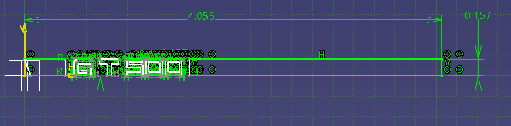
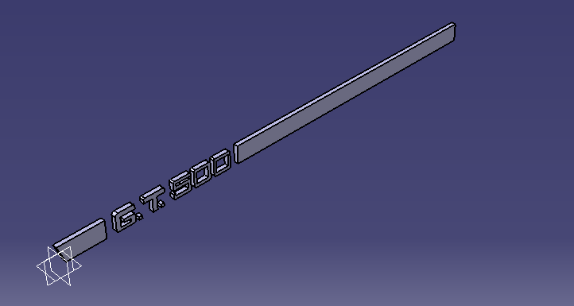
For side strip, sketch the rectangle with 4.055x0.157 and then extrude it. For having a better look GT 500 is sketch and removing the outer part and keeping it

- Window:
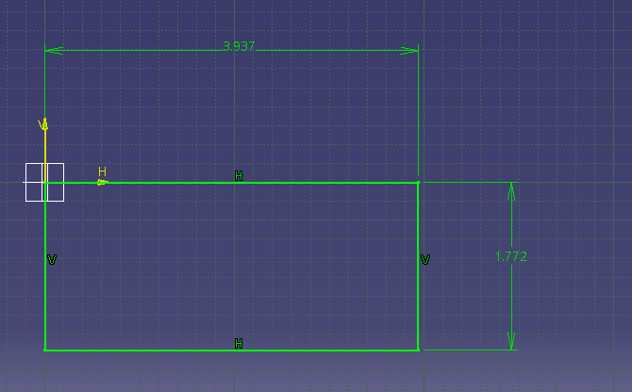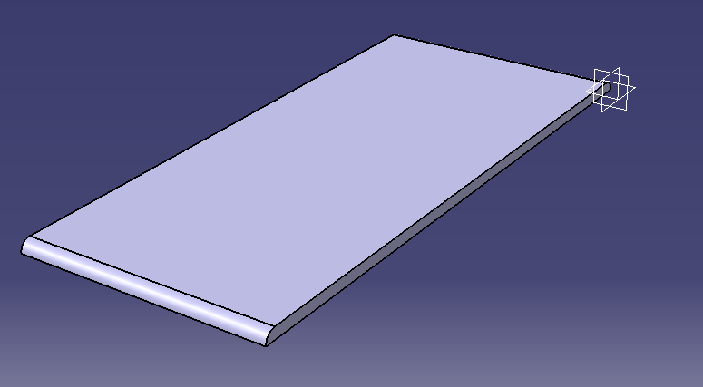
For a window, just sketch a 3.937x1.772 rectangle and extruded it.
- Side window:
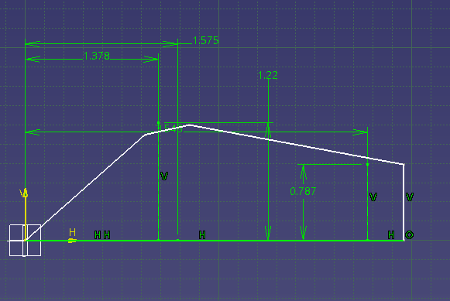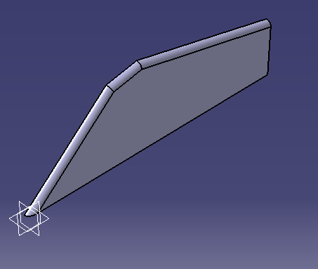
For side window sketch the window side in 2D and then extrude it to 0.01 thickness.

- Knob:
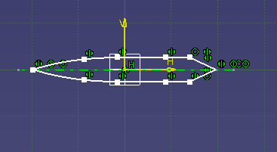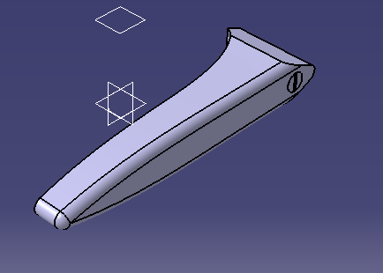
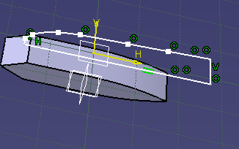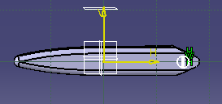
For knob, make a 2D sketch as shown then extrude it with a pad command finally other sections are extruded and removed.

- Final shape:
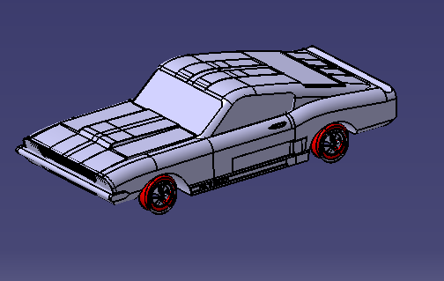
Most of the time spent was on assembly all the parts. This session faced most difficulties to attach the parts. For assembly open the assembly file, start from right side body part towards the left one by one attached with mate constraints, then roof and windows are attached with the car body. Finally, at last wheel assembly is fixed.

- Lessons Learned:
From this project, we have learned the following things:
- How the complex shape parts are designed.
- How to trace with a spline, already design.
- How to remove the sections to have a complex shape.
- How to use a revolve command for circular symmetric parts.
- How to assemble the final parts with different constraints.
Comparison with other CAD Softwares:
Unigraphics and Pro-E are fine Computer Aided Design (CAD) programs. However, there are more companies - worldwide - using CATIA than all the other CAD programs combined. Therefore, there is more demand for CATIA designers than there are for designers using any other CAD program. If you want to give yourself the best opportunity for to further your career, then CATIA is the right choice.
Conclusion:
Overall the project was a complex one there are some critical points which took a lot of struggle to complete but at the end due to a continuous struggle and hard work we have completed this project well with all the requirements and guidelines and got this ultimate design project completed in limited time.
Some of the problematic portion was the creation of side window, knob and side strip but due to our team effort and skills and giving the proper time to the project with full concentration we have overcome every difficulty and performed the task and got our project completed.

